

**PRIVATE CLINIC SYSTEM**

**Software Design Specification**

**Version 1.0**

# 

# 

# 

– Da Nang, October 2024 –

# TABLE OF FIGURE

## 1. Record of changes

| **Date** | **A, M, D** | **In charge** | **Change Description** |
| --- | --- | --- | --- |
| 05/10/2024 | A | All | Initial |
| 05/10/2024 | A | All | Create package diagram |
| 13/03/2023 | A | All | Add database diagram |
|  |  |  |  |
|  |  |  |  |
|  |  |  |  |
|  |  |  |  |
|  |  |  |  |
|  |  |  |  |
|  |  |  |  |
|  |  |  |  |
|  |  |  |  |
|  |  |  |  |

**Note**: A – Added, M – Modified, D – Deleted

– Da Nang, October 2024 –

**Table of Contents**

**TABLE OF FIGURE 2**

1. Record of changes 2

**I. Overview 4**

**1. Code Packages and Folders: 4**

1.1. Back-End:(ASP.NET core Web Api) 4

1.2. Front-End (Nextjs) 5

**2. Database Design 8**

**a. Database Schema 8**

**b. Table Description 8**

**II. Code Designs 12**

1. Common Class Diagram 12

a. Common Class Diagram 12

b. Common Class Specifications 12

**2. Auth 16**

2.1. Register 16

2.2. Login 21

2.3. Confirm email to verify account 26

2.4. Forgot Password 29

2.5. Login With Google 33

2.6. Changing Password 39

2.7. Resend email register user 45

3. User 49

3.1. Get User Profile 49

3.2. Get all doctor for booking 53

3.3. Get all doctor who is on duty 54

3.4. Update User Avatar 57

3.5. Send a feedback 61

3.6. Get all doctors who is on duty 66

3.7. View feedback 69

3.8. Get consultation overview 78

4. Doctor 85

4.1. Get Doctor Profile 85

4.2. Update Doctor Profile 90

4.3. Get all medical report 97

4.4. Create retreatment notification 103

5. Appointment 109

5.1. Get Appointments By Date 109

5.2 Get the recent appointment of the doctor 114

5.3 Update Appointment Status 117

5.4 Get Users Booked Appointment 122

5.5. Get Absent Appointments 123

5.6. Create New Appointment 130

6. Schedule 138

6.1. Create schedule 138

6.2. Update schedule 143

6.2 Get schedule By Date 148

6.3 Remove all schedule by date 151

7. Medical report 157

7.1. Get the medical report by ID 157

7.2. Create new medical report 163

7.3. Get recent medical report 170

8. Services Order 176

8.1. Order Service 176

8.2. Get Service Order Items 181

9. Medicines Order 186

9.1. Order Medicine 186

10. Queue Rooms 190

10.1. Create queue room 190

10.2. Get All Queue Room 194

11. Chat Rooms 198

11.1. Assign chat room 198

12. Chat Contents 202

12.1. Get Chats By ChatRoomId 202

12.2. Create chat content 206

13. Payment 211

13.1. Handle redirect url Payment 211

14. Admin 218

14.1. Doctor 218

14.2. Create a medicine 235

14.3. Create a service 239

# I. Overview

## 1. Code Packages and Folders:

### 1.1. Back-End:(ASP.NET core Web Api)

[***Implemented according to Vertical Slice Architecture***](https://verticalslicearchitecture.com/)

We apply this architecture because using the **Vertical Slice** architecture **(VSA)** in an ASP.NET Core Web API helps optimize the development, maintenance, and scalability process by organizing the codebase around features rather than following the traditional layered model. When implementing features, they are developed independently, avoiding code conflicts between team members, making the source code easier to manage and more transparent. Performance optimization and scalability are also strong points of this architecture.

The package code below illustrates the foundation of this architecture. For a more detailed understanding, please refer to the provided source [here.](https://verticalslicearchitecture.com/)

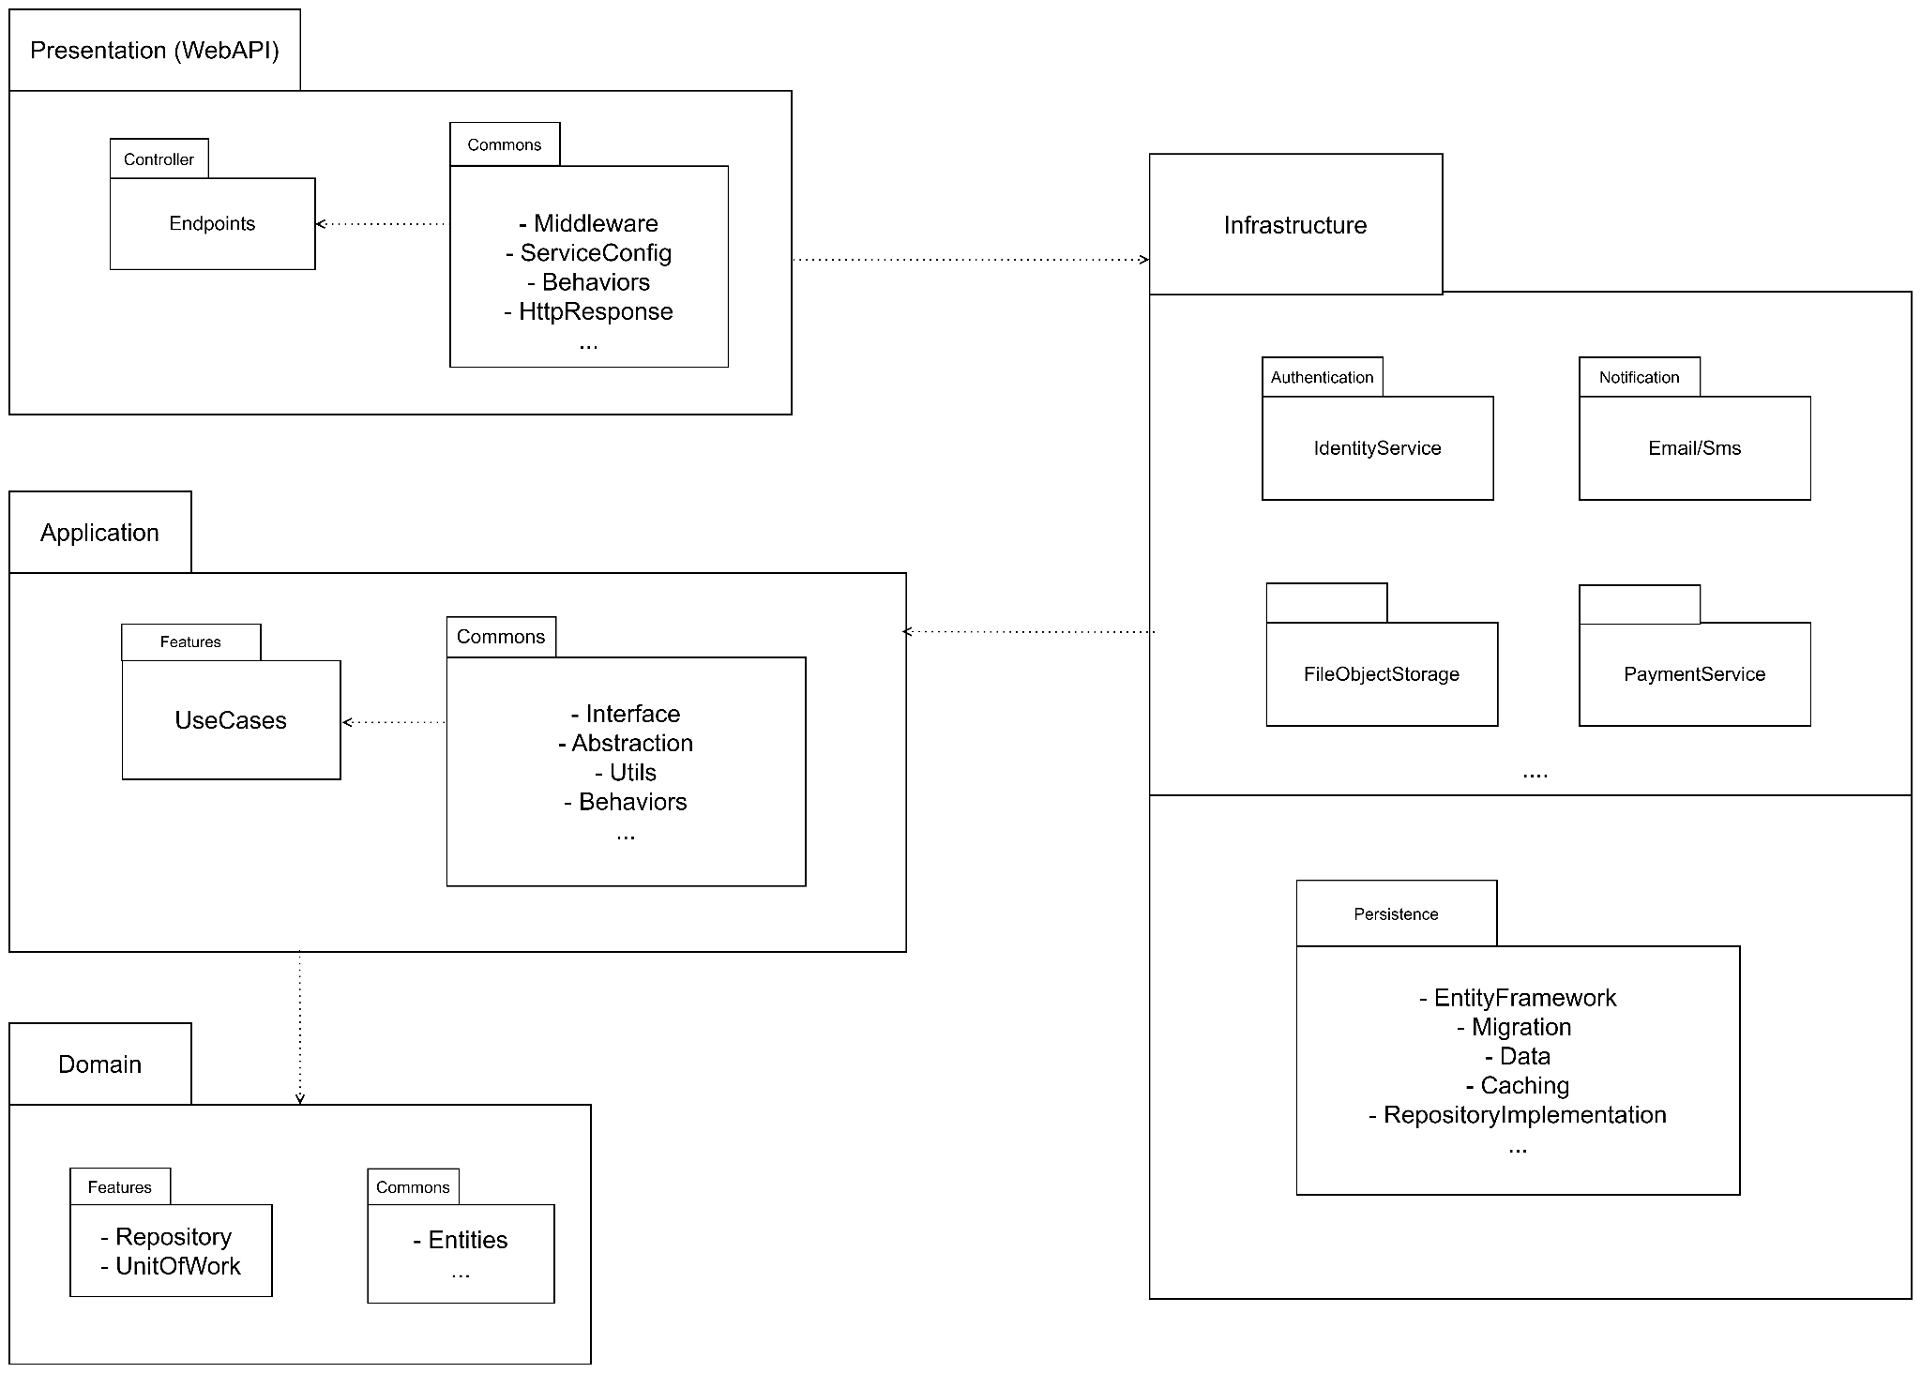

***Package descriptions***

| **No** | **Package** | **Description** |
| --- | --- | --- |
| *01* | *Domain* | *The Domain Layer is the core of the application, containing all the business logic and core entities (domain entities). It is completely independent of any external frameworks, databases, or libraries.*  *Entities: Objects such as Patient, Doctor, and Medicine are defined here. Interfaces: Definitions like IRepository<T>, IUnitOfWork are defined to handle database* |
| *02* | *Application* | *The Application Layer focuses on executing the business processes of the application, containing specific use cases and describing how the system interacts with other layers. It doesn’t contain any database or UI details but holds interaction and processing logic.*  *It uses Interfaces from the Domain Layer to execute tasks, so this layer can be easily changed without affecting other layers.* |
| *03* | *Infrastructure* | *The Infrastructure Layer is responsible for handling external technology-specific details such as database storage, external service connections (e.g., payment systems, emails, storage), and I/O operations. It contains implementations of the Interfaces defined in the Domain or Application Layer. However, it can only depend on the Application and Domain layers and must not depend on Presentation.* |
| *04* | *Presentation* | *The Presentation Layer is the outermost part of the system, handling all user interactions or communication with other systems via APIs. It may include controllers in Web API, or other elements like middleware to handle HTTP requests. This layer does not contain business logic. Instead, it receives and processes requests from the user and passes them to the Application Layer to execute the use cases.* |
| *05* | *…* |  |

### 1.2. Front-End (Nextjs)

We chose [**Nextjs**](https://nextjs.org/docs) combined with **TypeScript** for frontend development because Next.js's **server-side rendering (SSR)** and **static site generation (SSG)** enhance performance and SEO. **TypeScript** provides static type checking, reducing errors during development and making the code more maintainable. Together, these technologies offer high performance, scalability, and a stable development experience, making them ideal for modern web applications.

***Next Js resource folder structure:***

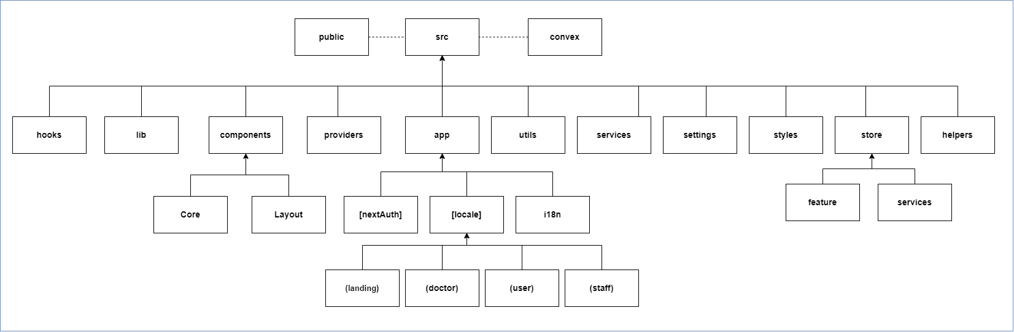

***Folder descriptions:***

| **No** | **Folder** | **Description** |
| --- | --- | --- |
| *01* | *public* | *The public folder contains all the static assets of the website, such as images.* |
| *02* | *convex* | *The configuration folder for the real-time database is used to implement the internal notification function within the system.* |
| *03* | *src* | *The main source code of the front-end application, where all the display logic and user functionality will be implemented within this folder.* |
| *04* | *app* | *The* ***app*** *directory is extremely important in a Next.js application. The* ***app*** *directory is the main component for building the structure, layout, and direct routing to different areas and screens. It prioritizes SSR (Server-Side Rendering) mode for optimal SEO.* |
| *05* | *[nextAuth]* | *This dynamic route allows for managing user sessions. It is used to store authentication information, such as related tokens. It is suitable for login functions using external accounts like Google or Facebook.* |
| *04* | *[locale]* | *The [locale] is a root dynamic route that manages the language transition and maintains the multilingual state of the application. For example:* ***https://pclinic.com/vi/...*** *will be in Vietnamese and maintained, while other variants like* ***https://pclinic.com/en/...*** *will be in English* |
| *05* | *i18n* | *The* [*i18n*](https://www.i18next.com/) *configuration folder allows for flexible and quick language switching while always maintaining the state.* |
| *06* | *(landing),(doctor), (staff), (user)* | *These are “Optional Catch-All Route” directories routed according to different layouts depending on the user's role. Naturally, each layout will be distinct and separate, making it important to validate roles against each other to prevent improper intentions. Each route will be divided according to element routes, for example:* ***https://pclinic.com/vi/doctor/medical-report/view?id=13ad...*** |
| *07* | *components* | *This is the folder that contains all the components in the web application.* |
| *08* | *components/core* | *Contains all the common components used for a shared purpose across the web application.* |
| *09* | *Core* | *It contains all the common components used for the same purpose across the web application (commons). Additionally, it includes smaller component elements (modules) for easier development and maintenance of the web application.* |
| *10* | *Layout* | *The folder includes UI layouts for building user interfaces according to specific roles. For example, the homepage layout might be a landing page with a header at the top and a footer at the bottom, with various sections in between. In contrast, the layouts for doctors, staff, and users are structured as dashboards with a side navigation bar, where the navigation will differ based on the role.* |
| *11* | *store* | *The* ***store*** *is a directory for Redux, specifically using* [*Redux Toolkit.*](https://redux-toolkit.js.org/introduction/getting-started) |
| *12* | *store/features* | *The* ***feature*** *is a folder that contains reducers to manage changes to the states controlled by Redux, such as* [*reducers*](https://redux.js.org/tutorials/fundamentals/part-3-state-actions-reducers) *for controlling the state of the sidebar or the authentication information of the system's users.* |
| *13* | *store/services* | *The* ***services*** *folder includes mutations and queries used for communication with the backend application through APIs, supported and optimized by* [*RTK Query*](https://redux-toolkit.js.org/rtk-query/overview) *from* [*Redux Toolkit*](https://redux-toolkit.js.org/introduction/getting-started) *(which offers caching, performance optimization, automatic state management, refetching,etc.).* |
| *14* | *hooks* | *It is used to create custom hooks.* |
| *15* | *lib* | *It is used to configure various types of libraries.* |
| *16* | *providers* | *It is used to provide the necessary providers within the application.* |
| *17* | *utils* | *It is used to build utilities that facilitate easier and more efficient application development.* |
| *18* | *services* | *It is used to configure third-party services for the application.* |
| *19* | *settings* | *It is used to configure global variables that are used throughout the application. Additionally, it serves as a place to store all the endpoints provided by the backend to facilitate communication using* [*RTK Query.*](https://redux-toolkit.js.org/rtk-query/overview) |
| *20* | *styles* | *It is a directory for setting global styles for the web application, such as themes, colors, etc. This is applied with libraries to support quick interface building, optimizing time when combining support libraries like* [*Ant Design*](https://ant.design/) *with* [*Styled Components.*](https://styled-components.com/) |
| *21* | *helper* | *The helpers folder contains files with static data in the form of exported functions with pre-defined key-value objects. This supports rendering a dynamic interface with different values and user permissions, and it can also be used for various other purposes.* |
| *…* | *…* | *…* |

## 2. Database Design

### a. Database Schema

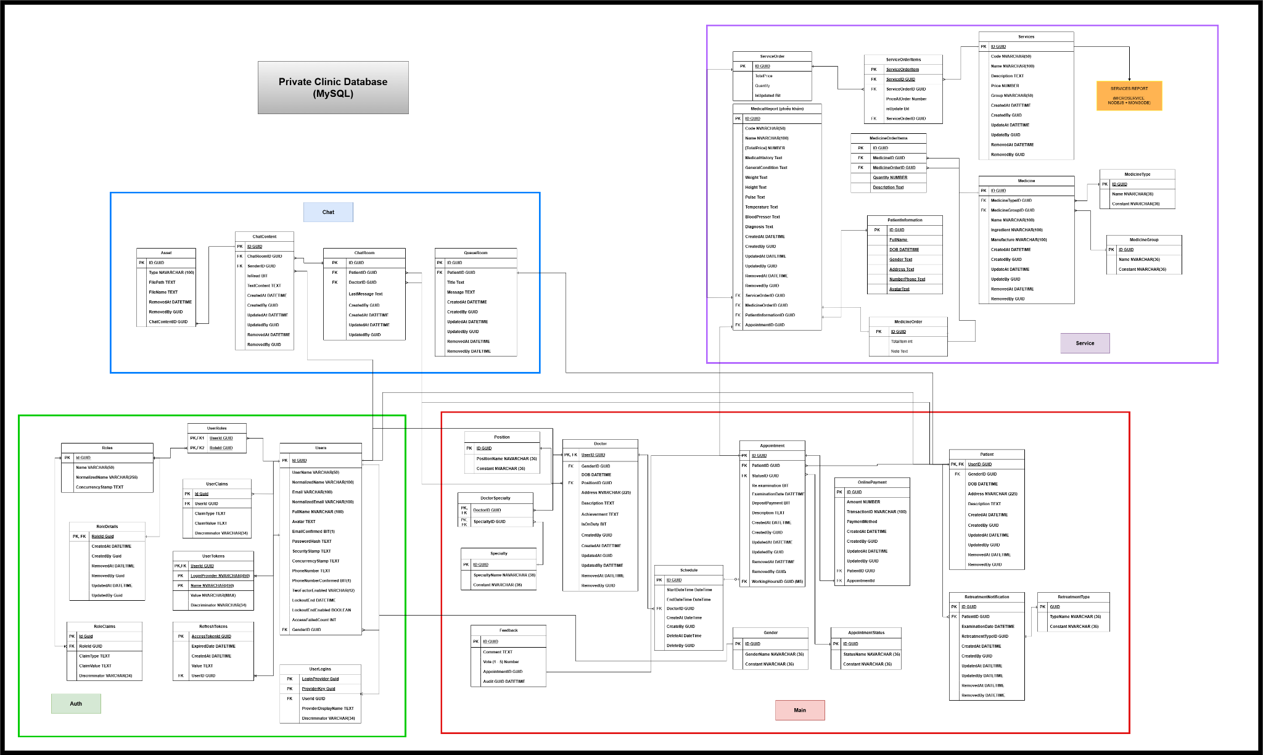

[***CLINIC_PROJECT_Database.drawio***](https://app.diagrams.net/#G1ilAEL6qIuqxneB5PxqWU38qrONqAsLSU#%7B%22pageId%22%3A%22qii-i743TTGAs4LN8BWo%22%7D)

### b. Table Description

| **No** | **Table** | **Description** |
| --- | --- | --- |
| *01* | *User* | *The Users entity is the cornerstone of the authentication system. It stores essential information about each user account, including credentials, personal details, and account status. This entity is crucial for user identification, authentication, and personalization throughout the system. It supports features like email verification, phone number confirmation, and security measures such as two-factor authentication and account lockouts.* |
| *02* | *Roles* | *Roles define the various levels of access and permissions within the system. This entity allows for a flexible and scalable approach to user authorization. By associating users with roles, the system can efficiently manage access control across different parts of the application. Roles can represent different user types admin, staff, doctor, user) or specific permission sets.* |
| *03* | *UserRoles* | *UserRoles serves as a bridge between the Users and Roles entities, enabling a many-to-many relationship. This flexible structure allows each user to have multiple roles, and each role to be assigned to multiple users.* |
| *04* | *RoleDetail* | *RoleDetails provides metadata and auditing information for roles. This information is valuable for system administration, auditing, and troubleshooting.* |
| *05* | *UserTokens* | *UserTokens manages authentication tokens for users across various login providers. This entity is crucial for implementing secure, token-based authentication systems. It enhances security by allowing for fine-grained control over token validity and revocation.* |
| *06* | *RefreshToken* | *The RefreshTokens entity is dedicated to handling refresh tokens, which are essential for maintaining user sessions securely over extended periods. By using refresh tokens, the system can issue short-lived access tokens while still providing a seamless user experience.* |
| *07* | *Patient* | *The Patient entity is the core of the medical appointment system, storing essential information about individuals seeking medical care. This entity is crucial for maintaining patient records, tracking medical history, and facilitating appointment scheduling.* |
| *08* | *Doctor* | *The Doctor entity represents medical professionals available for appointments. It stores information about each doctor, including their specialties, qualifications, and availability. This entity is essential for managing the medical staff, their schedules, and their relationships with patients and appointments.* |
| *09* | *Appointment* | *The Appointment entity serves as the central point for scheduling and managing patient-doctor interactions. It links patients with doctors at specific times, stores information about the nature of the visit, and tracks the status of each appointment. This entity is crucial for efficient time management and ensuring smooth operation of the medical facility.* |
| *10* | *Schedule* | *The Schedule entity manages the availability of doctors. It defines the time slots when each doctor is available for appointments, helping to prevent scheduling conflicts and optimize the use of medical resources. This entity is key to efficient appointment booking and time management for both patients and medical staff.* |
| *11* | *Position* | *The Position entity likely represents different roles or job positions within the medical facility. This could include various types of medical staff, administrative roles, or specialized positions. It helps in organizing the workforce and defining responsibilities within the healthcare system.* |
| *12* | *Specialty* | *The Specialty entity categorizes different areas of medical expertise. It's used to classify doctors based on their fields of specialization, allowing for more targeted and efficient patient-doctor matching. This entity enhances the system's ability to route patients to the most appropriate medical professionals.* |
| *13* | *DoctorSpecialties* | *This junction entity creates a many-to-many relationship between doctors and specialties. It allows each doctor to have multiple specialties and each specialty to be associated with multiple doctors, providing flexibility in representing the diverse skills of medical professionals.* |
| *14* | *Gender* | *The Gender entity likely stores gender information, which can be important for patient demographics, medical considerations, and potentially for matching patients with preferred healthcare providers.* |
| *15* | *AppointmentStatus* | *The AppointmentStatus entity defines various states an appointment can be in (e.g., pending, completed, canceled). It's crucial for tracking the lifecycle of appointments and managing the overall scheduling system efficiently.* |
| *16* | *Feedback* | *The Feedback entity is a crucial component of the medical appointment system, designed to capture and store patient opinions, experiences, and suggestions. T* |
| *17* | *OnlinePayment* | *The OnlinePayment entity manages financial aspects of medical services. It likely includes information about costs associated with different types of appointments, examinations, or procedures, supporting billing and financial management within the healthcare system.* |
| *18* | *RetreatmentTurn* | *The RetreatmentType entity categorizes different kinds of retreatments* |
| *19* | *Service* | *The Services entity is the foundation of the medical service system. It defines and categorizes the various medical services offered by the healthcare facility. This entity is crucial for organizing the range of treatments, procedures, and consultations available to patients, and it likely includes information about pricing, service codes, and descriptions.* |
| *20* | *ServiceOrder* | *The ServiceOrder entity represents a specific instance of a service being provided to a patient. It acts as a transaction record, linking the service, patient, and potentially the healthcare provider. This entity is essential for tracking the services rendered, managing billing, and maintaining a history of patient treatments.* |
| *21* | *SerivceOrderItem* | *This entity breaks down a ServiceOrder into individual items or components. It allows for more detailed tracking of complex services that may involve multiple steps or resources. This granular approach supports accurate billing and resource management.* |
| *22* | *MedicalReport* | *The MedicalReport entity stores comprehensive medical information gathered during a patient's visit or treatment. It includes vital signs, diagnoses, and other clinical observations. This entity is crucial for maintaining detailed patient health records, supporting continuity of care, and facilitating informed medical decision-making.* |
| *23* | *MedicineType* | *This entity categorizes different types of medicines, which helps in organizing the pharmacy inventory and can assist healthcare providers in quickly identifying appropriate medications for various conditions.* |
| *24* | *MedicineGroup* | *The MedicineGroup entity likely represents broader categories of medications, allowing for higher-level organization and classification of pharmaceutical products.* |
| *25* | *MedicineOrder* | *The MedicineOrder entity represents prescriptions or orders for medication. It links patients with specific medicines, potentially including dosage information and duration of treatment. This entity is crucial for managing medication distribution and tracking patient prescriptions.* |
| *26* | *MedicineOrderItem* | *This entity breaks down a MedicineOrder into individual items, allowing for detailed tracking of complex prescriptions that may involve multiple medications or dosages.* |
| *27* | *PatientInformation* | *The PatientInformation entity stores essential demographic and contact information for patients. It's a critical component for patient identification, communication, and maintaining accurate records.* |
| *28* | *Medicine* | *The Medicine entity represents pharmaceutical products used in treatments. It likely includes details about each medication, such as its name, type, ingredients, and manufacturer. This entity is essential for managing the facility's pharmacy inventory and ensuring proper medication administration.* |
| *29* | *ChatContent* | *The ChatContent entity is the core of the chat system, representing individual messages within a conversation. It stores the actual content of each message, along with metadata such as the sender, timestamp, and read status. This entity is crucial for maintaining the chronological order of messages and enabling features like message history and search.* |
| *30* | *ChatRoom* | *The ChatRoom entity represents a conversation space where two or more users can exchange messages. It serves as a container for ChatContent entities and manages the overall context of a conversation. This entity likely includes information about the participants, conversation status, and possibly chat room settings or preferences.* |
| *31* | *QueueRoom* | *The QueueRoom entity appears to be a specialized type of chat room, possibly used for managing queued conversations or support tickets. It might be used in scenarios where users are waiting to be connected with a service representative or in a system that manages prioritized communication channels.* |
| *32* | *Asset* | *The Asset entity represents files or media that can be shared within the chat system. This could include images, documents, audio files, or any other type of attachment that users might want to exchange during their conversations. The Asset entity helps in organizing and managing these shared resources efficiently.* |
| *..* | *..* | … |

# II. Code Designs

## 1. Common Class Diagram

### a. Common Class Diagram

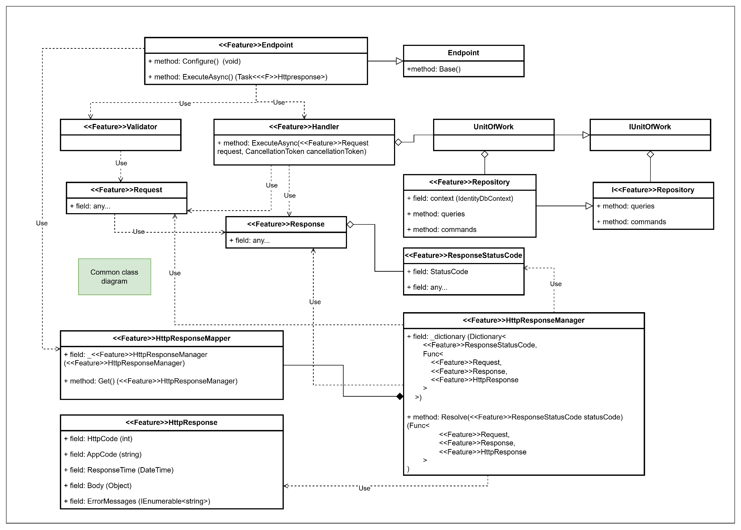

### b. Common Class Specifications

#### Endpoint abstract Class

Description: The Endpoint<TRequest, TResponse> class in FastEndpoints is an abstract base class designed to handle API endpoints that require both request (TRequest) and response (TResponse) Data Transfer Objects (DTOs). It provides the fundamental structure for implementing request processing, validation, and response handling in a RESTful web service.

| **No** | **Method** | **Description** |
| --- | --- | --- |
| *01* | *Execute(TRequest request): Task<TResponse>* | *Executes the main logic for processing the request of type <name="TRequest"/> and returns a response of type <name="TResponse"/>.* |
|  |  |  |

#### <<Feature>>Endpoint Class

Description: The Endpoint<TRequest, TResponse> class serves as a foundational building block for API endpoints, providing essential capabilities such as request handling, validation, service management.

| **No** | **Method** | **Description** |
| --- | --- | --- |
| *01* | *Execute()* | *It will call the service logic and respond to the result. After that convert to http response. Finally return api endpoint with information.* |
| *02* | *Configure()* | *It configs swagger, use middleware/processor for that endpoint* |

#### <<Feature>>HttpResponseMapper Class

Description: The <<Feature>>HttpResponseMapper class is a singleton pattern implementation, It will call the <Feature>HttpResponseManager to mapper appcode to status code.

| **No** | **Method** | **Description** |
| --- | --- | --- |
| *01* | *Get()* | *Create an instance object httpResponseManager. Apply a lazy init object.* |

#### 

#### <<Feature>>HttpResponseManager Class

Description: The <<Feature>>HttpResponseManager class converts normal response to HttpResponse (relative to http) with appcode to status code. And also maps corresponding error messages.

| **No** | **Method** | **Description** |
| --- | --- | --- |
| *01* | *HttpResponse*  *Manager*  *[Constructor]* | *Create an instance object httpResponseManager. Apply a lazy init object.* |

#### 

#### <<Feature>>HttpResponse Class

Description: The <<Feature>>HttpResponse class contains the information about response api, such as: Body, StatusCode, ErrorMessage,...

| **No** | **Method** | **Description** |
| --- | --- | --- |
| *01* | *N/A* | *No* |

#### I<<Feature>>Handler Interface

Description: This interface is a wrap interface from ICommandHandler that is used from library FastEndpoind. It is equivalent to a service layer where we write business logic for an application.

| **No** | **Method** | **Description** |
| --- | --- | --- |
| *01* | *ExecuteAsync*  *(Request request,*  *CancellationToken ct)* | *Method has not been defined in this interface* |

#### <<Feature>>Handler class

Description: This class is implemented from IFeatureHandler.

| **No** | **Method** | **Description** |
| --- | --- | --- |
| *01* | *ExecuteAsync*  *(Request request,*  *CancellationToken ct)* | *The method where all business logic is written here. It has dependency injection repository, unit of work, other external service, etc..It contains all of the feature’s logic.* |

#### <<Feature>>Request class

Description: This class represents a request DTO.

| **No** | **Method** | **Description** |
| --- | --- | --- |
| *01* | *Get()*  *Set()* | *N/A* |

#### <<Feature>>Response class

Description: This class represents a response DTO.

| **No** | **Method** | **Description** |
| --- | --- | --- |
| *01* | *Get()*  *Set()* | *N/A* |

#### <<Feature>>Validator class

Description: This class contains a constructor implemented of FeatureRequestValidator<TRequest, TResponse> to validate each field of <<Feature>>Request class and throw a response if it has one failed validation.

| **No** | **Method** | **Description** |
| --- | --- | --- |
| *01* | *N/A* | *N/A* |

#### IUnitOfWork interface

Description: Interface The Unit of Work (UoW) pattern is a design pattern used to manage and coordinate repositories in a system that involves multiple repositories.

| **No** | **Method** | **Description** |
| --- | --- | --- |
| *01* | *N/A* | *N/A* |

#### UnitOfWork class

Description: Implement an interface unit of work.

| **No** | **Method** | **Description** |
| --- | --- | --- |
| *01* | *N/A* | *N/A* |

#### I<<Feature>>Repository interface

Description: This interface defines actions that feature need to get or write with database operations.

| **No** | **Method** | **Description** |
| --- | --- | --- |
| *01* | *N/A* | *N/A* |

#### <<Feature>>Repository class

Description: This class is a implement of repository interface, write raw sql or Linq to perform actions with database

| **No** | **Method** | **Description** |
| --- | --- | --- |
| *01* | *N/A* | *N/A* |

## 2. Auth

### 2.1. Register

#### a. Class Diagram

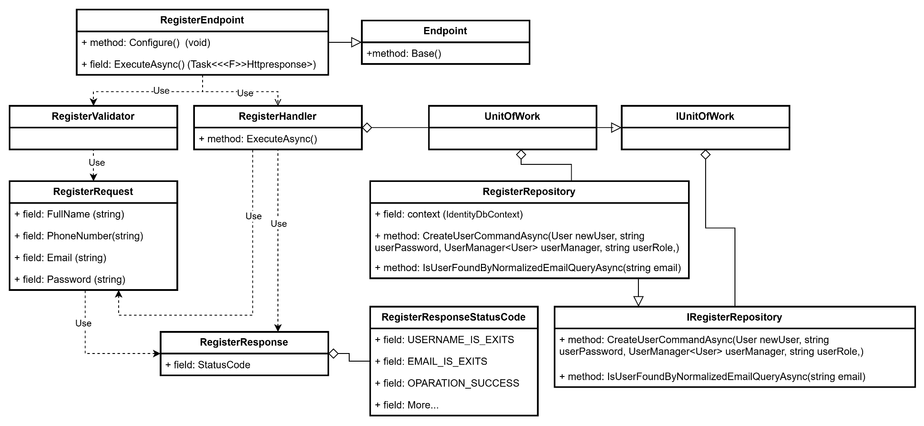

#### b. Class Specifications

#### RegisterEndpoint class

*Same as common given before,* *review here**.*

1. ***Endpoint abstract class***

*Same as common given before,* *review here**.*

1. ***RegisterValidator class***

*Same as common given before,* *review here**.*

1. ***RegisterHandler class***

*Same as common given before,* *review here**.*

1. ***IUnitOfWork interface***

*Same as common given before,* *review here**.*

1. ***UnitOfWork class***

*Same as common given before,* *review here**.*

1. ***RegisterRequest class***

*This class is a Request DTO class that handles the necessary fields to register an user.*

| **No** | **Fields** | **Description** |
| --- | --- | --- |
| *01* | *FullName* | *This field requires the user to enter the full name.* |
| *02* | *PhoneNumber* | *This field requires the user to enter phone number* |
| *03* | *Email* | *This field requires the user to enter their own email correctly* |
| *04* | *Password* | *This field requires the user to enter the account password* |

1. ***RegisterResponse class***

| **No** | **Fields** | **Description** |
| --- | --- | --- |
| *01* | *StatusCode* | *This field will return an app code and http code.* |

1. ***RegisterResponseStatusCode Enum class***

This enum class contains some necessary app code like USER_NAME_IS_EXIST, EMAIL_IS_EXIST,.... Purpose to handle response with specifically code of errors.

1. ***IRegisterRepository interface***

This interface class contains method to interact with database

| **No** | **Method** | **Description** |
| --- | --- | --- |
| *01* | ***CreateUserCommandAsync****(User newUser, string userPassword, UserManager<User> userManager, string userRole,)* | *Defines a method to create a new user* |
| *02* | ***IsUserFoundByNormalizedEmailQueryAsync****(string email)* | *Defines a method to check the email is existed or note* |

1. ***RegisterRepository***

This class is an implementation of the IRegisterRepository interface***.***

| **No** | **Fields** | **Description** |
| --- | --- | --- |
| *01* | *_context* | *This field is database context* |

| **No** | **Method** | **Description** |
| --- | --- | --- |
| *01* | ***CreateUserCommandAsync****(User newUser, string userPassword, UserManager<User> userManager, string userRole,)* | *Execute statements that interact with the database and return the desired value* |
| *02* | ***IsUserFoundByNormalizedEmailQueryAsync****(string email)* | *Execute statements that interact with the database and return the desired value* |

#### c. Sequence Diagram

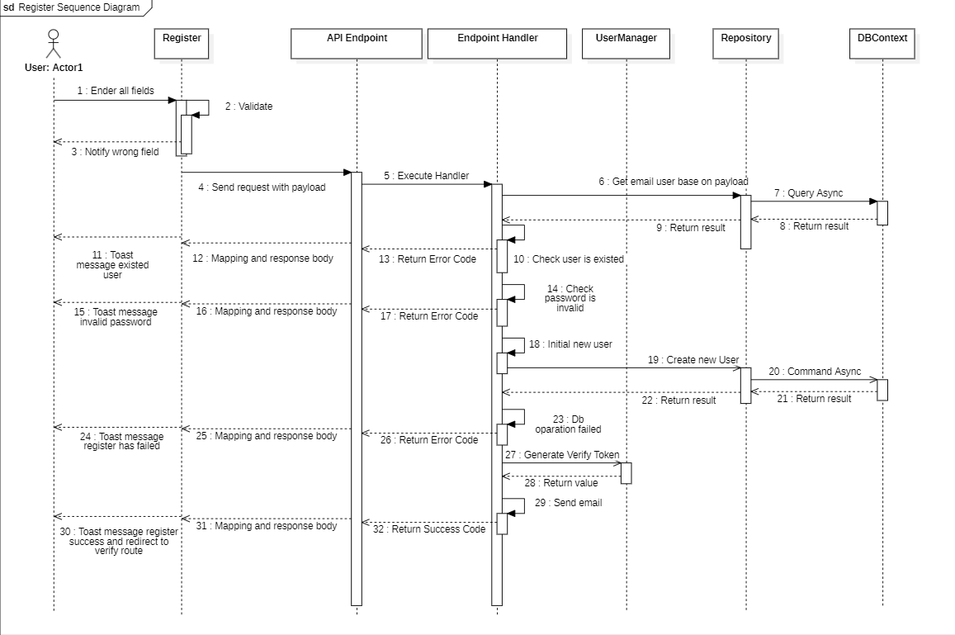

#### d. Database Queries (LinQ)

public async Task<bool> CreateUserAndAddUserRoleCommandAsync(

User newUser,

string userPassword,

UserManager<User> userManager,

string userRole,

CancellationToken cancellationToken

)

{

var dbTransactionResult = false;

await _context

.Database.CreateExecutionStrategy()

.ExecuteAsync(operation: async () =>

{

using var transaction = await _context.Database.BeginTransactionAsync(

cancellationToken: cancellationToken

);

try

{

var result = await userManager.CreateAsync(

user: newUser,

password: userPassword

);

if (!result.Succeeded)

{

throw new DbUpdateConcurrencyException();

}

result = await userManager.AddToRoleAsync(user: newUser, role: userRole);

if (!result.Succeeded)

{

throw new DbUpdateConcurrencyException();

}

await _context.SaveChangesAsync(cancellationToken: cancellationToken);

await transaction.CommitAsync(cancellationToken: cancellationToken);

dbTransactionResult = true;

}

catch

{

await transaction.RollbackAsync(cancellationToken: cancellationToken);

}

});

return dbTransactionResult;

}

public Task<bool> IsUserFoundByNormalizedEmailQueryAsync(

string email,

CancellationToken cancellation

)

{

email = email.ToUpper();

return _users.AnyAsync(

predicate: user => user.NormalizedEmail.Equals(email),

cancellationToken: cancellation

);

}

### 2.2. Login

#### a. Class Diagram

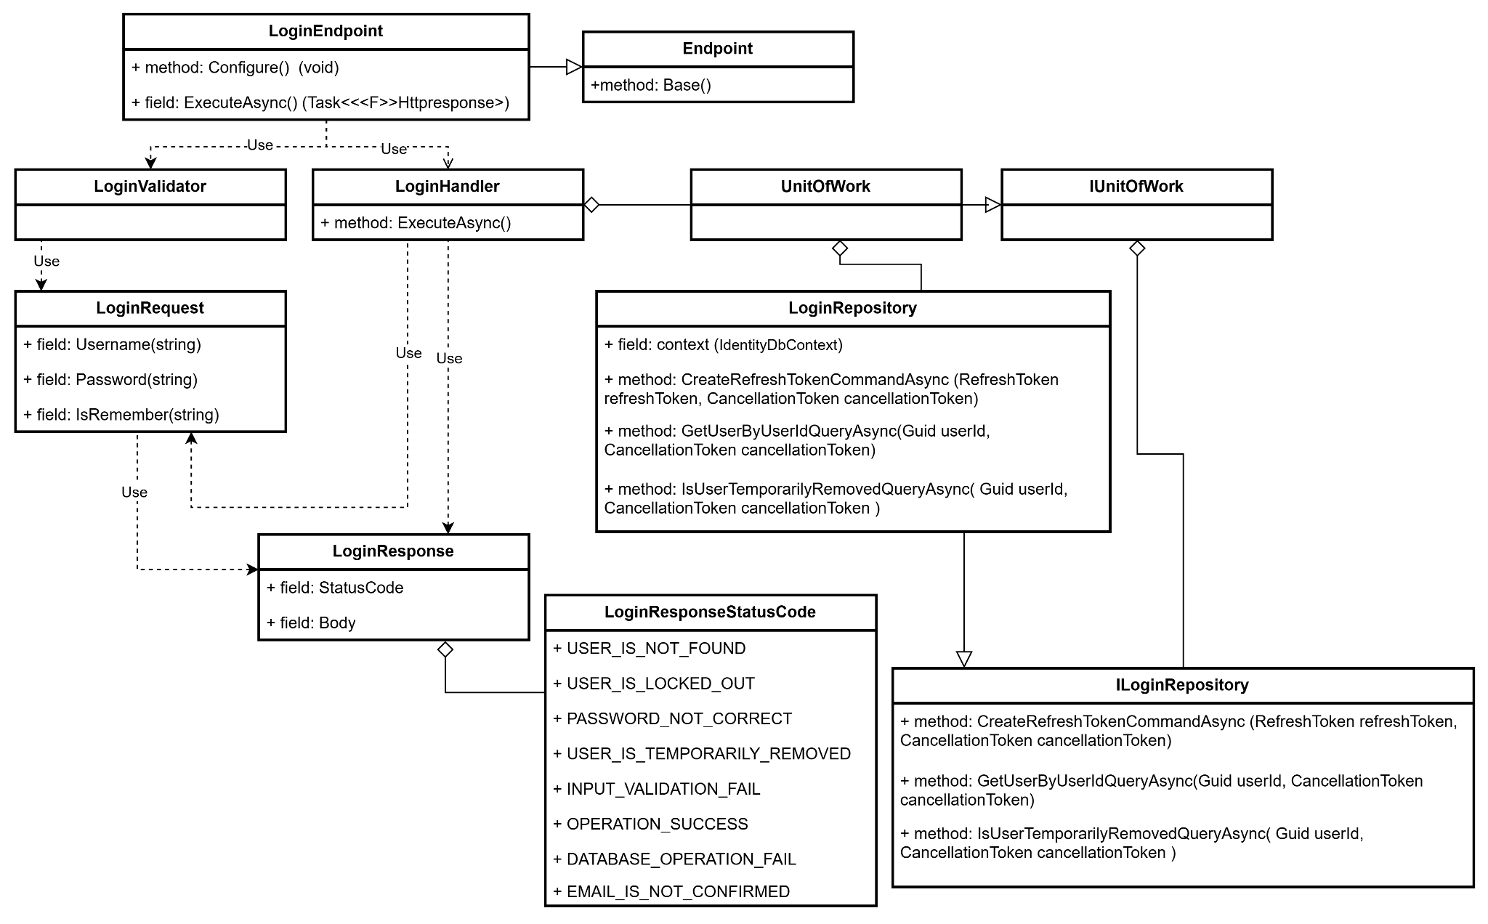

#### b. Class Specifications

#### LoginEndpoint class

1. *Same as common given before,* [*review here*](https://docs.google.com/document/d/1tTZUy0kDp6tdHb6MY85cNBVlDSK0k0N9w2NXBLPTu-c/edit?fbclid=IwY2xjawGR2bhleHRuA2FlbQIxMAABHXaevmejUQr8xjrbJMfMO6hQO6XsKvZsbr5U851poewOjCfrtFF50NgfSw_aem_jQpoUpBPqSRtRL6zkcCqRA#heading=h.m7r87enxie2d)*.*
2. ***Endpoint abstract class***
3. *Same as common given before,* [*review here*](https://docs.google.com/document/d/1tTZUy0kDp6tdHb6MY85cNBVlDSK0k0N9w2NXBLPTu-c/edit?fbclid=IwY2xjawGR2bhleHRuA2FlbQIxMAABHXaevmejUQr8xjrbJMfMO6hQO6XsKvZsbr5U851poewOjCfrtFF50NgfSw_aem_jQpoUpBPqSRtRL6zkcCqRA#heading=h.ac857vak9ccs)*.*
4. ***LoginrValidator class***
5. *Same as common given before,* [*review here*](https://docs.google.com/document/d/1tTZUy0kDp6tdHb6MY85cNBVlDSK0k0N9w2NXBLPTu-c/edit?fbclid=IwY2xjawGR2bhleHRuA2FlbQIxMAABHXaevmejUQr8xjrbJMfMO6hQO6XsKvZsbr5U851poewOjCfrtFF50NgfSw_aem_jQpoUpBPqSRtRL6zkcCqRA#heading=h.mapewhyr52db)*.*
6. ***LoginHandler class***
7. *Same as common given before,* [*review here*](https://docs.google.com/document/d/1tTZUy0kDp6tdHb6MY85cNBVlDSK0k0N9w2NXBLPTu-c/edit?fbclid=IwY2xjawGR2bhleHRuA2FlbQIxMAABHXaevmejUQr8xjrbJMfMO6hQO6XsKvZsbr5U851poewOjCfrtFF50NgfSw_aem_jQpoUpBPqSRtRL6zkcCqRA#heading=h.3lfr3mcrnl8j)*.*
8. ***IUnitOfWork interface***
9. *Same as common given before,* [*review here*](https://docs.google.com/document/d/1tTZUy0kDp6tdHb6MY85cNBVlDSK0k0N9w2NXBLPTu-c/edit?fbclid=IwY2xjawGR2bhleHRuA2FlbQIxMAABHXaevmejUQr8xjrbJMfMO6hQO6XsKvZsbr5U851poewOjCfrtFF50NgfSw_aem_jQpoUpBPqSRtRL6zkcCqRA#heading=h.plvhy3azezgm)*.*
10. ***UnitOfWork class***
11. *Same as common given before,* [*review here*](https://docs.google.com/document/d/1tTZUy0kDp6tdHb6MY85cNBVlDSK0k0N9w2NXBLPTu-c/edit?fbclid=IwY2xjawGR2bhleHRuA2FlbQIxMAABHXaevmejUQr8xjrbJMfMO6hQO6XsKvZsbr5U851poewOjCfrtFF50NgfSw_aem_jQpoUpBPqSRtRL6zkcCqRA#heading=h.75tksa2v2ybj)*.*
12. ***LoginRequest class***

*This class is a Request DTO class that handles the necessary fields to login an user.*

| **No** | **Fields** | **Description** |
| --- | --- | --- |
| *01* | *Username* | *This field requires the user to enter the Username.* |
| *02* | *Password* | *This field requires the user to enter Password* |
| *03* | *IsRemember* | *This field requires the select IsRemember* |

1. ***LoginResponse class***

| **No** | **Fields** | **Description** |
| --- | --- | --- |
| *01* | *StatusCode* | *This field will return an app code and http code.* |
| *02* | *ResponseBody* | *This object contain information that returned* |

1. ***LoginResponseStatusCode Enum class***

This enum class contains some necessary app code like USER_IS_NOT_FOUND, PASSWORD_NOT_CORRECT, OPERATION_SUCCESS .... Purpose to handle response with specifically code of errors.

1. ***ILoginRepository interface***

This interface class contains method to interact with database

| **No** | **Method** | **Description** |
| --- | --- | --- |
| *01* | ***CreateRefreshTokenCommandAsync(***  *RefreshToken refreshToken,*  *CancellationToken cancellationToken* ***)*** | *Defines a method to create refresh token* |
| *02* | ***GetUserByUserIdQueryAsync****(Guid userId, CancellationToken cancellationToken)* | *Defines a method to get user by id.* |
| *03* | ***IsUserTemporarilyRemovedQueryAsync(****Guid userId, CancellationToken cancellationToken* ***)*** | *Defines a method to check user temporarily removed.* |

1. ***LoginRepository***

This class is an implementation of the IRegisterRepository interface***.***

| **No** | **Fields** | **Description** |
| --- | --- | --- |
| *01* | *_context* | *This field is database context* |

| **No** | **Method** | **Description** |
| --- | --- | --- |
| *01* | ***CreateRefreshTokenCommandAsync(***  *RefreshToken refreshToken,*  *CancellationToken cancellationToken* ***)*** | *Execute statements that interact with the database and return the desired value* |
| *02* | ***GetUserByUserIdQueryAsync****(Guid userId, CancellationToken cancellationToken)* | *Execute statements that interact with the database and return the desired value* |
| *03* | ***IsUserTemporarilyRemovedQueryAsync(****Guid userId, CancellationToken cancellationToken* ***)*** | *Execute statements that interact with the database and return the desired value* |

#### c. Sequence Diagram

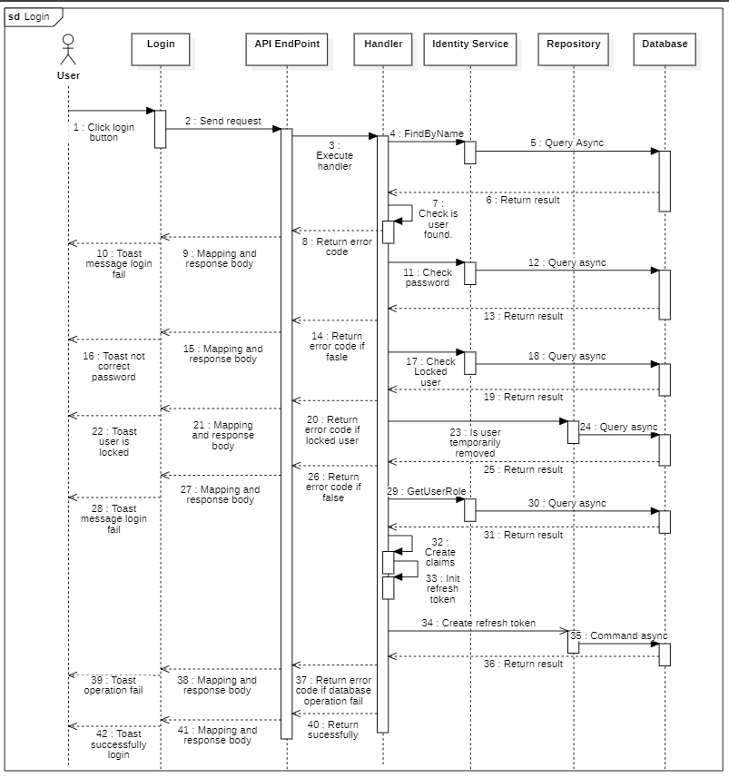

#### d. Database Queries (LinQ)

public async Task<bool> CreateRefreshTokenCommandAsync(

RefreshToken refreshToken,

CancellationToken cancellationToken

)

{

try

{

await _refreshTokens

.Where(reToken => reToken.UserId.Equals(refreshToken.UserId))

.ExecuteDeleteAsync(cancellationToken: cancellationToken);

await _refreshTokens.AddAsync(

entity: refreshToken,

cancellationToken: cancellationToken

);

await _context.SaveChangesAsync();

}

catch

{

return false;

}

return true;

}

public Task<User> GetUserByUserIdQueryAsync(Guid userId, CancellationToken cancellationToken)

{

return _users

.AsNoTracking()

.Where(predicate: user => user.Id == userId)

.Select(selector: user => new User()

{

Avatar = user.Avatar,

FullName = user.FullName,

Email = user.Email,

})

.FirstOrDefaultAsync(cancellationToken: cancellationToken);

}

public Task<bool> IsUserTemporarilyRemovedQueryAsync(

Guid userId,

CancellationToken cancellationToken

)

{

return _users.AnyAsync(

predicate: user =>

user.Id == userId

&& user.RemovedBy != CommonConstant.DEFAULT_ENTITY_ID_AS_GUID

&& user.RemovedAt != CommonConstant.MIN_DATE_TIME,

cancellationToken: cancellationToken

);

}

### 2.3. Confirm email to verify account

#### a. Class Diagram

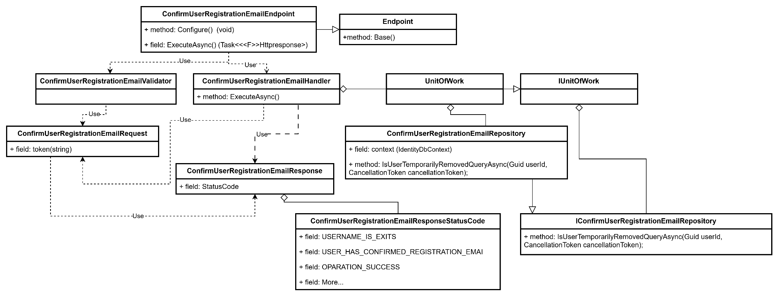

#### b. Class Specifications

#### ConfirmUserRegistrationEmailEnpoint class

*Same as common given before,* *review here**.*

1. ***Endpoint Abstract class***

*Same as common given before,* *review here**.*

1. ***ConfirmUserRegistrationEmailValidator class***

*Same as common given before,* *review here**.*

1. ***ConfirmUserRegistrationEmailHandler class***

*Same as common given before,* *review here**.*

1. ***IUnitOfWork interface class***

*Same as common given before,* *review here**.*

1. ***UnitOfWork class***

*Same as common given before,* *review here**.*

1. ***ConfirmUserRegistrationEmailRequest class***

| **No** | **Fields** | **Description** |
| --- | --- | --- |
| *01* | *Token* | *This field is contain confirm token when user click on the link* |

1. ***ConfirmUserRegistrationEmailResponse class***

| **No** | **Fields** | **Description** |
| --- | --- | --- |
| *01* | *StatusCode* | *This field will return an app code and http code.* |

1. ***ConfirmUserRegistrationEmailResponseStatusCode class***

This enum class contains some necessary app code like USER_NAME_IS_EXIST, EMAIL_IS_EXIST,.... Purpose to handle response with specifically code of errors.

1. ***IConfirmUserRegistrationEmailRepository interface class***

| **No** | **Method** | **Description** |
| --- | --- | --- |
| *01* | ***IsUserTemporarilyRemovedQueryAsync****(Guid userId, CancellationToken cancellationToken);* | *Defines a method to check temporarily removed user* |

1. ***ConfirmUserRegistrationEmailRepository class***

| **No** | **Fields** | **Description** |
| --- | --- | --- |
| *01* | *_context* | *This field is database context* |

| **No** | **Method** | **Description** |
| --- | --- | --- |
| *01* | ***IsUserTemporarilyRemovedQueryAsync****(Guid userId, CancellationToken cancellationToken);* | *Execute statements that interact with the database and return the desired value* |

#### c. Sequence Diagram

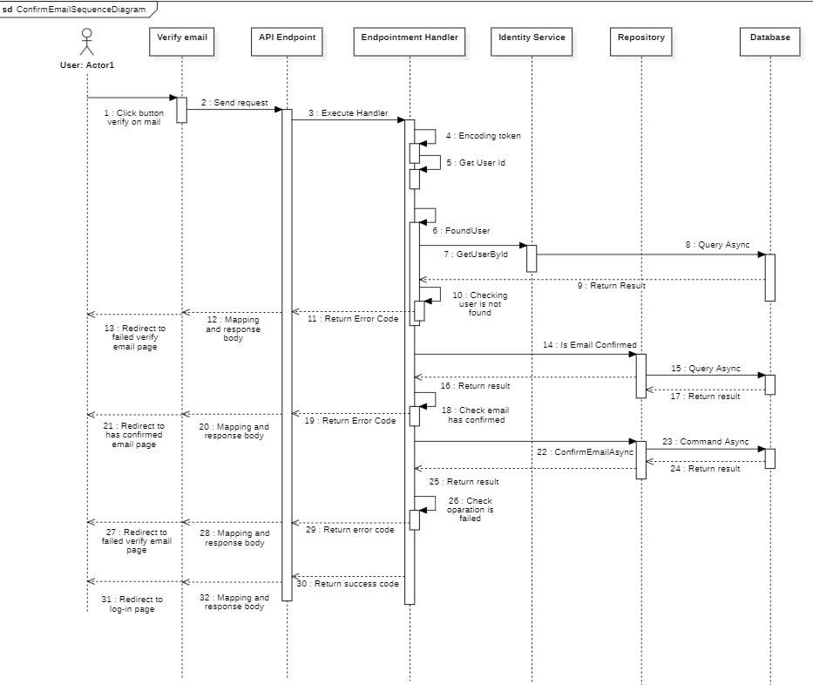

#### d. Database Queries (LinQ)

public Task<bool> IsUserTemporarilyRemovedQueryAsync(

Guid userId,

CancellationToken cancellationToken

)

{

return _users.AnyAsync(

predicate: userDetail =>

userDetail.Id == userId

&& userDetail.RemovedBy != CommonConstant.DEFAULT_ENTITY_ID_AS_GUID

&& userDetail.RemovedAt != CommonConstant.MIN_DATE_TIME,

cancellationToken: cancellationToken

);

}

### 2.4. Forgot Password

#### a. Class diagram

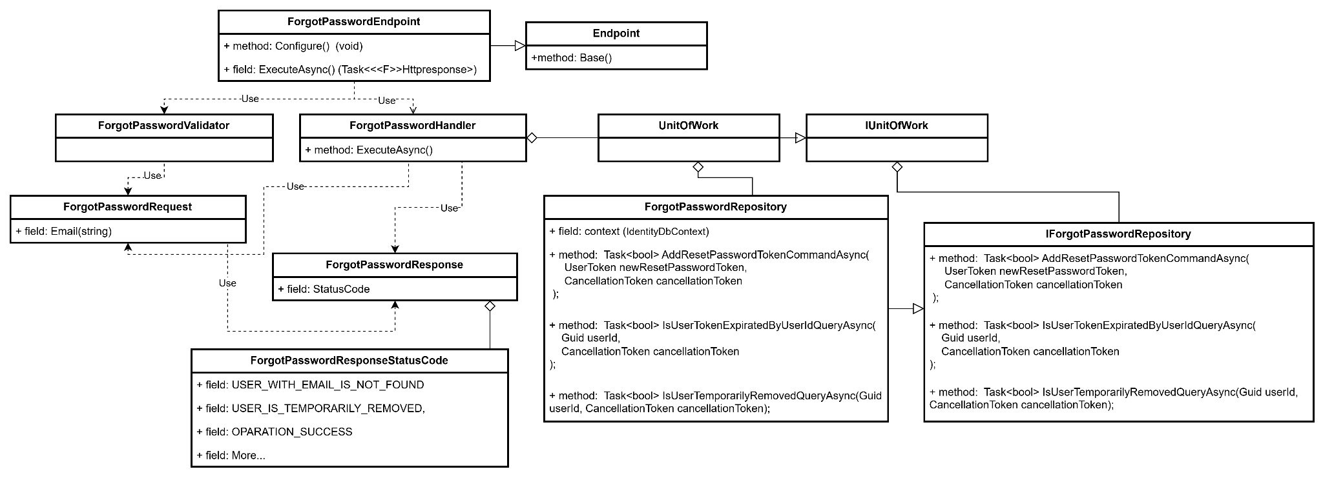

#### b. Class Specifications

#### ForgotPasswordEndpoint class

*Same as common given before,* *review here**.*

1. ***Endpoint Abstract class***

*Same as common given before,* *review here**.*

1. ***ForgotPasswordValidator class***

*Same as common given before,* *review here**.*

1. ***ForgotPasswordHandler class***

*Same as common given before,* *review here**.*

1. ***IUnitOfWork interface class***

*Same as common given before,* *review here**.*

1. ***UnitOfWork class***

*Same as common given before,* *review here**.*

1. ***ForgotPasswordRequest class***

| **No** | **Fields** | **Description** |
| --- | --- | --- |
| *01* | *Email* | *This field required user to enter their email* |

1. ***ForgotPasswordResponse class***

| **No** | **Fields** | **Description** |
| --- | --- | --- |
| *01* | *StatusCode* | *This field will return an app code and http code.* |

1. ***ForgotPasswordResponseStatusCode enum class***

This enum class contains some necessary app code like USER_NAME_IS_EXIST, EMAIL_IS_EXIST,.... Purpose to handle response with specifically code of errors.

1. ***IForgotPasswordrepository interface class***

| **No** | **Method** | **Description** |
| --- | --- | --- |
| *01* | *Task<bool>* ***AddResetPasswordTokenCommandAsync****(*  *UserToken newResetPasswordToken,*  *CancellationToken cancellationToken*  *);* | *Defines a method to create a new reset password token* |
| *02* | *Task<bool>* ***IsUserTokenExpiratedByUserIdQueryAsync****(*  *Guid userId,*  *CancellationToken cancellationToken*  *);* | *Defines a method to check token expired* |

1. ***ForgotPasswordrepository class***

| **No** | **Method** | **Description** |
| --- | --- | --- |
| *01* | *Task<bool>* ***AddResetPasswordTokenCommandAsync****(*  *UserToken newResetPasswordToken,*  *CancellationToken cancellationToken*  *);* | *Execute statements that interact with the database and return the desired value* |
| *02* | *Task<bool>* ***IsUserTokenExpiratedByUserIdQueryAsync****(*  *Guid userId,*  *CancellationToken cancellationToken*  *);* | *Execute statements that interact with the database and return the desired value* |

#### c. Sequence Diagram

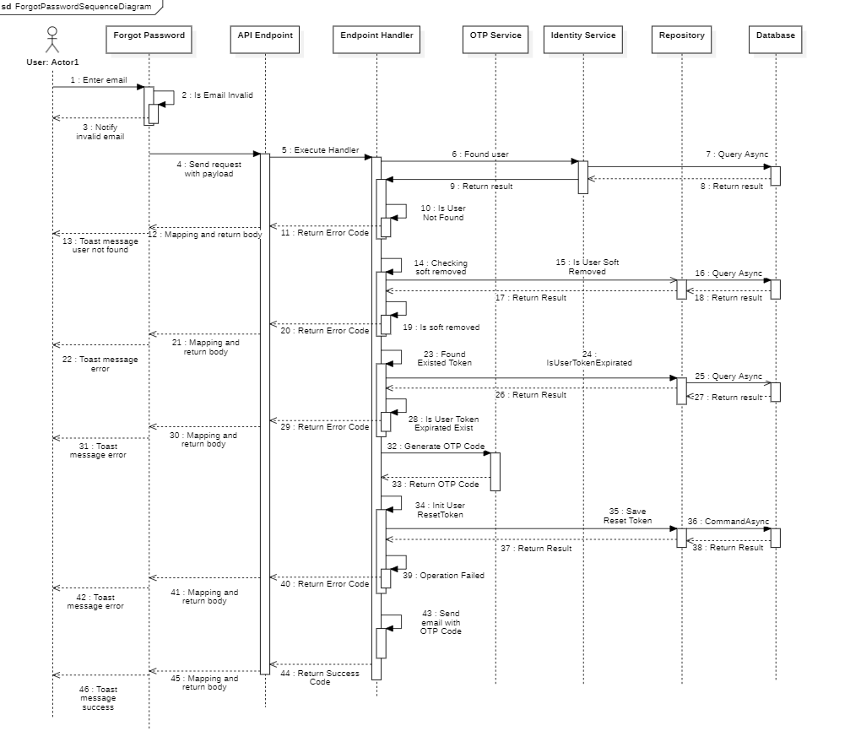

#### d. Database Queries (LinQ)

public async Task<bool> AddResetPasswordTokenCommandAsync(

UserToken newResetPasswordToken,

CancellationToken cancellationToken

)

{

try

{

await _userTokens.AddAsync(

entity: newResetPasswordToken,

cancellationToken: cancellationToken

);

await _context.SaveChangesAsync();

}

catch

{

return false;

}

return true;

}

public Task<bool> IsUserTokenExpiratedByUserIdQueryAsync(

Guid userId,

CancellationToken cancellationToken

)

{

return _userTokens.AnyAsync(

predicate: userToken =>

userToken.UserId == userId && userToken.ExpiredAt > DateTime.UtcNow,

cancellationToken: cancellationToken

);

}

public Task<bool> IsUserTemporarilyRemovedQueryAsync(

Guid userId,

CancellationToken cancellationToken

)

{

return _users.AnyAsync(

predicate: userDetail =>

userDetail.Id == userId

&& userDetail.RemovedBy != CommonConstant.DEFAULT_ENTITY_ID_AS_GUID

&& userDetail.RemovedAt != CommonConstant.MIN_DATE_TIME,

cancellationToken: cancellationToken

);

}

### 2.5. Login With Google

#### a. Class Diagram

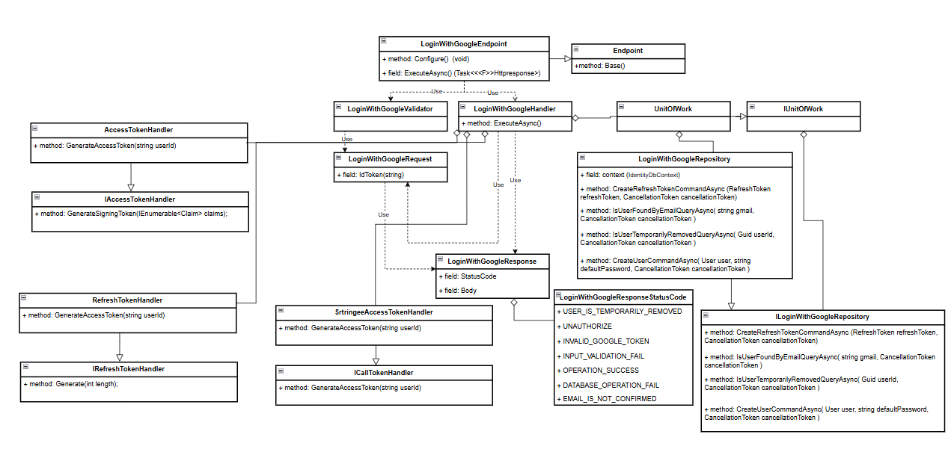

#### b. Class Specifications

#### LoginWithGoogleEndpoint class

1. *Same as common given before,* [*review here*](https://docs.google.com/document/d/1tTZUy0kDp6tdHb6MY85cNBVlDSK0k0N9w2NXBLPTu-c/edit?fbclid=IwY2xjawGR2bhleHRuA2FlbQIxMAABHXaevmejUQr8xjrbJMfMO6hQO6XsKvZsbr5U851poewOjCfrtFF50NgfSw_aem_jQpoUpBPqSRtRL6zkcCqRA#heading=h.m7r87enxie2d)*.*
2. ***Endpoint abstract class***
3. *Same as common given before,* [*review here*](https://docs.google.com/document/d/1tTZUy0kDp6tdHb6MY85cNBVlDSK0k0N9w2NXBLPTu-c/edit?fbclid=IwY2xjawGR2bhleHRuA2FlbQIxMAABHXaevmejUQr8xjrbJMfMO6hQO6XsKvZsbr5U851poewOjCfrtFF50NgfSw_aem_jQpoUpBPqSRtRL6zkcCqRA#heading=h.ac857vak9ccs)*.*
4. ***LoginWithGoogleValidator class***
5. *Same as common given before,* [*review here*](https://docs.google.com/document/d/1tTZUy0kDp6tdHb6MY85cNBVlDSK0k0N9w2NXBLPTu-c/edit?fbclid=IwY2xjawGR2bhleHRuA2FlbQIxMAABHXaevmejUQr8xjrbJMfMO6hQO6XsKvZsbr5U851poewOjCfrtFF50NgfSw_aem_jQpoUpBPqSRtRL6zkcCqRA#heading=h.mapewhyr52db)*.*
6. ***LoginWithGoogleHandler class***
7. *Same as common given before,* [*review here*](https://docs.google.com/document/d/1tTZUy0kDp6tdHb6MY85cNBVlDSK0k0N9w2NXBLPTu-c/edit?fbclid=IwY2xjawGR2bhleHRuA2FlbQIxMAABHXaevmejUQr8xjrbJMfMO6hQO6XsKvZsbr5U851poewOjCfrtFF50NgfSw_aem_jQpoUpBPqSRtRL6zkcCqRA#heading=h.3lfr3mcrnl8j)*.*
8. ***IUnitOfWork interface***
9. *Same as common given before,* [*review here*](https://docs.google.com/document/d/1tTZUy0kDp6tdHb6MY85cNBVlDSK0k0N9w2NXBLPTu-c/edit?fbclid=IwY2xjawGR2bhleHRuA2FlbQIxMAABHXaevmejUQr8xjrbJMfMO6hQO6XsKvZsbr5U851poewOjCfrtFF50NgfSw_aem_jQpoUpBPqSRtRL6zkcCqRA#heading=h.plvhy3azezgm)*.*
10. ***UnitOfWork class***
11. *Same as common given before,* [*review here*](https://docs.google.com/document/d/1tTZUy0kDp6tdHb6MY85cNBVlDSK0k0N9w2NXBLPTu-c/edit?fbclid=IwY2xjawGR2bhleHRuA2FlbQIxMAABHXaevmejUQr8xjrbJMfMO6hQO6XsKvZsbr5U851poewOjCfrtFF50NgfSw_aem_jQpoUpBPqSRtRL6zkcCqRA#heading=h.75tksa2v2ybj)*.*
12. ***LoginWithGoogleRequest class***

*This class is a Request DTO class that handles the necessary fields to login an user.*

| **No** | **Fields** | **Description** |
| --- | --- | --- |
| *01* | *IdToken* | *This field requires the user to enter the IdToken.* |

1. ***LoginWithGoogleResponse class***

| **No** | **Fields** | **Description** |
| --- | --- | --- |
| *01* | *StatusCode* | *This field will return an app code and http code.* |
| *02* | *ResponseBody* | *This object contain information that returned* |

1. ***LoginWithGoogleResponseStatusCode Enum class***

This enum class contains some necessary app code like INVALID_GOOGLE_TOKEN, UN_AUTHORIZED, OPERATION_SUCCESS .... Purpose to handle response with specifically code of errors.

1. ***ILoginWithGoogleRepository interface***

This interface class contains method to interact with database

| **No** | **Method** | **Description** |
| --- | --- | --- |
| *01* | ***CreateRefreshTokenCommandAsync(***  *RefreshToken refreshToken,*  *CancellationToken cancellationToken* ***)*** | *Defines a method to create refresh token* |
| *02* | ***IsUserFoundByEmailQueryAsync(*** *string gmail, CancellationToken cancellationToken* ***)*** | *Defines a method to get user by id.* |
| *03* | ***IsUserTemporarilyRemovedQueryAsync(****Guid userId, CancellationToken cancellationToken* ***)*** | *Defines a method to check user temporarily removed.* |
|  | ***CreateUserCommandAsync****( User user, string defaultPassword, CancellationToken cancellationToken )* | *Defines a method to create user.* |

1. ***LoginWithGoogleRepository***

This class is an implementation of the IRegisterRepository interface***.***

| **No** | **Fields** | **Description** |
| --- | --- | --- |
| *01* | *_context* | *This field is database context* |

| **No** | **Method** | **Description** |
| --- | --- | --- |
| *01* | ***CreateRefreshTokenCommandAsync(***  *RefreshToken refreshToken,*  *CancellationToken cancellationToken* ***)*** | *Execute statements that interact with the database and return the desired value* |
| *02* | ***IsUserFoundByEmailQueryAsync(*** *string gmail, CancellationToken cancellationToken* ***)*** | *Execute statements that interact with the database and return the desired value* |
| *03* | ***IsUserTemporarilyRemovedQueryAsync(****Guid userId, CancellationToken cancellationToken* ***)*** | *Execute statements that interact with the database and return the desired value* |
| *04* | ***CreateUserCommandAsync****( User user, string defaultPassword, CancellationToken cancellationToken )* | *Execute statements that interact with the database and return the desired value* |

#### c. Sequence Diagram

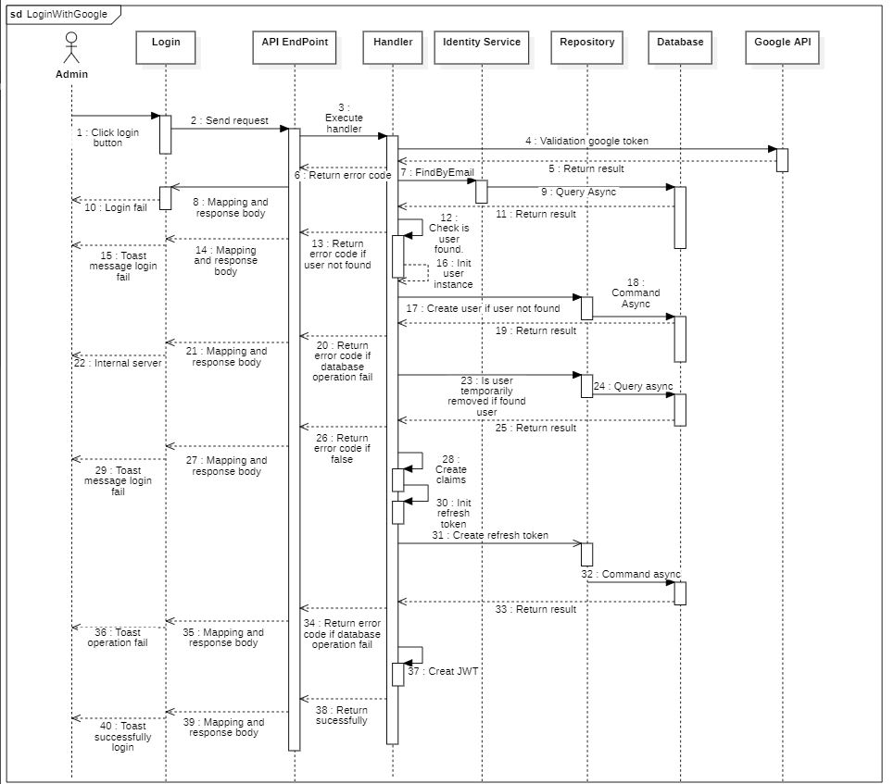

#### d. Database Queries (LinQ)

public async Task<bool> CreateRefreshTokenCommandAsync(

RefreshToken refreshToken,

CancellationToken cancellationToken

)

{

try

{

await _refreshTokens

.Where(reToken => reToken.UserId.Equals(refreshToken.UserId))

.ExecuteDeleteAsync(cancellationToken: cancellationToken);

await _refreshTokens.AddAsync(

entity: refreshToken,

cancellationToken: cancellationToken

);

await _context.SaveChangesAsync();

}

catch

{

return false;

}

return true;

}

public async Task<bool> CreateUserCommandAsync(

User user,

string defaultPassword,

CancellationToken cancellationToken

)

{

try

{

await _userManager.CreateAsync(user: user, password: defaultPassword);

await _userManager.AddToRoleAsync(user: user, role: "user");

var emailConfirmationToken = await _userManager.GenerateEmailConfirmationTokenAsync(

user: user

);

await _userManager.ConfirmEmailAsync(user: user, token: emailConfirmationToken);

await _context.SaveChangesAsync();

}

catch

{

return false;

}

return true;

}

public Task<bool> IsUserFoundByEmailQueryAsync(

string gmail,

CancellationToken cancellationToken

)

{

return _context.Users.AnyAsync(

entity => entity.NormalizedEmail == gmail.ToUpper(),

cancellationToken

);

}

public Task<bool> IsUserTemporarilyRemovedByIdQueryAsync(

string gmail,

CancellationToken cancellationToken

)

{

return _context.Users.AnyAsync(

entity => entity.Email == gmail && entity.RemovedAt != CommonConstant.MIN_DATE_TIME,

cancellationToken

);

}

### 2.6. Changing Password

#### a. Class Diagram

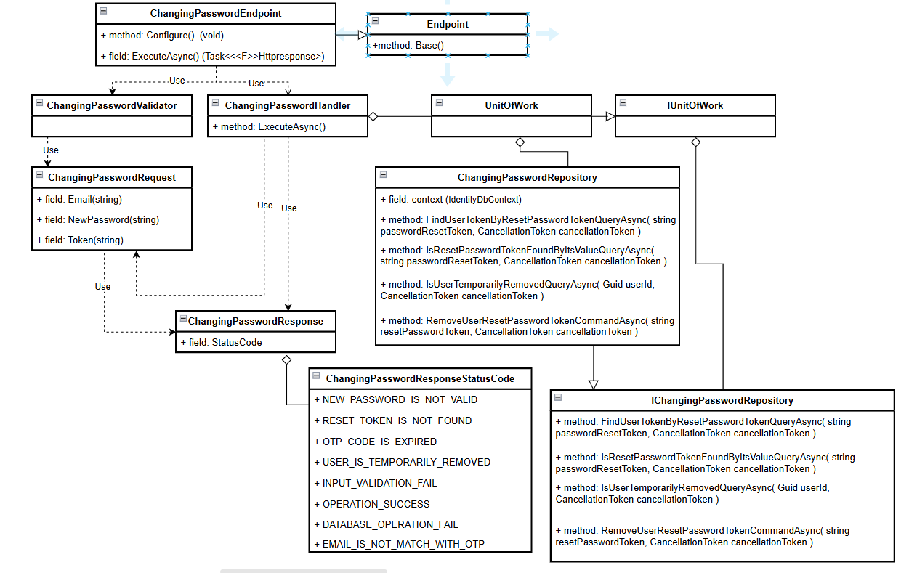

#### b. Class Specifications

#### ChangingPasswordEndpoint class

1. *Same as common given before,* [*review here*](https://docs.google.com/document/d/1tTZUy0kDp6tdHb6MY85cNBVlDSK0k0N9w2NXBLPTu-c/edit?fbclid=IwY2xjawGR2bhleHRuA2FlbQIxMAABHXaevmejUQr8xjrbJMfMO6hQO6XsKvZsbr5U851poewOjCfrtFF50NgfSw_aem_jQpoUpBPqSRtRL6zkcCqRA#heading=h.m7r87enxie2d)*.*
2. ***Endpoint abstract class***
3. *Same as common given before,* [*review here*](https://docs.google.com/document/d/1tTZUy0kDp6tdHb6MY85cNBVlDSK0k0N9w2NXBLPTu-c/edit?fbclid=IwY2xjawGR2bhleHRuA2FlbQIxMAABHXaevmejUQr8xjrbJMfMO6hQO6XsKvZsbr5U851poewOjCfrtFF50NgfSw_aem_jQpoUpBPqSRtRL6zkcCqRA#heading=h.ac857vak9ccs)*.*
4. ***ChangingPasswordValidator class***
5. *Same as common given before,* [*review here*](https://docs.google.com/document/d/1tTZUy0kDp6tdHb6MY85cNBVlDSK0k0N9w2NXBLPTu-c/edit?fbclid=IwY2xjawGR2bhleHRuA2FlbQIxMAABHXaevmejUQr8xjrbJMfMO6hQO6XsKvZsbr5U851poewOjCfrtFF50NgfSw_aem_jQpoUpBPqSRtRL6zkcCqRA#heading=h.mapewhyr52db)*.*
6. ***ChangingPasswordHandler class***
7. *Same as common given before,* [*review here*](https://docs.google.com/document/d/1tTZUy0kDp6tdHb6MY85cNBVlDSK0k0N9w2NXBLPTu-c/edit?fbclid=IwY2xjawGR2bhleHRuA2FlbQIxMAABHXaevmejUQr8xjrbJMfMO6hQO6XsKvZsbr5U851poewOjCfrtFF50NgfSw_aem_jQpoUpBPqSRtRL6zkcCqRA#heading=h.3lfr3mcrnl8j)*.*
8. ***IUnitOfWork interface***
9. *Same as common given before,* [*review here*](https://docs.google.com/document/d/1tTZUy0kDp6tdHb6MY85cNBVlDSK0k0N9w2NXBLPTu-c/edit?fbclid=IwY2xjawGR2bhleHRuA2FlbQIxMAABHXaevmejUQr8xjrbJMfMO6hQO6XsKvZsbr5U851poewOjCfrtFF50NgfSw_aem_jQpoUpBPqSRtRL6zkcCqRA#heading=h.plvhy3azezgm)*.*
10. ***UnitOfWork class***
11. *Same as common given before,* [*review here*](https://docs.google.com/document/d/1tTZUy0kDp6tdHb6MY85cNBVlDSK0k0N9w2NXBLPTu-c/edit?fbclid=IwY2xjawGR2bhleHRuA2FlbQIxMAABHXaevmejUQr8xjrbJMfMO6hQO6XsKvZsbr5U851poewOjCfrtFF50NgfSw_aem_jQpoUpBPqSRtRL6zkcCqRA#heading=h.75tksa2v2ybj)*.*
12. ***ChangingPasswordRequest class***

*This class is a Request DTO class that handles the necessary fields to login an user.*

| **No** | **Fields** | **Description** |
| --- | --- | --- |
| *01* | *Email* | *This field requires the user to enter the Email.* |
| *02* | *NewPassword* | *This field requires the user to enter the NewPassword .* |
| *03* | *ResetPasswordToken* | *This field requires the user to enter the ResetPasswordToken .* |

1. ***ChangingPasswordResponse class***

| **No** | **Fields** | **Description** |
| --- | --- | --- |
| *01* | *StatusCode* | *This field will return an app code and http code.* |

1. ***ChangingPasswordResponseStatusCode Enum class***

This enum class contains some necessary app code like OPERATION_SUCCESS .... Purpose to handle response with specifically code of errors.

1. ***IChangingPasswordRepository interface***

This interface class contains method to interact with database

| **No** | **Method** | **Description** |
| --- | --- | --- |
| *01* | ***FindUserTokenByResetPasswordTokenQueryAsync****( string passwordResetToken, CancellationToken cancellationToken* ***)*** | *Defines a method to find user token by reset password* |
| *02* | ***IsResetPasswordTokenFoundByItsValueQueryAsync****( string passwordResetToken, CancellationToken cancellationToken )* | *Defines a method to get user by id.* |
| *03* | ***IsUserTemporarilyRemovedQueryAsync(****Guid userId, CancellationToken cancellationToken* ***)*** | *Defines a method to check user temporarily removed.* |
|  | ***RemoveUserResetPasswordTokenCommandAsync****( string resetPasswordToken, CancellationToken cancellationToken )* | *Defines a method to reset pass word token.* |

1. ***ChangingPasswordRepository***

This class is an implementation of the IRegisterRepository interface***.***

| **No** | **Fields** | **Description** |
| --- | --- | --- |
| *01* | *_context* | *This field is database context* |

| **No** | **Method** | **Description** |
| --- | --- | --- |
| *01* | ***FindUserTokenByResetPasswordTokenQueryAsync****( string passwordResetToken, CancellationToken cancellationToken* ***)*** | *Execute statements that interact with the database and return the desired value* |
| *02* | ***IsResetPasswordTokenFoundByItsValueQueryAsync****( string passwordResetToken, CancellationToken cancellationToken )* | *Execute statements that interact with the database and return the desired value* |
| *03* | ***IsUserTemporarilyRemovedQueryAsync(****Guid userId, CancellationToken cancellationToken* ***)*** | *Execute statements that interact with the database and return the desired value* |
| *04* | ***RemoveUserResetPasswordTokenCommandAsync****( string resetPasswordToken, CancellationToken cancellationToken )* | *Execute statements that interact with the database and return the desired value* |

#### c. Sequence Diagram

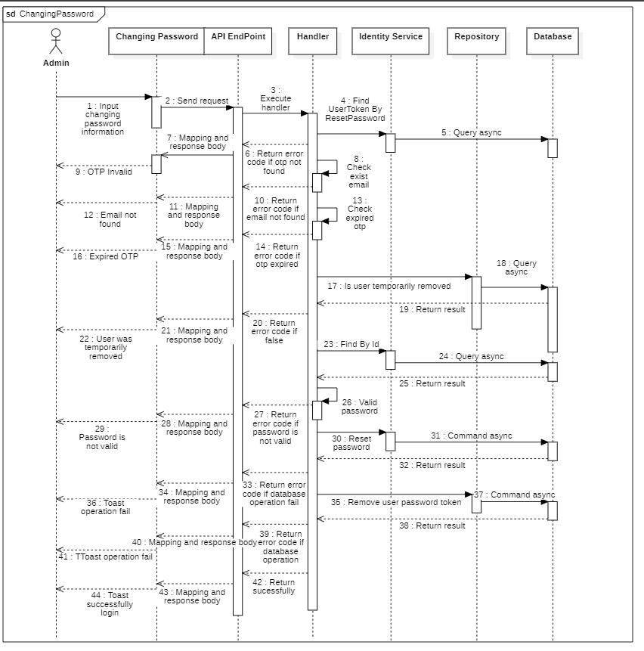

#### d. Database Queries (LinQ)

public Task<UserToken> FindUserTokenByResetPasswordTokenQueryAsync(

string passwordResetToken,

CancellationToken cancellationToken

)

{

return _userTokens

.AsNoTracking()

.Where(predicate: userToken => userToken.Value == passwordResetToken)

.Select(selector: userToken => new UserToken

{

UserId = userToken.UserId,

ExpiredAt = userToken.ExpiredAt,

Value = userToken.Value,

User = new() { NormalizedEmail = userToken.User.NormalizedEmail }

})

.FirstOrDefaultAsync(cancellationToken: cancellationToken);

}

public Task<bool> IsResetPasswordTokenFoundByItsValueQueryAsync(

string passwordResetToken,

CancellationToken cancellationToken

)

{

return _userTokens.AnyAsync(

predicate: userToken => userToken.Value.Equals(passwordResetToken),

cancellationToken: cancellationToken

);

}

public Task<bool> IsUserTemporarilyRemovedQueryAsync(

Guid userId,

CancellationToken cancellationToken

)

{

return _users.AnyAsync(

predicate: user =>

user.Id == userId

&& user.RemovedBy != CommonConstant.DEFAULT_ENTITY_ID_AS_GUID

&& user.RemovedAt != CommonConstant.MIN_DATE_TIME,

cancellationToken: cancellationToken

);

}

public async Task<bool> RemoveUserResetPasswordTokenCommandAsync(

string resetPasswordToken,

CancellationToken cancellationToken

)

{

var executedTransactionResult = false;

await _context

.Database.CreateExecutionStrategy()

.ExecuteAsync(operation: async () =>

{

using var transaction = await _context.Database.BeginTransactionAsync(

cancellationToken: cancellationToken

);

try

{

await _userTokens

.Where(predicate: userToken => userToken.Value.Equals(resetPasswordToken))

.ExecuteDeleteAsync(cancellationToken: cancellationToken);

await _userTokens

.Where(predicate: userToken => userToken.ExpiredAt < DateTime.Now)

.ExecuteDeleteAsync(cancellationToken: cancellationToken);

await transaction.CommitAsync(cancellationToken: cancellationToken);

executedTransactionResult = true;

}

catch

{

await transaction.RollbackAsync(cancellationToken: cancellationToken);

}

});

return executedTransactionResult;

}

### 2.7. Resend email register user

#### a. Class Diagram

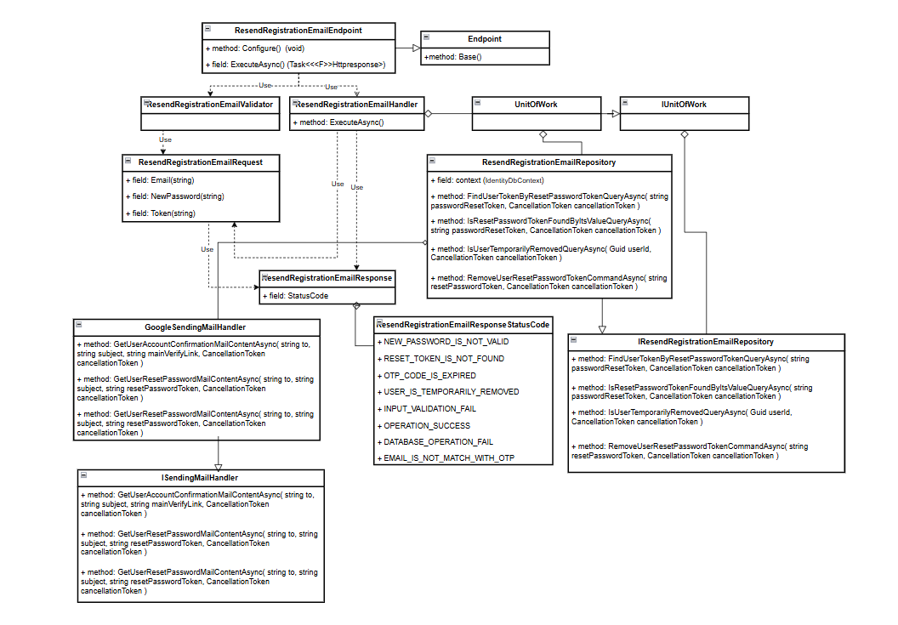

#### b. Class Specifications

#### ResendUserRegistrationConfirmedEmailEndpoint class

1. *Same as common given before,* [*review here*](https://docs.google.com/document/d/1tTZUy0kDp6tdHb6MY85cNBVlDSK0k0N9w2NXBLPTu-c/edit?fbclid=IwY2xjawGR2bhleHRuA2FlbQIxMAABHXaevmejUQr8xjrbJMfMO6hQO6XsKvZsbr5U851poewOjCfrtFF50NgfSw_aem_jQpoUpBPqSRtRL6zkcCqRA#heading=h.m7r87enxie2d)*.*
2. ***Endpoint abstract class***
3. *Same as common given before,* [*review here*](https://docs.google.com/document/d/1tTZUy0kDp6tdHb6MY85cNBVlDSK0k0N9w2NXBLPTu-c/edit?fbclid=IwY2xjawGR2bhleHRuA2FlbQIxMAABHXaevmejUQr8xjrbJMfMO6hQO6XsKvZsbr5U851poewOjCfrtFF50NgfSw_aem_jQpoUpBPqSRtRL6zkcCqRA#heading=h.ac857vak9ccs)*.*
4. ***ResendUserRegistrationConfirmedEmailValidator class***
5. *Same as common given before,* [*review here*](https://docs.google.com/document/d/1tTZUy0kDp6tdHb6MY85cNBVlDSK0k0N9w2NXBLPTu-c/edit?fbclid=IwY2xjawGR2bhleHRuA2FlbQIxMAABHXaevmejUQr8xjrbJMfMO6hQO6XsKvZsbr5U851poewOjCfrtFF50NgfSw_aem_jQpoUpBPqSRtRL6zkcCqRA#heading=h.mapewhyr52db)*.*
6. ***ResendUserRegistrationConfirmedEmailHandler class***
7. *Same as common given before,* [*review here*](https://docs.google.com/document/d/1tTZUy0kDp6tdHb6MY85cNBVlDSK0k0N9w2NXBLPTu-c/edit?fbclid=IwY2xjawGR2bhleHRuA2FlbQIxMAABHXaevmejUQr8xjrbJMfMO6hQO6XsKvZsbr5U851poewOjCfrtFF50NgfSw_aem_jQpoUpBPqSRtRL6zkcCqRA#heading=h.3lfr3mcrnl8j)*.*
8. ***IUnitOfWork interface***
9. *Same as common given before,* [*review here*](https://docs.google.com/document/d/1tTZUy0kDp6tdHb6MY85cNBVlDSK0k0N9w2NXBLPTu-c/edit?fbclid=IwY2xjawGR2bhleHRuA2FlbQIxMAABHXaevmejUQr8xjrbJMfMO6hQO6XsKvZsbr5U851poewOjCfrtFF50NgfSw_aem_jQpoUpBPqSRtRL6zkcCqRA#heading=h.plvhy3azezgm)*.*
10. ***UnitOfWork class***
11. *Same as common given before,* [*review here*](https://docs.google.com/document/d/1tTZUy0kDp6tdHb6MY85cNBVlDSK0k0N9w2NXBLPTu-c/edit?fbclid=IwY2xjawGR2bhleHRuA2FlbQIxMAABHXaevmejUQr8xjrbJMfMO6hQO6XsKvZsbr5U851poewOjCfrtFF50NgfSw_aem_jQpoUpBPqSRtRL6zkcCqRA#heading=h.75tksa2v2ybj)*.*
12. ***ResendUserRegistrationConfirmedEmailRequest class***

*This class is a Request DTO class that handles the necessary fields to login an user.*

| **No** | **Fields** | **Description** |
| --- | --- | --- |
| *01* | *Email* | *This field requires the user to enter the Email.* |

1. ***ResendUserRegistrationConfirmedEmailResponse class***

| **No** | **Fields** | **Description** |
| --- | --- | --- |
| *01* | *StatusCode* | *This field will return an app code and http code.* |

1. ***ResendUserRegistrationConfirmedEmailResponseStatusCode Enum class***

This enum class contains some necessary app code like OPERATION_SUCCESS .... Purpose to handle response with specifically code of errors.

1. ***IResendUserRegistrationConfirmedEmailRepository interface***

This interface class contains method to interact with database

| **No** | **Method** | **Description** |
| --- | --- | --- |
| *01* | ***IsUserTemporarilyRemovedQueryAsync(****Guid userId, CancellationToken cancellationToken* ***)*** | *Defines a method to check user temporarily removed.* |

1. ***ResendUserRegistrationConfirmedEmailRepository***

This class is an implementation of the IRegisterRepository interface***.***

| **No** | **Fields** | **Description** |
| --- | --- | --- |
| *01* | *_context* | *This field is database context* |

| **No** | **Method** | **Description** |
| --- | --- | --- |
| *03* | ***IsUserTemporarilyRemovedQueryAsync(****Guid userId, CancellationToken cancellationToken* ***)*** | *Execute statements that interact with the database and return the desired value* |

#### c. Sequence Diagram

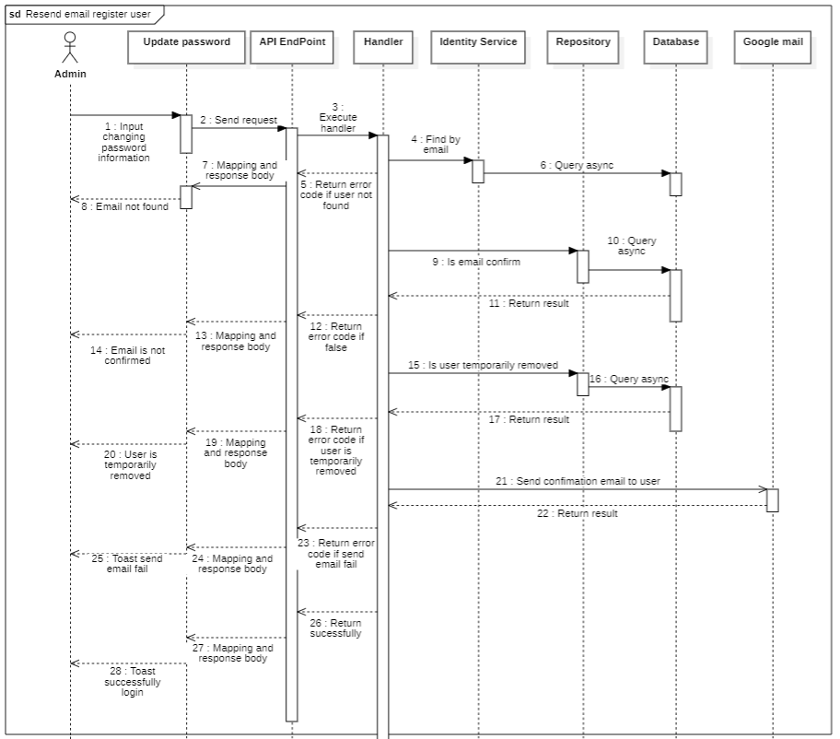

#### d. Database Queries (LinQ)

public Task<bool> IsUserTemporarilyRemovedQueryAsync(

Guid userId,

CancellationToken cancellationToken

)

{

return _users.AnyAsync(

predicate: userDetail =>

userDetail.Id == userId

&& userDetail.RemovedBy != CommonConstant.DEFAULT_ENTITY_ID_AS_GUID

&& userDetail.RemovedAt != CommonConstant.MIN_DATE_TIME,

cancellationToken: cancellationToken

);

}

## 3. User

### 3.1. Get User Profile

#### a. Class diagram

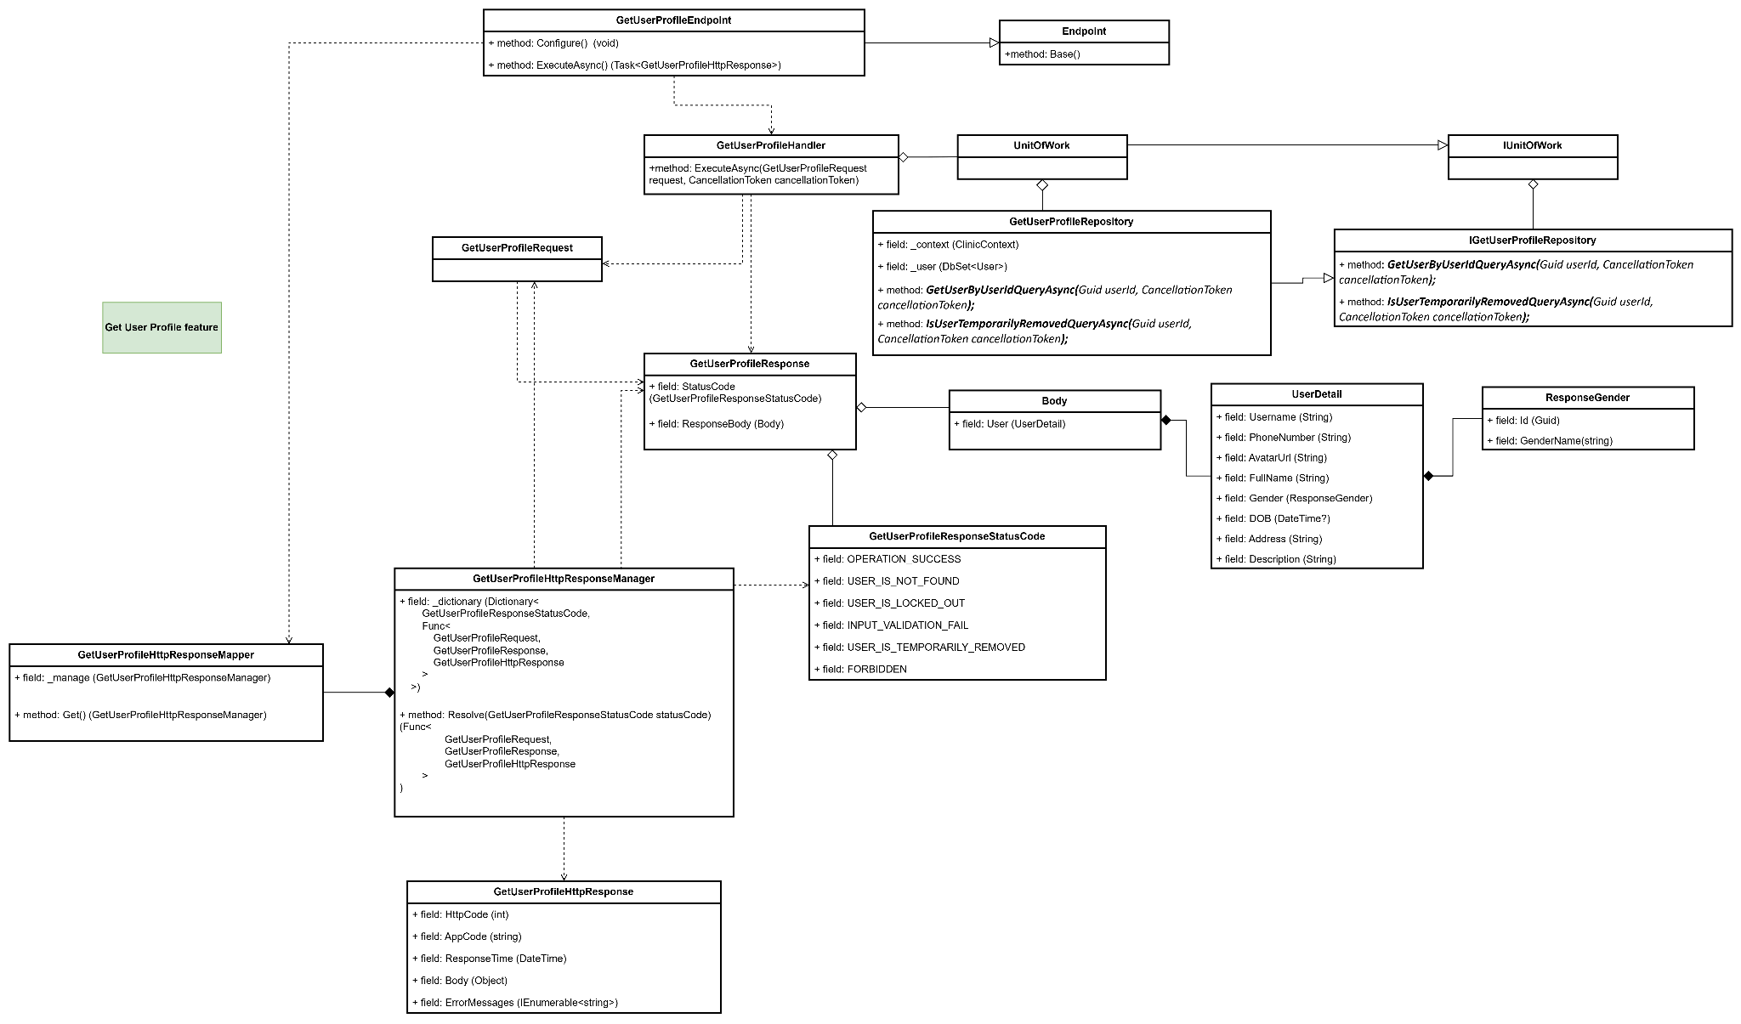

#### b. Class Specifications

#### GetUserProfileEndpoint class

*Same as common given before,* [*review here*](https://docs.google.com/document/d/1tTZUy0kDp6tdHb6MY85cNBVlDSK0k0N9w2NXBLPTu-c/edit?fbclid=IwY2xjawGRuZpleHRuA2FlbQIxMAABHUWj7GBmcsB0TEQOSeFgkcMlTv6kK6aEkUnExmkf0x_20x3n5Tikj9MvPA_aem_7Ik47wBVUygzT8J9mpiG0w#heading=h.m7r87enxie2d)*.*

1. ***Endpoint abstract class***

*Same as common given before,* [*review here*](https://docs.google.com/document/d/1tTZUy0kDp6tdHb6MY85cNBVlDSK0k0N9w2NXBLPTu-c/edit?fbclid=IwY2xjawGRuZpleHRuA2FlbQIxMAABHUWj7GBmcsB0TEQOSeFgkcMlTv6kK6aEkUnExmkf0x_20x3n5Tikj9MvPA_aem_7Ik47wBVUygzT8J9mpiG0w#heading=h.ac857vak9ccs)*.*

1. ***GetUserProfileValidator class***

*Same as common given before,* [*review here*](https://docs.google.com/document/d/1tTZUy0kDp6tdHb6MY85cNBVlDSK0k0N9w2NXBLPTu-c/edit?fbclid=IwY2xjawGRuZpleHRuA2FlbQIxMAABHUWj7GBmcsB0TEQOSeFgkcMlTv6kK6aEkUnExmkf0x_20x3n5Tikj9MvPA_aem_7Ik47wBVUygzT8J9mpiG0w#heading=h.mapewhyr52db)*.*

1. ***GetUserProfileHandler class***

*Same as common given before,* [*review here*](https://docs.google.com/document/d/1tTZUy0kDp6tdHb6MY85cNBVlDSK0k0N9w2NXBLPTu-c/edit?fbclid=IwY2xjawGRuZpleHRuA2FlbQIxMAABHUWj7GBmcsB0TEQOSeFgkcMlTv6kK6aEkUnExmkf0x_20x3n5Tikj9MvPA_aem_7Ik47wBVUygzT8J9mpiG0w#heading=h.3lfr3mcrnl8j)*.*

1. ***IUnitOfWork interface***

*Same as common given before,* [*review here*](https://docs.google.com/document/d/1tTZUy0kDp6tdHb6MY85cNBVlDSK0k0N9w2NXBLPTu-c/edit?fbclid=IwY2xjawGRuZpleHRuA2FlbQIxMAABHUWj7GBmcsB0TEQOSeFgkcMlTv6kK6aEkUnExmkf0x_20x3n5Tikj9MvPA_aem_7Ik47wBVUygzT8J9mpiG0w#heading=h.plvhy3azezgm)*.*

1. ***UnitOfWork class***

*Same as common given before,* [*review here*](https://docs.google.com/document/d/1tTZUy0kDp6tdHb6MY85cNBVlDSK0k0N9w2NXBLPTu-c/edit?fbclid=IwY2xjawGRuZpleHRuA2FlbQIxMAABHUWj7GBmcsB0TEQOSeFgkcMlTv6kK6aEkUnExmkf0x_20x3n5Tikj9MvPA_aem_7Ik47wBVUygzT8J9mpiG0w#heading=h.75tksa2v2ybj)*.*

1. ***GetUserProfileRequest class***

| **No** | **Fields** | **Description** |
| --- | --- | --- |
| *Empty request* | | |

1. ***GetUserProfileResponse class***

| **No** | **Fields** | **Description** |
| --- | --- | --- |
| *01* | *StatusCode* | *This field will return an app code and http code.* |
| *02* | *Username* | *This field will return username of user’s account* |
| *03* | *PhoneNumber* | *This field will return phone number of user* |
| *04* | *AvatarUrl* | *This field will return avatar url of user* |
| *05* | *FullName* | *This field will return phone number of user* |
| *06* | *Gender* | *This field will return gender of user* |
| *07* | *DOB* | *This field will return date of birth of user* |
| *08* | *Address* | *This field will return address of user* |
| *09* | *Description* | *This field will return description of user* |

1. ***GetUserProfileResponseStatusCode Enum class***

This enum class contains some necessary app code like USER_IS_NOT_FOUND, USER_IS_LOCKED_OUT, USER_IS_TEMPORARILY_REMOVED, OPERATION_SUCCESS,.... Purpose to handle response with specifically code of errors.

1. ***IGetUserProfileRepository interface***

This interface class contains method to interact with database

| **No** | **Method** | **Description** |
| --- | --- | --- |
| *01* | ***GetUserByUserIdQueryAsync(****Guid userId, CancellationToken cancellationToken****);*** | *Defines a method to get user by id* |
| *02* | ***IsUserTemporarilyRemovedQueryAsync(****Guid userId, CancellationToken cancellationToken****);*** | *Defines a method to check the user account is removed or not* |

1. ***GetUserProfileRepository***

This class is an implementation of the *IGetUserProfileRepository* interface***.***

| **No** | **Fields** | **Description** |
| --- | --- | --- |
| *01* | *_context* | *This field is database context* |
| *02* | *_users* | *Property to interact with the Users table in the database* |

| **No** | **Method** | **Description** |
| --- | --- | --- |
| *01* | ***GetUserByUserIdQueryAsync(****Guid userId, CancellationToken cancellationToken****);*** | *Execute statements that interact with the database and return the desired value* |
| *02* | ***IsUserTemporarilyRemovedQueryAsync(****Guid userId, CancellationToken cancellationToken****);*** | *Execute statements that interact with the database and return the desired value* |

#### c. Sequence Diagram(s)

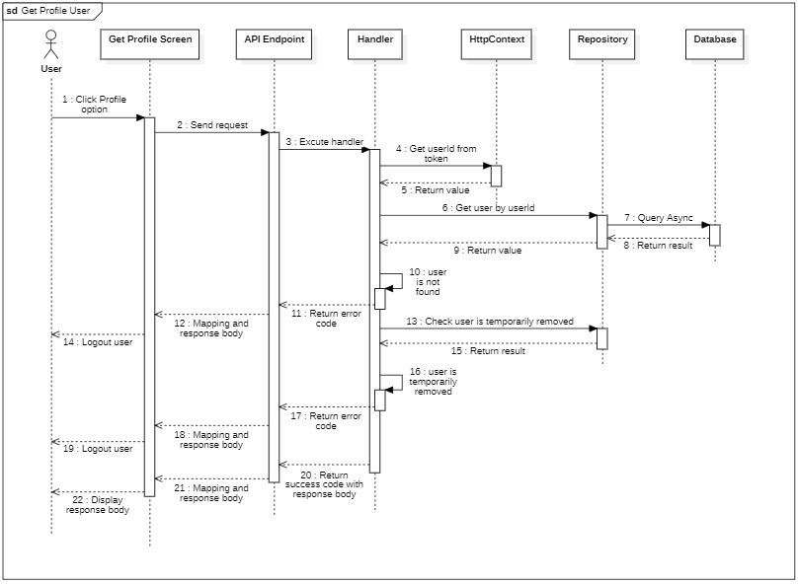

#### d. Database Queries

public Task<User> GetUserByUserIdQueryAsync(Guid userId, CancellationToken cancellationToken)

{

return _users

.AsNoTracking()

.Where(predicate: user => user.Id == userId)

.Select(selector: user => new User()

{

UserName = user.UserName,

FullName = user.FullName,

PhoneNumber = user.PhoneNumber,

Avatar = user.Avatar,

Gender = new()

{

Name = user.Gender.Name,

Constant = user.Gender.Constant,

Id = user.Gender.Id,

},

Patient = new()

{

DOB = user.Patient.DOB,

Address = user.Patient.Address,

Description = user.Patient.Description,

},

})

.FirstOrDefaultAsync(cancellationToken: cancellationToken);

}

public Task<bool> IsUserTemporarilyRemovedQueryAsync(

Guid userId,

CancellationToken cancellationToken

)

{

return _users.AnyAsync(

predicate: entity =>

entity.Id == userId && entity.RemovedAt != CommonConstant.MIN_DATE_TIME,

cancellationToken: cancellationToken

);

}

### 3.2. Get all doctor for booking

#### a. Class diagram

#### b. Class Specifications

#### c. Sequence Diagram(s)

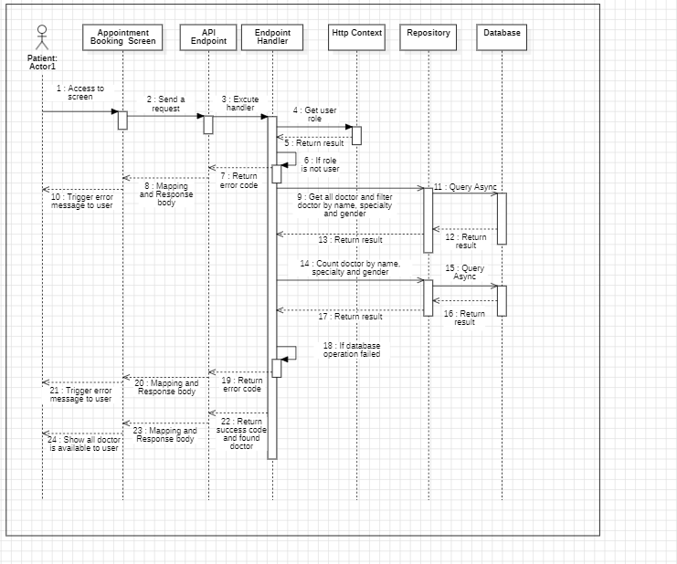

#### d. Database Queries

### 

### 3.3. Get all doctor who is on duty

#### a. Class diagram

#### b. Class Specifications

#### GetAvailableDoctorEndpoint class

* 1. *Same as common given before,* [*review here*](https://docs.google.com/document/d/1tTZUy0kDp6tdHb6MY85cNBVlDSK0k0N9w2NXBLPTu-c/edit?fbclid=IwY2xjawGRuZpleHRuA2FlbQIxMAABHUWj7GBmcsB0TEQOSeFgkcMlTv6kK6aEkUnExmkf0x_20x3n5Tikj9MvPA_aem_7Ik47wBVUygzT8J9mpiG0w#heading=h.m7r87enxie2d)*.*

1. ***Endpoint abstract class***
   1. *Same as common given before,* [*review here*](https://docs.google.com/document/d/1tTZUy0kDp6tdHb6MY85cNBVlDSK0k0N9w2NXBLPTu-c/edit?fbclid=IwY2xjawGRuZpleHRuA2FlbQIxMAABHUWj7GBmcsB0TEQOSeFgkcMlTv6kK6aEkUnExmkf0x_20x3n5Tikj9MvPA_aem_7Ik47wBVUygzT8J9mpiG0w#heading=h.ac857vak9ccs)*.*
2. ***GetAvailableDoctorValidator class***
   1. *Same as common given before,* [*review here*](https://docs.google.com/document/d/1tTZUy0kDp6tdHb6MY85cNBVlDSK0k0N9w2NXBLPTu-c/edit?fbclid=IwY2xjawGRuZpleHRuA2FlbQIxMAABHUWj7GBmcsB0TEQOSeFgkcMlTv6kK6aEkUnExmkf0x_20x3n5Tikj9MvPA_aem_7Ik47wBVUygzT8J9mpiG0w#heading=h.mapewhyr52db)*.*
3. ***GetAvailableDoctorHandler class***
   1. *Same as common given before,* [*review here*](https://docs.google.com/document/d/1tTZUy0kDp6tdHb6MY85cNBVlDSK0k0N9w2NXBLPTu-c/edit?fbclid=IwY2xjawGRuZpleHRuA2FlbQIxMAABHUWj7GBmcsB0TEQOSeFgkcMlTv6kK6aEkUnExmkf0x_20x3n5Tikj9MvPA_aem_7Ik47wBVUygzT8J9mpiG0w#heading=h.3lfr3mcrnl8j)*.*
4. ***IUnitOfWork interface***
   1. *Same as common given before,* [*review here*](https://docs.google.com/document/d/1tTZUy0kDp6tdHb6MY85cNBVlDSK0k0N9w2NXBLPTu-c/edit?fbclid=IwY2xjawGRuZpleHRuA2FlbQIxMAABHUWj7GBmcsB0TEQOSeFgkcMlTv6kK6aEkUnExmkf0x_20x3n5Tikj9MvPA_aem_7Ik47wBVUygzT8J9mpiG0w#heading=h.plvhy3azezgm)*.*
5. ***UnitOfWork class***
   1. *Same as common given before,* [*review here*](https://docs.google.com/document/d/1tTZUy0kDp6tdHb6MY85cNBVlDSK0k0N9w2NXBLPTu-c/edit?fbclid=IwY2xjawGRuZpleHRuA2FlbQIxMAABHUWj7GBmcsB0TEQOSeFgkcMlTv6kK6aEkUnExmkf0x_20x3n5Tikj9MvPA_aem_7Ik47wBVUygzT8J9mpiG0w#heading=h.75tksa2v2ybj)*.*
6. ***GetAvailableDoctorRequest class***

| **No** | **Fields** | **Description** |
| --- | --- | --- |
| *Empty request* | | |

1. ***GetAvailableDoctorResponse class***

| **No** | **Fields** | **Description** |
| --- | --- | --- |
| *01* | *StatusCode* | *This field will return an app code and http code.* |
| *02* | *ResponseBody* | *Contains the main data body of the response* |

1. ***Body class***

| **No** | **Fields** | **Description** |
| --- | --- | --- |
| *01* | *Doctors* | *The Doctors property is a read-only collection of Doctor objects, representing all doctors in the system. It allows safe, non-modifiable access to each doctor's details, such as name and specialty, for features like appointment booking and doctor listings.* |

1. ***Doctor class***

| **No** | **Fields** | **Description** |
| --- | --- | --- |
| *01* | *DoctorId* | *Unique identifier for each doctor.* |
| *02* | *AvatarUrl* | *URL of the doctor's profile image, immutable after set.* |
| *03* | *FullName* | *Doctor's full name, immutable after set.* |

1. ***GetAvailableDoctorResponseStatusCode Enum class***

This enum class contains some necessary app code like OPERATION_SUCCESS,... Purpose to handle response with specifically code of errors.

1. ***IGetAvailableDoctorRepository interface***

This interface class contains method to interact with database

| **No** | **Method** | **Description** |
| --- | --- | --- |
| *01* | ***public async Task<IEnumerable<User>> GetAvailableDoctorQueryAsync(***  *CancellationToken cancellationToken*  ***)*** | *Defines a method to retrieve a list of available doctors as User objects asynchronously, filtered by IsOnDuty status.* |

1. ***GetAvailableDoctorRepository***

This class is an implementation of the *ICreateScheduleRepository* interface***.***

| **No** | **Fields** | **Description** |
| --- | --- | --- |
| *01* | *_context* | *This field is database context* |
| *02* | *_doctors* | *Property to interact with the Doctors table in the database* |

| **No** | **Method** | **Description** |
| --- | --- | --- |
| *01* | ***public async Task<IEnumerable<User>> GetAvailableDoctorQueryAsync(***  *CancellationToken cancellationToken*  ***)*** | *Execute statements that interact with the database and return the desired value* |

#### c. Sequence Diagram(s)

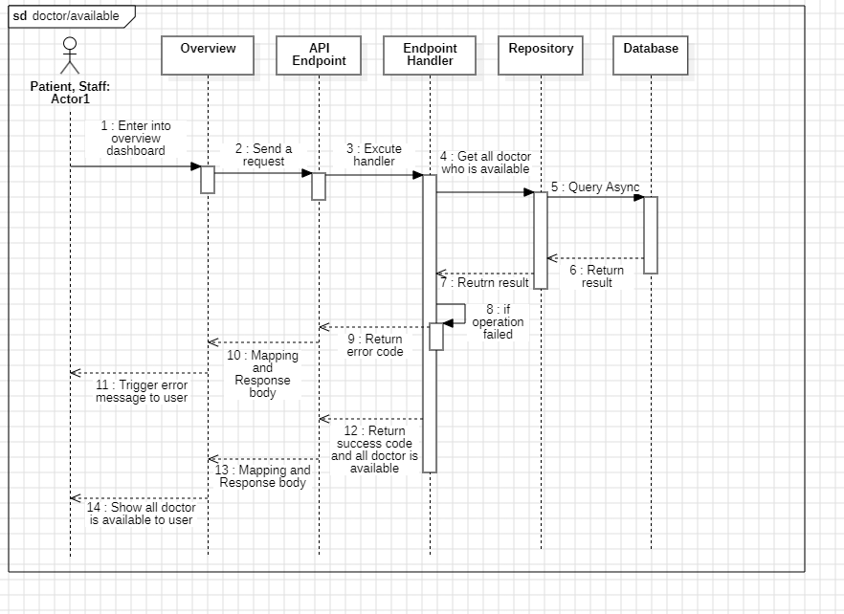

#### d. Database Queries

**public async Task<IEnumerable<User>> GetAvailableDoctorQueryAsync(**

**CancellationToken cancellationToken**

**)**

{

return await _doctors

.AsNoTracking()

.Where(entity => entity.Doctor.IsOnDuty)

.Select(entity => new User()

{

Id = entity.Id,

FullName = entity.FullName,

Avatar = entity.Avatar,

})

.ToListAsync(cancellationToken);

}

### 3.4. Update User Avatar

#### a. Class diagram

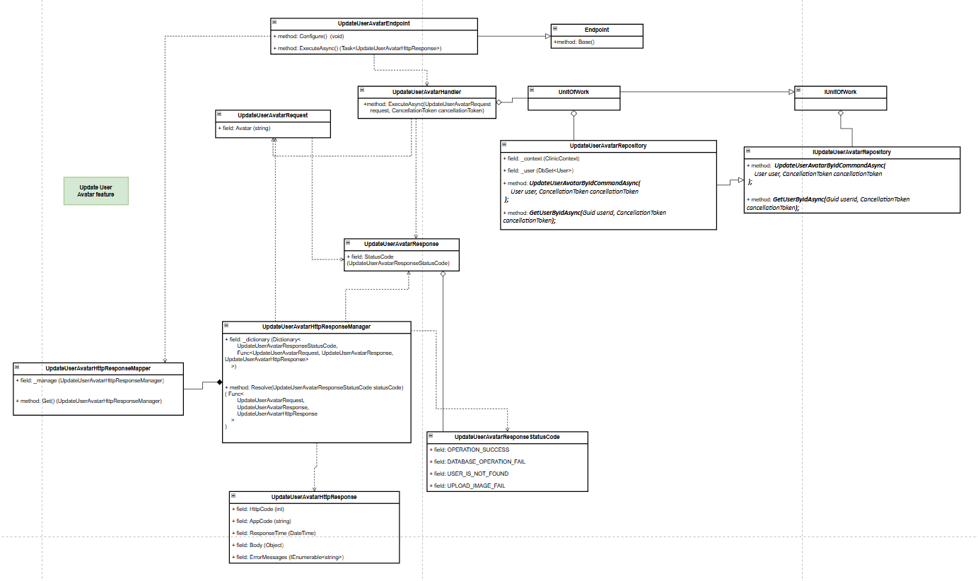

#### b. Class Specifications

***1.*** ***UpdateUserAvatarEndpoint class***

*Same as common given before,* [*review here*](https://docs.google.com/document/d/1tTZUy0kDp6tdHb6MY85cNBVlDSK0k0N9w2NXBLPTu-c/edit?fbclid=IwY2xjawGRuZpleHRuA2FlbQIxMAABHUWj7GBmcsB0TEQOSeFgkcMlTv6kK6aEkUnExmkf0x_20x3n5Tikj9MvPA_aem_7Ik47wBVUygzT8J9mpiG0w#heading=h.m7r87enxie2d)*.*

***2.*** ***Endpoint abstract class***

*Same as common given before,* [*review here*](https://docs.google.com/document/d/1tTZUy0kDp6tdHb6MY85cNBVlDSK0k0N9w2NXBLPTu-c/edit?fbclid=IwY2xjawGRuZpleHRuA2FlbQIxMAABHUWj7GBmcsB0TEQOSeFgkcMlTv6kK6aEkUnExmkf0x_20x3n5Tikj9MvPA_aem_7Ik47wBVUygzT8J9mpiG0w#heading=h.ac857vak9ccs)*.*

***3.*** ***UpdateUserAvatarValidator class***

*Same as common given before,* [*review here*](https://docs.google.com/document/d/1tTZUy0kDp6tdHb6MY85cNBVlDSK0k0N9w2NXBLPTu-c/edit?fbclid=IwY2xjawGRuZpleHRuA2FlbQIxMAABHUWj7GBmcsB0TEQOSeFgkcMlTv6kK6aEkUnExmkf0x_20x3n5Tikj9MvPA_aem_7Ik47wBVUygzT8J9mpiG0w#heading=h.mapewhyr52db)*.*

***4.*** ***UpdateUserAvatarHandler class***

*Same as common given before,* [*review here*](https://docs.google.com/document/d/1tTZUy0kDp6tdHb6MY85cNBVlDSK0k0N9w2NXBLPTu-c/edit?fbclid=IwY2xjawGRuZpleHRuA2FlbQIxMAABHUWj7GBmcsB0TEQOSeFgkcMlTv6kK6aEkUnExmkf0x_20x3n5Tikj9MvPA_aem_7Ik47wBVUygzT8J9mpiG0w#heading=h.3lfr3mcrnl8j)*.*

***5.*** ***IUnitOfWork interface***

*Same as common given before,* [*review here*](https://docs.google.com/document/d/1tTZUy0kDp6tdHb6MY85cNBVlDSK0k0N9w2NXBLPTu-c/edit?fbclid=IwY2xjawGRuZpleHRuA2FlbQIxMAABHUWj7GBmcsB0TEQOSeFgkcMlTv6kK6aEkUnExmkf0x_20x3n5Tikj9MvPA_aem_7Ik47wBVUygzT8J9mpiG0w#heading=h.plvhy3azezgm)*.*

***6.*** ***UnitOfWork class***

*Same as common given before,* [*review here*](https://docs.google.com/document/d/1tTZUy0kDp6tdHb6MY85cNBVlDSK0k0N9w2NXBLPTu-c/edit?fbclid=IwY2xjawGRuZpleHRuA2FlbQIxMAABHUWj7GBmcsB0TEQOSeFgkcMlTv6kK6aEkUnExmkf0x_20x3n5Tikj9MvPA_aem_7Ik47wBVUygzT8J9mpiG0w#heading=h.75tksa2v2ybj)*.*

***7.*** ***UpdateUserAvatarRequest class***

| **No** | **Fields** | **Description** |
| --- | --- | --- |
| *01* | Avatar | This field indicates the avatar user wants to update to. |

***8.*** ***UpdateUserAvatarResponse class***

| **No** | **Fields** | **Description** |
| --- | --- | --- |
| *01* | *StatusCode* | *This field will return an app code and http code.* |

***9.*** ***UpdateUserAvatarResponseStatusCode Enum class***

This enum class contains some necessary app code like USER_IS_NOT_FOUND, DATABASE_OPERATION_FAIL, OPERATION_SUCCESS,.... Purpose to handle response with specifically code of errors.

***10.*** ***IUpdateUserAvatarRepository interface***

This interface class contains method to interact with database

| **No** | **Method** | **Description** |
| --- | --- | --- |
| *01* | ***Task<bool> UpdateUserAvatarByIdCommandAsync(User user, CancellationToken cancellationToken = default)*** | *Updates the avatar of the specified User object and returns a boolean indicating success or failure.* |
| *02* | ***Task<User> GetUserByIdAsync(Guid userId, CancellationToken cancellationToken = default)*** | *Retrieves a User object by its unique identifier, userId.* |

***11.*** ***UpdateUserAvatarRepository***

This class is an implementation of the *IGetUserProfileRepository* interface***.***

| **No** | **Fields** | **Description** |
| --- | --- | --- |
| *01* | *_context* | *This field is database context* |
| *02* | *_users* | *Property to interact with the Users table in the database* |

| **No** | **Method** | **Description** |
| --- | --- | --- |
| *01* | ***Task<bool> UpdateUserAvatarByIdCommandAsync(User user, CancellationToken cancellationToken = default)*** | *Updates the avatar image for the specified User object in the database and saves changes, returning success or failure.* |
| *02* | ***Task<User> GetUserByIdAsync(Guid userId, CancellationToken cancellationToken = default)*** | *Retrieves a User object by userId from the User table.* |

#### c. Sequence Diagram(s)

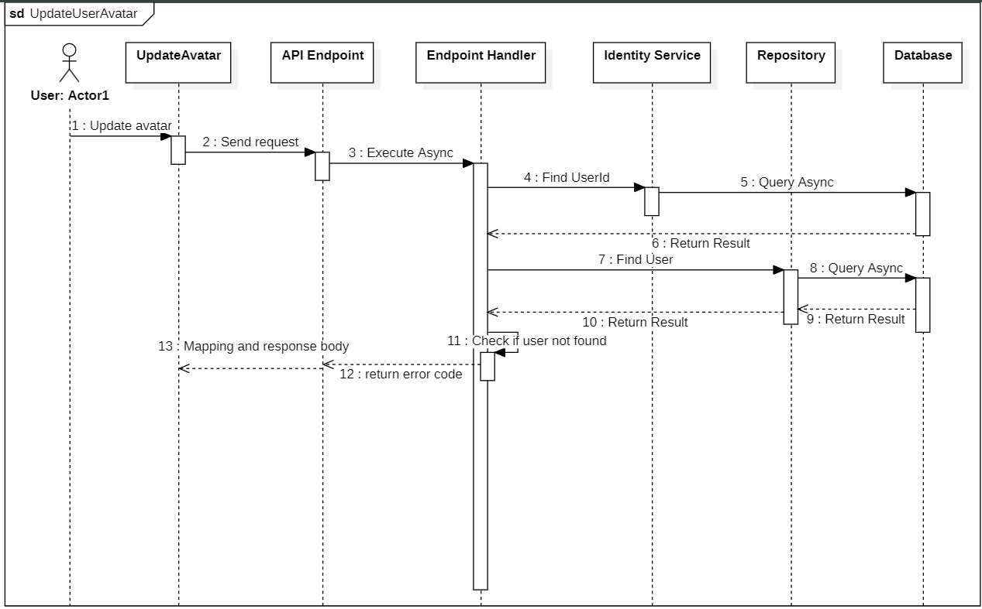

#### d. Database Queries

**public async Task<User> GetUserByIdAsync(Guid userId, CancellationToken cancellationToken)**

{

return await _context.Users

//.Include(u => u.Doctor) // Include the related Doctor entity

.FirstOrDefaultAsync(u => u.Id == userId, cancellationToken);

}

**public async Task<bool> UpdateUserAvatarByIdCommandAsync(User user, CancellationToken cancellationToken)**

{

_context.Users.Update(user);

return await _context.SaveChangesAsync(cancellationToken) > 0;

}

### 3.5. Send a feedback

#### a. Class diagram

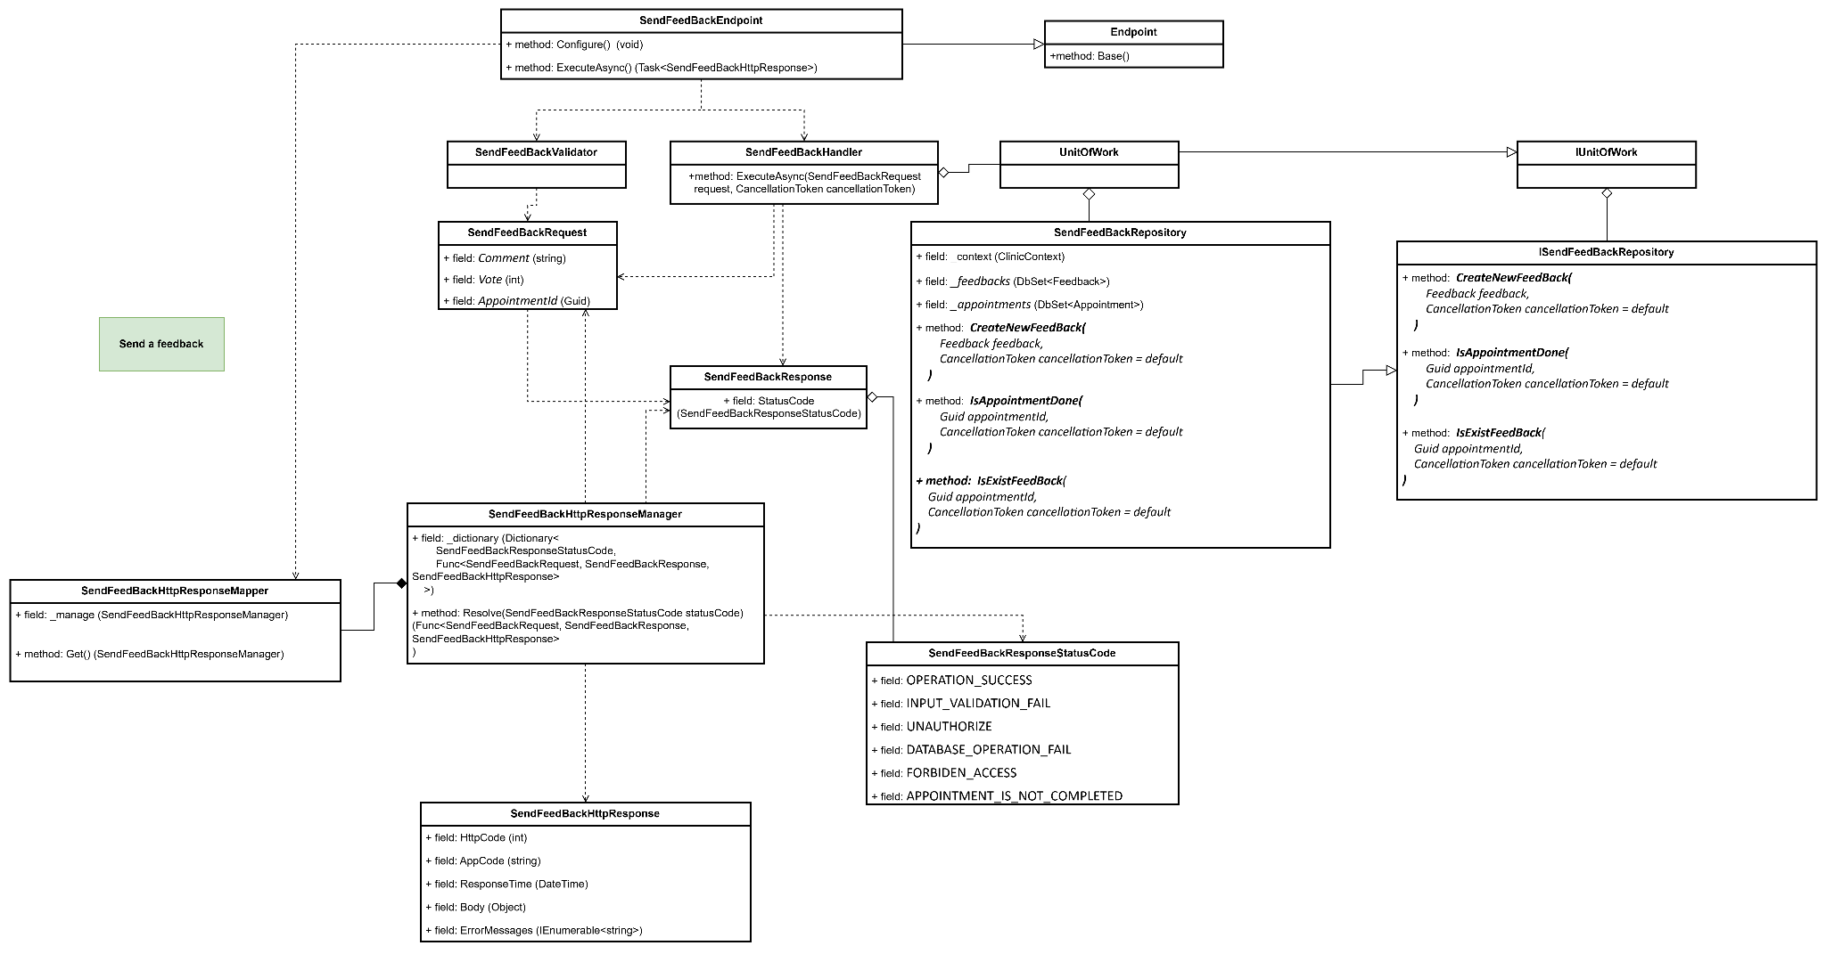

#### b. Class Specifications

#### SendFeedBackEndpoint class

*Same as common given before,* [*review here*](https://docs.google.com/document/d/1tTZUy0kDp6tdHb6MY85cNBVlDSK0k0N9w2NXBLPTu-c/edit?fbclid=IwY2xjawGRuZpleHRuA2FlbQIxMAABHUWj7GBmcsB0TEQOSeFgkcMlTv6kK6aEkUnExmkf0x_20x3n5Tikj9MvPA_aem_7Ik47wBVUygzT8J9mpiG0w#heading=h.m7r87enxie2d)*.*

1. ***Endpoint abstract class***

*Same as common given before,* [*review here*](https://docs.google.com/document/d/1tTZUy0kDp6tdHb6MY85cNBVlDSK0k0N9w2NXBLPTu-c/edit?fbclid=IwY2xjawGRuZpleHRuA2FlbQIxMAABHUWj7GBmcsB0TEQOSeFgkcMlTv6kK6aEkUnExmkf0x_20x3n5Tikj9MvPA_aem_7Ik47wBVUygzT8J9mpiG0w#heading=h.ac857vak9ccs)*.*

1. ***SendFeedBackValidator class***

*Same as common given before,* [*review here*](https://docs.google.com/document/d/1tTZUy0kDp6tdHb6MY85cNBVlDSK0k0N9w2NXBLPTu-c/edit?fbclid=IwY2xjawGRuZpleHRuA2FlbQIxMAABHUWj7GBmcsB0TEQOSeFgkcMlTv6kK6aEkUnExmkf0x_20x3n5Tikj9MvPA_aem_7Ik47wBVUygzT8J9mpiG0w#heading=h.mapewhyr52db)*.*

1. ***SendFeedBackHandler class***

*Same as common given before,* [*review here*](https://docs.google.com/document/d/1tTZUy0kDp6tdHb6MY85cNBVlDSK0k0N9w2NXBLPTu-c/edit?fbclid=IwY2xjawGRuZpleHRuA2FlbQIxMAABHUWj7GBmcsB0TEQOSeFgkcMlTv6kK6aEkUnExmkf0x_20x3n5Tikj9MvPA_aem_7Ik47wBVUygzT8J9mpiG0w#heading=h.3lfr3mcrnl8j)*.*

1. ***IUnitOfWork interface***

*Same as common given before,* [*review here*](https://docs.google.com/document/d/1tTZUy0kDp6tdHb6MY85cNBVlDSK0k0N9w2NXBLPTu-c/edit?fbclid=IwY2xjawGRuZpleHRuA2FlbQIxMAABHUWj7GBmcsB0TEQOSeFgkcMlTv6kK6aEkUnExmkf0x_20x3n5Tikj9MvPA_aem_7Ik47wBVUygzT8J9mpiG0w#heading=h.plvhy3azezgm)*.*

1. ***UnitOfWork class***

*Same as common given before,* [*review here*](https://docs.google.com/document/d/1tTZUy0kDp6tdHb6MY85cNBVlDSK0k0N9w2NXBLPTu-c/edit?fbclid=IwY2xjawGRuZpleHRuA2FlbQIxMAABHUWj7GBmcsB0TEQOSeFgkcMlTv6kK6aEkUnExmkf0x_20x3n5Tikj9MvPA_aem_7Ik47wBVUygzT8J9mpiG0w#heading=h.75tksa2v2ybj)*.*

1. ***SendFeedBackRequest class***

| **No** | **Fields** | **Description** |
| --- | --- | --- |
| *01* | *Comment* | *This is the user's written feedback about their experience or interaction. It allows patients to leave detailed comments or remarks regarding the service they received, such as specific compliments or areas needing improvement.* |
| *02* | *Vote* | *This is a numerical rating (typically on a predefined scale, such as 1-5). It enables patients to provide a quick quantitative assessment of their satisfaction level with the service or appointment.* |
| *03* | *AppointmentId* | *This is a unique identifier for the specific appointment associated with the feedback. By linking feedback to a particular appointment, the system can keep records of comments and ratings for each session, making it easy to review feedback on a per-appointment basis.* |

1. ***SendFeedBackResponse class***

| **No** | **Fields** | **Description** |
| --- | --- | --- |
| *01* | *StatusCode* | *This field will return an app code and http code.* |

1. ***SendFeedBackResponseStatusCode Enum class***

This enum class contains some necessary app code like INPUT_VALIDATION_FAIL, OPERATION_SUCCESS, UNAUTHORIZE, DATABASE_OPERATION_FAIL, FORBIDEN_ACCESS, APPOINTMENT_IS_NOT_COMPLETED,.... Purpose to handle response with specifically code of errors.

1. ***ISendFeedBackRepository interface***

This interface class contains method to interact with database

| **No** | **Method** | **Description** |
| --- | --- | --- |
| *01* | ***CreateNewFeedBack(***  *Feedback feedback,*  *CancellationToken cancellationToken = default*  ***)*** | *Defines a method to add a new feedback entry to the system.* |
| *02* | ***IsAppointmentDone(***  *Guid appointmentId,*  *CancellationToken cancellationToken = default*  ***)*** | *Defines a method to check if a specific appointment is marked as "Completed."* |
| *03* | ***public async Task<bool> IsExistFeedBack****(*  *Guid appointmentId,*  *CancellationToken cancellationToken = default*  ***)*** | *Defines a method to check if feedback has already been submitted for a specific appointment.* |

1. ***SendFeedBackRepository***

This class is an implementation of the *IGetUserProfileRepository* interface***.***

| **No** | **Fields** | **Description** |
| --- | --- | --- |
| *01* | *_context* | *This field is database context* |
| *02* | *_feedbacks* | *Property to interact with the Feedbacks table in the database* |
| *03* | *_appointments* | *Property to interact with the Appointments table in the database* |

| **No** | **Method** | **Description** |
| --- | --- | --- |
| *01* | ***CreateNewFeedBack(***  *Feedback feedback,*  *CancellationToken cancellationToken = default*  ***)*** | *Execute statements that interact with the database and return the desired value* |
| *02* | ***IsAppointmentDone(***  *Guid appointmentId,*  *CancellationToken cancellationToken = default*  ***)*** | *Execute statements that interact with the database and return the desired value* |
| *03* | ***public async Task<bool>*** *IsExistFeedBack(*  *Guid appointmentId,*  *CancellationToken cancellationToken = default*  ***)*** | *Execute statements that interact with the database and return the desired value* |

#### c. Sequence Diagram(s)

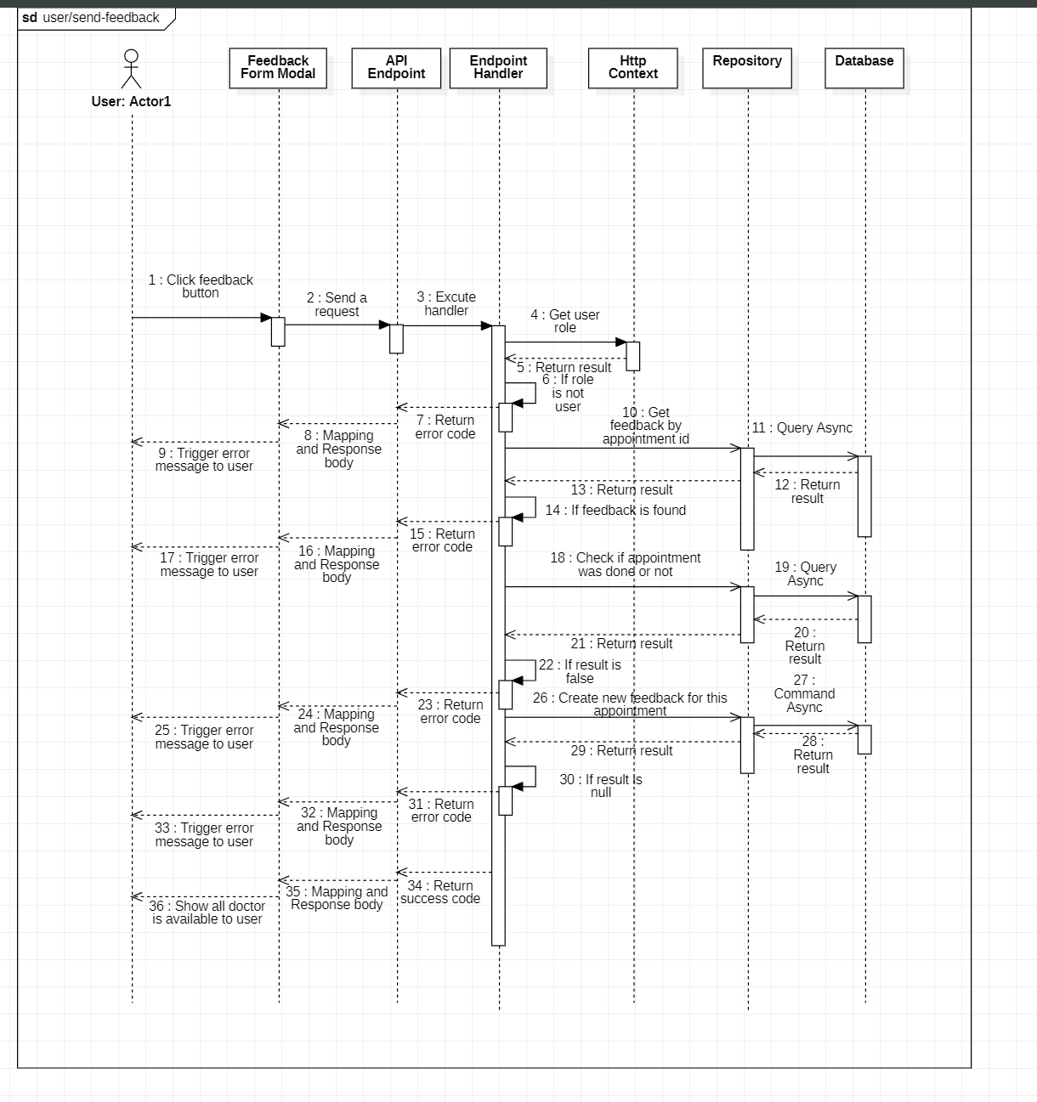

#### d. Database Queries

**public async Task<bool> CreateNewFeedBack(**

**Feedback feedback,**

**CancellationToken cancellationToken = default**

**)**

{

try

{

_feedbacks.Add(feedback);

await _context.SaveChangesAsync(cancellationToken: cancellationToken);

}

catch (Exception ex)

{

await Console.Out.WriteLineAsync(ex.ToString());

return false;

}

return true;

}

**public async Task<bool> IsAppointmentDone(**

**Guid appointmentId,**

**CancellationToken cancellationToken = default**

**)**

{

return await _appointments.AnyAsync(

appointment => appointment.AppointmentStatus.Constant.Equals("Completed"),

cancellationToken

);

}

**public async Task<bool> IsExistFeedBack(**

**Guid appointmentId,**

**CancellationToken cancellationToken = default**

**)**

{

return await _feedbacks.AnyAsync(

feedback => feedback.AppointmentId == appointmentId,

cancellationToken

);

}

### 3.6. Get all doctors who is on duty

#### a. Class diagram

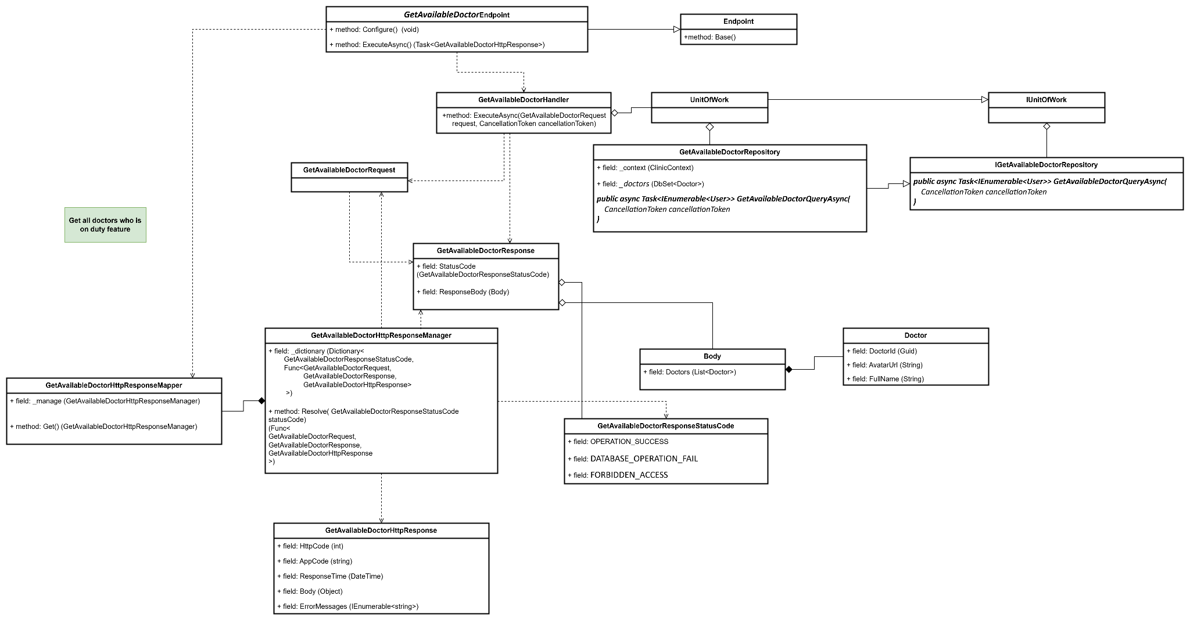

#### b. Class Specifications

#### GetAvailableDoctorEndpoint class

*Same as common given before,* [*review here*](https://docs.google.com/document/d/1tTZUy0kDp6tdHb6MY85cNBVlDSK0k0N9w2NXBLPTu-c/edit?fbclid=IwY2xjawGRuZpleHRuA2FlbQIxMAABHUWj7GBmcsB0TEQOSeFgkcMlTv6kK6aEkUnExmkf0x_20x3n5Tikj9MvPA_aem_7Ik47wBVUygzT8J9mpiG0w#heading=h.m7r87enxie2d)*.*

1. ***Endpoint abstract class***

*Same as common given before,* [*review here*](https://docs.google.com/document/d/1tTZUy0kDp6tdHb6MY85cNBVlDSK0k0N9w2NXBLPTu-c/edit?fbclid=IwY2xjawGRuZpleHRuA2FlbQIxMAABHUWj7GBmcsB0TEQOSeFgkcMlTv6kK6aEkUnExmkf0x_20x3n5Tikj9MvPA_aem_7Ik47wBVUygzT8J9mpiG0w#heading=h.ac857vak9ccs)*.*

1. ***GetAvailableDoctorValidator class***

*Same as common given before,* [*review here*](https://docs.google.com/document/d/1tTZUy0kDp6tdHb6MY85cNBVlDSK0k0N9w2NXBLPTu-c/edit?fbclid=IwY2xjawGRuZpleHRuA2FlbQIxMAABHUWj7GBmcsB0TEQOSeFgkcMlTv6kK6aEkUnExmkf0x_20x3n5Tikj9MvPA_aem_7Ik47wBVUygzT8J9mpiG0w#heading=h.mapewhyr52db)*.*

1. ***GetAvailableDoctorHandler class***

*Same as common given before,* [*review here*](https://docs.google.com/document/d/1tTZUy0kDp6tdHb6MY85cNBVlDSK0k0N9w2NXBLPTu-c/edit?fbclid=IwY2xjawGRuZpleHRuA2FlbQIxMAABHUWj7GBmcsB0TEQOSeFgkcMlTv6kK6aEkUnExmkf0x_20x3n5Tikj9MvPA_aem_7Ik47wBVUygzT8J9mpiG0w#heading=h.3lfr3mcrnl8j)*.*

1. ***IUnitOfWork interface***

*Same as common given before,* [*review here*](https://docs.google.com/document/d/1tTZUy0kDp6tdHb6MY85cNBVlDSK0k0N9w2NXBLPTu-c/edit?fbclid=IwY2xjawGRuZpleHRuA2FlbQIxMAABHUWj7GBmcsB0TEQOSeFgkcMlTv6kK6aEkUnExmkf0x_20x3n5Tikj9MvPA_aem_7Ik47wBVUygzT8J9mpiG0w#heading=h.plvhy3azezgm)*.*

1. ***UnitOfWork class***

*Same as common given before,* [*review here*](https://docs.google.com/document/d/1tTZUy0kDp6tdHb6MY85cNBVlDSK0k0N9w2NXBLPTu-c/edit?fbclid=IwY2xjawGRuZpleHRuA2FlbQIxMAABHUWj7GBmcsB0TEQOSeFgkcMlTv6kK6aEkUnExmkf0x_20x3n5Tikj9MvPA_aem_7Ik47wBVUygzT8J9mpiG0w#heading=h.75tksa2v2ybj)*.*

1. ***GetAvailableDoctorRequest class***

| **No** | **Fields** | **Description** |
| --- | --- | --- |
| *Empty request* | | |

1. ***GetAvailableDoctorResponse class***

| **No** | **Fields** | **Description** |
| --- | --- | --- |
| *01* | *StatusCode* | *This field will return an app code and http code.* |
| *02* | *ResponseBody* | *This field will return a instance is type of Body* |

1. ***GetAvailableDoctorResponseStatusCode Enum class***

This enum class contains important app codes like OPERATION_SUCCESS and DATABASE_OPERATION_FAIL, FORBIDDEN_ACCESS. These codes are designed to handle responses with specific error or success statuses, making it easier to manage different outcomes in the application.

1. ***GetAvailableDoctorRepository interface***

This interface class contains method to interact with database

| **No** | **Method** | **Description** |
| --- | --- | --- |
| *01* | ***public async Task<IEnumerable<User>> GetAvailableDoctorQueryAsync(***  *CancellationToken cancellationToken*  ***)*** | *Defines a method to retrieve a collection of available doctors who is on duty from the database or service asynchronously.* |

1. ***GetAvailableDoctorRepository class***

This class is an implementation of the *IGetUserProfileRepository* interface***.***

| **No** | **Fields** | **Description** |
| --- | --- | --- |
| *01* | *_context* | *This field is database context* |
| *02* | *_doctors* | *Property to interact with the Doctors table in the database* |

| **No** | **Method** | **Description** |
| --- | --- | --- |
| *01* | ***public async Task<IEnumerable<User>> GetAvailableDoctorQueryAsync(***  *CancellationToken cancellationToken*  ***)*** | *Execute statements that interact with the database and return the desired value* |

1. **Body class**

| **No** | **Fields** | **Description** |
| --- | --- | --- |
| *01* | *Doctors* | *Represents a collection of Doctor objects.* |

1. **Doctor class**

| **No** | **Fields** | **Description** |
| --- | --- | --- |
| *01* | *DoctorId* | *A unique identifier for each doctor.* |
| *02* | *AvatarUrl* | *The URL of the doctor's profile picture.* |
| *03* | *FullName* | *The full name of the doctor.* |

#### c. Sequence Diagram(s)

#### d. Database Queries

**public async Task<IEnumerable<User>> GetAvailableDoctorQueryAsync(**

**CancellationToken cancellationToken**

**)**

{

return await _doctors

.AsNoTracking()

.Where(entity => entity.Doctor.IsOnDuty)

.Select(entity => new User()

{

Id = entity.Id,

FullName = entity.FullName,

Avatar = entity.Avatar,

})

.ToListAsync(cancellationToken);

}

### 3.7. View feedback

#### a. Class diagram

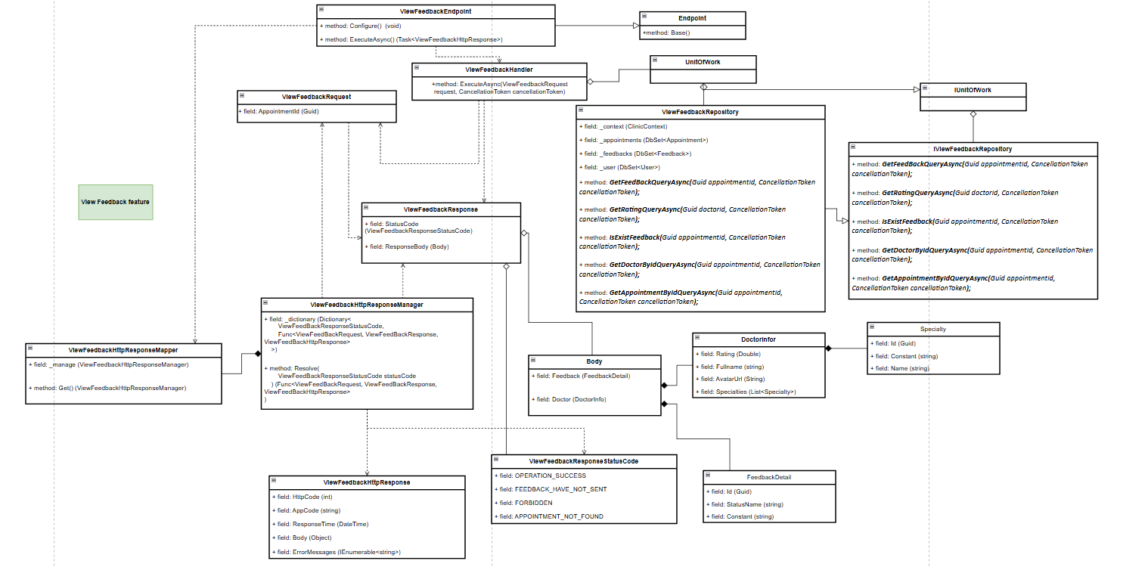

#### b. Class Specifications

***1.*** ***ViewFeedBackEndpoint class***

***Same as common given before,*** [***review here***](https://docs.google.com/document/d/1tTZUy0kDp6tdHb6MY85cNBVlDSK0k0N9w2NXBLPTu-c/edit?fbclid=IwY2xjawGRuZpleHRuA2FlbQIxMAABHUWj7GBmcsB0TEQOSeFgkcMlTv6kK6aEkUnExmkf0x_20x3n5Tikj9MvPA_aem_7Ik47wBVUygzT8J9mpiG0w#heading=h.m7r87enxie2d)***.***

***2.*** ***Endpoint abstract class***

***Same as common given before,*** [***review here***](https://docs.google.com/document/d/1tTZUy0kDp6tdHb6MY85cNBVlDSK0k0N9w2NXBLPTu-c/edit?fbclid=IwY2xjawGRuZpleHRuA2FlbQIxMAABHUWj7GBmcsB0TEQOSeFgkcMlTv6kK6aEkUnExmkf0x_20x3n5Tikj9MvPA_aem_7Ik47wBVUygzT8J9mpiG0w#heading=h.ac857vak9ccs)***.***

***3.*** ***ViewFeedBackValidator class***

***Same as common given before,*** [***review here***](https://docs.google.com/document/d/1tTZUy0kDp6tdHb6MY85cNBVlDSK0k0N9w2NXBLPTu-c/edit?fbclid=IwY2xjawGRuZpleHRuA2FlbQIxMAABHUWj7GBmcsB0TEQOSeFgkcMlTv6kK6aEkUnExmkf0x_20x3n5Tikj9MvPA_aem_7Ik47wBVUygzT8J9mpiG0w#heading=h.mapewhyr52db)***.***

***4.*** ***ViewFeedBackHandler class***

***Same as common given before,*** [***review here***](https://docs.google.com/document/d/1tTZUy0kDp6tdHb6MY85cNBVlDSK0k0N9w2NXBLPTu-c/edit?fbclid=IwY2xjawGRuZpleHRuA2FlbQIxMAABHUWj7GBmcsB0TEQOSeFgkcMlTv6kK6aEkUnExmkf0x_20x3n5Tikj9MvPA_aem_7Ik47wBVUygzT8J9mpiG0w#heading=h.3lfr3mcrnl8j)***.***

***5.*** ***IUnitOfWork interface***

***Same as common given before,*** [***review here***](https://docs.google.com/document/d/1tTZUy0kDp6tdHb6MY85cNBVlDSK0k0N9w2NXBLPTu-c/edit?fbclid=IwY2xjawGRuZpleHRuA2FlbQIxMAABHUWj7GBmcsB0TEQOSeFgkcMlTv6kK6aEkUnExmkf0x_20x3n5Tikj9MvPA_aem_7Ik47wBVUygzT8J9mpiG0w#heading=h.plvhy3azezgm)***.***

***6.*** ***UnitOfWork class***

***Same as common given before,*** [***review here***](https://docs.google.com/document/d/1tTZUy0kDp6tdHb6MY85cNBVlDSK0k0N9w2NXBLPTu-c/edit?fbclid=IwY2xjawGRuZpleHRuA2FlbQIxMAABHUWj7GBmcsB0TEQOSeFgkcMlTv6kK6aEkUnExmkf0x_20x3n5Tikj9MvPA_aem_7Ik47wBVUygzT8J9mpiG0w#heading=h.75tksa2v2ybj)***.***

***7.*** ***ViewFeedBackRequest class***

| ***No*** | ***Fields*** | ***Description*** |
| --- | --- | --- |
| ***01*** | ***AppointmentId*** | ***This is a unique identifier for the specific appointment associated with the feedback. By linking feedback to a particular appointment, the system can keep records of comments and ratings for each session, making it easy to review feedback on a per-appointment basis.*** |

***8.*** ***ViewFeedBackResponse class***

| ***No*** | ***Fields*** | ***Description*** |
| --- | --- | --- |
| ***01*** | ***StatusCode*** | ***This field will return an app code and http code.*** |
| ***02*** | ***ResponseBody*** | ***Contains the main data body of the response.*** |

***9.*** ***Body class***

| ***No*** | ***Fields*** | ***Description*** |
| --- | --- | --- |
| ***01*** | ***Feedback*** | ***Contains details of the feedback, including comment and rating.*** |
| ***02*** | ***Doctor*** | ***Nested class with information about the doctor providing the feedback.*** |

***10.*** ***FeedbackDetail class***

| ***No*** | ***Fields*** | ***Description*** |
| --- | --- | --- |
| ***01*** | ***Id*** | ***Unique identifier for the feedback entry.*** |
| ***02*** | ***Comment*** | ***Text of the feedback provided by the patient.*** |
| ***03*** | ***Vote*** | ***Numeric rating or vote provided in the feedback.*** |

***11.*** ***DoctorInfor class***

| ***No*** | ***Fields*** | ***Description*** |
| --- | --- | --- |
| ***01*** | ***Rating*** | ***Overall rating of the doctor based on feedback.*** |
| ***02*** | ***Fullname*** | ***Full name of the doctor.*** |
| ***03*** | ***AvatarUrl*** | ***URL or path to the doctor’s avatar image.*** |
| ***04*** | ***Specialties*** | ***Collection of specialties in which the doctor is certified.*** |

***12.*** ***Specialty class***

| ***No*** | ***Fields*** | ***Description*** |
| --- | --- | --- |
| ***01*** | ***Id*** | ***Unique identifier for the specialty..*** |
| ***02*** | ***Name*** | ***Name of the specialty (e.g., Cardiology).*** |
| ***03*** | ***Constant*** | ***Constant or code representing the specialty.*** |

***13.*** ***ViewFeedBackResponseStatusCode Enum class***

***This enum class contains some necessary app code like OPERATION_SUCCESS, FEEDBACK_HAVE_NOT_SENT, FORBIDDEN, APPOINTMENT_NOT_FOUND, .... Purpose to handle response with specifically code of errors.***

***14.*** ***IViewFeedBackRepository interface***

***This interface class contains method to interact with database***

| ***No*** | ***Method*** | ***Description*** |
| --- | --- | --- |
| ***01*** | ***Task<Feedback> GetFeedBackQueryAsync(Guid appointmentId, CancellationToken cancellationToken);*** | ***Defines a method to retrieve feedback for a specified appointment.*** |
| ***02*** | ***GetRatingQueryAsync(Guid doctorId, CancellationToken cancellationToken)*** | ***Defines a method to retrieve the average rating for a specified doctor.*** |
| ***03*** | ***IsExistFeedback(Guid appointmentId, CancellationToken cancellationToken)*** | ***Checks if feedback already exists for a specific appointment.*** |
| ***04*** | ***GetDoctorByIdQueryAsync(Guid appointmentId, CancellationToken cancellationToken)*** | ***Retrieves details of the doctor associated with a specific appointment.*** |
| ***05*** | ***GetAppointmentByIdQueryAsync(Guid appointmentId, CancellationToken cancellationToken)*** | ***Retrieves details of an appointment by its ID, including related schedule and doctor.*** |

***15.*** ***ViewFeedBackRepository***

***This class is an implementation of the IGetUserProfileRepository interface.***

| ***No*** | ***Fields*** | ***Description*** |
| --- | --- | --- |
| ***01*** | ***_context*** | ***This field is database context*** |
| ***02*** | ***_feedbacks*** | ***Property to interact with the Feedbacks table in the database*** |
| ***03*** | ***_appointments*** | ***Property to interact with the Appointments table in the database*** |
| ***04*** | ***_user*** | ***Property to access the User table in the database.*** |

| ***No*** | ***Method*** | ***Description*** |
| --- | --- | --- |
| ***01*** | ***public async Task<Appointment> GetAppointmentByIdQueryAsync(***  *Guid appointmentId,*  *CancellationToken cancellationToken*  ***)*** | ***Retrieves the appointment details along with associated schedule and doctor information, if available, for the specified appointment ID.*** |
| ***02*** | ***public async Task<User> GetDoctorByIdQueryAsync(***  *Guid appointmentId,*  *CancellationToken cancellationToken*  ***)*** | ***Retrieves doctor information, including name, avatar, and specialties, for a specified appointment.*** |
| ***03*** | ***public async Task<bool> IsExistFeedBack(***  *Guid appointmentId,*  *CancellationToken cancellationToken = default*  ***)*** | ***Checks if feedback already exists for the specified appointment, returning true if it does.*** |
|  | ***public async Task<Feedback> GetFeedBackQueryAsync(***  *Guid appointmentId,*  *CancellationToken cancellationToken*  ***)*** | ***Retrieves feedback for a specific appointment.*** |
|  | ***public async Task<double> GetRatingQueryAsync(***  *Guid doctorId,*  *CancellationToken cancellationToken*  ***)*** | ***Calculates and returns the average rating for a specific doctor based on existing feedback.*** |

#### c. Sequence Diagram(s)

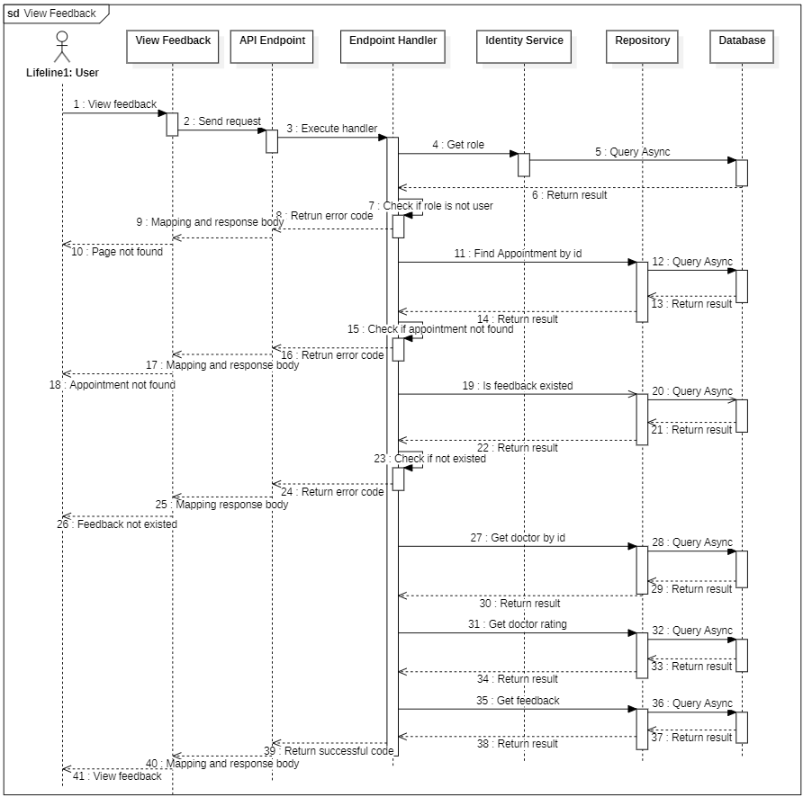

#### d. Database Queries

**public async Task<Appointment> GetAppointmentByIdQueryAsync(**

**Guid appointmentId,**

**CancellationToken cancellationToken**

**)**

{

return await _appointments

.AsNoTracking()

.Include(entity => entity.Schedule)

.ThenInclude(entity => entity.Doctor)

.Where(entity => entity.Id == appointmentId)

.FirstOrDefaultAsync(cancellationToken);

}

**public async Task<User> GetDoctorByIdQueryAsync(**

**Guid appointmentId,**

**CancellationToken cancellationToken**

**)**

{

var currentAppointment = await _appointments

.AsNoTracking()

.Include(entity => entity.Schedule)

.ThenInclude(entity => entity.Doctor)

.Where(entity => entity.Id == appointmentId)

.FirstOrDefaultAsync(cancellationToken);

if (currentAppointment == null)

{

return null;

}

return await _user

.Where(entity => entity.Id == currentAppointment.Schedule.Doctor.UserId)

.Select(entity => new User()

{

FullName = entity.FullName,

Avatar = entity.Avatar,

Doctor = new()

{

DoctorSpecialties = entity.Doctor.DoctorSpecialties.Select(

doctorSpecialty => new DoctorSpecialty()

{

Specialty = new Specialty()

{

Id = doctorSpecialty.Specialty.Id,

Name = doctorSpecialty.Specialty.Name,

Constant = doctorSpecialty.Specialty.Constant,

},

}

),

},

})

.FirstOrDefaultAsync(cancellationToken);

}

**public async Task<Feedback> GetFeedBackQueryAsync(**

**Guid appointmentId,**

**CancellationToken cancellationToken**

**)**

{

return await _feedbacks

.Where(entity => entity.AppointmentId == appointmentId)

.FirstOrDefaultAsync(cancellationToken);

}

**public async Task<double> GetRatingQueryAsync(**

**Guid doctorId,**

**CancellationToken cancellationToken**

**)**

{

return await _feedbacks

.Where(entity => entity.Appointment.Schedule.DoctorId == doctorId)

.AverageAsync(entity => entity.Vote);

}

**public async Task<bool> IsExistFeedback(Guid appointmentId, CancellationToken cancellationToken)**

{

return await _appointments.AnyAsync(entity =>

entity.Id == appointmentId && entity.Feedback != null

);

}

### 3.8. Get consultation overview

#### a. Class diagram

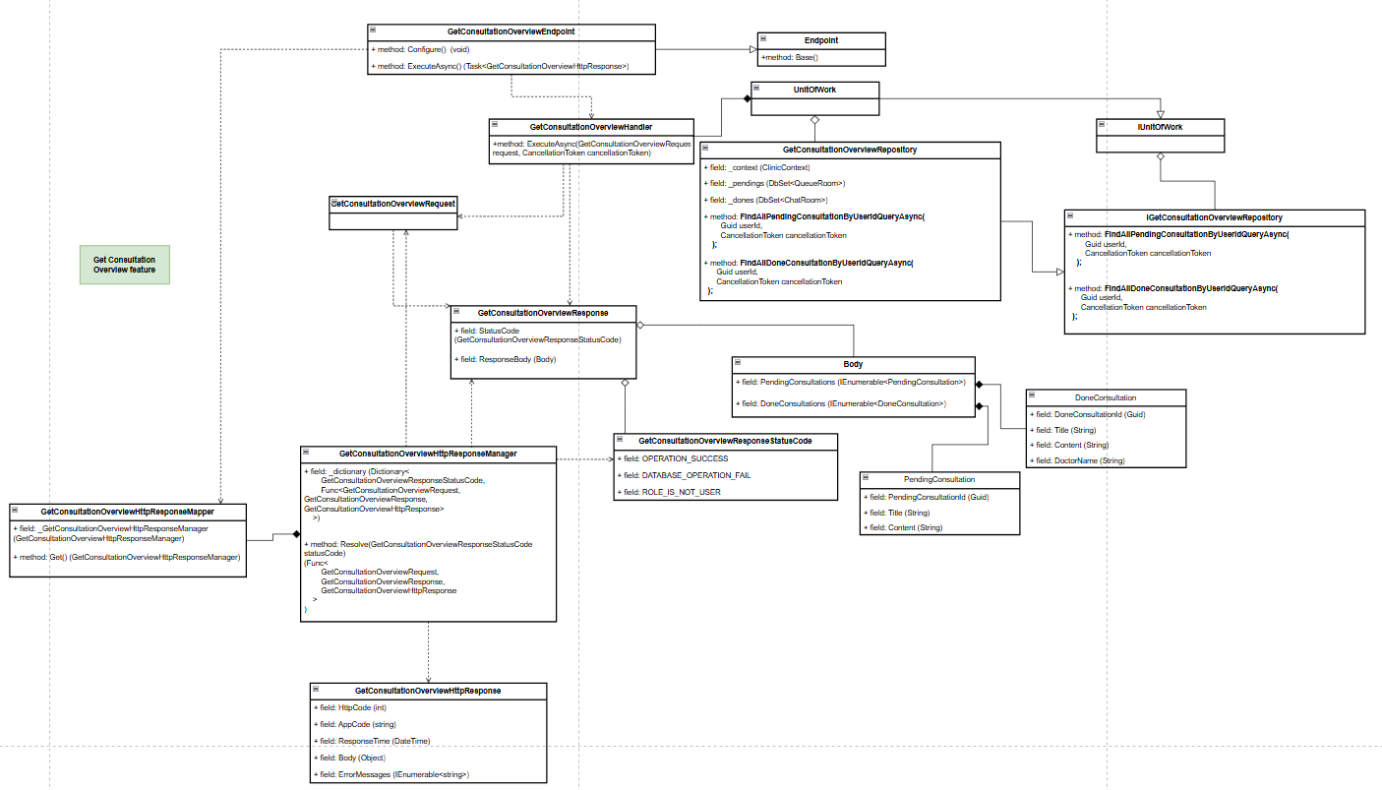

#### b. Class Specifications

1. ***GetConsultationOverviewEndpoint class***

***a.*** ***Same as common given before,*** [***review here***](https://docs.google.com/document/d/1tTZUy0kDp6tdHb6MY85cNBVlDSK0k0N9w2NXBLPTu-c/edit?fbclid=IwY2xjawGRuZpleHRuA2FlbQIxMAABHUWj7GBmcsB0TEQOSeFgkcMlTv6kK6aEkUnExmkf0x_20x3n5Tikj9MvPA_aem_7Ik47wBVUygzT8J9mpiG0w#heading=h.m7r87enxie2d)***.***

1. ***Endpoint abstract class***

***a.*** ***Same as common given before,*** [***review here***](https://docs.google.com/document/d/1tTZUy0kDp6tdHb6MY85cNBVlDSK0k0N9w2NXBLPTu-c/edit?fbclid=IwY2xjawGRuZpleHRuA2FlbQIxMAABHUWj7GBmcsB0TEQOSeFgkcMlTv6kK6aEkUnExmkf0x_20x3n5Tikj9MvPA_aem_7Ik47wBVUygzT8J9mpiG0w#heading=h.ac857vak9ccs)***.***

1. ***GetConsultationOverviewValidator class***

***a.*** ***Same as common given before,*** [***review here***](https://docs.google.com/document/d/1tTZUy0kDp6tdHb6MY85cNBVlDSK0k0N9w2NXBLPTu-c/edit?fbclid=IwY2xjawGRuZpleHRuA2FlbQIxMAABHUWj7GBmcsB0TEQOSeFgkcMlTv6kK6aEkUnExmkf0x_20x3n5Tikj9MvPA_aem_7Ik47wBVUygzT8J9mpiG0w#heading=h.mapewhyr52db)***.***

1. ***GetConsultationOverviewHandler class***

***a.*** ***Same as common given before,*** [***review here***](https://docs.google.com/document/d/1tTZUy0kDp6tdHb6MY85cNBVlDSK0k0N9w2NXBLPTu-c/edit?fbclid=IwY2xjawGRuZpleHRuA2FlbQIxMAABHUWj7GBmcsB0TEQOSeFgkcMlTv6kK6aEkUnExmkf0x_20x3n5Tikj9MvPA_aem_7Ik47wBVUygzT8J9mpiG0w#heading=h.3lfr3mcrnl8j)***.***

1. ***IUnitOfWork interface***

***a.*** ***Same as common given before,*** [***review here***](https://docs.google.com/document/d/1tTZUy0kDp6tdHb6MY85cNBVlDSK0k0N9w2NXBLPTu-c/edit?fbclid=IwY2xjawGRuZpleHRuA2FlbQIxMAABHUWj7GBmcsB0TEQOSeFgkcMlTv6kK6aEkUnExmkf0x_20x3n5Tikj9MvPA_aem_7Ik47wBVUygzT8J9mpiG0w#heading=h.plvhy3azezgm)***.***

1. ***UnitOfWork class***

***a.*** ***Same as common given before,*** [***review here***](https://docs.google.com/document/d/1tTZUy0kDp6tdHb6MY85cNBVlDSK0k0N9w2NXBLPTu-c/edit?fbclid=IwY2xjawGRuZpleHRuA2FlbQIxMAABHUWj7GBmcsB0TEQOSeFgkcMlTv6kK6aEkUnExmkf0x_20x3n5Tikj9MvPA_aem_7Ik47wBVUygzT8J9mpiG0w#heading=h.75tksa2v2ybj)***.***

1. ***GetConsultationOverviewRequest class***

| ***No*** | ***Fields*** | ***Description*** |
| --- | --- | --- |
| ***Empty request*** | | |

***8.*** ***GetConsultationOverviewResponse class***

| ***No*** | ***Fields*** | ***Description*** |
| --- | --- | --- |
| ***01*** | ***StatusCode*** | ***This field will return an app code and http code.*** |
| ***02*** | ***ResponseBody*** | ***Contains the main data body of the response*** |

***9.*** ***Body class***

| ***No*** | ***Fields*** | ***Description*** |
| --- | --- | --- |
| ***01*** | ***PendingConsultations*** | ***A collection of pending consultations, each containing a PendingConsultation object.*** |
| ***02*** | ***DoneConsultations*** | ***A collection of done consultations, each containing a DoneConsultation object.*** |

***10.*** ***PendingConsultation class***

| ***No*** | ***Fields*** | ***Description*** |
| --- | --- | --- |
| ***01*** | ***PendingConsultationId*** | ***Unique identifier for the pending consultation.*** |
| ***02*** | ***Title*** | ***Title or brief description of the pending consultation.*** |
| ***03*** | ***Content*** | ***Detailed content or notes regarding the pending consultation.*** |

***11.*** ***DoneConsultation Class***

| ***No*** | ***Fields*** | ***Description*** |
| --- | --- | --- |
| ***01*** | ***DoneConsultationId*** | ***Unique identifier for the completed consultation.*** |
| ***02*** | ***DoctorName*** | ***Name of the doctor who handled the consultation.*** |
| ***03*** | ***Title*** | ***Title or brief description of the completed consultation.*** |
| ***04*** | ***Content*** | ***Detailed content or notes regarding the completed consultation.*** |

***12.*** ***GetConsultationOverviewResponseStatusCode Enum class***

***This enum class contains some necessary app code like OPERATION_SUCCESS, DATABASE_OPERATION_FAIL, ROLE_IS_NOT_USER,.... Purpose to handle response with specifically code of errors.***

***13.*** ***IGetConsultationOverviewRepository interface***

***This interface class contains method to interact with database***

| ***No*** | ***Method*** | ***Description*** |
| --- | --- | --- |
| ***01*** | ***public async Task<IEnumerable<QueueRoom>> FindAllPendingConsultationByUserIdQueryAsync(***  *Guid userId,*  *CancellationToken cancellationToken*  ***)*** | ***Defines a method to retrieve all pending consultations for a specific user, based on the userId.*** |
| ***02*** | ***public async Task<IEnumerable<ChatRoom>> FindAllDoneConsultationByUserIdQueryAsync(***  *Guid userId,*  *CancellationToken cancellationToken*  ***)*** | ***Defines a method to retrieve all completed (done) consultations for a specific user, based on the userId.*** |

***14.*** ***GetConsultationOverviewRepository***

***This class is an implementation of the ICreateScheduleRepository interface.***

| ***No*** | ***Fields*** | ***Description*** |
| --- | --- | --- |
| ***01*** | ***_context*** | ***This field is database context*** |
| ***02*** | ***_pendings*** | ***Property to interact with the QueueRoom table, which holds pending consultations.*** |
| ***03*** | ***_dones*** | ***Property to interact with the ChatRoom table, which holds completed consultations.*** |

| ***No*** | ***Method*** | ***Description*** |
| --- | --- | --- |
| ***01*** | ***public async Task<IEnumerable<QueueRoom>> FindAllPendingConsultationByUserIdQueryAsync(***  *Guid userId,*  *CancellationToken cancellationToken*  ***)*** | ***Queries the database to return all pending consultations for a specific user. This is done by filtering the QueueRoom table based on the userId.*** |
| ***02*** | ***public async Task<IEnumerable<ChatRoom>> FindAllDoneConsultationByUserIdQueryAsync(***  *Guid userId,*  *CancellationToken cancellationToken*  ***)*** | ***Queries the database to return all completed consultations for a specific user. This is done by filtering the ChatRoom table based on the userId.*** |

#### c. Sequence Diagram(s)

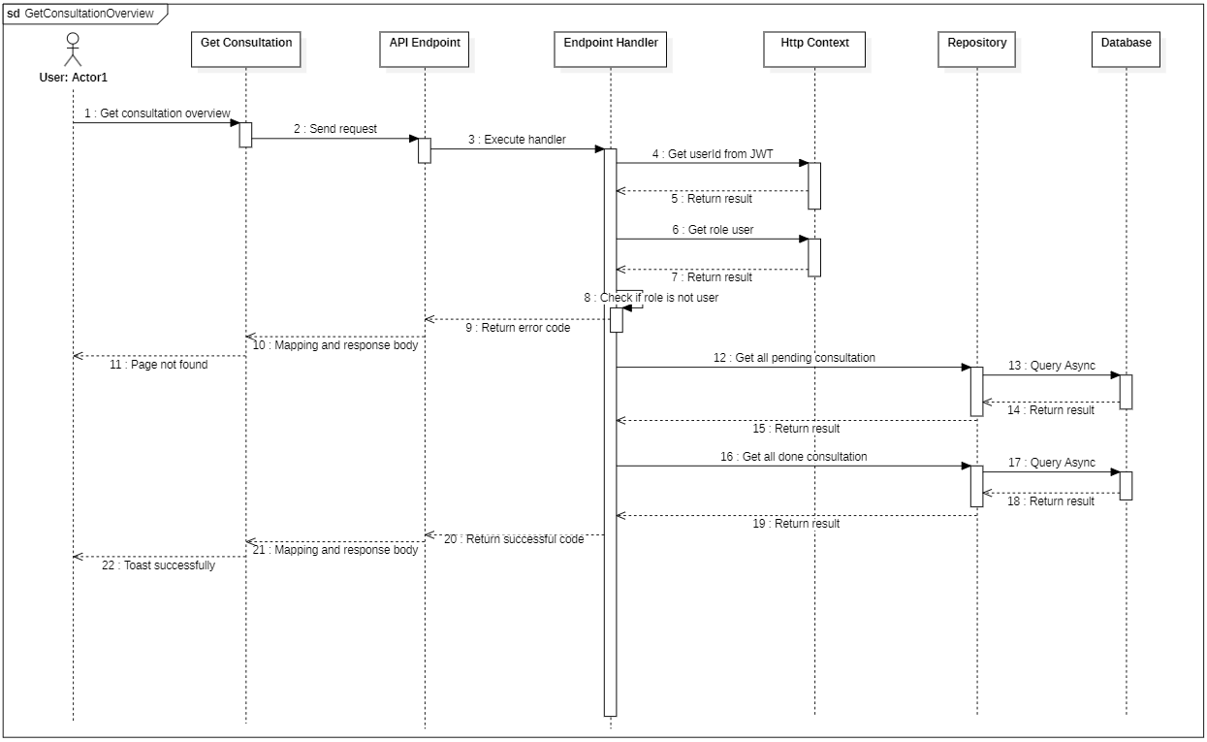

#### d. Database Queries

**public async Task<IEnumerable<QueueRoom>> FindAllPendingConsultationByUserIdQueryAsync(**

**Guid userId,**

**CancellationToken cancellationToken**

**)**

{

return await _pendings

.Where(queue => queue.PatientId == userId)

.Select(queue => new QueueRoom()

{

Id = queue.Id,

Title = queue.Title,

Message = queue.Message,

})

.ToListAsync(cancellationToken: cancellationToken);

}

**public async Task<IEnumerable<ChatRoom>> FindAllDoneConsultationByUserIdQueryAsync(**

**Guid userId,**

**CancellationToken cancellationToken**

**)**

{

return await

_dones

.Where(done => done.PatientId == userId)

.Select(done => new ChatRoom()

{

Id= done.Id,

LastMessage = done.LastMessage,

Doctor = new Domain.Commons.Entities.Doctor()

{

User = new User()

{

FullName = done.Doctor.User.FullName,

}

}

})

.ToListAsync(cancellationToken: cancellationToken);

}

## 4. Doctor

### 4.1. Get Doctor Profile

#### a. Class diagram

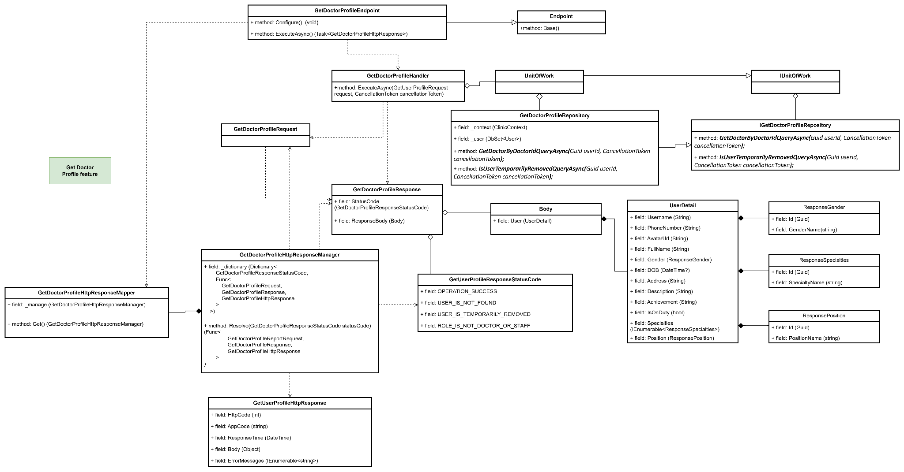

#### b. Class Specifications

1. ***GetDoctorProfileEndpoint class***

*Same as common given before,* [*review here*](https://docs.google.com/document/d/1tTZUy0kDp6tdHb6MY85cNBVlDSK0k0N9w2NXBLPTu-c/edit?fbclid=IwY2xjawGRuZpleHRuA2FlbQIxMAABHUWj7GBmcsB0TEQOSeFgkcMlTv6kK6aEkUnExmkf0x_20x3n5Tikj9MvPA_aem_7Ik47wBVUygzT8J9mpiG0w#heading=h.m7r87enxie2d)*.*

1. ***Endpoint abstract class***

*Same as common given before,* [*review here*](https://docs.google.com/document/d/1tTZUy0kDp6tdHb6MY85cNBVlDSK0k0N9w2NXBLPTu-c/edit?fbclid=IwY2xjawGRuZpleHRuA2FlbQIxMAABHUWj7GBmcsB0TEQOSeFgkcMlTv6kK6aEkUnExmkf0x_20x3n5Tikj9MvPA_aem_7Ik47wBVUygzT8J9mpiG0w#heading=h.ac857vak9ccs)*.*

1. ***GetDoctorProfileValidator class***

*Same as common given before,* [*review here*](https://docs.google.com/document/d/1tTZUy0kDp6tdHb6MY85cNBVlDSK0k0N9w2NXBLPTu-c/edit?fbclid=IwY2xjawGRuZpleHRuA2FlbQIxMAABHUWj7GBmcsB0TEQOSeFgkcMlTv6kK6aEkUnExmkf0x_20x3n5Tikj9MvPA_aem_7Ik47wBVUygzT8J9mpiG0w#heading=h.mapewhyr52db)*.*

1. ***GetDoctorProfileHandler class***

*Same as common given before,* [*review here*](https://docs.google.com/document/d/1tTZUy0kDp6tdHb6MY85cNBVlDSK0k0N9w2NXBLPTu-c/edit?fbclid=IwY2xjawGRuZpleHRuA2FlbQIxMAABHUWj7GBmcsB0TEQOSeFgkcMlTv6kK6aEkUnExmkf0x_20x3n5Tikj9MvPA_aem_7Ik47wBVUygzT8J9mpiG0w#heading=h.3lfr3mcrnl8j)*.*

1. ***IUnitOfWork interface***

*Same as common given before,* [*review here*](https://docs.google.com/document/d/1tTZUy0kDp6tdHb6MY85cNBVlDSK0k0N9w2NXBLPTu-c/edit?fbclid=IwY2xjawGRuZpleHRuA2FlbQIxMAABHUWj7GBmcsB0TEQOSeFgkcMlTv6kK6aEkUnExmkf0x_20x3n5Tikj9MvPA_aem_7Ik47wBVUygzT8J9mpiG0w#heading=h.plvhy3azezgm)*.*

1. ***UnitOfWork class***

*Same as common given before,* [*review here*](https://docs.google.com/document/d/1tTZUy0kDp6tdHb6MY85cNBVlDSK0k0N9w2NXBLPTu-c/edit?fbclid=IwY2xjawGRuZpleHRuA2FlbQIxMAABHUWj7GBmcsB0TEQOSeFgkcMlTv6kK6aEkUnExmkf0x_20x3n5Tikj9MvPA_aem_7Ik47wBVUygzT8J9mpiG0w#heading=h.75tksa2v2ybj)*.*

1. ***GetDoctorProfileRequest class***

| **No** | **Fields** | **Description** |
| --- | --- | --- |
| *Empty request* | | |

1. ***GetDoctorProfileResponse class***

| **No** | **Fields** | **Description** |
| --- | --- | --- |
| *01* | *StatusCode* | *This field will return an app code and http code.* |
| *02* | *Username* | *This field will return username of user’s account* |
| *03* | *PhoneNumber* | *This field will return phone number of user* |
| *04* | *AvatarUrl* | *This field will return avatar url of user* |
| *05* | *FullName* | *This field will return phone number of user* |
| *06* | *Gender* | *This field will return gender of user* |
| *07* | *DOB* | *This field will return date of birth of user* |
| *08* | *Address* | *This field will return address of user* |
| *09* | *Description* | *This field will return description of user* |
| *10* | *Achievement* | *This field will return achievement of user* |
| *11* | *IsOnDuty* | *This field will return status in on duty of user* |
| *12* | *Specialties* | *This field will return list of specialty of user* |
| *13* | *Position* | *This field will return position of user* |

1. ***GetDoctorProfileResponseStatusCode Enum class***

This enum class contains some necessary app code like USER_IS_NOT_FOUND,, USER_IS_TEMPORARILY_REMOVED, OPERATION_SUCCESS,.... Purpose to handle response with specifically code of errors.

1. ***IGetDoctorProfileRepository interface***

This interface class contains method to interact with database

| **No** | **Method** | **Description** |
| --- | --- | --- |
| *01* | ***GetDoctorByDoctorIdQueryAsync(****Guid userId, CancellationToken cancellationToken****);*** | *Defines a method to get user by id* |
| *02* | ***IsUserTemporarilyRemovedQueryAsync(****Guid userId, CancellationToken cancellationToken****);*** | *Defines a method to check the user account is removed or not* |

1. ***GetDoctorProfileRepository***

This class is an implementation of the *IGetDoctorProfileRepository* interface***.***

| **No** | **Fields** | **Description** |
| --- | --- | --- |
| *01* | *_context* | *This field is database context* |
| *02* | *_users* | *Property to interact with the Users table in the database* |

| **No** | **Method** | **Description** |
| --- | --- | --- |
| *01* | ***GetDoctorByDoctorIdQueryAsync(****Guid userId, CancellationToken cancellationToken****);*** | *Execute statements that interact with the database and return the desired value* |
| *02* | ***IsUserTemporarilyRemovedQueryAsync(****Guid userId, CancellationToken cancellationToken****);*** | *Execute statements that interact with the database and return the desired value* |

#### c. Sequence Diagram(s)

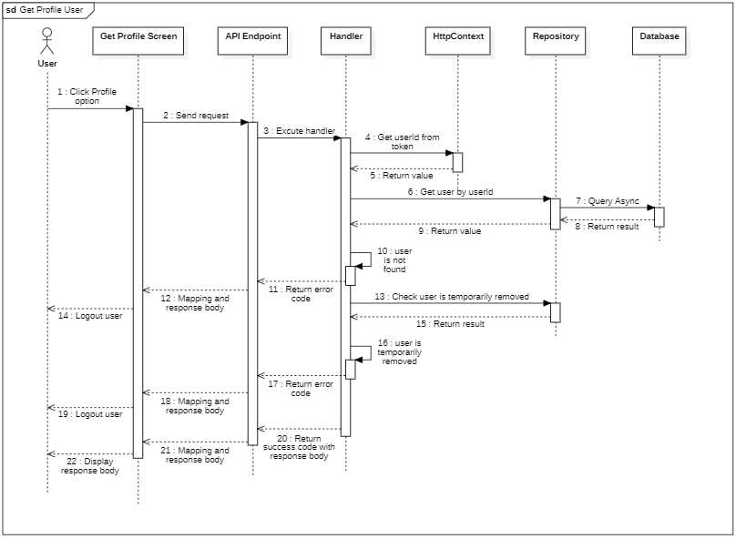

#### d. Database Queries

**public Task<User> GetDoctorByDoctorIdQueryAsync**(

Guid userId,

CancellationToken cancellationToken

)

{

return _users

.AsNoTracking()

.Where(predicate: user => user.Id == userId)

.Select(selector: user => new User()

{

UserName = user.UserName,

FullName = user.FullName,

PhoneNumber = user.PhoneNumber,

Avatar = user.Avatar,

Gender = new()

{

Name = user.Gender.Name,

Constant = user.Gender.Constant,

Id = user.Gender.Id,

},

Doctor = new()

{

DOB = user.Doctor.DOB,

Description = user.Doctor.Description,

Position = new()

{

Name = user.Doctor.Position.Name,

Constant = user.Doctor.Position.Constant,

Id = user.Doctor.Position.Id,

},

DoctorSpecialties = user

.Doctor.DoctorSpecialties.Select(doctorSpecialty => new DoctorSpecialty()

{

Specialty = new()

{

Constant = doctorSpecialty.Specialty.Constant,

Name = doctorSpecialty.Specialty.Name,

Id = doctorSpecialty.Specialty.Id,

},

})

.ToList(),

Address = user.Doctor.Address,

Achievement = user.Doctor.Achievement,

IsOnDuty = user.Doctor.IsOnDuty

},

})

.FirstOrDefaultAsync(cancellationToken: cancellationToken);

}

**public Task<bool> IsUserTemporarilyRemovedQueryAsync**(

Guid userId,

CancellationToken cancellationToken

)

{

return _users.AnyAsync(

predicate: entity =>

entity.Id == userId && entity.RemovedAt != CommonConstant.MIN_DATE_TIME,

cancellationToken: cancellationToken

);

}

### 4.2. Update Doctor Profile

#### a. Class diagram

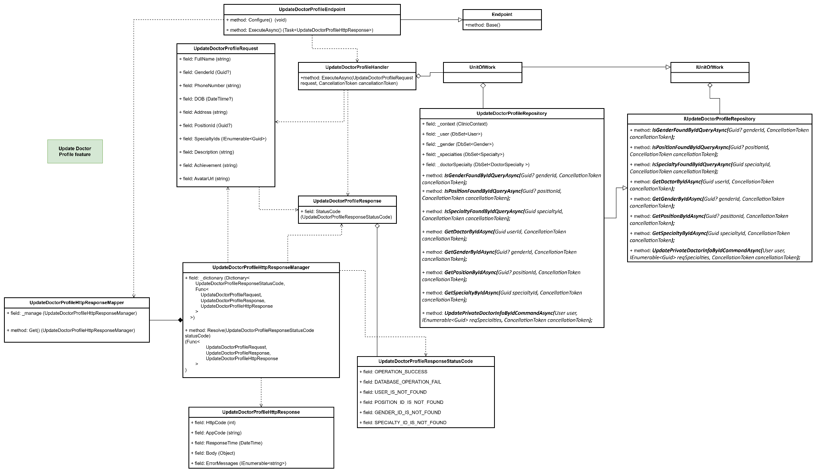

#### b. Class Specifications

#### UpdateDoctorProfileEndpoint class

* 1. *Same as common given before,* [*review here*](https://docs.google.com/document/d/1tTZUy0kDp6tdHb6MY85cNBVlDSK0k0N9w2NXBLPTu-c/edit?fbclid=IwY2xjawGRuZpleHRuA2FlbQIxMAABHUWj7GBmcsB0TEQOSeFgkcMlTv6kK6aEkUnExmkf0x_20x3n5Tikj9MvPA_aem_7Ik47wBVUygzT8J9mpiG0w#heading=h.m7r87enxie2d)*.*

1. ***Endpoint abstract class***
   1. *Same as common given before,* [*review here*](https://docs.google.com/document/d/1tTZUy0kDp6tdHb6MY85cNBVlDSK0k0N9w2NXBLPTu-c/edit?fbclid=IwY2xjawGRuZpleHRuA2FlbQIxMAABHUWj7GBmcsB0TEQOSeFgkcMlTv6kK6aEkUnExmkf0x_20x3n5Tikj9MvPA_aem_7Ik47wBVUygzT8J9mpiG0w#heading=h.ac857vak9ccs)*.*
2. ***UpdateDoctorValidator class***
   1. *Same as common given before,* [*review here*](https://docs.google.com/document/d/1tTZUy0kDp6tdHb6MY85cNBVlDSK0k0N9w2NXBLPTu-c/edit?fbclid=IwY2xjawGRuZpleHRuA2FlbQIxMAABHUWj7GBmcsB0TEQOSeFgkcMlTv6kK6aEkUnExmkf0x_20x3n5Tikj9MvPA_aem_7Ik47wBVUygzT8J9mpiG0w#heading=h.mapewhyr52db)*.*
3. ***UpdateDoctorProfileHandler class***
   1. *Same as common given before,* [*review here*](https://docs.google.com/document/d/1tTZUy0kDp6tdHb6MY85cNBVlDSK0k0N9w2NXBLPTu-c/edit?fbclid=IwY2xjawGRuZpleHRuA2FlbQIxMAABHUWj7GBmcsB0TEQOSeFgkcMlTv6kK6aEkUnExmkf0x_20x3n5Tikj9MvPA_aem_7Ik47wBVUygzT8J9mpiG0w#heading=h.3lfr3mcrnl8j)*.*
4. ***IUnitOfWork interface***
   1. *Same as common given before,* [*review here*](https://docs.google.com/document/d/1tTZUy0kDp6tdHb6MY85cNBVlDSK0k0N9w2NXBLPTu-c/edit?fbclid=IwY2xjawGRuZpleHRuA2FlbQIxMAABHUWj7GBmcsB0TEQOSeFgkcMlTv6kK6aEkUnExmkf0x_20x3n5Tikj9MvPA_aem_7Ik47wBVUygzT8J9mpiG0w#heading=h.plvhy3azezgm)*.*
5. ***UnitOfWork class***
   1. *Same as common given before,* [*review here*](https://docs.google.com/document/d/1tTZUy0kDp6tdHb6MY85cNBVlDSK0k0N9w2NXBLPTu-c/edit?fbclid=IwY2xjawGRuZpleHRuA2FlbQIxMAABHUWj7GBmcsB0TEQOSeFgkcMlTv6kK6aEkUnExmkf0x_20x3n5Tikj9MvPA_aem_7Ik47wBVUygzT8J9mpiG0w#heading=h.75tksa2v2ybj)*.*
6. ***UpdateDoctorProfileRequest class***

| **No** | **Fields** | **Description** |
| --- | --- | --- |
| *01* | *FullName* | *This field required user to enter their full name* |
| *02* | *GenderId* | *This field required user to choose their gender* |
| *03* | *PhoneNumber* | *This field required user to enter their phone number* |
| *04* | *DOB* | *This field required user to enter their date of birth* |
| *05* | *Address* | *This field required user to enter their address* |
| *06* | *PositionId* | *This field required user to choose their position* |
| *07* | *SpecialtyIds* | *This field required user to enter their specialties* |
| *08* | *Description* | *This field required user to enter their description* |
| *09* | *Achievement* | *This field required user to enter their achievement* |
| *10* | *Avatar Url* | *This field required user to choose their avatar* |

1. ***UpdateDoctorProfileResponse class***

| **No** | **Fields** | **Description** |
| --- | --- | --- |
| *01* | *StatusCode* | *This field will return an app code and http code.* |

1. ***UpdateDoctorProfileResponseStatusCode Enum class***

This enum class contains some necessary app code like USER_IS_NOT_FOUND, USER_IS_TEMPORARILY_REMOVED, OPERATION_SUCCESS, DATABASE_OPERATION_FAIL, GENDER_ID_IS_NOT_FOUND, POSITION_ID_IS_NOT_FOUND, SPECIALTY_ID_IS_NOT_FOUND

.... Purpose to handle response with specifically code of errors.

1. ***IUpdateDoctorProfileRepository interface***

This interface class contains method to interact with database

| **No** | **Method** | **Description** |
| --- | --- | --- |
| *01* | ***IsGenderFoundByIdQueryAsync(****Guid? genderId, CancellationToken cancellationToken****);*** | *Defines a method to check the gender id is exist or not* |
| *02* | ***IsPositionFoundByIdQueryAsync(****Guid? positionId, CancellationToken cancellationToken****);*** | *Defines a method to check the position id is exist or not* |
| *03* | ***IsSpecialtyFoundByIdQueryAsync(****Guid specialtyId, CancellationToken cancellationToken****);*** | *Defines a method to check the specialty id is exist or not* |
| *04* | ***GetDoctorByIdAsync(****Guid userId, CancellationToken cancellationToken****);*** | *Defines a method to get the doctor by id* |
| *05* | ***GetGenderByIdAsync(****Guid? genderId, CancellationToken cancellationToken****);*** | *Defines a method to get the gender by id* |
| *06* | ***GetPositionByIdAsync(****Guid? positionId, CancellationToken cancellationToken****);*** | *Defines a method to get the position by id* |
| *07* | ***GetSpecialtyByIdAsync(****Guid specialtyId, CancellationToken cancellationToken****);*** | *Defines a method to get the specialty by id* |
| *08* | ***UpdatePrivateDoctorInfoByIdCommandAsync(****User user, IEnumerable<Guid> reqSpecialties, CancellationToken cancellationToken****);*** | *Defines a method to update the user profile* |

1. ***UpdateDoctorProfileRepository***

This class is an implementation of the *IUpdateDoctorProfileRepository* interface***.***

| **No** | **Fields** | **Description** |
| --- | --- | --- |
| *01* | *_context* | *This field is database context* |
| *02* | *_users* | *Field to interact with the Users table in the database* |
| *03* | *_genders* | *Field to interact with the Genders table in the database* |
| *04* | *_positions* | *Field to interact with the Positions table in the database* |
| *05* | *_specialties* | *Field to interact with the Specialties table in the database* |
| *06* | *_doctorSpecialty* | *Field to interact with the DoctorSpecialty table in the database* |

| **No** | **Method** | **Description** |
| --- | --- | --- |
| *01* | ***IsGenderFoundByIdQueryAsync(****Guid? genderId, CancellationToken cancellationToken****);*** | *Execute statements that interact with the database and return the desired value* |
| *02* | ***IsPositionFoundByIdQueryAsync(****Guid? positionId, CancellationToken cancellationToken****);*** | *Execute statements that interact with the database and return the desired value* |
| *03* | ***IsSpecialtyFoundByIdQueryAsync(****Guid specialtyId, CancellationToken cancellationToken****);*** | *Execute statements that interact with the database and return the desired value* |
| *04* | ***GetDoctorByIdAsync(****Guid userId, CancellationToken cancellationToken****);*** | *Execute statements that interact with the database and return the desired value* |
| *05* | ***GetGenderByIdAsync(****Guid? genderId, CancellationToken cancellationToken****);*** | *Execute statements that interact with the database and return the desired value* |
| *06* | ***GetPositionByIdAsync(****Guid? positionId, CancellationToken cancellationToken****);*** | *Execute statements that interact with the database and return the desired value* |
| *07* | ***GetSpecialtyByIdAsync(****Guid specialtyId, CancellationToken cancellationToken****);*** | *Execute statements that interact with the database and return the desired value* |
| *08* | ***UpdatePrivateDoctorInfoByIdCommandAsync(****User user, IEnumerable<Guid> reqSpecialties, CancellationToken cancellationToken****);*** | *Execute statements that interact with the database and return the desired value* |

#### c. Sequence Diagram(s)

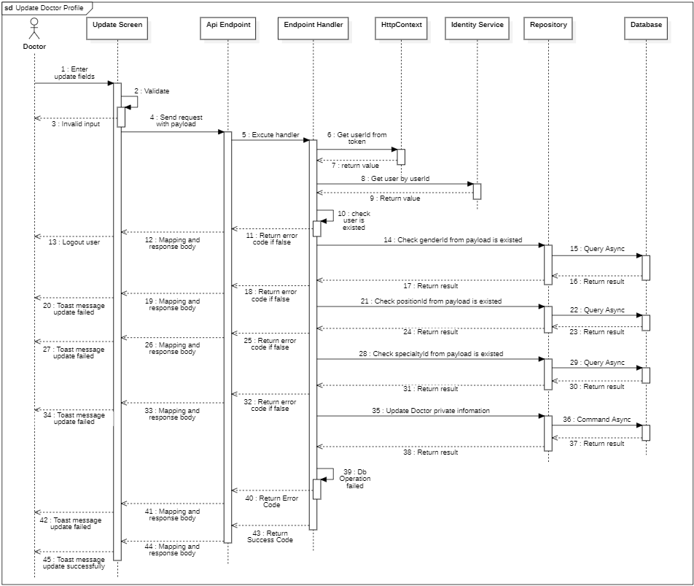

#### d. Database Queries

**public Task<bool>** **IsGenderFoundByIdQueryAsync**(

Guid? genderId,

CancellationToken cancellationToken

)

{

return _genders.AnyAsync(

predicate: entity => entity.Id == genderId,

cancellationToken: cancellationToken

);

}

**public Task<bool>** **IsPositionFoundByIdQueryAsync**(

Guid? positionId,

CancellationToken cancellationToken

)

{

return _positions.AnyAsync(

predicate: entity => entity.Id == positionId,

cancellationToken: cancellationToken

);

}

**public Task<bool>** **IsSpecialtyFoundByIdQueryAsync**(

Guid specialtyId,

CancellationToken cancellationToken

)

{

return _specialties.AnyAsync(

predicate: entity => entity.Id == specialtyId,

cancellationToken: cancellationToken

);

}

**public async Task<Gender>** **GetGenderByIdAsync**(

Guid? genderId,

CancellationToken cancellationToken

)

{

return await _genders

.Where(gender => gender.Id == genderId)

.FirstOrDefaultAsync(cancellationToken);

}

**public async Task<Position>** **GetPositionByIdAsync**(

Guid? positionId,

CancellationToken cancellationToken

)

{

return await _positions

.Where(position => position.Id == positionId)

.FirstOrDefaultAsync(cancellationToken);

}

**public async Task<Specialty>** **GetSpecialtyByIdAsync**(

Guid specialtyId,

CancellationToken cancellationToken

)

{

return await _specialties

.Where(specialty => specialty.Id == specialtyId)

.FirstOrDefaultAsync(cancellationToken);

}

**public async Task<User>** **GetDoctorByIdAsync**(Guid userId, CancellationToken cancellationToken)

{

return await _users

.Include(u => u.Doctor)

.ThenInclude(doctor => doctor.DoctorSpecialties)

.ThenInclude(specicalty => specicalty.Specialty)

.AsSplitQuery()

.FirstOrDefaultAsync(u => u.Id == userId, cancellationToken);

}

**public async Task<bool>** **UpdatePrivateDoctorInfoByIdCommandAsync**(

User user,

IEnumerable<Guid> reqSpecialties,

CancellationToken cancellationToken

)

{

if (!Equals(user.Doctor, null))

{

var doctorSpecialties = user.Doctor.DoctorSpecialties;

var existingSpecialties = doctorSpecialties.Select(ds => ds.SpecialtyID).ToList();

var specialtiesToRemove = doctorSpecialties

.Where(ds => !reqSpecialties.Contains(ds.SpecialtyID))

.ToList();

_doctorSpecialty.RemoveRange(specialtiesToRemove);

var specialtiesToAdd = reqSpecialties

.Where(id => !existingSpecialties.Contains(id))

.Select(id => new DoctorSpecialty { DoctorId = user.Id, SpecialtyID = id })

.ToList();

await _doctorSpecialty.AddRangeAsync(specialtiesToAdd, cancellationToken);

}

_context.Users.Update(user);

return await _context.SaveChangesAsync(cancellationToken) > 0;

}

### 4.3. Get all medical report

#### a. Class diagram

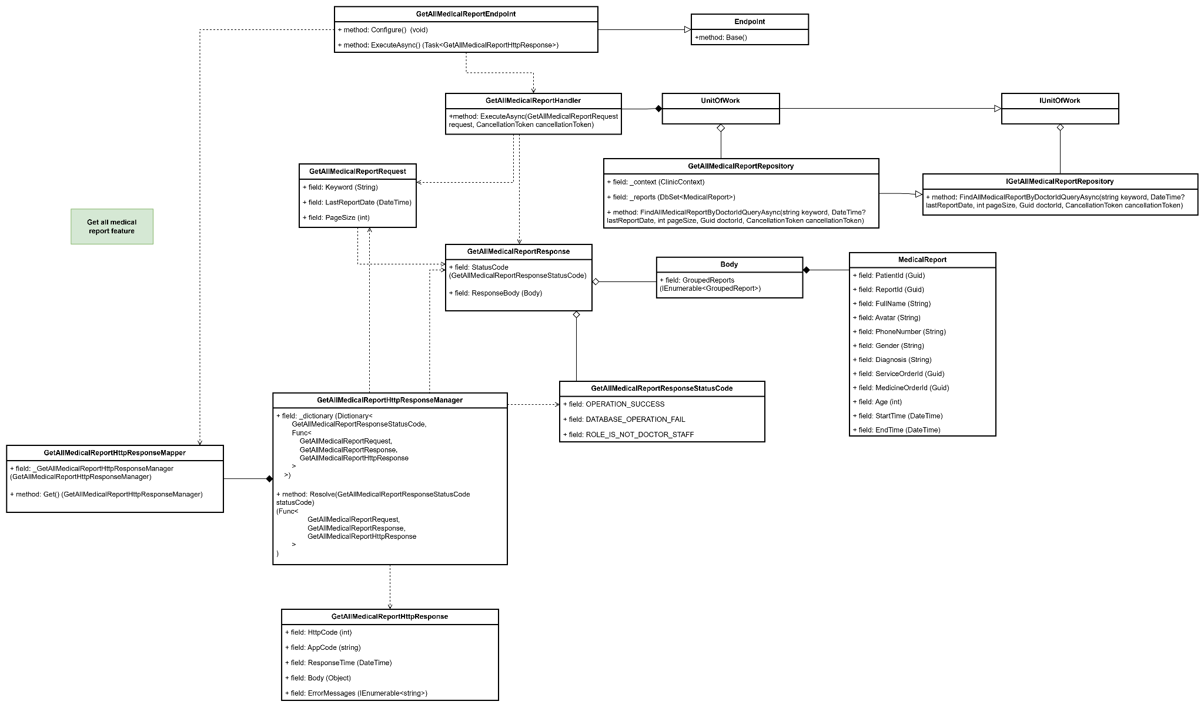

#### b. Class Specifications

#### GetAllMedicalReportEndpoint class

* 1. *Same as common given before,* [*review here*](https://docs.google.com/document/d/1tTZUy0kDp6tdHb6MY85cNBVlDSK0k0N9w2NXBLPTu-c/edit?fbclid=IwY2xjawGRuZpleHRuA2FlbQIxMAABHUWj7GBmcsB0TEQOSeFgkcMlTv6kK6aEkUnExmkf0x_20x3n5Tikj9MvPA_aem_7Ik47wBVUygzT8J9mpiG0w#heading=h.m7r87enxie2d)*.*

1. ***Endpoint abstract class***
   1. *Same as common given before,* [*review here*](https://docs.google.com/document/d/1tTZUy0kDp6tdHb6MY85cNBVlDSK0k0N9w2NXBLPTu-c/edit?fbclid=IwY2xjawGRuZpleHRuA2FlbQIxMAABHUWj7GBmcsB0TEQOSeFgkcMlTv6kK6aEkUnExmkf0x_20x3n5Tikj9MvPA_aem_7Ik47wBVUygzT8J9mpiG0w#heading=h.ac857vak9ccs)*.*
2. ***GetAllMedicalReportHandler class***
   1. *Same as common given before,* [*review here*](https://docs.google.com/document/d/1tTZUy0kDp6tdHb6MY85cNBVlDSK0k0N9w2NXBLPTu-c/edit?fbclid=IwY2xjawGRuZpleHRuA2FlbQIxMAABHUWj7GBmcsB0TEQOSeFgkcMlTv6kK6aEkUnExmkf0x_20x3n5Tikj9MvPA_aem_7Ik47wBVUygzT8J9mpiG0w#heading=h.3lfr3mcrnl8j)*.*
3. ***IUnitOfWork interface***
   1. *Same as common given before,* [*review here*](https://docs.google.com/document/d/1tTZUy0kDp6tdHb6MY85cNBVlDSK0k0N9w2NXBLPTu-c/edit?fbclid=IwY2xjawGRuZpleHRuA2FlbQIxMAABHUWj7GBmcsB0TEQOSeFgkcMlTv6kK6aEkUnExmkf0x_20x3n5Tikj9MvPA_aem_7Ik47wBVUygzT8J9mpiG0w#heading=h.plvhy3azezgm)*.*
4. ***UnitOfWork class***

*Same as common given before,* [*review here*](https://docs.google.com/document/d/1tTZUy0kDp6tdHb6MY85cNBVlDSK0k0N9w2NXBLPTu-c/edit?fbclid=IwY2xjawGRuZpleHRuA2FlbQIxMAABHUWj7GBmcsB0TEQOSeFgkcMlTv6kK6aEkUnExmkf0x_20x3n5Tikj9MvPA_aem_7Ik47wBVUygzT8J9mpiG0w#heading=h.75tksa2v2ybj)*.*

1. ***GetAllMedicalReportRequest class***

| **No** | **Fields** | **Description** |
| --- | --- | --- |
| *01* | *Keyword* | *This property represents a search keyword that can be used to filter or search for specific data. The BindFrom attribute maps this property to the "keyword" query parameter, allowing the system to retrieve the value directly from a request. It is optional, as indicated by the nullable type string?.* |
| *02* | *PageSize* | *This property defines the number of records per page in a paginated response, with a default value of 2. It helps control the number of items retrieved in a single request, improving data handling and performance.* |
| *03* | *LastReportDate* | *This property represents the date of the most recent report to filter records based on report timing. The BindFrom attribute maps it to the "lastReportDate" query parameter, allowing requests to specify this date for filtering. It is also optional, as shown by the nullable type DateTime?.* |

1. ***GetAllMedicalReportResponse class***

| **No** | **Fields** | **Description** |
| --- | --- | --- |
| *01* | *StatusCode* | *This field will return an app code and http code.* |
| *02* | *ResponseBody* | *Contains the response data for the request. The Body type holds the details of the medical report data being returned, encapsulating information relevant to the request's result.* |

1. ***Body class***

| **No** | **Fields** | **Description** |
| --- | --- | --- |
| *01* | *GroupedReports* | *Represents a collection of grouped medical reports. Each item in this collection is of type GroupedReport, which likely contains details of medical reports organized based on specific criteria (e.g., by date, patient, or diagnosis type).* |

1. ***GroupedReport class***

| **No** | **Fields** | **Description** |
| --- | --- | --- |
| *01* | *MedicalReports* | *Represents a collection of medical reports for a specific grouping, such as by date or patient. Each item in this collection is a MedicalReport object, containing detailed information about individual medical reports. This property allows easy access to multiple reports in a structured format, facilitating batch processing or display.* |
| *02* | *DayOfDate* | *Represents the specific date associated with the collection of medical reports.* |

1. ***MedicalReport class***

| **No** | **Fields** | **Description** |
| --- | --- | --- |
| *01* | *FullName* | *Contains the full name of the patient, including first, middle, and last names, to identify the patient associated with this report.* |
| *02* | *Avatar* | *Holds a URL or file path to the patient’s avatar image, allowing visual identification of the patient.* |
| *03* | *PhoneNumber* | *Contains the contact phone number of the patient for communication.* |
| *04* | *Gender* | *Represents the gender of the patient, typically as a string such as "Male," "Female," or other specified options.* |
| *05* | *StartTime* | *Records the start time of the medical examination or consultation, marking when the patient’s session began.* |
| *06* | *EndTime* | *Records the end time of the medical examination or consultation, indicating when the patient’s session concluded.* |
| *07* | *Age* | *Represents the age of the patient at the time of the report, used for context in diagnosis and treatment.* |
| *08* | *Diagnosis* | *Contains the diagnosis or assessment result of the patient’s condition as determined during the medical examination.* |
| *09* | *ServiceOrderId* | *Represents the unique identifier for the service order associated with this report, linking it to specific medical services provided.* |
| *10* | *MedicineOrderId* | *Represents the unique identifier for the medicine order associated with this report, linking it to prescribed medications.* |

1. ***GetAllMedicalReportResponseStatusCode Enum class***

This enum class contains some necessary app code like OPERATION_SUCCESS, DATABASE_OPERATION_FAIL, ROLE_IS_NOT_DOCTOR_STAFF. Purpose to handle response with specifically code of errors.

1. ***IGetAllMedicalReportRepository interface***

This interface class contains method to interact with database

| **No** | **Method** | **Description** |
| --- | --- | --- |
| *01* | ***FindAllMedicalReportByDoctorIdQueryAsync(***  ***string keyword,***  ***DateTime? lastReportDate,***  ***int pageSize,***  ***Guid doctorId,***  ***CancellationToken cancellationToken)*** | *Defines a method to get all medical reports.* |

1. ***GetAllMedicalReportRepository***

This class is an implementation of the IGetAllMedicalReportRepository interface***.***

| **No** | **Fields** | **Description** |
| --- | --- | --- |
| *01* | *_context* | *This field is database context* |
| *02* | *_reports* | *Field to interact with the MedicalReports table in the database* |

| **No** | **Method** | **Description** |
| --- | --- | --- |
| *01* | ***FindAllMedicalReportByDoctorIdQueryAsync(***  ***string keyword,***  ***DateTime? lastReportDate,***  ***int pageSize,***  ***Guid doctorId,***  ***CancellationToken cancellationToken)*** | *Execute statements that interact with the database and return all medical reports found.* |

#### c. Sequence Diagram(s)

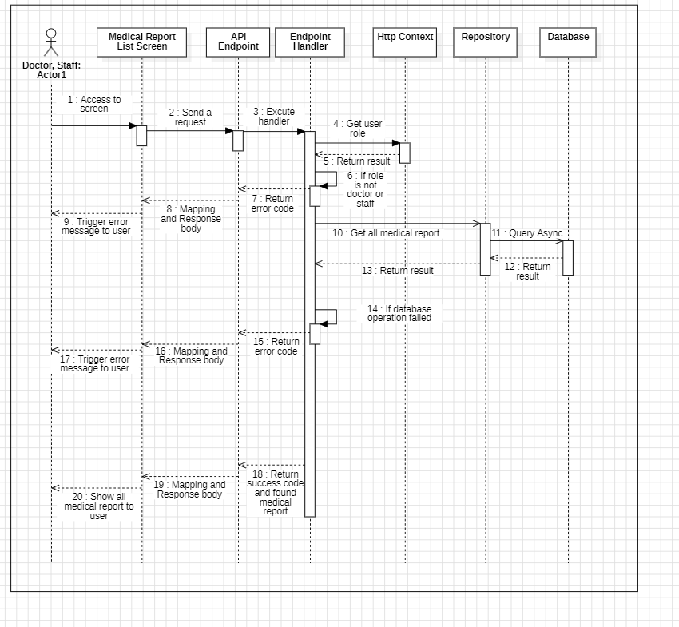

#### d. Database Queries

**public async Task<IEnumerable<MedicalReport>> FindAllMedicalReportByDoctorIdQueryAsync(**

**string keyword,**

**DateTime? lastReportDate,**

**int pageSize,**

**Guid doctorId,**

**CancellationToken cancellationToken**

**)**

{

var latestDateBeforeGivenDate = await _reports

.Where(report =>

report.Appointment.Schedule.Doctor.UserId == doctorId

&& report.Appointment.Schedule.StartDate.Date

< (lastReportDate.HasValue ? lastReportDate.Value.Date : DateTime.Now.Date)

)

.OrderByDescending(report => report.Appointment.Schedule.StartDate)

.Select(report => report.Appointment.Schedule.StartDate.Date)

.FirstOrDefaultAsync(cancellationToken: cancellationToken);

var reportsQuery = _reports.AsQueryable();

if (!string.IsNullOrEmpty(keyword))

{

reportsQuery = reportsQuery.Where(entity =>

entity.PatientInformation.FullName.Contains(keyword)

);

}

reportsQuery = reportsQuery.Where(report =>

report.Appointment.Schedule.Doctor.UserId == doctorId

);

reportsQuery = reportsQuery.Where(report =>

report.Appointment.Schedule.StartDate.Date == latestDateBeforeGivenDate.Date

);

return await reportsQuery

.OrderByDescending(report => report.Appointment.Schedule.StartDate)

.Select(report => new MedicalReport()

{

Id = report.Id,

Diagnosis = report.Diagnosis,

PatientInformation = new PatientInformation()

{

Id = report.PatientInformation.Id,

FullName = report.PatientInformation.FullName,

DOB = report.PatientInformation.DOB,

Gender = report.PatientInformation.Gender,

PhoneNumber = report.PatientInformation.PhoneNumber,

},

Appointment = new Appointment()

{

Schedule = new Schedule()

{

StartDate = report.Appointment.Schedule.StartDate,

EndDate = report.Appointment.Schedule.EndDate,

},

Patient = new Patient()

{

User = new User() { Avatar = report.Appointment.Patient.User.Avatar },

},

},

ServiceOrder = new ServiceOrder()

{

Id = report.ServiceOrder.Id

},

MedicineOrder = new MedicineOrder()

{

Id= report.MedicineOrder.Id

}

})

.Take(pageSize)

.ToListAsync(cancellationToken: cancellationToken);

}

### 4.4. Create retreatment notification

#### a. Class diagram

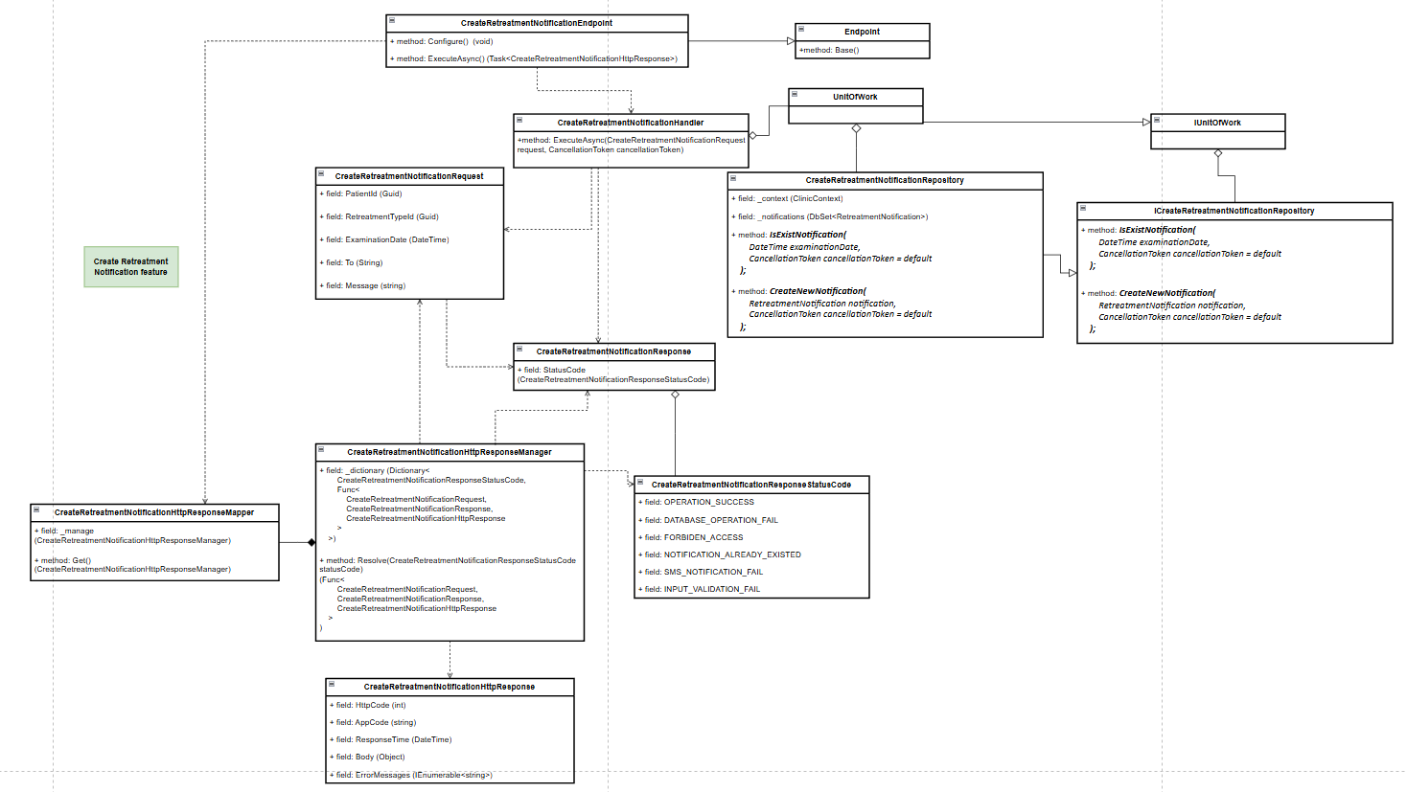

#### b. Class Specifications

***1.*** ***CreateRetreatmentNotificationEndpoint class***

***Same as common given before,*** [***review here***](https://docs.google.com/document/d/1tTZUy0kDp6tdHb6MY85cNBVlDSK0k0N9w2NXBLPTu-c/edit?fbclid=IwY2xjawGRuZpleHRuA2FlbQIxMAABHUWj7GBmcsB0TEQOSeFgkcMlTv6kK6aEkUnExmkf0x_20x3n5Tikj9MvPA_aem_7Ik47wBVUygzT8J9mpiG0w#heading=h.m7r87enxie2d)***.***

***2.*** ***Endpoint abstract class***

***Same as common given before,*** [***review here***](https://docs.google.com/document/d/1tTZUy0kDp6tdHb6MY85cNBVlDSK0k0N9w2NXBLPTu-c/edit?fbclid=IwY2xjawGRuZpleHRuA2FlbQIxMAABHUWj7GBmcsB0TEQOSeFgkcMlTv6kK6aEkUnExmkf0x_20x3n5Tikj9MvPA_aem_7Ik47wBVUygzT8J9mpiG0w#heading=h.ac857vak9ccs)***.***

***3.*** ***CreateRetreatmentNotificationValidator class***

***Same as common given before,*** [***review here***](https://docs.google.com/document/d/1tTZUy0kDp6tdHb6MY85cNBVlDSK0k0N9w2NXBLPTu-c/edit?fbclid=IwY2xjawGRuZpleHRuA2FlbQIxMAABHUWj7GBmcsB0TEQOSeFgkcMlTv6kK6aEkUnExmkf0x_20x3n5Tikj9MvPA_aem_7Ik47wBVUygzT8J9mpiG0w#heading=h.mapewhyr52db)***.***

***4.*** ***CreateRetreatmentNotificationHandler class***

***Same as common given before,*** [***review here***](https://docs.google.com/document/d/1tTZUy0kDp6tdHb6MY85cNBVlDSK0k0N9w2NXBLPTu-c/edit?fbclid=IwY2xjawGRuZpleHRuA2FlbQIxMAABHUWj7GBmcsB0TEQOSeFgkcMlTv6kK6aEkUnExmkf0x_20x3n5Tikj9MvPA_aem_7Ik47wBVUygzT8J9mpiG0w#heading=h.3lfr3mcrnl8j)***.***

***5.*** ***IUnitOfWork interface***

***Same as common given before,*** [***review here***](https://docs.google.com/document/d/1tTZUy0kDp6tdHb6MY85cNBVlDSK0k0N9w2NXBLPTu-c/edit?fbclid=IwY2xjawGRuZpleHRuA2FlbQIxMAABHUWj7GBmcsB0TEQOSeFgkcMlTv6kK6aEkUnExmkf0x_20x3n5Tikj9MvPA_aem_7Ik47wBVUygzT8J9mpiG0w#heading=h.plvhy3azezgm)***.***

***6.*** ***UnitOfWork class***

***Same as common given before,*** [***review here***](https://docs.google.com/document/d/1tTZUy0kDp6tdHb6MY85cNBVlDSK0k0N9w2NXBLPTu-c/edit?fbclid=IwY2xjawGRuZpleHRuA2FlbQIxMAABHUWj7GBmcsB0TEQOSeFgkcMlTv6kK6aEkUnExmkf0x_20x3n5Tikj9MvPA_aem_7Ik47wBVUygzT8J9mpiG0w#heading=h.75tksa2v2ybj)***.***

***7.*** ***CreateRetreatmentNotificationRequest class***

| ***No*** | ***Fields*** | ***Description*** |
| --- | --- | --- |
| ***01*** | ***ExaminationDate*** | ***The date of the scheduled examination for the retreatment. This helps to specify when the follow-up or retreatment session is planned, allowing both patient and healthcare staff to prepare accordingly.*** |
| ***02*** | ***RetreatmentTypeId*** | ***A unique identifier for the specific type of retreatment being requested. This field allows the system to categorize and manage different types of retreatments, ensuring appropriate handling based on the retreatment type.*** |
| ***03*** | ***PatientId*** | ***The unique identifier of the patient who will receive the retreatment. Linking this request to a specific patient allows the system to track and manage retreatments on an individual patient basis.*** |
| ***04*** | ***Message*** | ***A reminder message to inform the patient about their scheduled retreatment, including details of the appointment date. This message ensures the patient is aware of the upcoming session.*** |
| ***05*** | ***To*** | ***The recipient's phone number, where the retreatment notification will be sent. This directs the notification to the patient or designated contact for the retreatment appointment reminder.*** |

***8.*** ***CreateRetreatmentNotificationResponse class***

| ***No*** | ***Fields*** | ***Description*** |
| --- | --- | --- |
| ***01*** | ***StatusCode*** | ***This field will return an app code and http code.*** |

***9.*** ***CreateRetreatmentNotificationResponseStatusCode Enum class***

***This enum class contains some necessary app code like INPUT_VALIDATION_FAIL, OPERATION_SUCCESS, DATABASE_OPERATION_FAIL, FORBIDEN_ACCESS, NOTIFICATION_ALREADY_EXISTED, SMS_NOTIFICATION_FAIL, .... Purpose to handle response with specifically code of errors.***

***10.*** ***ICreateRetreatmentNotificationRepository interface***

***This interface class contains method to interact with database***

| ***No*** | ***Method*** | ***Description*** |
| --- | --- | --- |
| ***01*** | ***Task<bool> IsExistNotification(***  *DateTime examinationDate,*  *CancellationToken cancellationToken = default*  ***);*** | ***Checks if a notification already exists for a specified examination date.*** |
| ***02*** | ***Task<bool> CreateNewNotification(***  *RetreatmentNotification notification,*  *CancellationToken cancellationToken = default*  ***);*** | ***Adds a new retreatment notification to the database.*** |

***11.*** ***SendFeedBackRepository***

***This class is an implementation of the IGetUserProfileRepository interface.***

| ***No*** | ***Fields*** | ***Description*** |
| --- | --- | --- |
| ***01*** | ***_context*** | ***This field is database context*** |
| ***02*** | ***_notifications*** | ***Property for interacting with the RetreatmentNotification table in the database.*** |

| ***No*** | ***Method*** | ***Description*** |
| --- | --- | --- |
| ***01*** | ***Task<bool> IsExistNotification(***  *DateTime examinationDate,*  *CancellationToken cancellationToken = default*  ***);*** | ***Executes the operation to add a new retreatment notification to the database.*** |
| ***02*** | ***Task<bool> CreateNewNotification(***  *RetreatmentNotification notification,*  *CancellationToken cancellationToken = default*  ***);*** | ***Checks the database for any existing notification for a specified examination date, returning true if found.*** |

#### c. Sequence Diagram(s)

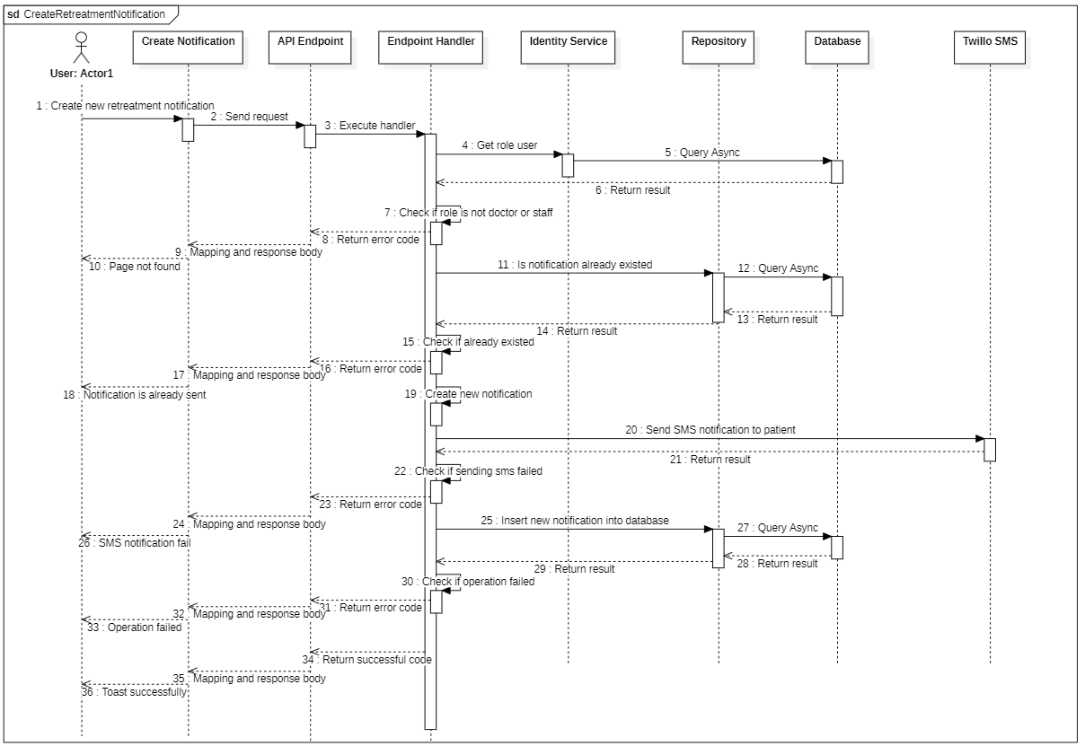

#### d. Database Queries

**public async Task<bool> CreateNewNotification(**

**RetreatmentNotification notification,**

**CancellationToken cancellationToken = default**

**)**

{

try

{

_notifications.Add(notification);

await _context.SaveChangesAsync(cancellationToken: cancellationToken);

}

catch (Exception ex)

{

await Console.Out.WriteLineAsync(ex.ToString());

return false;

}

return true;

}

**public async Task<bool> IsExistNotification(**

**DateTime examinationDate,**

**CancellationToken cancellationToken = default**

**)**

{

return await _notifications.AnyAsync(

notification => notification.ExaminationDate.Date.Equals(examinationDate.Date),

cancellationToken

);

}

## 5. Appointment

### 5.1. Get Appointments By Date

#### a. Class diagram

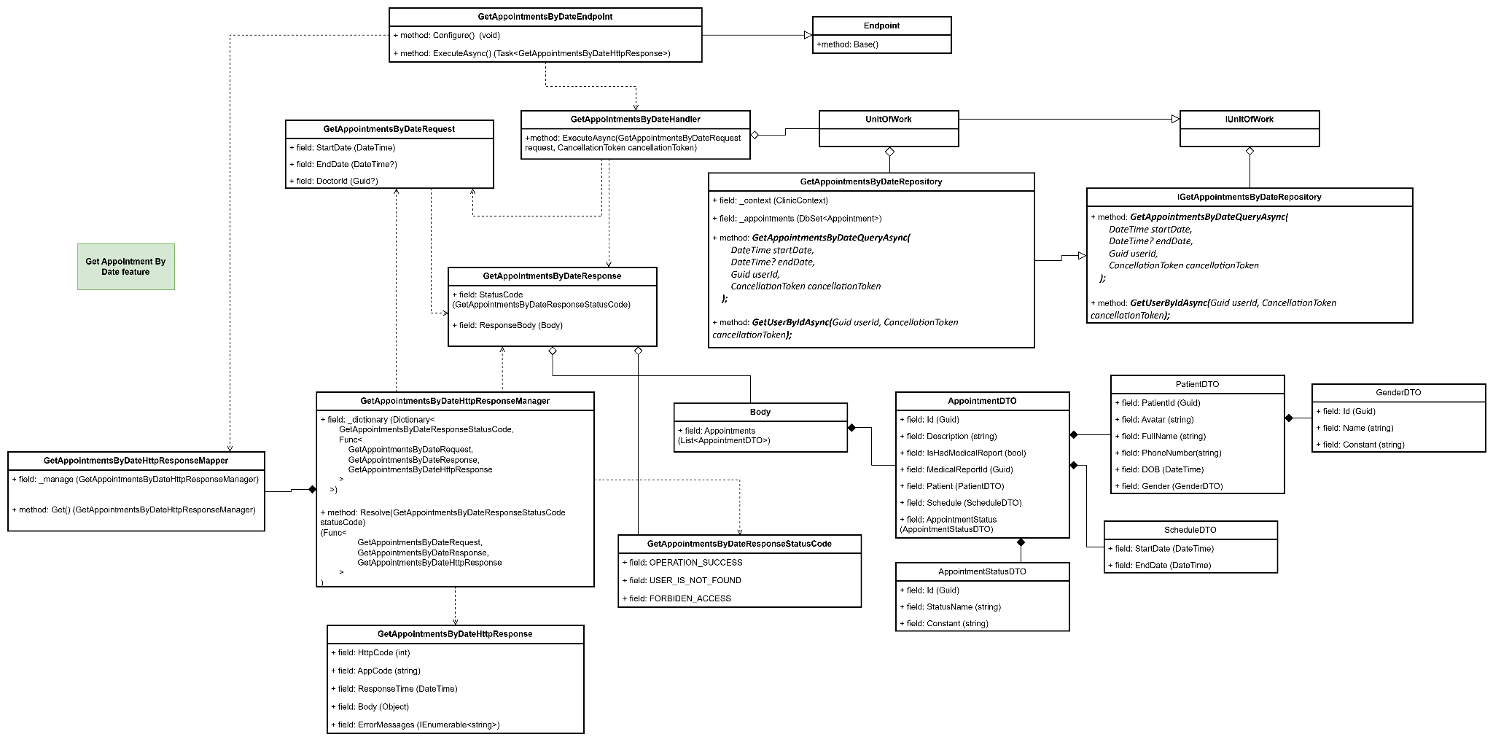

#### b. Class Specifications

#### GetAppointmentsByDateEndpoint class

* 1. *Same as common given before,* [*review here*](https://docs.google.com/document/d/1tTZUy0kDp6tdHb6MY85cNBVlDSK0k0N9w2NXBLPTu-c/edit?fbclid=IwY2xjawGRuZpleHRuA2FlbQIxMAABHUWj7GBmcsB0TEQOSeFgkcMlTv6kK6aEkUnExmkf0x_20x3n5Tikj9MvPA_aem_7Ik47wBVUygzT8J9mpiG0w#heading=h.m7r87enxie2d)*.*

1. ***Endpoint abstract class***
   1. *Same as common given before,* [*review here*](https://docs.google.com/document/d/1tTZUy0kDp6tdHb6MY85cNBVlDSK0k0N9w2NXBLPTu-c/edit?fbclid=IwY2xjawGRuZpleHRuA2FlbQIxMAABHUWj7GBmcsB0TEQOSeFgkcMlTv6kK6aEkUnExmkf0x_20x3n5Tikj9MvPA_aem_7Ik47wBVUygzT8J9mpiG0w#heading=h.ac857vak9ccs)*.*
2. ***GetAppointmentsByDateValidator class***
   1. *Same as common given before,* [*review here*](https://docs.google.com/document/d/1tTZUy0kDp6tdHb6MY85cNBVlDSK0k0N9w2NXBLPTu-c/edit?fbclid=IwY2xjawGRuZpleHRuA2FlbQIxMAABHUWj7GBmcsB0TEQOSeFgkcMlTv6kK6aEkUnExmkf0x_20x3n5Tikj9MvPA_aem_7Ik47wBVUygzT8J9mpiG0w#heading=h.mapewhyr52db)*.*
3. ***GetAppointmentsByDateHandler class***
   1. *Same as common given before,* [*review here*](https://docs.google.com/document/d/1tTZUy0kDp6tdHb6MY85cNBVlDSK0k0N9w2NXBLPTu-c/edit?fbclid=IwY2xjawGRuZpleHRuA2FlbQIxMAABHUWj7GBmcsB0TEQOSeFgkcMlTv6kK6aEkUnExmkf0x_20x3n5Tikj9MvPA_aem_7Ik47wBVUygzT8J9mpiG0w#heading=h.3lfr3mcrnl8j)*.*
4. ***IUnitOfWork interface***
   1. *Same as common given before,* [*review here*](https://docs.google.com/document/d/1tTZUy0kDp6tdHb6MY85cNBVlDSK0k0N9w2NXBLPTu-c/edit?fbclid=IwY2xjawGRuZpleHRuA2FlbQIxMAABHUWj7GBmcsB0TEQOSeFgkcMlTv6kK6aEkUnExmkf0x_20x3n5Tikj9MvPA_aem_7Ik47wBVUygzT8J9mpiG0w#heading=h.plvhy3azezgm)*.*
5. ***UnitOfWork class***
   1. *Same as common given before,* [*review here*](https://docs.google.com/document/d/1tTZUy0kDp6tdHb6MY85cNBVlDSK0k0N9w2NXBLPTu-c/edit?fbclid=IwY2xjawGRuZpleHRuA2FlbQIxMAABHUWj7GBmcsB0TEQOSeFgkcMlTv6kK6aEkUnExmkf0x_20x3n5Tikj9MvPA_aem_7Ik47wBVUygzT8J9mpiG0w#heading=h.75tksa2v2ybj)*.*
6. ***GetAppointmentsByDateRequest class***

| **No** | **Fields** | **Description** |
| --- | --- | --- |
| *01* | *StartDate* | *This field required user to choose start date* |
| *02* | *EndDate* | *This field required user to choose end date* |
| *03* | *DoctorId* | *This field required to get appointment of specific doctor* |

1. ***GetAppointmentsByDateResponse class***

| **No** | **Fields** | **Description** |
| --- | --- | --- |
| *01* | *StatusCode* | *This field will return an app code and http code.* |
| *02* | *ResponseBody* | *Contains the main data body of the response, which includes the list of appointments, represented by Body.* |

***8.1 Body inner class***

| **No** | **Fields** | **Description** |
| --- | --- | --- |
| *03* | *Appointments* | *A list of appointmentDTO objects representing each appointment on the specified date.* |

***8.2. AppointmentDTO inner class***

| **No** | **Fields** | **Description** |
| --- | --- | --- |
| *01* | *Id* | *Unique identifier for the appointment.* |
| *02* | *Description* | *Description or notes associated with the appointment.* |
| *03* | *IsHadMedicalReport* | *Boolean indicating if a medical report has been generated for the appointment.* |
| *04* | *MedicalReportId* | *Unique identifier for the medical report associated with the appointment, if available.* |
| *06* | *Patient* | *Patient details associated with the appointment, represented by PatientDTO.* |
| *07* | *Schedule* | *Schedule details for the appointment, represented by ScheduleDTO.* |
| *08* | *AppointmentStatus* | *Status details of the appointment, represented by AppointmentStatusDTO.* |

***8.3. PatientDTO inner class***

| **No** | **Fields** | **Description** |
| --- | --- | --- |
| *01* | *PatientId* | *Unique identifier for the patient.* |
| *02* | *Avatar* | *URL or reference to the patient's avatar image.* |
| *03* | *FullName* | *Full name of the patient.* |
| *04* | *PhoneNumber* | *Contact phone number of the patient.* |
| *05* | *DOB* | *Date of birth of the patient.* |
| *06* | *PatientDTO.Gender* | *Gender details of the patient, represented by GenderDTO.* |

***8.4. GenderDTO inner class***

| **No** | **Fields** | **Description** |
| --- | --- | --- |
| *01* | *Id* | *Unique identifier for the gender type.* |
| *02* | *Name* | *Name of the gender (Nam, Nữ, Khác).* |
| *03* | *Constant* | *Constant value representing the gender type (Male, Female).* |

***8.5. ScheduleDTO inner class***

| *01* | *StartDate* | *Start date and time of the appointment.* |
| --- | --- | --- |
| *02* | *EndDate* | *End date and time of the appointment.* |

***8.6. AppointmentStatusDTO inner class***

| **No** | **Fields** | **Description** |
| --- | --- | --- |
| *01* | *Id* | *Unique identifier for the appointment status.* |
| *02* | *StatusName* | *Name of the appointment status (Đang chờ , Đã xong, Đã hủy).* |
| *03* | *Constant* | *Constant of the appointment status (Pending , Completed, Canceled).* |

1. ***GetAppointmentsByDateResponseStatusCode Enum class***

This enum class contains some necessary app code like OPERATION_SUCCESS, USER_IS_NOT_FOUND, FORBIDEN_ACCESS .... Purpose to handle response with specifically code of errors.

1. ***IGetAppointmentsByDateRepository interface***

This interface class contains method to interact with database

| **No** | **Method** | **Description** |
| --- | --- | --- |
| *01* | ***Task<User> GetUserByIdAsync(****Guid userId, CancellationToken cancellationToken****);*** | *Defines a method to get the user* |
| *02* | ***Task<IEnumerable<Appointment>> GetAppointmentsByDateQueryAsync(***  *DateTime startDate,*  *DateTime? endDate,*  *Guid userId,*  *CancellationToken cancellationToken*  ***);*** | *Defines a method to get list of appointment* |

1. ***GetAppointmentsByDateRepository***

This class is an implementation of the *IGetAppointmentsByDateRepository* interface***.***

| **No** | **Fields** | **Description** |
| --- | --- | --- |
| *01* | *_context* | *This field is database context* |
| *02* | *_appointments* | *Field to interact with the Appointments table in the database* |

| **No** | **Method** | **Description** |
| --- | --- | --- |
| *01* | ***Task<User> GetUserByIdAsync(****Guid userId, CancellationToken cancellationToken****);*** | *Contains the main data body of the response, which includes the list of appointments.* |
| *02* | ***Task<IEnumerable<Appointment>> GetAppointmentsByDateQueryAsync(***  *DateTime startDate,*  *DateTime? endDate,*  *Guid userId,*  *CancellationToken cancellationToken*  ***);*** | *Contains the main data body of the response, which includes the list of appointments.* |

#### c. Sequence Diagram(s)

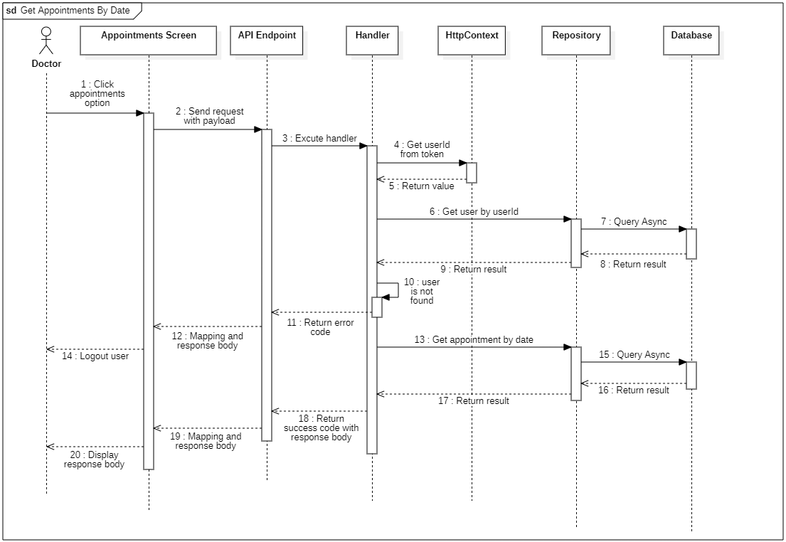

#### d. Database Queries

**public async Task<IEnumerable<Appointment>> GetAppointmentsByDateQueryAsync**(

DateTime startDate,

DateTime? endDate,

Guid userId,

CancellationToken cancellationToken = default

)

{

var result = _appointments

.Include(appointment => appointment.Patient)

.ThenInclude(patient => patient.User)

.ThenInclude(user => user.Gender)

.Include(appointment => appointment.Schedule)

.Include(appointment => appointment.MedicalReport)

.Include(appointment => appointment.AppointmentStatus)

.Where(appointment =>

appointment.DepositPayment == true && appointment.Schedule.DoctorId == userId

)

.AsQueryable();

if (endDate != null)

{

result = result.Where(entity =>

entity.Schedule.StartDate >= startDate && entity.Schedule.EndDate <= endDate

);

}

else

{

result = result.Where(entity => entity.Schedule.StartDate == startDate);

}

return await result

.OrderBy(appointment => appointment.Schedule.StartDate)

.ToListAsync(cancellationToken);

}

**public async Task<User> GetUserByIdAsync**(Guid userId, CancellationToken cancellationToken)

{

return await _context

.Users.Include(u => u.Doctor) // Include the related Doctor entity

.FirstOrDefaultAsync(u => u.Id == userId, cancellationToken);

}

### 5.2 Get the recent appointment of the doctor

#### a. Class diagram

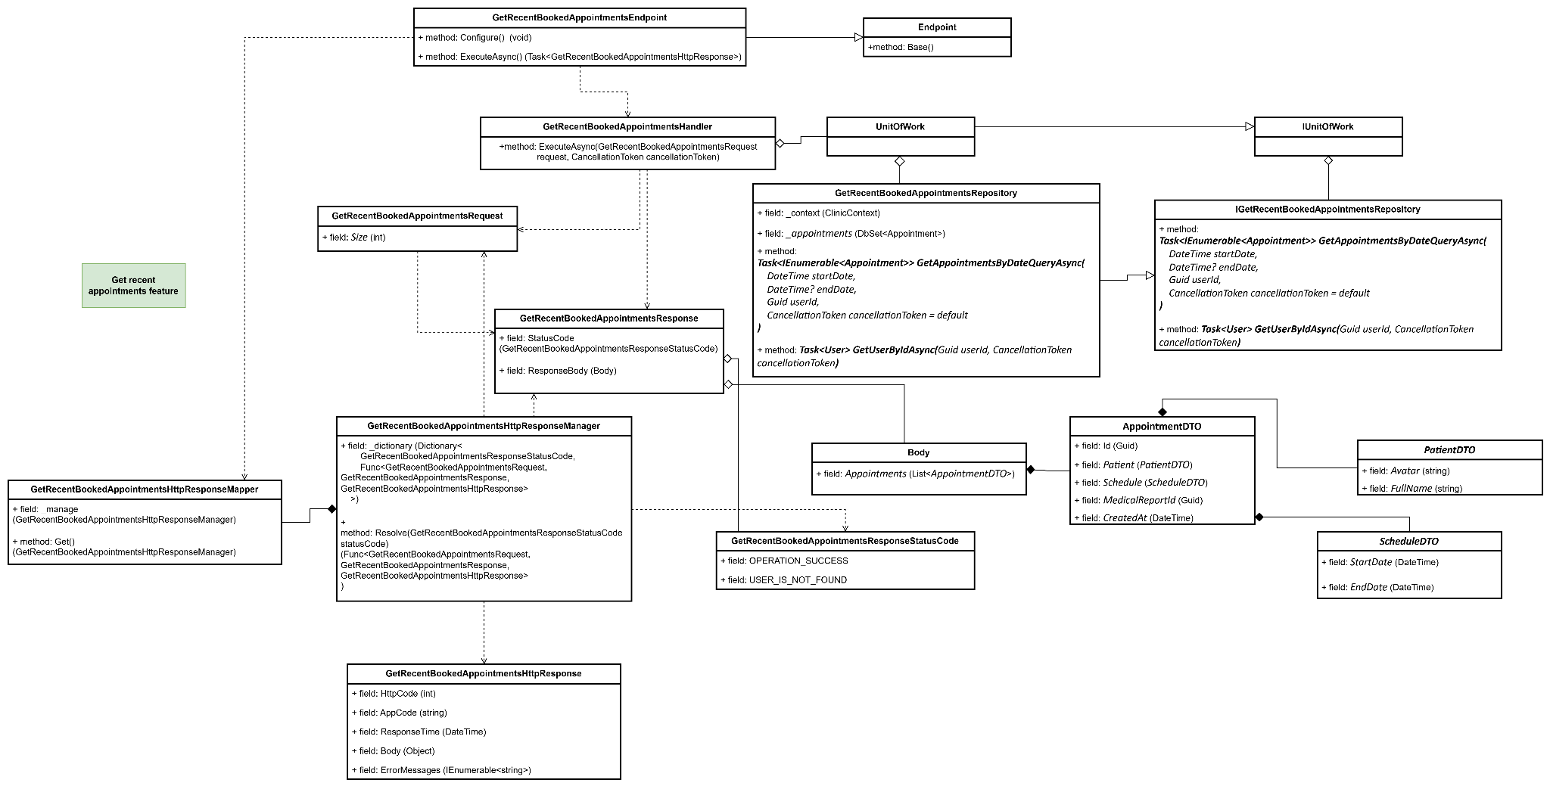

#### b. Class Specifications

#### GetRecentBookedAppointmentsEndpoint class

* 1. *Same as common given before,* [*review here*](https://docs.google.com/document/d/1tTZUy0kDp6tdHb6MY85cNBVlDSK0k0N9w2NXBLPTu-c/edit?fbclid=IwY2xjawGRuZpleHRuA2FlbQIxMAABHUWj7GBmcsB0TEQOSeFgkcMlTv6kK6aEkUnExmkf0x_20x3n5Tikj9MvPA_aem_7Ik47wBVUygzT8J9mpiG0w#heading=h.m7r87enxie2d)*.*

1. ***Endpoint abstract class***
   1. *Same as common given before,* [*review here*](https://docs.google.com/document/d/1tTZUy0kDp6tdHb6MY85cNBVlDSK0k0N9w2NXBLPTu-c/edit?fbclid=IwY2xjawGRuZpleHRuA2FlbQIxMAABHUWj7GBmcsB0TEQOSeFgkcMlTv6kK6aEkUnExmkf0x_20x3n5Tikj9MvPA_aem_7Ik47wBVUygzT8J9mpiG0w#heading=h.ac857vak9ccs)*.*
2. ***GetRecentBookedAppointmentsValidator class***
   1. *Same as common given before,* [*review here*](https://docs.google.com/document/d/1tTZUy0kDp6tdHb6MY85cNBVlDSK0k0N9w2NXBLPTu-c/edit?fbclid=IwY2xjawGRuZpleHRuA2FlbQIxMAABHUWj7GBmcsB0TEQOSeFgkcMlTv6kK6aEkUnExmkf0x_20x3n5Tikj9MvPA_aem_7Ik47wBVUygzT8J9mpiG0w#heading=h.mapewhyr52db)*.*
3. ***GetRecentBookedAppointmentsHandler class***
   1. *Same as common given before,* [*review here*](https://docs.google.com/document/d/1tTZUy0kDp6tdHb6MY85cNBVlDSK0k0N9w2NXBLPTu-c/edit?fbclid=IwY2xjawGRuZpleHRuA2FlbQIxMAABHUWj7GBmcsB0TEQOSeFgkcMlTv6kK6aEkUnExmkf0x_20x3n5Tikj9MvPA_aem_7Ik47wBVUygzT8J9mpiG0w#heading=h.3lfr3mcrnl8j)*.*
4. ***IUnitOfWork interface***
   1. *Same as common given before,* [*review here*](https://docs.google.com/document/d/1tTZUy0kDp6tdHb6MY85cNBVlDSK0k0N9w2NXBLPTu-c/edit?fbclid=IwY2xjawGRuZpleHRuA2FlbQIxMAABHUWj7GBmcsB0TEQOSeFgkcMlTv6kK6aEkUnExmkf0x_20x3n5Tikj9MvPA_aem_7Ik47wBVUygzT8J9mpiG0w#heading=h.plvhy3azezgm)*.*
5. ***UnitOfWork class***
   1. *Same as common given before,* [*review here*](https://docs.google.com/document/d/1tTZUy0kDp6tdHb6MY85cNBVlDSK0k0N9w2NXBLPTu-c/edit?fbclid=IwY2xjawGRuZpleHRuA2FlbQIxMAABHUWj7GBmcsB0TEQOSeFgkcMlTv6kK6aEkUnExmkf0x_20x3n5Tikj9MvPA_aem_7Ik47wBVUygzT8J9mpiG0w#heading=h.75tksa2v2ybj)*.*
6. ***GetRecentBookedAppointmentsRequest class***

| **No** | **Fields** | **Description** |
| --- | --- | --- |
| *01* | *Size* | *Size of returned appointment* |

1. ***GetRecentBookedAppointmentsResponse class***

| **No** | **Fields** | **Description** |
| --- | --- | --- |
| *01* | *StatusCode* | *This field will return an app code and http code.* |
| *02* | *ResponseBody* | *Contains the main data body of the response, which includes the list of appointments, represented by Body.* |

1. ***Body class***

| **No** | **Fields** | **Description** |
| --- | --- | --- |
| *01* | *Appointments* | *A list of AppointmentDTO objects representing each appointment on the specified date.* |

1. ***AppointmentDTO class***

| **No** | **Fields** | **Description** |
| --- | --- | --- |
| *01* | *Id* | *Unique identifier for the appointment.* |
| *02* | *Patient* | *PatientDTO object* |
| *03* | *Schedule* | *ScheduleDTO object* |
| *04* | *MedicalReportId* | *Unique identifier for the medical report associated with the appointment, if available.* |
| *05* | *CreatedAt* | *Created date of this appointment.* |

1. ***PatientDTO class***

| **No** | **Fields** | **Description** |
| --- | --- | --- |
| *01* | *Avatar* | *URL or reference to the patient's avatar image.* |
| *02* | *FullName* | *Full name of the patient.* |

1. ***ScheduleDTO class***

| **No** | **Fields** | **Description** |
| --- | --- | --- |
| *01* | *StartDate* | *Start date and time of the appointment.* |
| *02* | *EndDate* | *End date and time of the appointment.* |

1. ***GetRecentBookedAppointmentsResponseStatusCode Enum class***

This enum class contains some necessary app code like OPERATION_SUCCESS and USER_IS_NOT_FOUND. Purpose to handle response with specifically code of errors.

1. ***IGetRecentBookedAppointmentsRepository interface***

This interface class contains method to interact with database

| **No** | **Method** | **Description** |
| --- | --- | --- |
| *01* | ***public async Task<IEnumerable<Appointment>> GetAppointmentsByDateQueryAsync(***  *DateTime startDate,*  *DateTime? endDate,*  *Guid userId,*  *CancellationToken cancellationToken = default*  ***)*** | *Defines a method to fetch a list of appointments within a specific date range for a particular doctor, indicated by userId.* |
| *02* | ***public async Task<User> GetUserByIdAsync(****Guid userId, CancellationToken cancellationToken****)*** | *Defines a method to retrieve a User object by its unique identifier, userId, including the related Doctor data if applicable.* |

1. ***GetRecentBookedAppointmentsRepository***

This class is an implementation of the *IGetAppointmentsByDateRepository* interface***.***

| **No** | **Fields** | **Description** |
| --- | --- | --- |
| *01* | *_context* | *This field is database context* |
| *02* | *_appointments* | *Field to interact with the Appointments table in the database* |

| **No** | **Method** | **Description** |
| --- | --- | --- |
| *01* | ***public async Task<IEnumerable<Appointment>> GetAppointmentsByDateQueryAsync(***  *DateTime startDate,*  *DateTime? endDate,*  *Guid userId,*  *CancellationToken cancellationToken = default*  ***)*** | *Contains the main data body of the response, which includes the list of appointments.* |
| *02* | ***public async Task<User> GetUserByIdAsync(****Guid userId, CancellationToken cancellationToken****)*** | *Contains the main data body of the response, which includes the list of users.* |

#### c. Sequence Diagram(s)

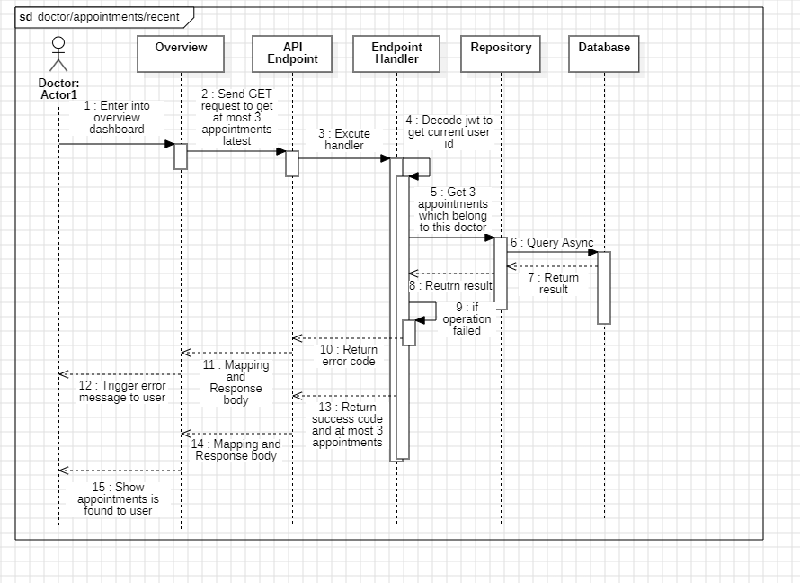

#### d. Database Queries

### 5.3 Update Appointment Status

#### a. Class diagram

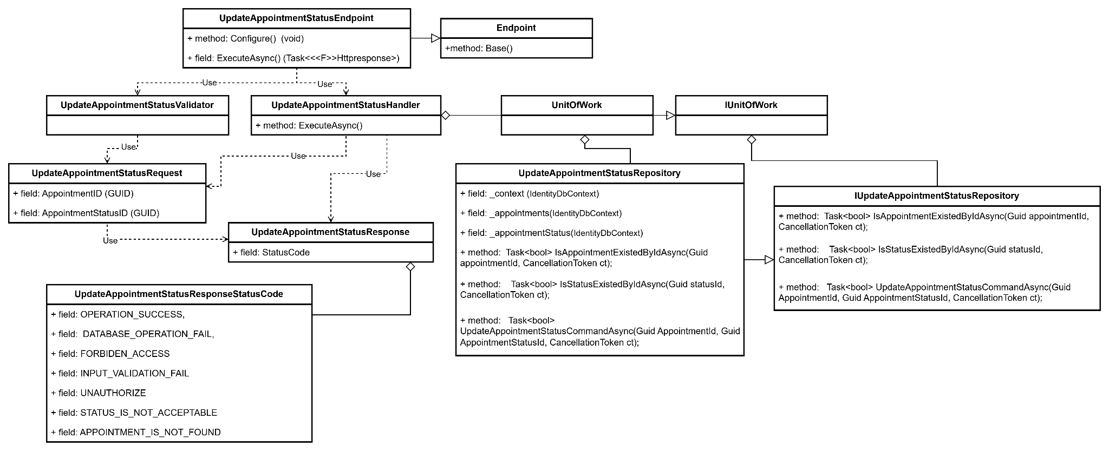

#### b. Class Specifications

#### UpdateAppointmentStatus class

*Same as common given before,* *review here**.*

1. ***Endpoint abstract class***

*Same as common given before,* *review here**.*

1. ***UpdateAppointmentStatusValidator class***

*Same as common given before,* *review here**.*

1. ***UpdateAppointmentStatusHandler class***

*Same as common given before,* *review here**.*

1. ***IUnitOfWork interface***

*Same as common given before,* *review here**.*

1. ***UnitOfWork class***

*Same as common given before,* *review here**.*

1. ***UpdateAppointmentStatusRequest class***

*This class is a Request DTO class that handles the necessary fields to register an user.*

| **No** | **Fields** | **Description** |
| --- | --- | --- |
| *01* | *AppointmentID* | *Requires a unique identifier for each appointment* |
| *02* | *AppointmentStatusID* | *Requires a unique identifier for each appointment status* |

1. ***UpdateAppointmentStatusResponse class***

| **No** | **Fields** | **Description** |
| --- | --- | --- |
| *01* | *StatusCode* | *This field will return an app code and http code.* |

1. ***UpdateAppointmentStatusResponseStatusCode Enum class***

This enum class contains some necessary app code like APPOINTMENT_IS_NOT_FOUND, FORBIDEN_ACCESS,.... Purpose to handle response with specifically code of errors.

1. ***IUpdateAppointmentStatusRepository interface***

This interface class contains method to interact with database

| **No** | **Fields** | **Description** |
| --- | --- | --- |
| *01* | *_context* | *This field is database context* |
| *02* | *_appointments* | *Field to interact with the Appointments table in the database* |
| *02* | *_appointmentStatus* | *Field to interact with the Appointment Status table in the database* |

| **No** | **Method** | **Description** |
| --- | --- | --- |
| *01* | ***Task<bool> IsAppointmentExistedByIdAsync****(Guid appointmentId, CancellationToken ct);* | *Defines a method to check if an appointment exists by its unique ID.* |
| *02* | ***Task<bool> IsStatusExistedByIdAsync(Guid statusId, CancellationToken ct);*** | *Defines a method to check if a specific status exists by its unique ID.* |
| *03* | ***Task<bool> UpdateAppointmentStatusCommandAsync****(Guid AppointmentId, Guid AppointmentStatusId, CancellationToken ct);* | *Defines a method to update the status of a specified appointment to a new status ID.* |
|  |  |  |

1. ***UpdateAppointmentStatusRepository***

This class is an implementation of the IRegisterRepository interface***.***

| **No** | **Method** | **Description** |
| --- | --- | --- |
| *01* | ***Task<bool> IsAppointmentExistedByIdAsync****(Guid appointmentId, CancellationToken ct);* | *Defines a method to check if an appointment exists by its unique ID.* |
| *02* | ***Task<bool> IsStatusExistedByIdAsync(Guid statusId, CancellationToken ct);*** | *Defines a method to check if a specific status exists by its unique ID.* |
| *03* | ***Task<bool> UpdateAppointmentStatusCommandAsync****(Guid AppointmentId, Guid AppointmentStatusId, CancellationToken ct);* | *Defines a method to update the status of a specified appointment to a new status ID.* |

#### c. Sequence Diagram(s)

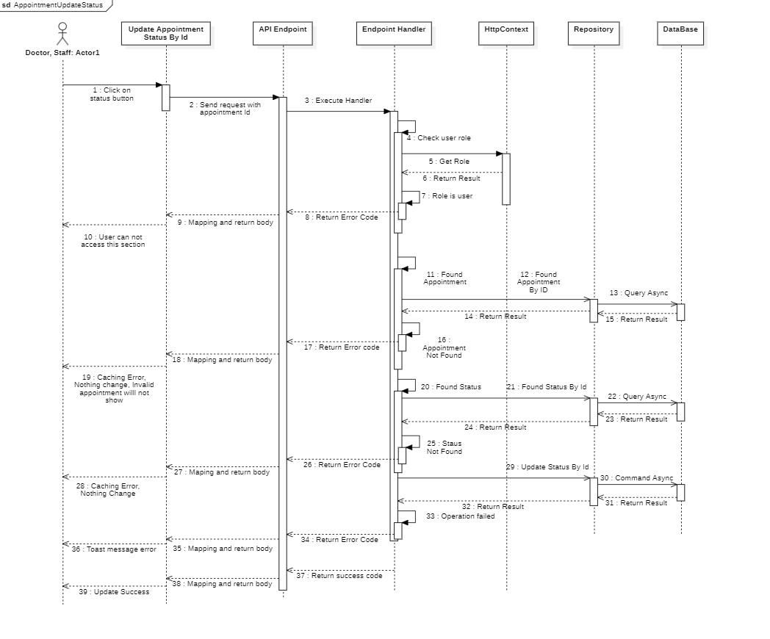

#### d. Database Queries

public Task<bool> IsAppointmentExistedByIdAsync(Guid appointmentId, CancellationToken ct)

{

return _appointment.AnyAsync(appointment => appointment.Id == appointmentId, ct);

}

public Task<bool> IsStatusExistedByIdAsync(Guid statusId, CancellationToken ct)

{

return _appointmentStatus.AnyAsync(status => status.Id == statusId, ct);

}

public async Task<bool> UpdateAppointmentStatusCommandAsync(

Guid AppointmentId,

Guid AppointmentStatusId,

CancellationToken ct

)

{

var dbResult = false;

await _context

.Database.CreateExecutionStrategy()

.ExecuteAsync(operation: async () =>

{

using var transaction = await _context.Database.BeginTransactionAsync(ct);

try

{

await _appointment

.Where(predicate: entity => entity.Id == AppointmentId)

.ExecuteUpdateAsync(setPropertyCalls: builder =>

builder.SetProperty(entity => entity.StatusId, AppointmentStatusId)

);

await transaction.CommitAsync(ct);

dbResult = true;

}

catch

{

await transaction.RollbackAsync(ct);

}

});

return dbResult;

}

### 5.4 Get Users Booked Appointment

#### a. Class diagram

#### b. Class Specifications

#### c. Sequence Diagram(s)

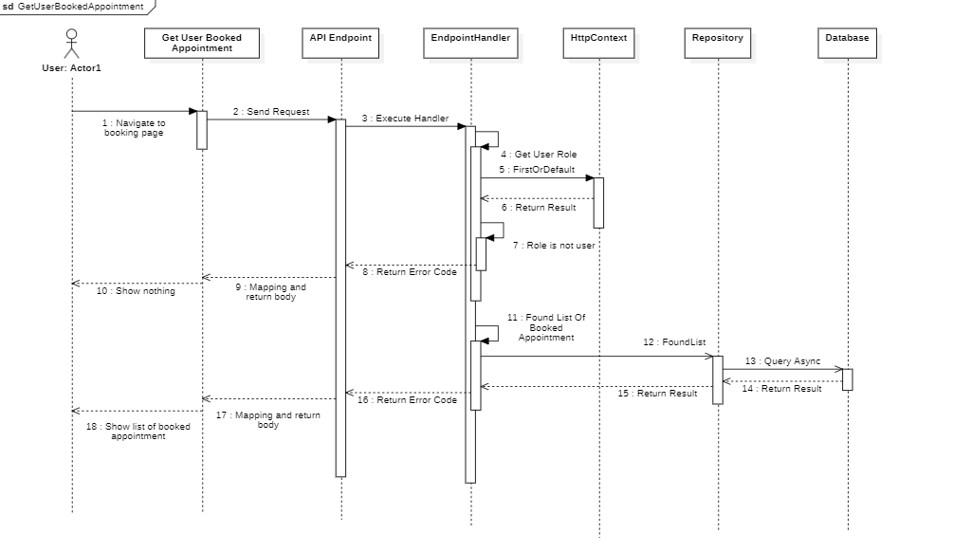

#### d. Database Queries

### 5.5. Get Absent Appointments

#### a. Class diagram

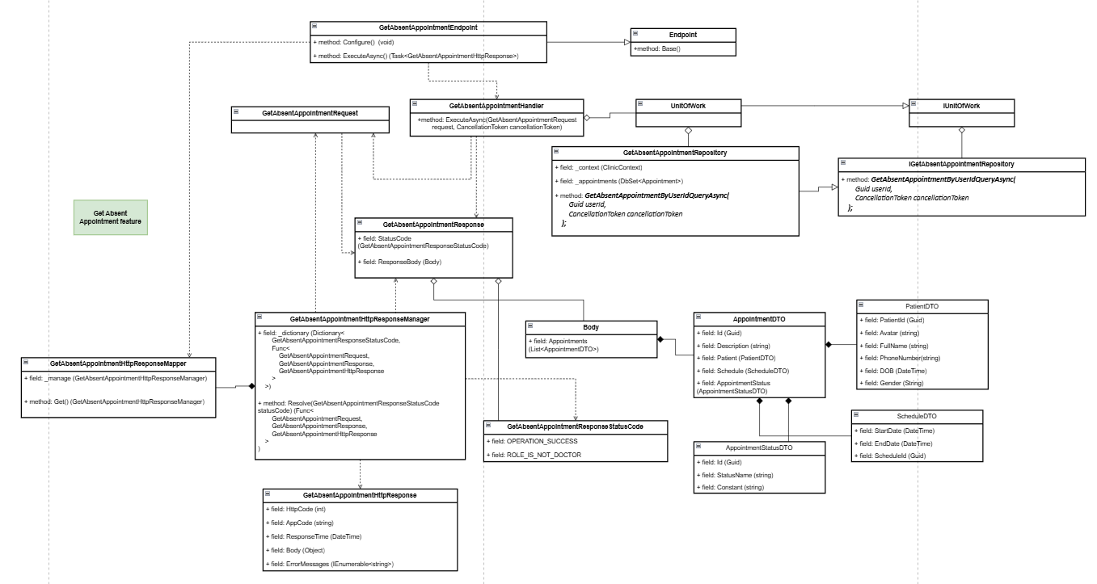

#### b. Class Specifications

***1.*** ***GetAbsentAppointmentEndpoint class***

*Same as common given before,* [*review here*](https://docs.google.com/document/d/1tTZUy0kDp6tdHb6MY85cNBVlDSK0k0N9w2NXBLPTu-c/edit?fbclid=IwY2xjawGRuSJleHRuA2FlbQIxMAABHYjI7nCoZIU2ktkJUxDtZ3Zx5tBNQiGoxIPJfuabdN9wobrfxMy7cWePnQ_aem_q381HO06sxWZI7wFU2pIoA#heading=h.m7r87enxie2d)*.*

***2.*** ***Endpoint abstract class***

*Same as common given before,* [*review here*](https://docs.google.com/document/d/1tTZUy0kDp6tdHb6MY85cNBVlDSK0k0N9w2NXBLPTu-c/edit?fbclid=IwY2xjawGRuSJleHRuA2FlbQIxMAABHYjI7nCoZIU2ktkJUxDtZ3Zx5tBNQiGoxIPJfuabdN9wobrfxMy7cWePnQ_aem_q381HO06sxWZI7wFU2pIoA#heading=h.ac857vak9ccs)*.*

***3.*** ***GetAbsentAppointmentValidator class***

*Same as common given before,* [*review here*](https://docs.google.com/document/d/1tTZUy0kDp6tdHb6MY85cNBVlDSK0k0N9w2NXBLPTu-c/edit?fbclid=IwY2xjawGRuSJleHRuA2FlbQIxMAABHYjI7nCoZIU2ktkJUxDtZ3Zx5tBNQiGoxIPJfuabdN9wobrfxMy7cWePnQ_aem_q381HO06sxWZI7wFU2pIoA#heading=h.mapewhyr52db)*.*

***4.*** ***GetAbsentAppointmentHandler class***

*Same as common given before,* [*review here*](https://docs.google.com/document/d/1tTZUy0kDp6tdHb6MY85cNBVlDSK0k0N9w2NXBLPTu-c/edit?fbclid=IwY2xjawGRuSJleHRuA2FlbQIxMAABHYjI7nCoZIU2ktkJUxDtZ3Zx5tBNQiGoxIPJfuabdN9wobrfxMy7cWePnQ_aem_q381HO06sxWZI7wFU2pIoA#heading=h.3lfr3mcrnl8j)*.*

***5.*** ***IUnitOfWork interface***

*Same as common given before,* [*review here*](https://docs.google.com/document/d/1tTZUy0kDp6tdHb6MY85cNBVlDSK0k0N9w2NXBLPTu-c/edit?fbclid=IwY2xjawGRuSJleHRuA2FlbQIxMAABHYjI7nCoZIU2ktkJUxDtZ3Zx5tBNQiGoxIPJfuabdN9wobrfxMy7cWePnQ_aem_q381HO06sxWZI7wFU2pIoA#heading=h.plvhy3azezgm)*.*

***6.*** ***UnitOfWork class***

*Same as common given before,* [*review here*](https://docs.google.com/document/d/1tTZUy0kDp6tdHb6MY85cNBVlDSK0k0N9w2NXBLPTu-c/edit?fbclid=IwY2xjawGRuSJleHRuA2FlbQIxMAABHYjI7nCoZIU2ktkJUxDtZ3Zx5tBNQiGoxIPJfuabdN9wobrfxMy7cWePnQ_aem_q381HO06sxWZI7wFU2pIoA#heading=h.75tksa2v2ybj)*.*

***7.*** ***GetAbsentAppointmentRequest class***

*This class is a Request DTO class that handles the necessary fields to get absent appointment.*

| **No** | **Fields** | **Description** |
| --- | --- | --- |
| *Empty request* | | |

***8.*** ***GetAbsentAppointmentResponse class***

| **No** | **Fields** | **Description** |
| --- | --- | --- |
| *01* | *StatusCode* | *This field will return an app code and http code.* |
| *02* | *ResponseBody* | *Contains the response data for the request. The* ***Body*** *class holds details of absent appointments* |

***9.*** ***Body class***

| **No** | **Fields** | **Description** |
| --- | --- | --- |
| *01* | *Appointment* | *Represents a collection of absent appointments. Each item in this collection is of type* ***AppointmentDetail****, which holds detailed information about individual absent appointments.* |

***10.*** ***AppointmentDetail class***

| **No** | **Fields** | **Description** |
| --- | --- | --- |
| *01* | *Id* | *A unique identifier for the absent appointment.* |
| *02* | *Description* | *Provides a description of the appointment or the reason for absence.* |
| *03* | *Schedules* | *Contains schedule information for the appointment, represented by the* ***Schedule*** *class.* |
| *04* | *Patients* | *Holds information about the patient associated with the appointment, represented by the* ***UserDetail*** *class.* |
| *05* | *AppointmentStatus* | *Represents the status of the appointment, such as "Absent" or "Pending," encapsulated in the* ***Status*** *class.* |

***11.*** ***Schedule class***

| **No** | **Fields** | **Description** |
| --- | --- | --- |
| *01* | *ScheduleId* | *The unique identifier for the specific schedule* |
| *02* | *StartDate* | *The start date and time for the appointment.* |
| *03* | *EndDate* | *The end date and time for the appointment.* |

***12.*** ***UserDetail class***

| **No** | **Fields** | **Description** |
| --- | --- | --- |
| *01* | *UserId* | *Unique identifier for the patient associated with the appointment.* |
| *02* | *FullName* | *Full name of the patient, including first, middle, and last names, to identify the patient.* |
| *03* | *AvatarUrl* | *URL or file path to the patient’s avatar image, for visual identification.* |
| *04* | *Gender* | *Represents the gender of the patient, typically as a string like "Male" or "Female."* |
| *05* | *PhoneNumber* | *Contains the contact phone number of the patient.* |
| *06* | *DOB* | *Date of birth of the patient, used for age calculation and other contextual information.* |

***13.*** ***Status class***

| **No** | **Fields** | **Description** |
| --- | --- | --- |
| *01* | *Id* | *A unique identifier for the appointment status.* |
| *02* | *StatusName* | *Name of the status, such as "Absent" or "Pending."* |
| *03* | *Constant* | *A constant or code representation of the status for internal use.* |

***14.*** ***GetAbsentAppointmentResponseStatusCode Enum class***

This enum class contains some necessary app code like OPERATION_SUCCESS,ROLE_IS_NOT_DOCTOR,.... Purpose to handle response with specifically code of errors.

***15.*** ***IGetAbsentRepository interface***

This interface class contains method to interact with database

| **No** | **Method** | **Description** |
| --- | --- | --- |
| *01* | ***Task<IEnumerable<Appointment>> GetAbsentAppointmentByUserIdQueryAsync(***  ***Guid userId,***  ***CancellationToken cancellationToken***  ***);*** | *Defines a method to get absent appointments* |

***16.*** ***GetAbsentRepository***

This class is an implementation of the IGetAbsentAppointmentRepository interface***.***

| **No** | **Fields** | **Description** |
| --- | --- | --- |
| *01* | *_context* | *This field is database context* |
| *02* | *_appointments* | *This field interacts with Appointment table* |

| **No** | **Method** | **Description** |
| --- | --- | --- |
| *01* | ***public async Task<IEnumerable<Appointment>> GetAbsentAppointmentByUserIdQueryAsync(***  ***Guid doctorId,***  ***CancellationToken cancellationToken***  ***)*** | *Execute statements that interact with the database and return the desired value* |

#### c. Sequence Diagram(s)

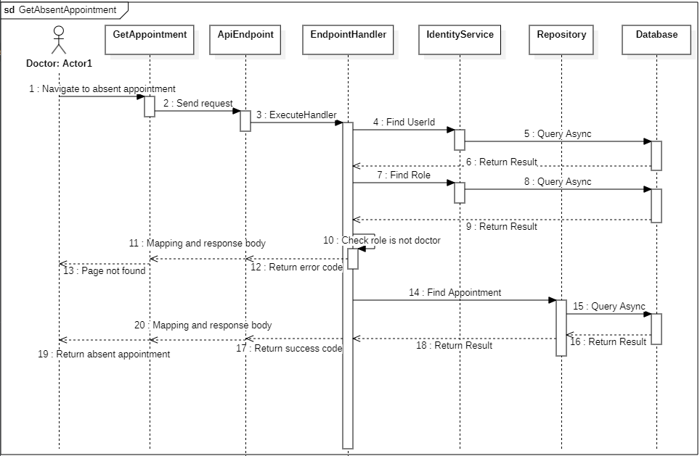

#### d. Database Queries

**public async Task<IEnumerable<Appointment>> GetAbsentAppointmentByUserIdQueryAsync(**

**Guid doctorId,**

**CancellationToken cancellationToken**

**)**

{

return await _appointments

.AsNoTracking()

.Where(appointment =>

appointment.Schedule.DoctorId == doctorId

&& appointment.AppointmentStatus.Constant.Equals("No-Show")

)

.Select(appointment => new Appointment()

{

Id = appointment.Id,

Schedule = new Schedule()

{

Id = appointment.Schedule.Id,

StartDate = appointment.Schedule.StartDate,

EndDate = appointment.Schedule.EndDate,

},

Patient = new Patient()

{

UserId = appointment.Patient.UserId,

User = new User()

{

FullName = appointment.Patient.User.FullName,

Avatar = appointment.Patient.User.Avatar,

Gender = appointment.Patient.User.Gender,

PhoneNumber = appointment.Patient.User.PhoneNumber,

},

DOB = appointment.Patient.DOB,

},

AppointmentStatus = new AppointmentStatus()

{

Id = appointment.AppointmentStatus.Id,

Constant = appointment.AppointmentStatus.Constant,

StatusName = appointment.AppointmentStatus.StatusName,

},

Description = appointment.Description,

})

.ToListAsync(cancellationToken: cancellationToken);

}

### 5.6. Create New Appointment

#### a. Class diagram

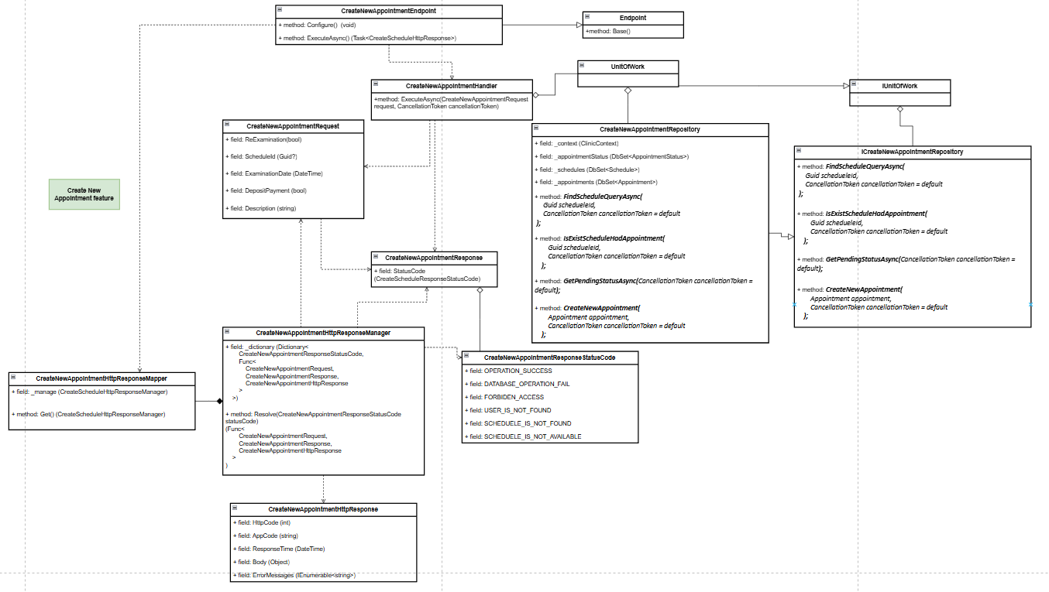

#### b. Class Specifications

1. ***CreateNewAppointmentEndpoint class***

*a.* *Same as common given before,* [*review here*](https://docs.google.com/document/d/1tTZUy0kDp6tdHb6MY85cNBVlDSK0k0N9w2NXBLPTu-c/edit?fbclid=IwY2xjawGRuZpleHRuA2FlbQIxMAABHUWj7GBmcsB0TEQOSeFgkcMlTv6kK6aEkUnExmkf0x_20x3n5Tikj9MvPA_aem_7Ik47wBVUygzT8J9mpiG0w#heading=h.m7r87enxie2d)*.*

1. ***Endpoint abstract class***

*a.* *Same as common given before,* [*review here*](https://docs.google.com/document/d/1tTZUy0kDp6tdHb6MY85cNBVlDSK0k0N9w2NXBLPTu-c/edit?fbclid=IwY2xjawGRuZpleHRuA2FlbQIxMAABHUWj7GBmcsB0TEQOSeFgkcMlTv6kK6aEkUnExmkf0x_20x3n5Tikj9MvPA_aem_7Ik47wBVUygzT8J9mpiG0w#heading=h.ac857vak9ccs)*.*

1. ***CreateNewAppointmentValidator class***

*a.* *Same as common given before,* [*review here*](https://docs.google.com/document/d/1tTZUy0kDp6tdHb6MY85cNBVlDSK0k0N9w2NXBLPTu-c/edit?fbclid=IwY2xjawGRuZpleHRuA2FlbQIxMAABHUWj7GBmcsB0TEQOSeFgkcMlTv6kK6aEkUnExmkf0x_20x3n5Tikj9MvPA_aem_7Ik47wBVUygzT8J9mpiG0w#heading=h.mapewhyr52db)*.*

1. ***CreateNewAppointmentHandler class***

*a.* *Same as common given before,* [*review here*](https://docs.google.com/document/d/1tTZUy0kDp6tdHb6MY85cNBVlDSK0k0N9w2NXBLPTu-c/edit?fbclid=IwY2xjawGRuZpleHRuA2FlbQIxMAABHUWj7GBmcsB0TEQOSeFgkcMlTv6kK6aEkUnExmkf0x_20x3n5Tikj9MvPA_aem_7Ik47wBVUygzT8J9mpiG0w#heading=h.3lfr3mcrnl8j)*.*

1. ***IUnitOfWork interface***

*a.* *Same as common given before,* [*review here*](https://docs.google.com/document/d/1tTZUy0kDp6tdHb6MY85cNBVlDSK0k0N9w2NXBLPTu-c/edit?fbclid=IwY2xjawGRuZpleHRuA2FlbQIxMAABHUWj7GBmcsB0TEQOSeFgkcMlTv6kK6aEkUnExmkf0x_20x3n5Tikj9MvPA_aem_7Ik47wBVUygzT8J9mpiG0w#heading=h.plvhy3azezgm)*.*

1. ***UnitOfWork class***

*a.* *Same as common given before,* [*review here*](https://docs.google.com/document/d/1tTZUy0kDp6tdHb6MY85cNBVlDSK0k0N9w2NXBLPTu-c/edit?fbclid=IwY2xjawGRuZpleHRuA2FlbQIxMAABHUWj7GBmcsB0TEQOSeFgkcMlTv6kK6aEkUnExmkf0x_20x3n5Tikj9MvPA_aem_7Ik47wBVUygzT8J9mpiG0w#heading=h.75tksa2v2ybj)*.*

1. ***CreateNewAppointmentRequest class***

| **No** | **Fields** | **Description** |
| --- | --- | --- |
| *01* | *ScheduleId* | *The ID of the schedule, used to identify the appointment's schedule.* |
| *02* | *ReExamination* | *Indicates whether the appointment is a re-examination* |
| *03* | *ExaminationDate* | *The scheduled date for the examination.* |
| *04* | *DepositPayment* | *Indicates whether a deposit payment has been made for the appointment.* |
| *05* | *Description* | *A detailed description of the appointment request (may include special notes or reason for visit).* |

***8.*** ***GetRecentBookedAppointmentsResponse class***

| **No** | **Fields** | **Description** |
| --- | --- | --- |
| *01* | *StatusCode* | *This field will return an app code and http code.* |
| *02* | *ResponseBody* | *Contains the main data body of the response, which includes the list of appointments, represented by Body.* |

***9.*** ***Body class***

| **No** | **Fields** | **Description** |
| --- | --- | --- |
| *01* | *Appointment* | *A* ***ResponseAppointment*** *object that represents the details of the appointment created.* |

***10.*** ***ResponseAppointment class***

| **No** | **Fields** | **Description** |
| --- | --- | --- |
| *01* | *Id* | *Unique identifier for the created appointment.* |
| *02* | *ExaminationDate* | *The scheduled date for the appointment.* |
| *03* | *DepositPayment* | *Indicates whether a deposit payment has been made for the appointment.* |

***13.*** ***CreateNewAppointmentResponseStatusCode Enum class***

This enum class contains some necessary app code likeINPUT_VALIDATION_FAIL, OPERATION_SUCCESS, UNAUTHORIZE, DATABASE_OPERATION_FAIL, FORBIDEN_ACCESS, USER_IS_NOT_FOUND, SCHEDUELE_IS_NOT_FOUND, SCHEDUELE_IS_NOT_AVAILABLE. Purpose to handle response with specifically code of errors.

***14.*** ***ICreateNewAppointmentRepository interface***

This interface class contains method to interact with database

| **No** | **Method** | **Description** |
| --- | --- | --- |
| *01* | ***Task<AppointmentStatus> GetPendingStatusAsync(CancellationToken cancellationToken = default);*** | *Retrieves the* ***AppointmentStatus*** *object that represents the "Pending" status.* |
| *02* | ***Task<Schedule> FindScheduleQueryAsync(***  ***Guid schedueleId,***  ***CancellationToken cancellationToken = default***  ***);*** | *Fetches a Schedule object by its unique identifier, scheduleId, to verify the schedule details.* |
| *03* | ***Task<bool> IsExistScheduleHadAppointment(Guid scheduleId, CancellationToken cancellationToken = default)*** | *Checks if a specific schedule, identified by scheduleId, already has an appointment associated with it.* |
| *04* | ***Task<bool> CreateNewAppointment(Appointment appointment, CancellationToken cancellationToken = default)*** | *Creates a new appointment entry in the database and returns a boolean indicating success or failure.* |

***15.*** ***CreateNewAppointmentsRepository***

This class is an implementation of the *IGetAppointmentsByDateRepository* interface***.***

| **No** | **Fields** | **Description** |
| --- | --- | --- |
| *01* | *_context* | *This field is database context* |
| *02* | *_appointmentStatus* | *Represents the AppointmentStatus table in the database for managing status data* |
| *03* | *_schedules* | *Represents the Schedule table for retrieving schedule information.* |
| *04* | *_appointments* | *Represents the Appointment table for creating and verifying appointments.* |

| **No** | **Method** | **Description** |
| --- | --- | --- |
| *01* | ***Task<bool> CreateNewAppointment(Appointment appointment, CancellationToken cancellationToken = default)*** | *Attempts to add a new appointment to the Appointments table and saves changes to the database, returning success or failure.* |
| *02* | ***Task<AppointmentStatus> GetPendingStatusAsync(CancellationToken cancellationToken = default)*** | *Retrieves the "Pending" status record from the AppointmentStatus table.* |
| *03* | ***Task<Schedule> FindScheduleQueryAsync(Guid scheduleId, CancellationToken cancellationToken = default)*** | *Queries the Schedule table by scheduleId and returns a limited Schedule object with essential information (e.g., StartDate).* |
| *04* | ***Task<bool> IsExistScheduleHadAppointment(Guid scheduleId, CancellationToken cancellationToken = default)*** | *Checks the Appointments table to determine if any appointments are already scheduled for the specified scheduleId.* |

#### c. Sequence Diagram(s)

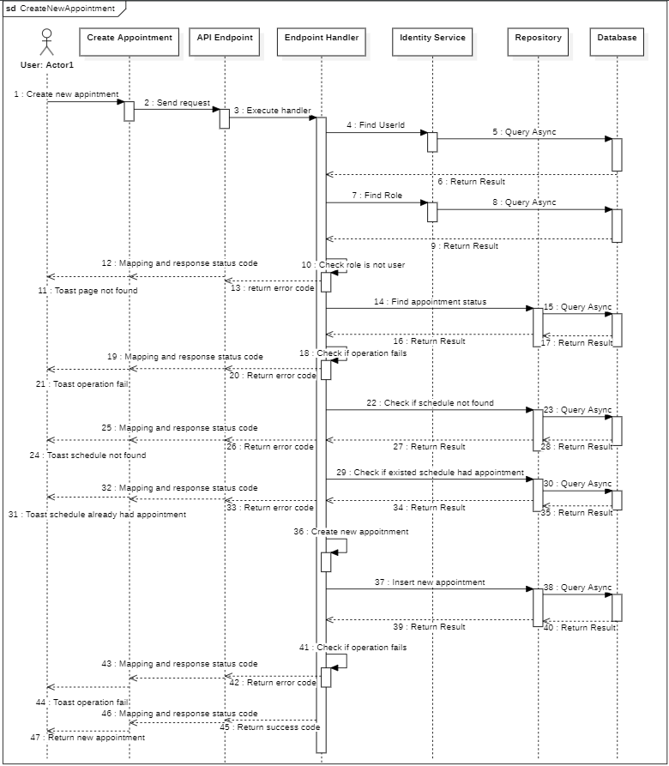

#### d. Database Queries

**public async Task<bool> CreateNewAppointment(**

**Appointment appointment,**

**CancellationToken cancellationToken = default**

**)**

{

try

{

_appointments.Add(appointment);

await _context.SaveChangesAsync(cancellationToken: cancellationToken);

}

catch (Exception ex)

{

await Console.Out.WriteLineAsync(ex.ToString());

return false;

}

return true;

}

**public Task<AppointmentStatus> GetPendingStatusAsync(**

**CancellationToken cancellationToken = default**

**)**

{

return _appointmentStatus.FirstOrDefaultAsync(

status => status.Constant == "Pending",

cancellationToken: cancellationToken

);

}

**public async Task<Schedule> FindScheduleQueryAsync(**

**Guid schedueleId,**

**CancellationToken cancellationToken = default**

**)**

{

return await _schedules

.Where(predicate: entity => entity.Id == schedueleId)

.Select(selector: entity => new Schedule { StartDate = entity.StartDate })

.FirstOrDefaultAsync(cancellationToken: cancellationToken);

}

**public Task<bool> IsExistScheduleHadAppointment(**

**Guid schedueleId,**

**CancellationToken cancellationToken = default**

**)**

{

return _appointments.AnyAsync(

appointment => appointment.ScheduleId == schedueleId,

cancellationToken: cancellationToken

);

}

## 6. Schedule

### 6.1. Create schedule

#### a. Class diagram

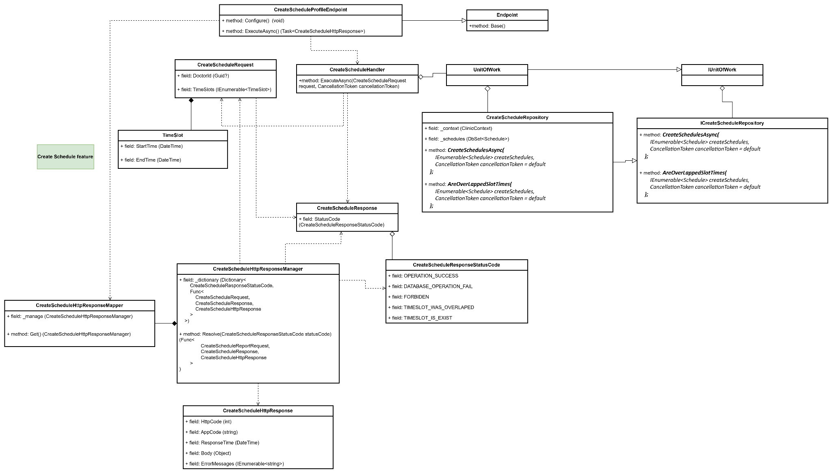

#### b. Class Specifications

#### CreateScheduleEndpoint class

* 1. *Same as common given before,* [*review here*](https://docs.google.com/document/d/1tTZUy0kDp6tdHb6MY85cNBVlDSK0k0N9w2NXBLPTu-c/edit?fbclid=IwY2xjawGRuZpleHRuA2FlbQIxMAABHUWj7GBmcsB0TEQOSeFgkcMlTv6kK6aEkUnExmkf0x_20x3n5Tikj9MvPA_aem_7Ik47wBVUygzT8J9mpiG0w#heading=h.m7r87enxie2d)*.*

1. ***Endpoint abstract class***
   1. *Same as common given before,* [*review here*](https://docs.google.com/document/d/1tTZUy0kDp6tdHb6MY85cNBVlDSK0k0N9w2NXBLPTu-c/edit?fbclid=IwY2xjawGRuZpleHRuA2FlbQIxMAABHUWj7GBmcsB0TEQOSeFgkcMlTv6kK6aEkUnExmkf0x_20x3n5Tikj9MvPA_aem_7Ik47wBVUygzT8J9mpiG0w#heading=h.ac857vak9ccs)*.*
2. ***CreateScheduleValidator class***
   1. *Same as common given before,* [*review here*](https://docs.google.com/document/d/1tTZUy0kDp6tdHb6MY85cNBVlDSK0k0N9w2NXBLPTu-c/edit?fbclid=IwY2xjawGRuZpleHRuA2FlbQIxMAABHUWj7GBmcsB0TEQOSeFgkcMlTv6kK6aEkUnExmkf0x_20x3n5Tikj9MvPA_aem_7Ik47wBVUygzT8J9mpiG0w#heading=h.mapewhyr52db)*.*
3. ***CreateScheduleHandler class***
   1. *Same as common given before,* [*review here*](https://docs.google.com/document/d/1tTZUy0kDp6tdHb6MY85cNBVlDSK0k0N9w2NXBLPTu-c/edit?fbclid=IwY2xjawGRuZpleHRuA2FlbQIxMAABHUWj7GBmcsB0TEQOSeFgkcMlTv6kK6aEkUnExmkf0x_20x3n5Tikj9MvPA_aem_7Ik47wBVUygzT8J9mpiG0w#heading=h.3lfr3mcrnl8j)*.*
4. ***IUnitOfWork interface***
   1. *Same as common given before,* [*review here*](https://docs.google.com/document/d/1tTZUy0kDp6tdHb6MY85cNBVlDSK0k0N9w2NXBLPTu-c/edit?fbclid=IwY2xjawGRuZpleHRuA2FlbQIxMAABHUWj7GBmcsB0TEQOSeFgkcMlTv6kK6aEkUnExmkf0x_20x3n5Tikj9MvPA_aem_7Ik47wBVUygzT8J9mpiG0w#heading=h.plvhy3azezgm)*.*
5. ***UnitOfWork class***
   1. *Same as common given before,* [*review here*](https://docs.google.com/document/d/1tTZUy0kDp6tdHb6MY85cNBVlDSK0k0N9w2NXBLPTu-c/edit?fbclid=IwY2xjawGRuZpleHRuA2FlbQIxMAABHUWj7GBmcsB0TEQOSeFgkcMlTv6kK6aEkUnExmkf0x_20x3n5Tikj9MvPA_aem_7Ik47wBVUygzT8J9mpiG0w#heading=h.75tksa2v2ybj)*.*
6. ***CreateScheduleRequest class***

| **No** | **Fields** | **Description** |
| --- | --- | --- |
| *01* | *DoctorId* | *Id of doctor which want to add schedule* |
| *02* | *TimeSlots* | *A list of TimeSlot object* |

***7.1 TimeSlot inner class***

| **No** | **Fields** | **Description** |
| --- | --- | --- |
| *01* | *StartTime* | *Start time of schedule (7:30)* |
| *02* | *EndTime* | *End time of schedule (9:30)* |

1. ***CreateScheduleResponse class***

| **No** | **Fields** | **Description** |
| --- | --- | --- |
| *01* | *StatusCode* | *This field will return an app code and http code.* |

1. ***CreateScheduleResponseStatusCode Enum class***

This enum class contains some necessary app code like OPERATION_SUCCESS, DATABASE_OPERATION_FAIL, FORBIDDEN, TIMESLOT_WAS_OVERLAPED, TIMESLOT_IS_EXIST .... Purpose to handle response with specifically code of errors.

1. ***ICreateScheduleRepository interface***

This interface class contains method to interact with database

| **No** | **Method** | **Description** |
| --- | --- | --- |
| *01* | ***CreateSchedulesAsync(***  *IEnumerable<Schedule> createSchedules,*  *CancellationToken cancellationToken = default*  ***);*** | *Defines a method to create schedule* |
| *02* | ***AreOverLappedSlotTimes(***  *IEnumerable<Schedule> createSchedules,*  *CancellationToken cancellationToken = default*  ***);*** | *Defines a method to check schedules are overlapped or not* |

1. ***CreateScheduleRepository***

This class is an implementation of the *ICreateScheduleRepository* interface***.***

| **No** | **Fields** | **Description** |
| --- | --- | --- |
| *01* | *_context* | *This field is database context* |
| *02* | *_schedules* | *Property to interact with the Schdules table in the database* |

| **No** | **Method** | **Description** |
| --- | --- | --- |
| *01* | ***CreateSchedulesAsync(***  *IEnumerable<Schedule> createSchedules,*  *CancellationToken cancellationToken = default*  ***);*** | *Execute statements that interact with the database and return the desired value* |
| *02* | ***AreOverLappedSlotTimes(***  *IEnumerable<Schedule> createSchedules,*  *CancellationToken cancellationToken = default*  ***);*** | *Execute statements that interact with the database and return the desired value* |

#### c. Sequence Diagram(s)

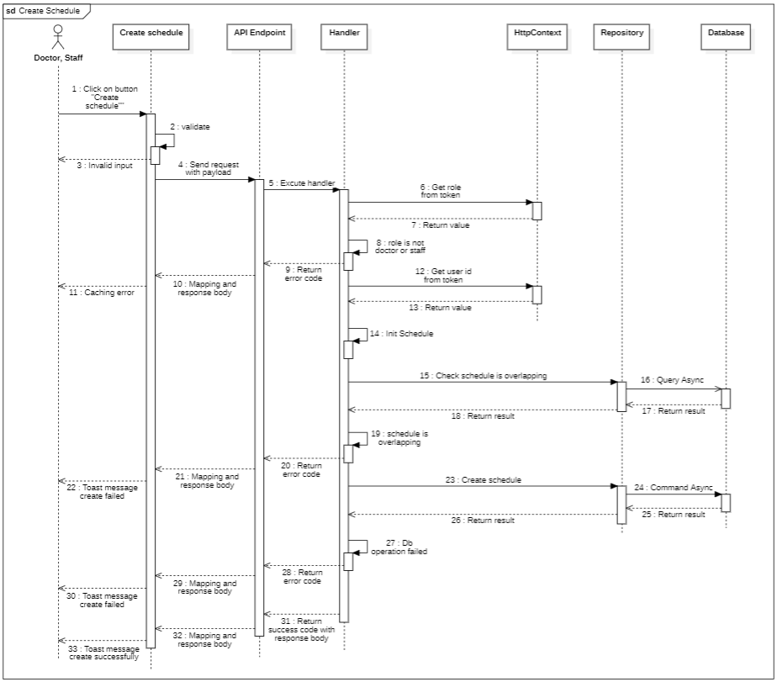

#### d. Database Queries

**public async Task<bool> AreOverLappedSlotTimes**(

IEnumerable<Schedule> createSchedules,

CancellationToken cancellationToken = default

)

{

var maxTime = createSchedules.Max(cs => cs.EndDate);

var minTime = createSchedules.Min(cs => cs.StartDate);

var existSlotTimes = await _schedules

.Where(predicate: schedule =>

schedule.StartDate < maxTime && schedule.EndDate > minTime

)

.ToListAsync(cancellationToken: cancellationToken);

foreach (var newSlot in createSchedules)

{

foreach (var existingSlot in existSlotTimes)

{

if (

existingSlot.StartDate < newSlot.EndDate

&& newSlot.StartDate < existingSlot.EndDate

)

{

return true;

}

}

}

return false;

}

**public async Task<bool> CreateSchedulesAsync**(

IEnumerable<Schedule> createSchedules,

CancellationToken cancellationToken = default

)

{

try

{

_schedules.AddRange(createSchedules);

await _context.SaveChangesAsync(cancellationToken: cancellationToken);

}

catch (Exception ex)

{

await Console.Out.WriteLineAsync(ex.ToString());

return false;

}

return true;

}

### 6.2. Update schedule

#### a. Class diagram

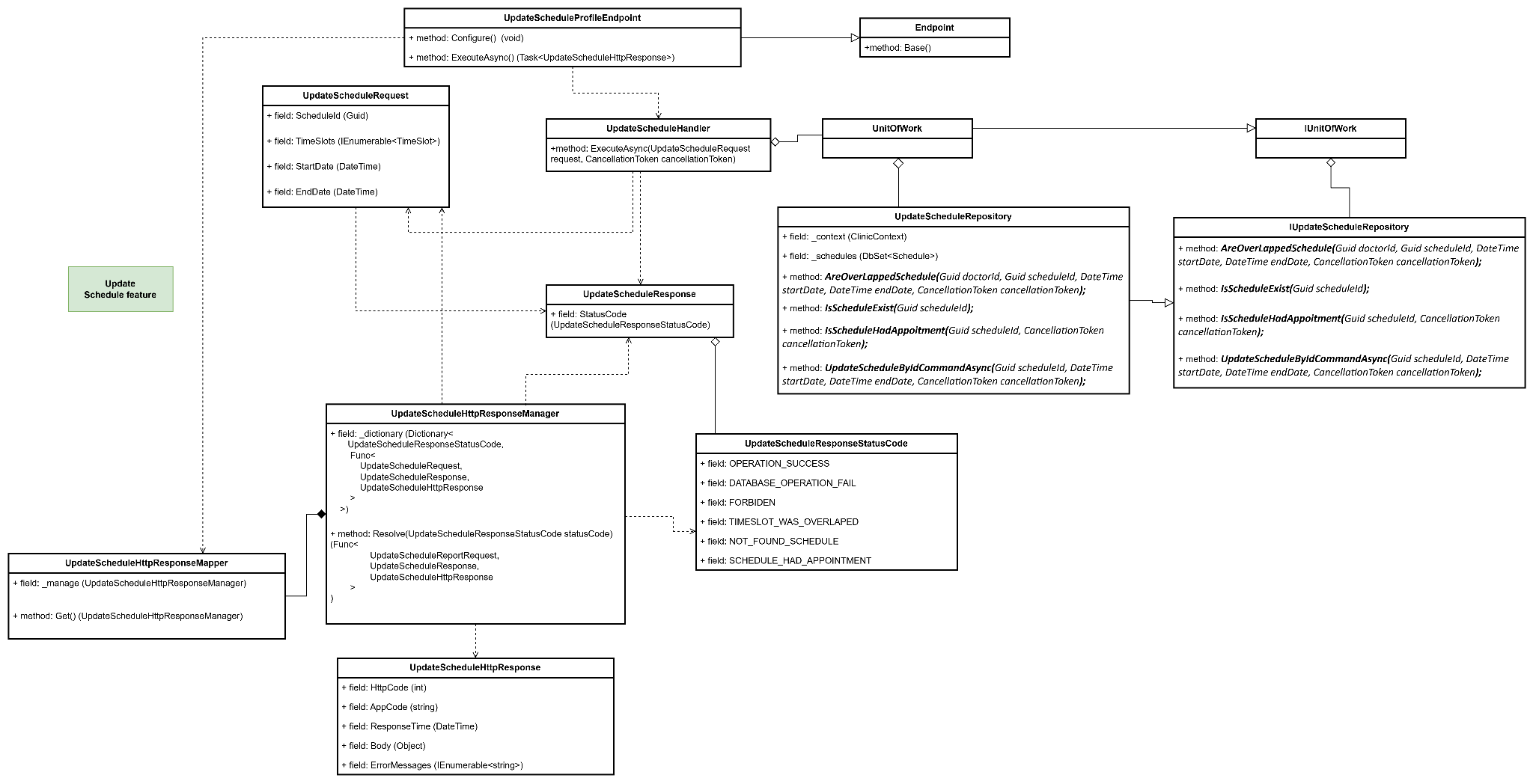

#### b. Class Specifications

#### UpdateScheduleEndpoint class

* 1. *Same as common given before,* [*review here*](https://docs.google.com/document/d/1tTZUy0kDp6tdHb6MY85cNBVlDSK0k0N9w2NXBLPTu-c/edit?fbclid=IwY2xjawGRuZpleHRuA2FlbQIxMAABHUWj7GBmcsB0TEQOSeFgkcMlTv6kK6aEkUnExmkf0x_20x3n5Tikj9MvPA_aem_7Ik47wBVUygzT8J9mpiG0w#heading=h.m7r87enxie2d)*.*

1. ***Endpoint abstract class***
   1. *Same as common given before,* [*review here*](https://docs.google.com/document/d/1tTZUy0kDp6tdHb6MY85cNBVlDSK0k0N9w2NXBLPTu-c/edit?fbclid=IwY2xjawGRuZpleHRuA2FlbQIxMAABHUWj7GBmcsB0TEQOSeFgkcMlTv6kK6aEkUnExmkf0x_20x3n5Tikj9MvPA_aem_7Ik47wBVUygzT8J9mpiG0w#heading=h.ac857vak9ccs)*.*
2. ***UpdateScheduleValidator class***
   1. *Same as common given before,* [*review here*](https://docs.google.com/document/d/1tTZUy0kDp6tdHb6MY85cNBVlDSK0k0N9w2NXBLPTu-c/edit?fbclid=IwY2xjawGRuZpleHRuA2FlbQIxMAABHUWj7GBmcsB0TEQOSeFgkcMlTv6kK6aEkUnExmkf0x_20x3n5Tikj9MvPA_aem_7Ik47wBVUygzT8J9mpiG0w#heading=h.mapewhyr52db)*.*
3. ***UpdateScheduleHandler class***
   1. *Same as common given before,* [*review here*](https://docs.google.com/document/d/1tTZUy0kDp6tdHb6MY85cNBVlDSK0k0N9w2NXBLPTu-c/edit?fbclid=IwY2xjawGRuZpleHRuA2FlbQIxMAABHUWj7GBmcsB0TEQOSeFgkcMlTv6kK6aEkUnExmkf0x_20x3n5Tikj9MvPA_aem_7Ik47wBVUygzT8J9mpiG0w#heading=h.3lfr3mcrnl8j)*.*
4. ***IUnitOfWork interface***
   1. *Same as common given before,* [*review here*](https://docs.google.com/document/d/1tTZUy0kDp6tdHb6MY85cNBVlDSK0k0N9w2NXBLPTu-c/edit?fbclid=IwY2xjawGRuZpleHRuA2FlbQIxMAABHUWj7GBmcsB0TEQOSeFgkcMlTv6kK6aEkUnExmkf0x_20x3n5Tikj9MvPA_aem_7Ik47wBVUygzT8J9mpiG0w#heading=h.plvhy3azezgm)*.*
5. ***UnitOfWork class***
   1. *Same as common given before,* [*review here*](https://docs.google.com/document/d/1tTZUy0kDp6tdHb6MY85cNBVlDSK0k0N9w2NXBLPTu-c/edit?fbclid=IwY2xjawGRuZpleHRuA2FlbQIxMAABHUWj7GBmcsB0TEQOSeFgkcMlTv6kK6aEkUnExmkf0x_20x3n5Tikj9MvPA_aem_7Ik47wBVUygzT8J9mpiG0w#heading=h.75tksa2v2ybj)*.*
6. ***UpdateScheduleRequest class***

| **No** | **Fields** | **Description** |
| --- | --- | --- |
| *01* | *ScheduleId* | *Id of schedule which want to update* |
| *02* | *StartDate* | *Start time of schedule (7:30)* |
| *03* | *EndDate* | *End time of schedule (9:30)* |

1. ***UpdateScheduleResponse class***

| **No** | **Fields** | **Description** |
| --- | --- | --- |
| *01* | *StatusCode* | *This field will return an app code and http code.* |

1. ***UpdateScheduleResponseStatusCode Enum class***

This enum class contains some necessary app code like OPERATION_SUCCESS, DATABASE_OPERATION_FAIL, FORBIDDEN, SCHEDULE_WAS_OVERLAPED, NOT_FOUND_SCHEDULE, SCHEDULE_HAD_APPOINTMENT.... Purpose to handle response with specifically code of errors.

1. ***IUpdateScheduleRepository interface***

This interface class contains method to interact with database

| **No** | **Method** | **Description** |
| --- | --- | --- |
| *01* | ***AreOverLappedSchedule(****Guid doctorId, Guid scheduleId, DateTime startDate, DateTime endDate, CancellationToken cancellationToken****);*** | *Defines a method to check schedules is overlapped or not* |
| *02* | ***IsScheduleExist(****Guid scheduleId****);*** | *Defines a method to check schedules is existed or not* |
| *03* | ***IsScheduleHadAppoitment(****Guid scheduleId, CancellationToken cancellationToken****);*** | *Defines a method to check schedules is already had appointment or not* |
| *04* | ***UpdateScheduleByIdCommandAsync(****Guid scheduleId, DateTime startDate, DateTime endDate, CancellationToken cancellationToken****);*** | *Defines a method to update schedule by id* |

1. ***UpdateScheduleRepository***

This class is an implementation of the *ICreateScheduleRepository* interface***.***

| **No** | **Fields** | **Description** |
| --- | --- | --- |
| *01* | *_context* | *This field is database context* |
| *02* | *_schedules* | *Property to interact with the Schdules table in the database* |

| **No** | **Method** | **Description** |
| --- | --- | --- |
| *01* | ***AreOverLappedSchedule(****Guid doctorId, Guid scheduleId, DateTime startDate, DateTime endDate, CancellationToken cancellationToken****);*** | *Execute statements that interact with the database and return the desired value* |
| *02* | ***IsScheduleExist(****Guid scheduleId****);*** | *Execute statements that interact with the database and return the desired value* |
| *03* | ***IsScheduleHadAppoitment(****Guid scheduleId, CancellationToken cancellationToken****);*** | *Execute statements that interact with the database and return the desired value* |
| *04* | ***UpdateScheduleByIdCommandAsync(****Guid scheduleId, DateTime startDate, DateTime endDate, CancellationToken cancellationToken****);*** | *Execute statements that interact with the database and return the desired value* |

#### c. Sequence Diagram(s)

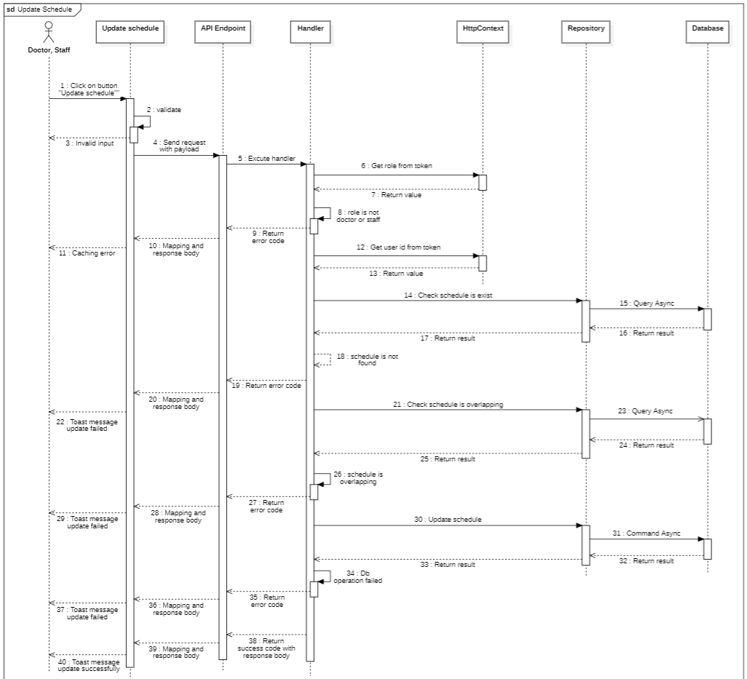

#### d. Database Queries

**public async Task<bool> AreOverLappedSchedule**(Guid doctorId, Guid scheduleId, DateTime startDate, DateTime endDate, CancellationToken cancellationToken)

{

var existSchedules = await _schedules

.Where(predicate: schedule => schedule.DoctorId == doctorId && schedule.Id != scheduleId)

.ToListAsync(cancellationToken: cancellationToken);

foreach (var schedule in existSchedules)

{

if (schedule.StartDate < endDate

&& startDate < schedule.EndDate)

{

return true;

}

}

return false;

}

**public Task<bool> IsScheduleExist**(Guid scheduleId)

{

return _schedules

.AnyAsync(schedule => schedule.Id == scheduleId);

}

**public async Task<bool> IsScheduleHadAppoitment**(Guid scheduleId, CancellationToken cancellationToken)

{

return await _schedules

.AnyAsync(schedule => schedule.Id == scheduleId && schedule.Appointment != null);

}

**public async Task<bool> UpdateScheduleByIdCommandAsync**(Guid scheduleId, DateTime startDate, DateTime endDate, CancellationToken cancellationToken)

{

var schedule = await _schedules

.FirstOrDefaultAsync(schedule => schedule.Id == scheduleId, cancellationToken);

if (schedule == null)

{

return false;

}

schedule.StartDate = startDate;

schedule.EndDate = endDate;

await _context.SaveChangesAsync(cancellationToken);

return true;

}

### 6.2 Get schedule By Date

#### a. Class diagram

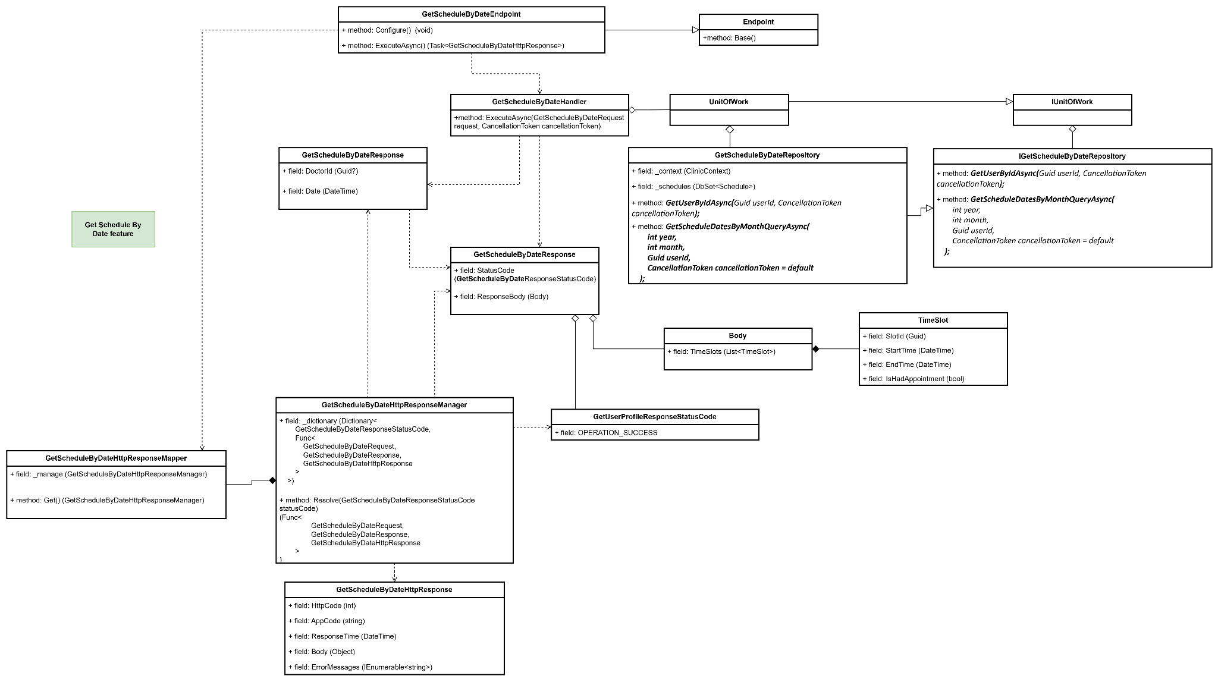

#### b. Class Specifications

#### GetScheduleByDateEndpoint class

* 1. *Same as common given before,* [*review here*](https://docs.google.com/document/d/1tTZUy0kDp6tdHb6MY85cNBVlDSK0k0N9w2NXBLPTu-c/edit?fbclid=IwY2xjawGRuZpleHRuA2FlbQIxMAABHUWj7GBmcsB0TEQOSeFgkcMlTv6kK6aEkUnExmkf0x_20x3n5Tikj9MvPA_aem_7Ik47wBVUygzT8J9mpiG0w#heading=h.m7r87enxie2d)*.*

1. ***Endpoint abstract class***
   1. *Same as common given before,* [*review here*](https://docs.google.com/document/d/1tTZUy0kDp6tdHb6MY85cNBVlDSK0k0N9w2NXBLPTu-c/edit?fbclid=IwY2xjawGRuZpleHRuA2FlbQIxMAABHUWj7GBmcsB0TEQOSeFgkcMlTv6kK6aEkUnExmkf0x_20x3n5Tikj9MvPA_aem_7Ik47wBVUygzT8J9mpiG0w#heading=h.ac857vak9ccs)*.*
2. ***GetScheduleByDateValidator class***
   1. *Same as common given before,* [*review here*](https://docs.google.com/document/d/1tTZUy0kDp6tdHb6MY85cNBVlDSK0k0N9w2NXBLPTu-c/edit?fbclid=IwY2xjawGRuZpleHRuA2FlbQIxMAABHUWj7GBmcsB0TEQOSeFgkcMlTv6kK6aEkUnExmkf0x_20x3n5Tikj9MvPA_aem_7Ik47wBVUygzT8J9mpiG0w#heading=h.mapewhyr52db)*.*
3. ***GetScheduleByDateHandler class***
   1. *Same as common given before,* [*review here*](https://docs.google.com/document/d/1tTZUy0kDp6tdHb6MY85cNBVlDSK0k0N9w2NXBLPTu-c/edit?fbclid=IwY2xjawGRuZpleHRuA2FlbQIxMAABHUWj7GBmcsB0TEQOSeFgkcMlTv6kK6aEkUnExmkf0x_20x3n5Tikj9MvPA_aem_7Ik47wBVUygzT8J9mpiG0w#heading=h.3lfr3mcrnl8j)*.*
4. ***IUnitOfWork interface***
   1. *Same as common given before,* [*review here*](https://docs.google.com/document/d/1tTZUy0kDp6tdHb6MY85cNBVlDSK0k0N9w2NXBLPTu-c/edit?fbclid=IwY2xjawGRuZpleHRuA2FlbQIxMAABHUWj7GBmcsB0TEQOSeFgkcMlTv6kK6aEkUnExmkf0x_20x3n5Tikj9MvPA_aem_7Ik47wBVUygzT8J9mpiG0w#heading=h.plvhy3azezgm)*.*
5. ***UnitOfWork class***
   1. *Same as common given before,* [*review here*](https://docs.google.com/document/d/1tTZUy0kDp6tdHb6MY85cNBVlDSK0k0N9w2NXBLPTu-c/edit?fbclid=IwY2xjawGRuZpleHRuA2FlbQIxMAABHUWj7GBmcsB0TEQOSeFgkcMlTv6kK6aEkUnExmkf0x_20x3n5Tikj9MvPA_aem_7Ik47wBVUygzT8J9mpiG0w#heading=h.75tksa2v2ybj)*.*
6. ***GetScheduleByDateRequest class***

| **No** | **Fields** | **Description** |
| --- | --- | --- |
| *01* | *DoctorId* | *Id of doctor which you want to get schedule* |
| *02* | *Date* | *Date which you want to get schedule* |

1. ***GetScheduleByDateResponse class***

| **No** | **Fields** | **Description** |
| --- | --- | --- |
| *01* | *StatusCode* | *This field will return an app code and http code.* |
| *02* | *ResponseBody* | *Contains the main data body of the response, which includes the list of appointments, represented by Body.* |

***8.1 Body inner class***

| **No** | **Fields** | **Description** |
| --- | --- | --- |
| *01* | *TimeSlots* | *A list of TimeSlot object* |

***8.2 TimeSlot******inner class***

| **No** | **Fields** | **Description** |
| --- | --- | --- |
| *01* | *SlotId* | *Id of schedule slot* |
| *02* | *StartTime* | *StartTime of shedule slot* |
| *03* | *EndTime* | *EndTime of schedule slot* |
| *04* | *IsHadAppointment* | *Return slot is had appointment or not* |

1. ***GetScheduleByDateResponseStatusCode Enum class***

This enum class contains some necessary app code like OPERATION_SUCCESS, .... Purpose to handle response with specifically code of errors.

1. ***IGetScheduleByDateRepository interface***

This interface class contains method to interact with database

| **No** | **Method** | **Description** |
| --- | --- | --- |
| *01* | ***GetSchedulesByDateQueryAsync(***  *Guid doctorId,*  *DateTime startDate,*  *DateTime endDate,*  *CancellationToken cancellationToken = default*  ***);*** | *Defines a method to get schedule by date and doctorId* |

1. ***GetScheduleByDateRepository***

This class is an implementation of the *ICreateScheduleRepository* interface***.***

| **No** | **Fields** | **Description** |
| --- | --- | --- |
| *01* | *_context* | *This field is database context* |
| *02* | *_schedules* | *Property to interact with the Schdeules table in the database* |

| **No** | **Method** | **Description** |
| --- | --- | --- |
| *01* | ***GetSchedulesByDateQueryAsync(***  *Guid doctorId,*  *DateTime startDate,*  *DateTime endDate,*  *CancellationToken cancellationToken = default*  ***);*** | *Execute statements that interact with the database and return the desired value* |

#### c. Sequence Diagram(s)

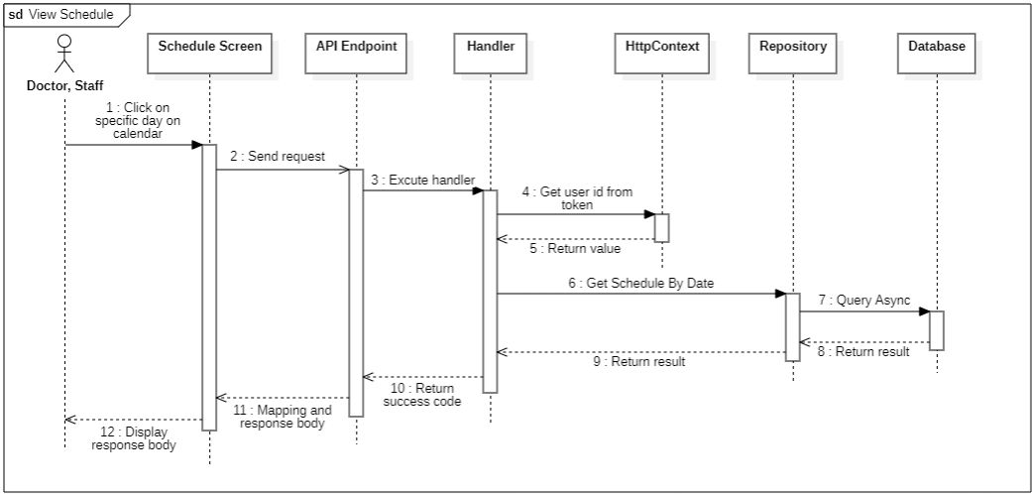

#### d. Database Queries

public async Task<IEnumerable<Schedule>> GetSchedulesByDateQueryAsync(

Guid doctorId,

DateTime startDate,

DateTime endDate,

CancellationToken cancellationToken = default

)

{

return await _schedules

.Where(entity =>

entity.StartDate >= startDate

&& entity.EndDate <= endDate

&& entity.DoctorId == doctorId

)

.Select(entity => new Schedule()

{

Id = entity.Id,

StartDate = entity.StartDate,

EndDate = entity.EndDate,

Appointment = entity.Appointment.ScheduleId == entity.Id ? entity.Appointment : null

})

.ToListAsync(cancellationToken);

}

### 6.3 Remove all schedule by date

#### a. Class diagram

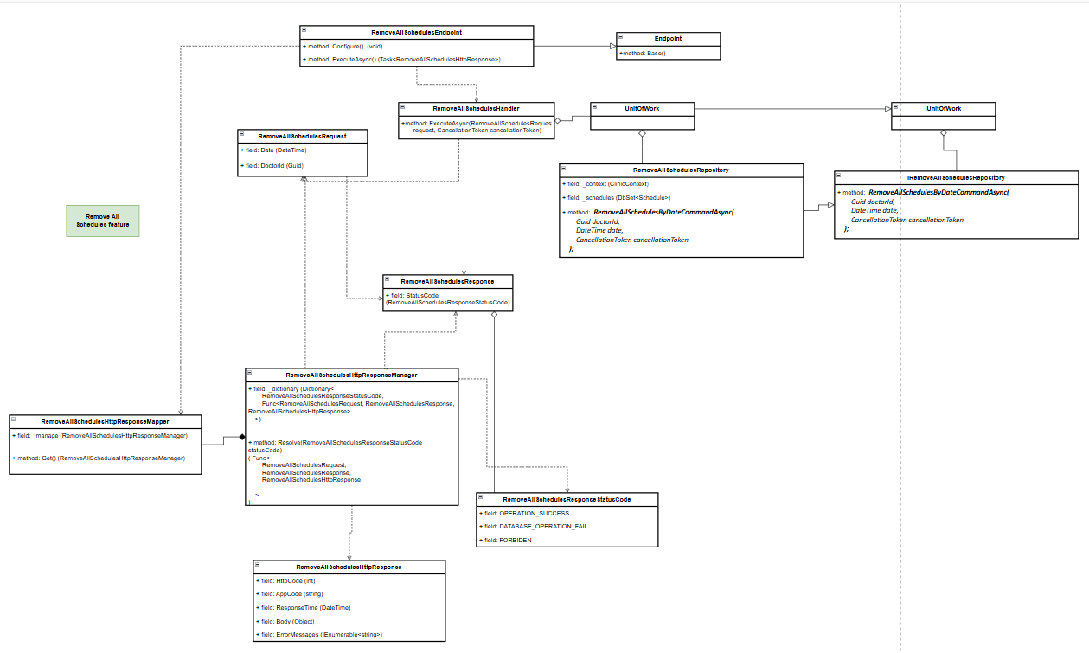

#### b. Class Specifications

1. ***RemoveAllScheduleEndpoint class***

*a.* *Same as common given before,* [*review here*](https://docs.google.com/document/d/1tTZUy0kDp6tdHb6MY85cNBVlDSK0k0N9w2NXBLPTu-c/edit?fbclid=IwY2xjawGRuZpleHRuA2FlbQIxMAABHUWj7GBmcsB0TEQOSeFgkcMlTv6kK6aEkUnExmkf0x_20x3n5Tikj9MvPA_aem_7Ik47wBVUygzT8J9mpiG0w#heading=h.m7r87enxie2d)*.*

1. ***Endpoint abstract class***

*a.* *Same as common given before,* [*review here*](https://docs.google.com/document/d/1tTZUy0kDp6tdHb6MY85cNBVlDSK0k0N9w2NXBLPTu-c/edit?fbclid=IwY2xjawGRuZpleHRuA2FlbQIxMAABHUWj7GBmcsB0TEQOSeFgkcMlTv6kK6aEkUnExmkf0x_20x3n5Tikj9MvPA_aem_7Ik47wBVUygzT8J9mpiG0w#heading=h.ac857vak9ccs)*.*

1. ***RemoveAllScheduleValidator class***

*a.* *Same as common given before,* [*review here*](https://docs.google.com/document/d/1tTZUy0kDp6tdHb6MY85cNBVlDSK0k0N9w2NXBLPTu-c/edit?fbclid=IwY2xjawGRuZpleHRuA2FlbQIxMAABHUWj7GBmcsB0TEQOSeFgkcMlTv6kK6aEkUnExmkf0x_20x3n5Tikj9MvPA_aem_7Ik47wBVUygzT8J9mpiG0w#heading=h.mapewhyr52db)*.*

1. ***RemoveAllScheduleHandler class***

*a.* *Same as common given before,* [*review here*](https://docs.google.com/document/d/1tTZUy0kDp6tdHb6MY85cNBVlDSK0k0N9w2NXBLPTu-c/edit?fbclid=IwY2xjawGRuZpleHRuA2FlbQIxMAABHUWj7GBmcsB0TEQOSeFgkcMlTv6kK6aEkUnExmkf0x_20x3n5Tikj9MvPA_aem_7Ik47wBVUygzT8J9mpiG0w#heading=h.3lfr3mcrnl8j)*.*

1. ***IUnitOfWork interface***

*a.* *Same as common given before,* [*review here*](https://docs.google.com/document/d/1tTZUy0kDp6tdHb6MY85cNBVlDSK0k0N9w2NXBLPTu-c/edit?fbclid=IwY2xjawGRuZpleHRuA2FlbQIxMAABHUWj7GBmcsB0TEQOSeFgkcMlTv6kK6aEkUnExmkf0x_20x3n5Tikj9MvPA_aem_7Ik47wBVUygzT8J9mpiG0w#heading=h.plvhy3azezgm)*.*

1. ***UnitOfWork class***

*a.* *Same as common given before,* [*review here*](https://docs.google.com/document/d/1tTZUy0kDp6tdHb6MY85cNBVlDSK0k0N9w2NXBLPTu-c/edit?fbclid=IwY2xjawGRuZpleHRuA2FlbQIxMAABHUWj7GBmcsB0TEQOSeFgkcMlTv6kK6aEkUnExmkf0x_20x3n5Tikj9MvPA_aem_7Ik47wBVUygzT8J9mpiG0w#heading=h.75tksa2v2ybj)*.*

1. ***RemoveAllScheduleRequest class***

| **No** | **Fields** | **Description** |
| --- | --- | --- |
| *01* | *DoctorId* | *Identifier for the doctor whose schedules should be removed on the specified date.* |
| *02* | *Date* | *Specifies the date for which all schedules are to be removed.* |

***8.*** ***RemoveAllScheduleResponse class***

| **No** | **Fields** | **Description** |
| --- | --- | --- |
| *01* | *StatusCode* | *This field will return an app code and http code.* |

***9.*** ***RemoveAllScheduleResponseStatusCode Enum class***

This enum class contains some necessary app code like DATABASE_OPERATION_FAIL, FORBIDDEN, OPERATION_SUCCESS, .... Purpose to handle response with specifically code of errors.

***10.*** ***IRemoveAllScheduleRepository interface***

This interface class contains method to interact with database

| **No** | **Method** | **Description** |
| --- | --- | --- |
| *01* | ***Task<bool> RemoveAllSchedulesByDateCommandAsync(***  *Guid doctorId,*  *DateTime date,*  *CancellationToken cancellationToken*  ***);*** | *Defines a method to remove all schedules for a specific doctor on a given date.* |

***11.*** ***GetScheduleByDateRepository***

This class is an implementation of the *ICreateScheduleRepository* interface***.***

| **No** | **Fields** | **Description** |
| --- | --- | --- |
| *01* | *_context* | *This field is database context* |
| *02* | *_schedules* | *Property to interact with the Schedules table in the database* |

| **No** | **Method** | **Description** |
| --- | --- | --- |
| *01* | ***public async Task<bool> RemoveAllSchedulesByDateCommandAsync(***  *Guid doctorId,*  *DateTime date,*  *CancellationToken cancellationToken*  ***)*** | *Executes the command to remove all schedules for a specified doctor on the provided date, filtering out any schedules with associated appointments. Returns true if successful, false otherwise.* |

#### c. Sequence Diagram(s)

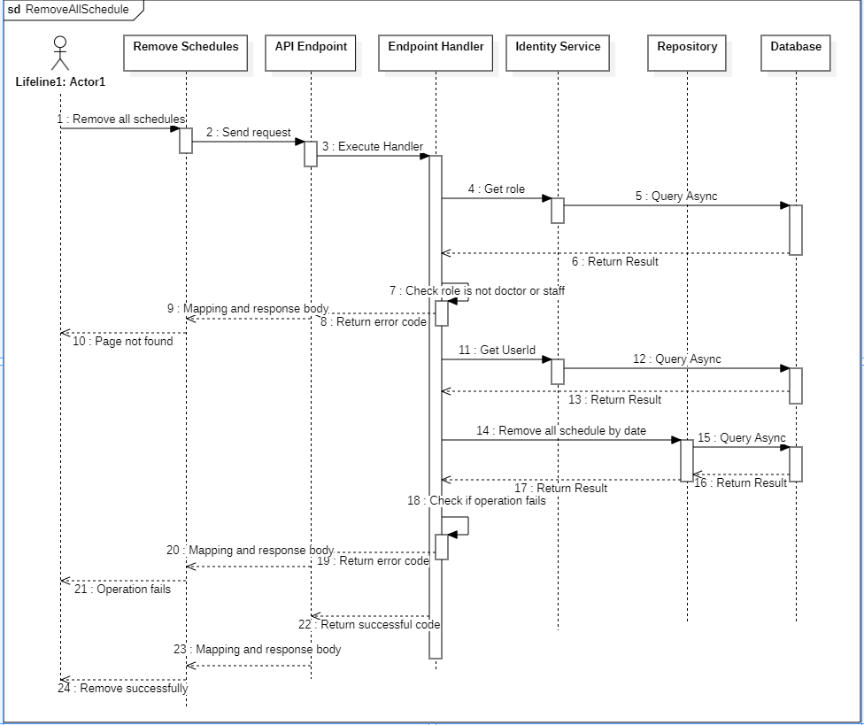

#### d. Database Queries

**public async Task<bool> RemoveAllSchedulesByDateCommandAsync(Guid doctorId, DateTime date, CancellationToken cancellationToken)**

{

// handle date

DateTime startDate = date.Date;

DateTime endDate = date.Date.AddDays(1).AddTicks(-1);

// find all schedule not having appointment on specific date

var schedules = await _schedules

.Where(schedule => schedule.DoctorId == doctorId &&

schedule.StartDate >= startDate &&

schedule.StartDate < endDate &&

schedule.Appointment == null

)

.ToListAsync(cancellationToken);

if (schedules.Count == 0)

{

return false;

}

// Remove all schedule not having appointment on specific date

_schedules.RemoveRange(schedules);

await _context.SaveChangesAsync(cancellationToken);

return true;

}

## 7. Medical report

### 7.1. Get the medical report by ID

#### a. Class diagram

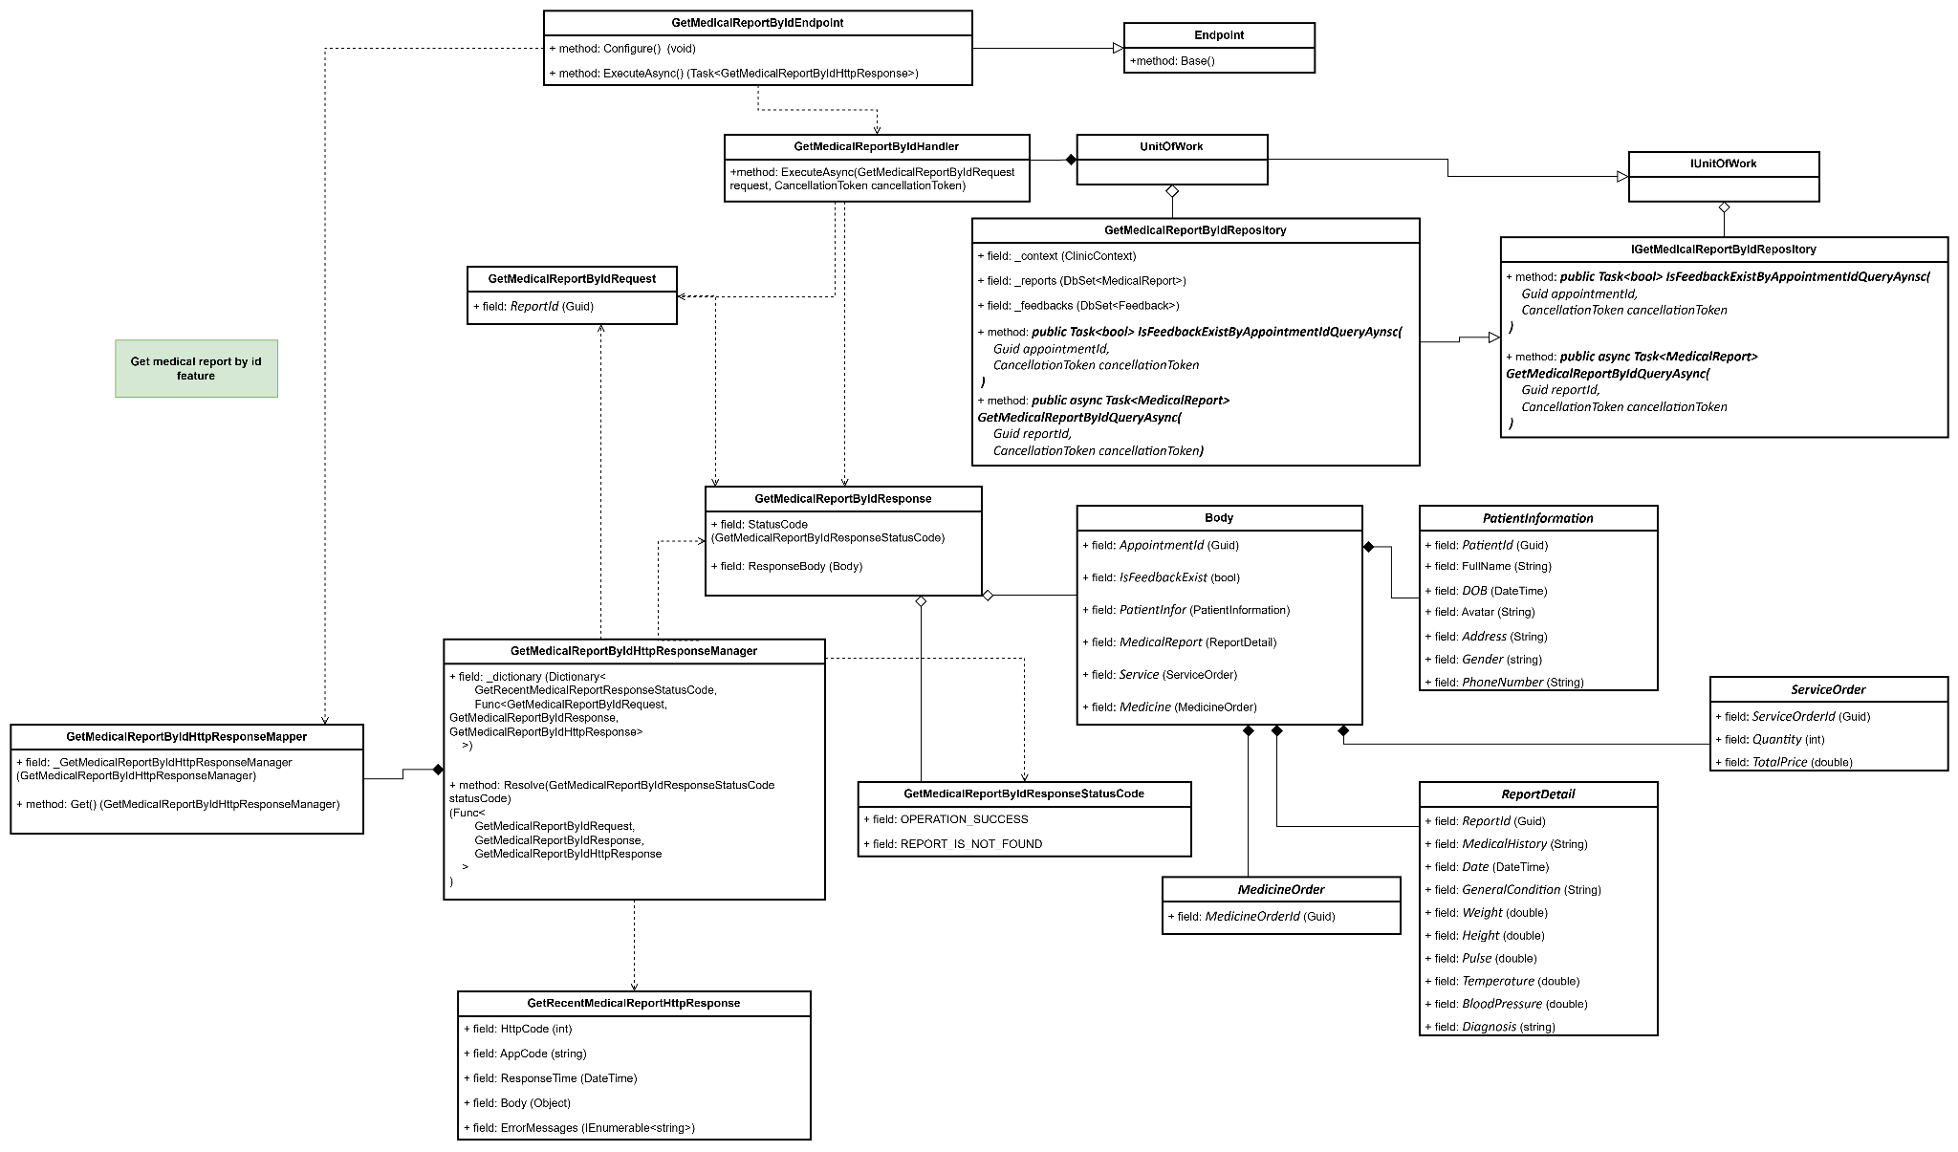

#### b. Class Specifications

#### GetMedicalReportByIdEndpoint class

* 1. *Same as common given before,* [*review here*](https://docs.google.com/document/d/1tTZUy0kDp6tdHb6MY85cNBVlDSK0k0N9w2NXBLPTu-c/edit?fbclid=IwY2xjawGRuZpleHRuA2FlbQIxMAABHUWj7GBmcsB0TEQOSeFgkcMlTv6kK6aEkUnExmkf0x_20x3n5Tikj9MvPA_aem_7Ik47wBVUygzT8J9mpiG0w#heading=h.m7r87enxie2d)*.*

1. ***Endpoint abstract class***
   1. *Same as common given before,* [*review here*](https://docs.google.com/document/d/1tTZUy0kDp6tdHb6MY85cNBVlDSK0k0N9w2NXBLPTu-c/edit?fbclid=IwY2xjawGRuZpleHRuA2FlbQIxMAABHUWj7GBmcsB0TEQOSeFgkcMlTv6kK6aEkUnExmkf0x_20x3n5Tikj9MvPA_aem_7Ik47wBVUygzT8J9mpiG0w#heading=h.ac857vak9ccs)*.*
2. ***GetMedicalReportByIdValidator class***
   1. *Same as common given before,* [*review here*](https://docs.google.com/document/d/1tTZUy0kDp6tdHb6MY85cNBVlDSK0k0N9w2NXBLPTu-c/edit?fbclid=IwY2xjawGRuZpleHRuA2FlbQIxMAABHUWj7GBmcsB0TEQOSeFgkcMlTv6kK6aEkUnExmkf0x_20x3n5Tikj9MvPA_aem_7Ik47wBVUygzT8J9mpiG0w#heading=h.mapewhyr52db)*.*
3. ***GetMedicalReportByIdHandler class***
   1. *Same as common given before,* [*review here*](https://docs.google.com/document/d/1tTZUy0kDp6tdHb6MY85cNBVlDSK0k0N9w2NXBLPTu-c/edit?fbclid=IwY2xjawGRuZpleHRuA2FlbQIxMAABHUWj7GBmcsB0TEQOSeFgkcMlTv6kK6aEkUnExmkf0x_20x3n5Tikj9MvPA_aem_7Ik47wBVUygzT8J9mpiG0w#heading=h.3lfr3mcrnl8j)*.*
4. ***IUnitOfWork interface***
   1. *Same as common given before,* [*review here*](https://docs.google.com/document/d/1tTZUy0kDp6tdHb6MY85cNBVlDSK0k0N9w2NXBLPTu-c/edit?fbclid=IwY2xjawGRuZpleHRuA2FlbQIxMAABHUWj7GBmcsB0TEQOSeFgkcMlTv6kK6aEkUnExmkf0x_20x3n5Tikj9MvPA_aem_7Ik47wBVUygzT8J9mpiG0w#heading=h.plvhy3azezgm)*.*
5. ***UnitOfWork class***
   1. *Same as common given before,* [*review here*](https://docs.google.com/document/d/1tTZUy0kDp6tdHb6MY85cNBVlDSK0k0N9w2NXBLPTu-c/edit?fbclid=IwY2xjawGRuZpleHRuA2FlbQIxMAABHUWj7GBmcsB0TEQOSeFgkcMlTv6kK6aEkUnExmkf0x_20x3n5Tikj9MvPA_aem_7Ik47wBVUygzT8J9mpiG0w#heading=h.75tksa2v2ybj)*.*
6. ***GetMedicalReportByIdRequest class***

| **No** | **Fields** | **Description** |
| --- | --- | --- |
| *01* | *ReportId* | *Id of medical report which you want to get.* |

1. ***GetMedicalReportByIdResponse class***

| **No** | **Fields** | **Description** |
| --- | --- | --- |
| *01* | *StatusCode* | *This field will return an app code and http code.* |
| *02* | *ResponseBody* | *Contains the main data body of the response* |

1. ***Body class***

| **No** | **Fields** | **Description** |
| --- | --- | --- |
| *01* | *AppointmentId* | *Unique identifier for the appointment.* |
| *02* | *IsFeedbackExist* | *Flag indicating if feedback is available.* |
| *03* | *PatientInfor* | *Nested class with patient's details (e.g., ID, name, DOB, contact).* |
| *04* | *MedicalReport* | *Nested class with report specifics like diagnosis, vitals, and medical history.* |
| *05* | *Service* | *Nested class with service order details (ID, quantity, price).* |
| *06* | *Medicine* | *Nested class with medicine order ID.* |

1. ***PatientInformation class***

| **No** | **Fields** | **Description** |
| --- | --- | --- |
| *01* | *PatientId* | *Unique identifier for the patient.* |
| *02* | *FullName* | *Full name of the patient.* |
| *03* | *DOB* | *Date of birth of the patient.* |
| *04* | *Avatar* | *URL or path to the patient’s avatar image.* |
| *05* | *Address* | *Patient's address.* |
| *06* | *Gender* | *Patient’s gender.* |
| *07* | *PhoneNumber* | *Patient's contact phone number* |

1. ***ReportDetail Class***

| **No** | **Fields** | **Description** |
| --- | --- | --- |
| *01* | *ReportId* | *Unique identifier for the medical report.* |
| *02* | *Date* | *Date of the medical report.* |
| *03* | *MedicalHistory* | *Patient's medical history.* |
| *04* | *GeneralCondition* | *Summary of the patient's general condition.* |
| *05* | *Weight* | *Patient's weight.* |
| *06* | *Height* | *Patient's height.* |
| *07* | *Pulse* | *Patient's pulse rate.* |
| *08* | *Temperature* | *Patient's body temperature.* |
| *09* | *BloodPressure* | *Patient's blood pressure reading.* |
| *10* | *Diagnosis* | *Diagnosis given during the appointment.* |

1. ***ServiceOrder class***

| **No** | **Fields** | **Description** |
| --- | --- | --- |
| *01* | *ServiceOrderId* | *Unique identifier for the service order.* |
| *02* | *Quantity* | *Quantity of services ordered.* |
| *03* | *TotalPrice* | *Total cost of the service order.* |

1. ***MedicineOrder class***

| **No** | **Fields** | **Description** |
| --- | --- | --- |
| *01* | *MedicineOrderId* | *Unique identifier for the medicine order.* |

1. ***GetMedicalReportByIdResponseStatusCode Enum class***

This enum class contains some necessary app code like OPERATION_SUCCESS and REPORT_IS_NOT_FOUND,.... Purpose to handle response with specifically code of errors.

1. ***IGetMedicalReportByIdRepository interface***

This interface class contains method to interact with database

| **No** | **Method** | **Description** |
| --- | --- | --- |
| *01* | ***public Task<bool> IsFeedbackExistByAppointmentIdQueryAynsc(***  *Guid appointmentId,*  *CancellationToken cancellationToken*  ***)*** | *Defines a method to check if feedback exists for a specific appointment, based on the appointmentId* |
| *02* | ***public async Task<MedicalReport> GetMedicalReportByIdQueryAsync(***  *Guid reportId,*  *CancellationToken cancellationToken*  ***)*** | *Defines a method to retrieve a MedicalReport object by its reportId, including comprehensive data about the report and associated entities such as appointment details, patient information, service order, and medicine order.* |

1. ***GetMedicalReportByIdRepository***

This class is an implementation of the *ICreateScheduleRepository* interface***.***

| **No** | **Fields** | **Description** |
| --- | --- | --- |
| *01* | *_context* | *This field is database context* |
| *02* | *_reports* | *Property to interact with the MedicalReports table in the database* |
| *03* | *_feedbacks* | *Property to interact with the Feedbacks table in the database* |

| **No** | **Method** | **Description** |
| --- | --- | --- |
| *01* | ***public Task<bool> IsFeedbackExistByAppointmentIdQueryAynsc(***  *Guid appointmentId,*  *CancellationToken cancellationToken*  ***)*** | *Execute statements that interact with the database and return the desired value* |
| *02* | ***public async Task<MedicalReport> GetMedicalReportByIdQueryAsync(***  *Guid reportId,*  *CancellationToken cancellationToken*  ***)*** | *Execute statements that interact with the database and return the desired value* |

#### c. Sequence Diagram(s)

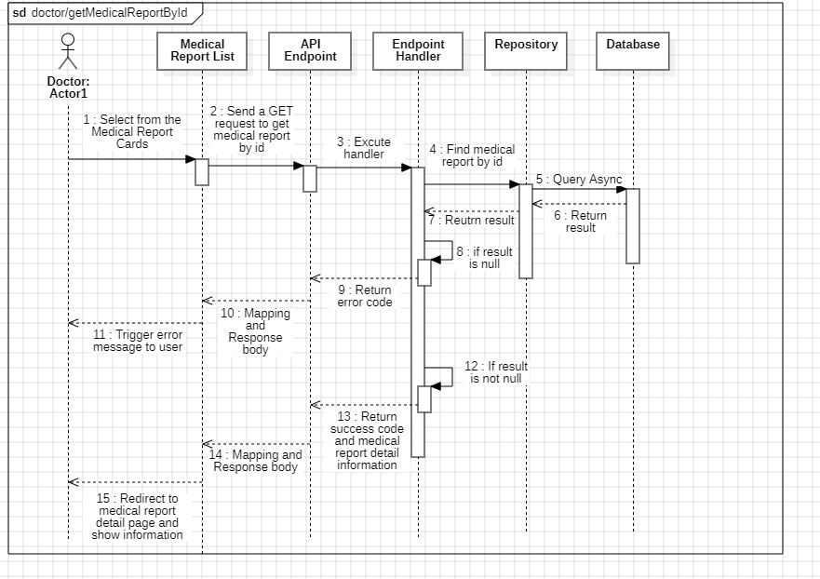

#### d. Database Queries

**public Task<bool> IsFeedbackExistByAppointmentIdQueryAynsc(**

**Guid appointmentId,**

**CancellationToken cancellationToken**

**)**

{

return _feedbacks.AnyAsync(

predicate: feedback => feedback.AppointmentId == appointmentId,

cancellationToken: cancellationToken

);

}

**public async Task<MedicalReport> GetMedicalReportByIdQueryAsync(**

**Guid reportId,**

**CancellationToken cancellationToken**

**)**

{

return await _reports

.Where(report => report.Id == reportId)

.Select(report => new MedicalReport()

{

Id = report.Id,

Diagnosis = report.Diagnosis,

MedicalHistory = report.MedicalHistory,

BloodPresser = report.BloodPresser,

Pulse = report.Pulse,

Temperature = report.Temperature,

Weight = report.Weight,

Height = report.Height,

GeneralCondition = report.GeneralCondition,

AppointmentId = report.AppointmentId,

Appointment = new Appointment()

{

Schedule = new Schedule() { StartDate = report.Appointment.Schedule.StartDate },

Patient = new Patient()

{

User = new User() { Avatar = report.Appointment.Patient.User.Avatar },

},

},

PatientInformation = new PatientInformation()

{

Id = report.PatientInformation.Id,

Gender = report.PatientInformation.Gender,

Address = report.PatientInformation.Address,

DOB = report.PatientInformation.DOB,

FullName = report.PatientInformation.FullName,

PhoneNumber = report.PatientInformation.PhoneNumber,

},

ServiceOrder = new ServiceOrder()

{

Id = report.ServiceOrder.Id,

Quantity = report.ServiceOrder.Quantity,

TotalPrice = report.ServiceOrder.TotalPrice,

},

MedicineOrder = new MedicineOrder() { Id = report.MedicineOrder.Id },

})

.FirstOrDefaultAsync();

}

## 

### 7.2. Create new medical report

#### a. Class diagram

#### b. Class Specifications

#### CreateMedialReport class

*Same as common given before,* *review here**.*

1. ***Endpoint abstract class***

*Same as common given before,* *review here**.*

1. ***CreateMedialReportValidator class***

*Same as common given before,* *review here**.*

1. ***CreateMedialReportHandler class***

*Same as common given before,* *review here**.*

1. ***IUnitOfWork interface***

*Same as common given before,* *review here**.*

1. ***UnitOfWork class***

*Same as common given before,* *review here**.*

1. ***CreateMedialReportRequest class***

*This class is a Request DTO class that handles the necessary fields to register an user.*

| **No** | **Fields** | **Description** |
| --- | --- | --- |
| *01* | *PatientID* | *This field requires the entry of a unique identifier for the patient, such as a generated Patient ID.* |
| *02* | *AppointmentID* | *Requires a unique identifier for each appointment, e.g., a numeric or alphanumeric code.* |
| *03* | *Name* | *This field should contain the full name of the patient.* |
| *04* | *MedicalHistory* | *Contains relevant information about past medical history, including conditions, treatments, etc.* |
| *05* | *GeneralCondition* | *Notes on the patient's current general condition, e.g., "Good," "Stable," "Needs Attention."* |
| *06* | *Weight* | *Patient's weight in kilograms (kg).* |
| *07* | *Height* | *Patient's height is centimeters (cm).* |
| *08* | *Pulse* | *Current pulse rate in beats per minute (bpm).* |
| *09* | *Temperature* | *Patient's body temperature in degrees Celsius (°C).* |
| *10* | *BloodPresser* | *Blood pressure reading in mmHg, e.g., "120/80."* |
| *11* | *Diagnosis* | *The doctor’s diagnosis of the patient’s current condition.* |

1. ***CreateMedialReportResponse class***

| **No** | **Fields** | **Description** |
| --- | --- | --- |
| *01* | *StatusCode* | *This field will return an app code and http code.* |
| *02* | *Body* | *This field will return a response value* |

1. ***CreateMedialReportResponseStatusCode Enum class***

This enum class contains some necessary app code like APPOINTMENT_IS_NOT_FOUND, FORBIDEN_ACCESS,.... Purpose to handle response with specifically code of errors.

1. ***ICreateMedialReportRepository interface***

This interface class contains method to interact with database

| **No** | **Method** | **Description** |
| --- | --- | --- |
| *01* | ***Task<User> FindPatientByIdQueryAsync****(Guid patientId, CancellationToken cancellationToken);* | *Defines a method to find a patient by their unique ID, returning user details if found.* |
| *02* | ***Task<bool> IsAppointmentFoundByIdQueryAsync****(*  *Guid appointmentId,*  *CancellationToken cancellationToken*  *);* | *Defines a method to check if an appointment exists by its unique ID.* |
| *03* | ***Task<bool> IsAppointmentReportedQueryAsync****(*  *Guid appointmentId,*  *CancellationToken cancellationToken*  *);* | *Defines a method to check if a medical report has already been created for a given appointment.* |
| *04* | ***Task<bool> CreateMedicalReportCommandAsync****(*  *MedicalReport newMedicalReport,*  *CancellationToken cancellationToken*  *);* | *Defines a method to create a new medical report based on provided medical report details.* |

1. ***CreateMedialReportRepository***

This class is an implementation of the IRegisterRepository interface***.***

| **No** | **Fields** | **Description** |
| --- | --- | --- |
| *01* | *_context* | *This field is database context* |
| *02* | *_appointments* | *Field to interact with the Appointments table in the database* |
| *03* | *_users* | *Field to interact with the User table in the database* |
| *04* | *_medicalReports* | *Field to interact with the MedicalReports table in the database* |

| **No** | **Method** | **Description** |
| --- | --- | --- |
| *01* | ***Task<User> FindPatientByIdQueryAsync****(Guid patientId, CancellationToken cancellationToken);* | *Defines a method to find a patient by their unique ID, returning user details if found.* |
| *02* | ***Task<bool> IsAppointmentFoundByIdQueryAsync****(*  *Guid appointmentId,*  *CancellationToken cancellationToken*  *);* | *Defines a method to check if an appointment exists by its unique ID.* |
|  | ***Task<bool> IsAppointmentReportedQueryAsync****(*  *Guid appointmentId,*  *CancellationToken cancellationToken*  *);* | *Defines a method to check if a medical report has already been created for a given appointment.* |
|  | ***Task<bool> CreateMedicalReportCommandAsync****(*  *MedicalReport newMedicalReport,*  *CancellationToken cancellationToken*  *);* | *Defines a method to create a new medical report based on provided medical report details.* |

#### c. Sequence Diagram(s)

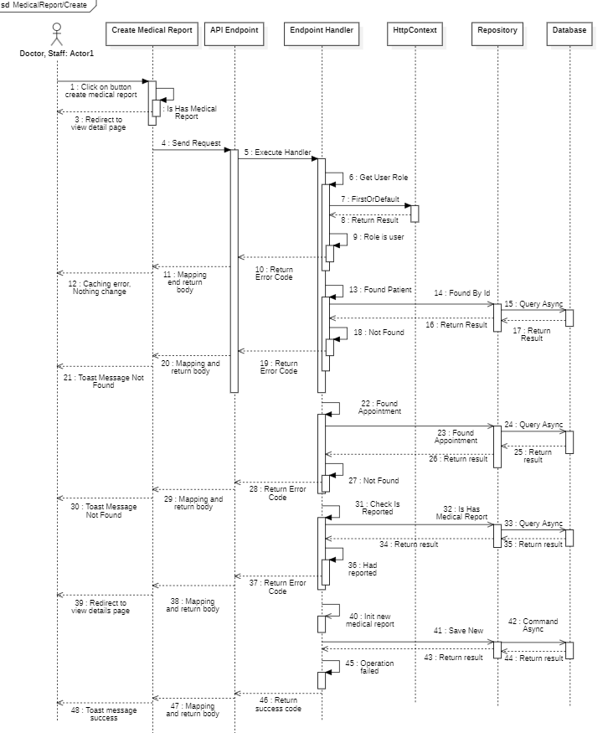

#### d. Database Queries

public async Task<bool> CreateMedicalReportCommandAsync(

MedicalReport newMedicalReport,

CancellationToken cancellationToken

)

{

try

{

_medicalReports.Add(entity: newMedicalReport);

await _context.SaveChangesAsync();

return true;

}

catch (Exception e)

{

await Console.Out.WriteLineAsync(e.Message);

return false;

}

}

public Task<User> FindPatientByIdQueryAsync(Guid patientId, CancellationToken cancellationToken)

{

return _users

.Where(predicate: entity => entity.Id == patientId)

.Select(selector: entity => new User()

{

Id = entity.Id,

FullName = entity.FullName,

Avatar = entity.Avatar,

PhoneNumber = entity.PhoneNumber,

Gender = new Gender()

{

Name = entity.Gender.Name,

Constant = entity.Gender.Constant,

},

Patient = new() { Address = entity.Patient.Address, DOB = entity.Patient.DOB, }

})

.FirstOrDefaultAsync(cancellationToken: cancellationToken);

}

public Task<bool> IsAppointmentFoundByIdQueryAsync(

Guid appointmentId,

CancellationToken cancellationToken

)

{

return _appointments.AnyAsync(

predicate: entity => entity.Id == appointmentId,

cancellationToken: cancellationToken

);

}

public Task<bool> IsAppointmentReportedQueryAsync(

Guid appointmentId,

CancellationToken cancellationToken

)

{

return _appointments.AnyAsync(

predicate: entity =>

entity.Id == appointmentId && !Equals(entity.MedicalReport, default),

cancellationToken: cancellationToken

);

}

}

### 7.3. Get recent medical report

#### a. Class diagram

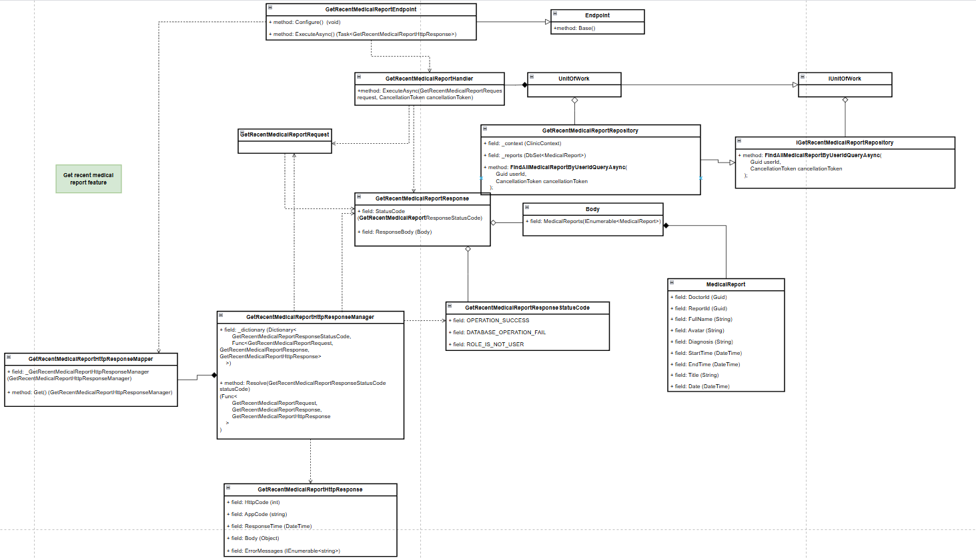

#### b. Class Specifications

1. ***GetRecentMedicalReportEndpoint class***

***a.*** ***Same as common given before,*** [***review here***](https://docs.google.com/document/d/1tTZUy0kDp6tdHb6MY85cNBVlDSK0k0N9w2NXBLPTu-c/edit?fbclid=IwY2xjawGRuZpleHRuA2FlbQIxMAABHUWj7GBmcsB0TEQOSeFgkcMlTv6kK6aEkUnExmkf0x_20x3n5Tikj9MvPA_aem_7Ik47wBVUygzT8J9mpiG0w#heading=h.m7r87enxie2d)***.***

1. ***Endpoint abstract class***

***a.*** ***Same as common given before,*** [***review here***](https://docs.google.com/document/d/1tTZUy0kDp6tdHb6MY85cNBVlDSK0k0N9w2NXBLPTu-c/edit?fbclid=IwY2xjawGRuZpleHRuA2FlbQIxMAABHUWj7GBmcsB0TEQOSeFgkcMlTv6kK6aEkUnExmkf0x_20x3n5Tikj9MvPA_aem_7Ik47wBVUygzT8J9mpiG0w#heading=h.ac857vak9ccs)***.***

1. ***GetRecentMedicalReportValidator class***

***a.*** ***Same as common given before,*** [***review here***](https://docs.google.com/document/d/1tTZUy0kDp6tdHb6MY85cNBVlDSK0k0N9w2NXBLPTu-c/edit?fbclid=IwY2xjawGRuZpleHRuA2FlbQIxMAABHUWj7GBmcsB0TEQOSeFgkcMlTv6kK6aEkUnExmkf0x_20x3n5Tikj9MvPA_aem_7Ik47wBVUygzT8J9mpiG0w#heading=h.mapewhyr52db)***.***

1. ***GetRecentMedicalReportHandler class***

***a.*** ***Same as common given before,*** [***review here***](https://docs.google.com/document/d/1tTZUy0kDp6tdHb6MY85cNBVlDSK0k0N9w2NXBLPTu-c/edit?fbclid=IwY2xjawGRuZpleHRuA2FlbQIxMAABHUWj7GBmcsB0TEQOSeFgkcMlTv6kK6aEkUnExmkf0x_20x3n5Tikj9MvPA_aem_7Ik47wBVUygzT8J9mpiG0w#heading=h.3lfr3mcrnl8j)***.***

1. ***IUnitOfWork interface***

***a.*** ***Same as common given before,*** [***review here***](https://docs.google.com/document/d/1tTZUy0kDp6tdHb6MY85cNBVlDSK0k0N9w2NXBLPTu-c/edit?fbclid=IwY2xjawGRuZpleHRuA2FlbQIxMAABHUWj7GBmcsB0TEQOSeFgkcMlTv6kK6aEkUnExmkf0x_20x3n5Tikj9MvPA_aem_7Ik47wBVUygzT8J9mpiG0w#heading=h.plvhy3azezgm)***.***

1. ***UnitOfWork class***

***a.*** ***Same as common given before,*** [***review here***](https://docs.google.com/document/d/1tTZUy0kDp6tdHb6MY85cNBVlDSK0k0N9w2NXBLPTu-c/edit?fbclid=IwY2xjawGRuZpleHRuA2FlbQIxMAABHUWj7GBmcsB0TEQOSeFgkcMlTv6kK6aEkUnExmkf0x_20x3n5Tikj9MvPA_aem_7Ik47wBVUygzT8J9mpiG0w#heading=h.75tksa2v2ybj)***.***

1. ***GetRecentMedicalReportRequest class***

| ***No*** | ***Fields*** | ***Description*** |
| --- | --- | --- |
| ***Empty request*** | | |

***8.*** ***GetRecentMedicalReportResponse class***

| ***No*** | ***Fields*** | ***Description*** |
| --- | --- | --- |
| ***01*** | ***StatusCode*** | ***This field will return an app code and http code.*** |
| ***02*** | ***ResponseBody*** | ***Contains the main data body of the response*** |

***9.*** ***Body class***

| ***No*** | ***Fields*** | ***Description*** |
| --- | --- | --- |
| ***01*** | ***MedicalReports*** | ***A collection of recent medical reports, each represented by the MedicalReport nested class.*** |

***10.*** ***MedicalReport class***

| ***No*** | ***Fields*** | ***Description*** |
| --- | --- | --- |
| ***01*** | ***DoctorId*** | ***Unique identifier for the doctor associated with the medical report.*** |
| ***02*** | ***ReportId*** | ***Unique identifier for the specific medical report.*** |
| ***03*** | ***FullName*** | ***Full name of the doctor or medical professional who issued the report.*** |
| ***04*** | ***Avatar*** | ***URL or path to the patient’s avatar image.*** |
| ***05*** | ***StartTime*** | ***Date and time when the appointment or consultation started.*** |
| ***06*** | ***EndTime*** | ***Date and time when the appointment or consultation ended.*** |
| ***07*** | ***Date*** | ***Date of the medical report.*** |
| ***08*** | ***Diagnosis*** | ***Diagnosis provided during the consultation, summarizing the medical findings.*** |
| ***09*** | ***Title*** | ***Title or brief description of the report, giving an overview of the consultation's purpose or results.*** |

***11.*** ***GetRecentMedicalReportResponseStatusCode Enum class***

***This enum class contains some necessary app code like OPERATION_SUCCESS, DATABASE_OPERATION_FAIL, ROLE_IS_NOT_USER,.... Purpose to handle response with specifically code of errors.***

***12.*** ***IGetRecentMedicalReportRepository interface***

***This interface class contains method to interact with database***

| ***No*** | ***Method*** | ***Description*** |
| --- | --- | --- |
| ***01*** | ***public async Task<IEnumerable<MedicalReport>> FindAllMedicalReportByUserIdQueryAsync(***  *Guid userId,*  *CancellationToken cancellationToken*  ***)*** | ***Defines a method to retrieve a list of MedicalReport objects for a given userId, returning all recent reports associated with that user, ordered by appointment start date.*** |

***13.*** ***GetRecentMedicalReportRepository***

***This class is an implementation of the ICreateScheduleRepository interface.***

| ***No*** | ***Fields*** | ***Description*** |
| --- | --- | --- |
| ***01*** | ***_context*** | ***This field is database context*** |
| ***02*** | ***_reports*** | ***Property to interact with the MedicalReports table in the database*** |

| ***No*** | ***Method*** | ***Description*** |
| --- | --- | --- |
| ***01*** | ***public async Task<IEnumerable<MedicalReport>> FindAllMedicalReportByUserIdQueryAsync(***  *Guid userId,*  *CancellationToken cancellationToken*  ***)*** | ***Executes a query to retrieve a list of recent medical reports for the specified userId. Each report includes details such as diagnosis, report name, appointment schedule, and doctor information (including the doctor’s full name and avatar). The results are ordered by the start date of each appointment, from the most recent to the oldest.*** |

#### c. Sequence Diagram(s)

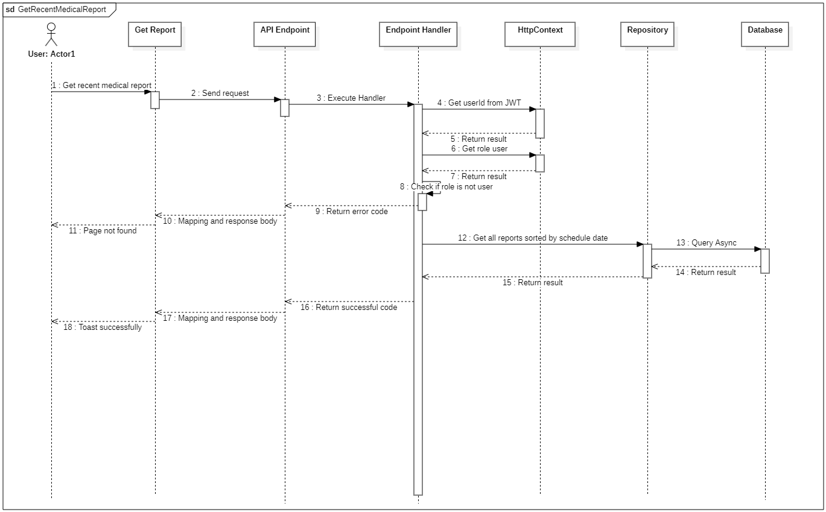

#### d. Database Queries

**public async Task<IEnumerable<MedicalReport>> FindAllMedicalReportByUserIdQueryAsync(**

**Guid userId,**

**CancellationToken cancellationToken**

**)**

{

return await _reports

.Where(report => report.Appointment.PatientId == userId)

.Select(report => new MedicalReport()

{

Id = report.Id,

Diagnosis = report.Diagnosis,

Name = report.Name,

Appointment = new Appointment()

{

Schedule = new Schedule()

{

StartDate = report.Appointment.Schedule.StartDate,

EndDate = report.Appointment.Schedule.EndDate,

Doctor = new Domain.Commons.Entities.Doctor()

{

UserId = report.Appointment.Schedule.DoctorId,

User = new User()

{

FullName = report.Appointment.Schedule.Doctor.User.FullName,

Avatar = report.Appointment.Schedule.Doctor.User.Avatar,

}

}

}

},

})

.OrderByDescending(report => report.Appointment.Schedule.StartDate)

.ToListAsync(cancellationToken: cancellationToken);

}

## 8. Services Order

### 8.1. Order Service

#### a. Class diagram

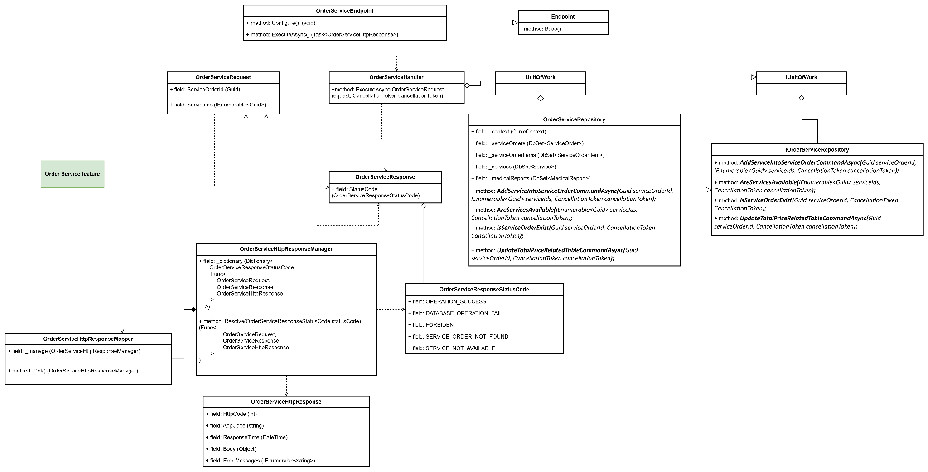

#### b. Class Specifications

#### OrderServiceEndpoint class

* 1. *Same as common given before,* [*review here*](https://docs.google.com/document/d/1tTZUy0kDp6tdHb6MY85cNBVlDSK0k0N9w2NXBLPTu-c/edit?fbclid=IwY2xjawGRuZpleHRuA2FlbQIxMAABHUWj7GBmcsB0TEQOSeFgkcMlTv6kK6aEkUnExmkf0x_20x3n5Tikj9MvPA_aem_7Ik47wBVUygzT8J9mpiG0w#heading=h.m7r87enxie2d)*.*

1. ***Endpoint abstract class***
   1. *Same as common given before,* [*review here*](https://docs.google.com/document/d/1tTZUy0kDp6tdHb6MY85cNBVlDSK0k0N9w2NXBLPTu-c/edit?fbclid=IwY2xjawGRuZpleHRuA2FlbQIxMAABHUWj7GBmcsB0TEQOSeFgkcMlTv6kK6aEkUnExmkf0x_20x3n5Tikj9MvPA_aem_7Ik47wBVUygzT8J9mpiG0w#heading=h.ac857vak9ccs)*.*
2. ***OrderServiceValidator class***
   1. *Same as common given before,* [*review here*](https://docs.google.com/document/d/1tTZUy0kDp6tdHb6MY85cNBVlDSK0k0N9w2NXBLPTu-c/edit?fbclid=IwY2xjawGRuZpleHRuA2FlbQIxMAABHUWj7GBmcsB0TEQOSeFgkcMlTv6kK6aEkUnExmkf0x_20x3n5Tikj9MvPA_aem_7Ik47wBVUygzT8J9mpiG0w#heading=h.mapewhyr52db)*.*
3. ***OrderServiceHandler class***
   1. *Same as common given before,* [*review here*](https://docs.google.com/document/d/1tTZUy0kDp6tdHb6MY85cNBVlDSK0k0N9w2NXBLPTu-c/edit?fbclid=IwY2xjawGRuZpleHRuA2FlbQIxMAABHUWj7GBmcsB0TEQOSeFgkcMlTv6kK6aEkUnExmkf0x_20x3n5Tikj9MvPA_aem_7Ik47wBVUygzT8J9mpiG0w#heading=h.3lfr3mcrnl8j)*.*
4. ***IUnitOfWork interface***
   1. *Same as common given before,* [*review here*](https://docs.google.com/document/d/1tTZUy0kDp6tdHb6MY85cNBVlDSK0k0N9w2NXBLPTu-c/edit?fbclid=IwY2xjawGRuZpleHRuA2FlbQIxMAABHUWj7GBmcsB0TEQOSeFgkcMlTv6kK6aEkUnExmkf0x_20x3n5Tikj9MvPA_aem_7Ik47wBVUygzT8J9mpiG0w#heading=h.plvhy3azezgm)*.*
5. ***UnitOfWork class***
   1. *Same as common given before,* [*review here*](https://docs.google.com/document/d/1tTZUy0kDp6tdHb6MY85cNBVlDSK0k0N9w2NXBLPTu-c/edit?fbclid=IwY2xjawGRuZpleHRuA2FlbQIxMAABHUWj7GBmcsB0TEQOSeFgkcMlTv6kK6aEkUnExmkf0x_20x3n5Tikj9MvPA_aem_7Ik47wBVUygzT8J9mpiG0w#heading=h.75tksa2v2ybj)*.*
6. ***OrderServiceRequest class***

| **No** | **Fields** | **Description** |
| --- | --- | --- |
| *01* | *ServiceOrderId* | *Require Id of service order* |
| *02* | *ServiceIds* | *Require a list of service id which want to order* |

1. ***OrderServiceResponse class***

| **No** | **Fields** | **Description** |
| --- | --- | --- |
| *01* | *StatusCode* | *This field will return an app code and http code.* |

1. ***OrderServiceResponseStatusCode Enum class***

This enum class contains some necessary app code like OPERATION_SUCCESS, DATABASE_OPERATION_FAILED, FORBIDDEN, SERVICE_ORDER_NOT_FOUND, SERVICE_NOT_AVAILABLE ,.... Purpose to handle response with specifically code of errors.

1. ***IOrderServiceRepository interface***

This interface class contains method to interact with database

| **No** | **Method** | **Description** |
| --- | --- | --- |
| *01* | ***AddServiceIntoServiceOrderCommandAsync(****Guid serviceOrderId, IEnumerable<Guid> serviceIds, CancellationToken cancellationToken****);*** | *Defines a method to add service* |
| *02* | ***AreServicesAvailable(****IEnumerable<Guid> serviceIds, CancellationToken cancellationToken****);*** | *Defines a method to check services that are available or not* |
| *03* | ***IsServiceOrderExist(****Guid serviceOrderId, CancellationToken CancellationToken****);*** | *Defines a method to check service order is existed* |
| *04* | ***UpdateTotalPriceRelatedTableCommandAsync(****Guid serviceOrderId, CancellationToken cancellationToken****);*** | *Defines a method to save total price into ServiceOrder table* |

1. ***OrderServiceRepository***

This class is an implementation of the *IOrderServiceRepository* interface***.***

| **No** | **Fields** | **Description** |
| --- | --- | --- |
| *01* | *_context* | *This field is database context* |
| *02* | *_serviceOrders* | *Property to interact with the ServiceOrders table in the database* |
| *03* | *_serviceOrderItems* | *Property to interact with the ServiceOrderItems table in the database* |
| *04* | *_services* | *Property to interact with the Services table in the database* |
| *05* | *_medicalReports* | *Property to interact with the MedicalReports table in the database* |

| **No** | **Method** | **Description** |
| --- | --- | --- |
| *01* | ***AddServiceIntoServiceOrderCommandAsync(****Guid serviceOrderId, IEnumerable<Guid> serviceIds, CancellationToken cancellationToken****);*** | *Execute statements that interact with the database and return the desired value* |
| *02* | ***AreServicesAvailable(****IEnumerable<Guid> serviceIds, CancellationToken cancellationToken****);*** | *Execute statements that interact with the database and return the desired value* |
| *03* | ***IsServiceOrderExist(****Guid serviceOrderId, CancellationToken CancellationToken****);*** | *Execute statements that interact with the database and return the desired value* |
| *04* | ***UpdateTotalPriceRelatedTableCommandAsync(****Guid serviceOrderId, CancellationToken cancellationToken****);*** | *Execute statements that interact with the database and return the desired value* |

#### c. Sequence Diagram(s)

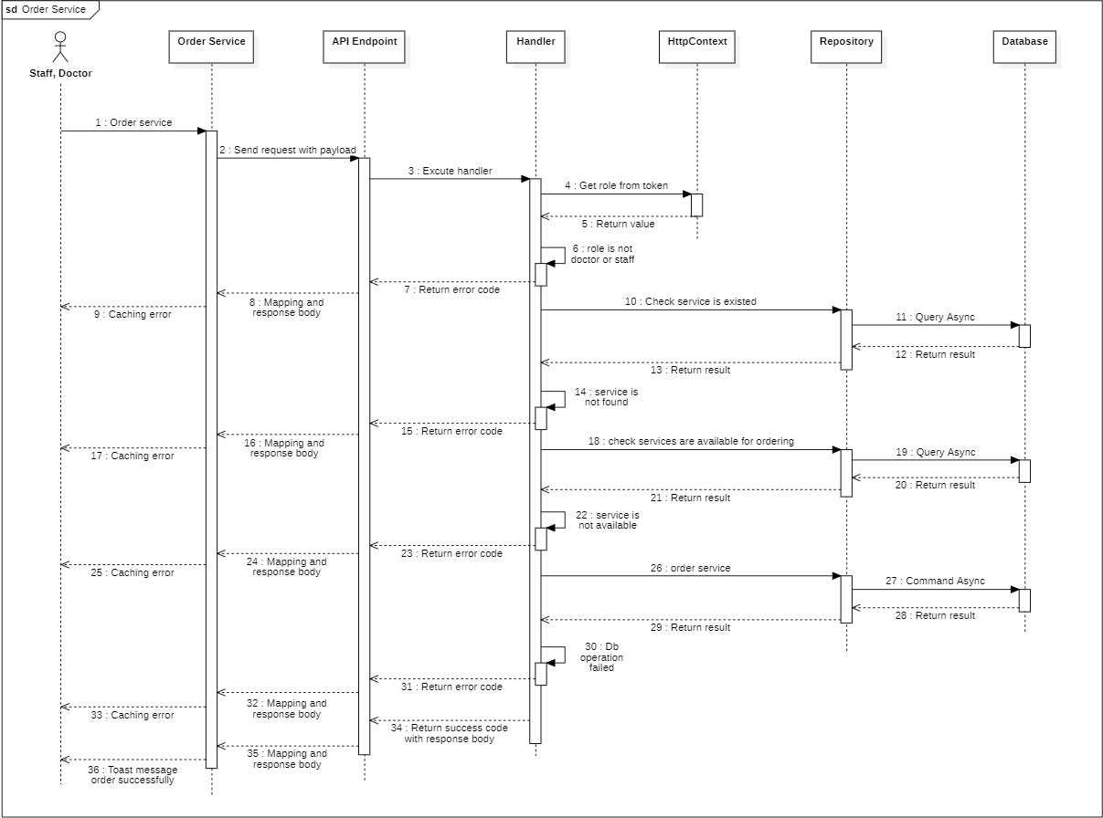

#### d. Database Queries

**public async Task<bool> AddServiceIntoServiceOrderCommandAsync**(

Guid serviceOrderId,

IEnumerable<Guid> serviceIds,

CancellationToken cancellationToken)

{.

var serviceOrder = await _serviceOrders

.Include(entity => entity.ServiceOrderItems)

.FirstOrDefaultAsync(entity => entity.Id == serviceOrderId, cancellationToken);

if (serviceOrder == null)

{

return false;

}

var existingServiceOrderItems = serviceOrder.ServiceOrderItems.ToList();

var existingServiceIds = existingServiceOrderItems.Select(entity => entity.ServiceId).ToList();

var serviceOrderItemsToRemove = existingServiceOrderItems

.Where(entity => !serviceIds.Contains(entity.ServiceId))

.ToList();

_serviceOrderItems.RemoveRange(serviceOrderItemsToRemove);

var serviceOrderItemsToAdd = serviceIds

.Where(id => !existingServiceIds.Contains(id))

.Select(id => new ServiceOrderItem

{

ServiceOrderId = serviceOrderId,

ServiceId = id,

PriceAtOrder = (int)_services.FirstOrDefault(service => service.Id == id).Price,

})

.ToList();

if (serviceOrderItemsToAdd.Any())

{

await _serviceOrderItems.AddRangeAsync(serviceOrderItemsToAdd, cancellationToken);

}

_serviceOrders.Update(serviceOrder);

return await _context.SaveChangesAsync(cancellationToken) > 0;

}

**public async Task<bool> AreServicesAvailable**(IEnumerable<Guid> serviceIds, CancellationToken cancellationToken)

{

var count = await _services

.Where(service => serviceIds.Contains(service.Id)

&& service.RemovedAt == CommonConstant.MIN_DATE_TIME

&& service.RemovedBy == CommonConstant.DEFAULT_ENTITY_ID_AS_GUID

)

.CountAsync();

return count == serviceIds.Count();

}

**public async Task<bool> IsServiceOrderExist**(Guid serviceOrderId, CancellationToken CancellationToken)

{

return await _serviceOrders.AnyAsync(entity => entity.Id == serviceOrderId);

}

**public async Task<bool> UpdateTotalPriceRelatedTableCommandAsync**(Guid serviceOrderId, CancellationToken cancellationToken)

{

var serviceOrder = await _serviceOrders

.Include(entity => entity.ServiceOrderItems)

.FirstOrDefaultAsync(entity => entity.Id == serviceOrderId, cancellationToken);

var existingMedicalReport = await _medicalReports.Where(entity => entity.ServiceOrderId == serviceOrderId).FirstOrDefaultAsync();

if (serviceOrder == null || existingMedicalReport == null)

{

return false;

}

var existingServiceOrderItems = serviceOrder.ServiceOrderItems.ToList();

var totalPrice = existingServiceOrderItems.Sum(entity => entity.PriceAtOrder);

serviceOrder.TotalPrice = totalPrice;

serviceOrder.Quantity = existingServiceOrderItems.Count();

existingMedicalReport.TotalPrice = totalPrice;

_serviceOrders.Update(serviceOrder);

_medicalReports.Update(existingMedicalReport);

return await _context.SaveChangesAsync(cancellationToken) > 0;

}

### 8.2. Get Service Order Items

#### a. Class diagram

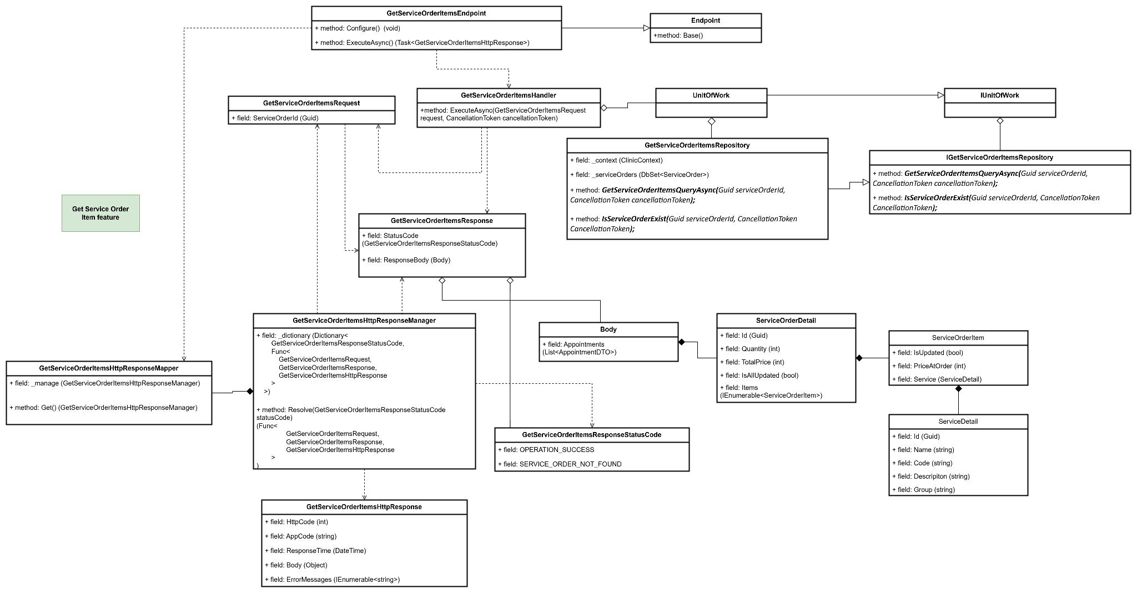

#### b. Class Specifications

#### OrderServiceEndpoint class

* 1. *Same as common given before,* [*review here*](https://docs.google.com/document/d/1tTZUy0kDp6tdHb6MY85cNBVlDSK0k0N9w2NXBLPTu-c/edit?fbclid=IwY2xjawGRuZpleHRuA2FlbQIxMAABHUWj7GBmcsB0TEQOSeFgkcMlTv6kK6aEkUnExmkf0x_20x3n5Tikj9MvPA_aem_7Ik47wBVUygzT8J9mpiG0w#heading=h.m7r87enxie2d)*.*

1. ***Endpoint abstract class***
   1. *Same as common given before,* [*review here*](https://docs.google.com/document/d/1tTZUy0kDp6tdHb6MY85cNBVlDSK0k0N9w2NXBLPTu-c/edit?fbclid=IwY2xjawGRuZpleHRuA2FlbQIxMAABHUWj7GBmcsB0TEQOSeFgkcMlTv6kK6aEkUnExmkf0x_20x3n5Tikj9MvPA_aem_7Ik47wBVUygzT8J9mpiG0w#heading=h.ac857vak9ccs)*.*
2. ***OrderServiceValidator class***
   1. *Same as common given before,* [*review here*](https://docs.google.com/document/d/1tTZUy0kDp6tdHb6MY85cNBVlDSK0k0N9w2NXBLPTu-c/edit?fbclid=IwY2xjawGRuZpleHRuA2FlbQIxMAABHUWj7GBmcsB0TEQOSeFgkcMlTv6kK6aEkUnExmkf0x_20x3n5Tikj9MvPA_aem_7Ik47wBVUygzT8J9mpiG0w#heading=h.mapewhyr52db)*.*
3. ***OrderServiceHandler class***
   1. *Same as common given before,* [*review here*](https://docs.google.com/document/d/1tTZUy0kDp6tdHb6MY85cNBVlDSK0k0N9w2NXBLPTu-c/edit?fbclid=IwY2xjawGRuZpleHRuA2FlbQIxMAABHUWj7GBmcsB0TEQOSeFgkcMlTv6kK6aEkUnExmkf0x_20x3n5Tikj9MvPA_aem_7Ik47wBVUygzT8J9mpiG0w#heading=h.3lfr3mcrnl8j)*.*
4. ***IUnitOfWork interface***
   1. *Same as common given before,* [*review here*](https://docs.google.com/document/d/1tTZUy0kDp6tdHb6MY85cNBVlDSK0k0N9w2NXBLPTu-c/edit?fbclid=IwY2xjawGRuZpleHRuA2FlbQIxMAABHUWj7GBmcsB0TEQOSeFgkcMlTv6kK6aEkUnExmkf0x_20x3n5Tikj9MvPA_aem_7Ik47wBVUygzT8J9mpiG0w#heading=h.plvhy3azezgm)*.*
5. ***UnitOfWork class***
   1. *Same as common given before,* [*review here*](https://docs.google.com/document/d/1tTZUy0kDp6tdHb6MY85cNBVlDSK0k0N9w2NXBLPTu-c/edit?fbclid=IwY2xjawGRuZpleHRuA2FlbQIxMAABHUWj7GBmcsB0TEQOSeFgkcMlTv6kK6aEkUnExmkf0x_20x3n5Tikj9MvPA_aem_7Ik47wBVUygzT8J9mpiG0w#heading=h.75tksa2v2ybj)*.*
6. ***OrderServiceRequest class***

| **No** | **Fields** | **Description** |
| --- | --- | --- |
| *01* | *ServiceOrderId* | *Require Id of service order* |

1. ***OrderServiceResponse class***

| **No** | **Fields** | **Description** |
| --- | --- | --- |
| *01* | *StatusCode* | *This field will return an app code and http code.* |
| *02* | *ResponseBody* | *Contains the main data body of the response, which includes the list of appointments, represented by Body.* |

***8.1 Body inner class***

| **No** | **Fields** | **Description** |
| --- | --- | --- |
| *01* | *ServiceOrder* | *A list of ServiceOrderDetail objects representing each service order.* |

***8.2 ServiceOrderItem inner class***

| **No** | **Fields** | **Description** |
| --- | --- | --- |
| *01* | *IsUpdated* | *Check the service is update result or not* |
| *02* | *PriceAtOrder* | *Price at order of service order item* |
| *03* | *Service* | *ServiceDetail objects representing detail each service.* |

***8.3 ServiceDetail inner class***

| **No** | **Fields** | **Description** |
| --- | --- | --- |
| *01* | *Id* | *Id of service* |
| *02* | *Code* | *Code of service* |
| *03* | *Name* | *Name of service* |
| *04* | *Description* | *Description of service* |
| *05* | *Group* | *Group of service* |

1. ***OrderServiceResponseStatusCode Enum class***

This enum class contains some necessary app code like OPERATION_SUCCESS, SERVICE_ORDER_NOT_FOUND ,.... Purpose to handle response with specifically code of errors.

1. ***IOrderServiceRepository interface***

This interface class contains method to interact with database

| **No** | **Method** | **Description** |
| --- | --- | --- |
| *01* | ***GetServiceOrderItemsQueryAsync(****Guid serviceOrderId, CancellationToken cancellationToken****);*** | *Defines a method to get service order by id* |
| *02* | ***IsServiceOrderExist(****Guid serviceOrderId, CancellationToken CancellationToken****);*** | *Defines a method to check service order that is existed or not* |

1. ***OrderServiceRepository***

This class is an implementation of the *IOrderServiceRepository* interface***.***

| **No** | **Fields** | **Description** |
| --- | --- | --- |
| *01* | *_context* | *This field is database context* |
| *02* | *_serviceOrders* | *Property to interact with the ServiceOrders table in the database* |

| **No** | **Method** | **Description** |
| --- | --- | --- |
| *01* | ***GetServiceOrderItemsQueryAsync(****Guid serviceOrderId, CancellationToken cancellationToken****);*** | *Execute statements that interact with the database and return the desired value* |
| *02* | ***IsServiceOrderExist(****Guid serviceOrderId, CancellationToken CancellationToken****);*** | *Execute statements that interact with the database and return the desired value* |

#### c. Sequence Diagram(s)

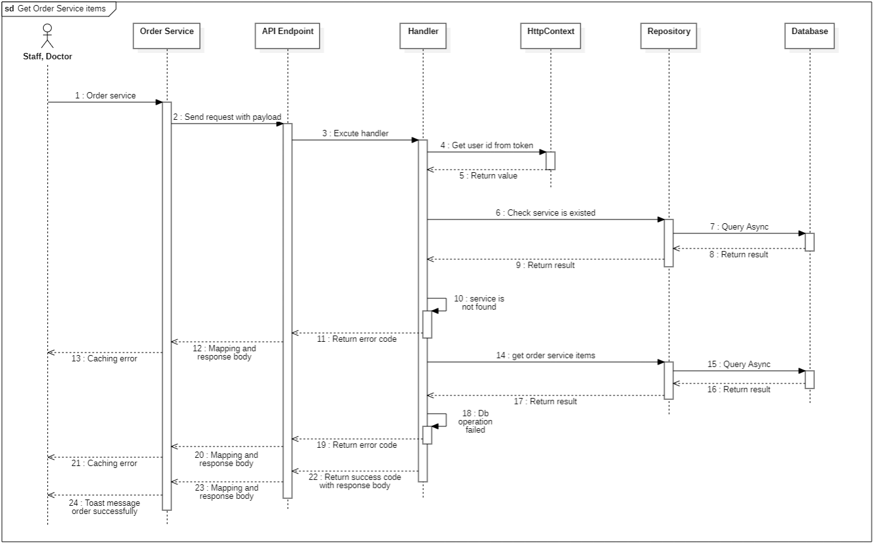

#### d. Database Queries

**public async Task<ServiceOrder> GetServiceOrderItemsQueryAsync**(Guid serviceOrderId, CancellationToken cancellationToken)

{

var serviceOrder = await _serviceOrders

.AsNoTracking()

.Where(entity => entity.Id == serviceOrderId)

.Select(entity =>

new ServiceOrder

{

Id = entity.Id,

IsAllUpdated = entity.IsAllUpdated,

ServiceOrderItems = entity.ServiceOrderItems.Select(item => new ServiceOrderItem

{

ServiceId = item.ServiceId,

PriceAtOrder = item.PriceAtOrder,

IsUpdated = item.IsUpdated,

Service = new Service()

{

Id = item.Service.Id,

Code = item.Service.Code,

Name = item.Service.Name,

Group = item.Service.Group,

Descripiton = item.Service.Descripiton

}

})

.ToList()

}

)

.FirstOrDefaultAsync(cancellationToken);

return serviceOrder;

}

**public async Task<bool> IsServiceOrderExist**(Guid serviceOrderId, CancellationToken CancellationToken)

{

return await _serviceOrders.AnyAsync(entity => entity.Id == serviceOrderId);

}

## 9. Medicines Order

### 9.1. Order Medicine

#### a. Class diagram

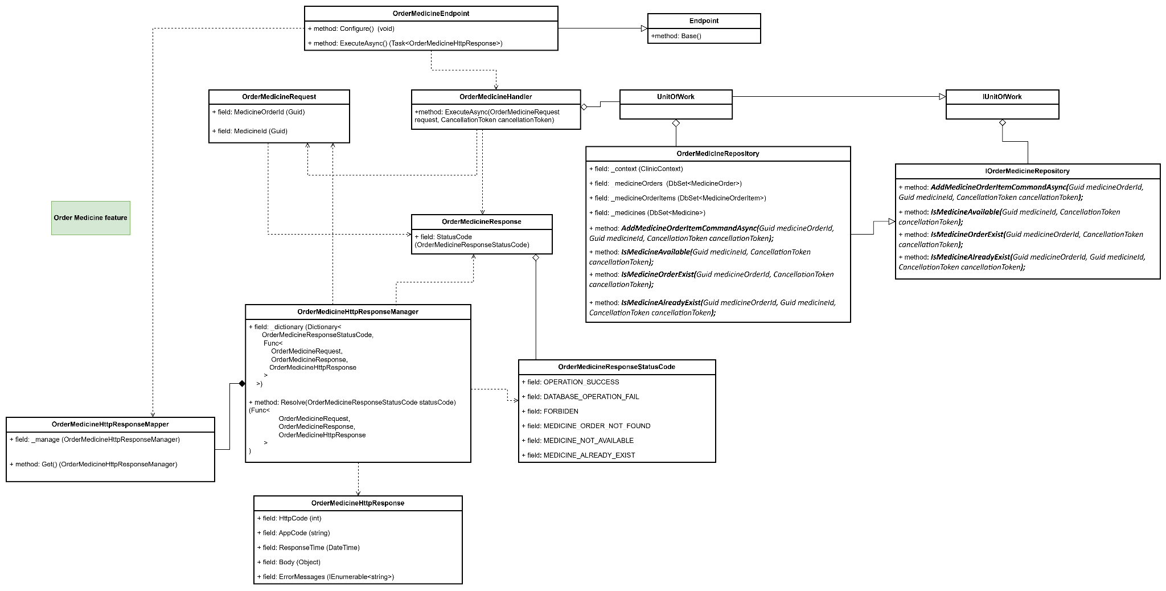

#### b. Class Specifications

#### OrderMedicineEndpoint class

* 1. *Same as common given before,* [*review here*](https://docs.google.com/document/d/1tTZUy0kDp6tdHb6MY85cNBVlDSK0k0N9w2NXBLPTu-c/edit?fbclid=IwY2xjawGRuZpleHRuA2FlbQIxMAABHUWj7GBmcsB0TEQOSeFgkcMlTv6kK6aEkUnExmkf0x_20x3n5Tikj9MvPA_aem_7Ik47wBVUygzT8J9mpiG0w#heading=h.m7r87enxie2d)*.*

1. ***Endpoint abstract class***
   1. *Same as common given before,* [*review here*](https://docs.google.com/document/d/1tTZUy0kDp6tdHb6MY85cNBVlDSK0k0N9w2NXBLPTu-c/edit?fbclid=IwY2xjawGRuZpleHRuA2FlbQIxMAABHUWj7GBmcsB0TEQOSeFgkcMlTv6kK6aEkUnExmkf0x_20x3n5Tikj9MvPA_aem_7Ik47wBVUygzT8J9mpiG0w#heading=h.ac857vak9ccs)*.*
2. ***OrderMedicineValidator class***
   1. *Same as common given before,* [*review here*](https://docs.google.com/document/d/1tTZUy0kDp6tdHb6MY85cNBVlDSK0k0N9w2NXBLPTu-c/edit?fbclid=IwY2xjawGRuZpleHRuA2FlbQIxMAABHUWj7GBmcsB0TEQOSeFgkcMlTv6kK6aEkUnExmkf0x_20x3n5Tikj9MvPA_aem_7Ik47wBVUygzT8J9mpiG0w#heading=h.mapewhyr52db)*.*
3. ***OrderMedicineHandler class***
   1. *Same as common given before,* [*review here*](https://docs.google.com/document/d/1tTZUy0kDp6tdHb6MY85cNBVlDSK0k0N9w2NXBLPTu-c/edit?fbclid=IwY2xjawGRuZpleHRuA2FlbQIxMAABHUWj7GBmcsB0TEQOSeFgkcMlTv6kK6aEkUnExmkf0x_20x3n5Tikj9MvPA_aem_7Ik47wBVUygzT8J9mpiG0w#heading=h.3lfr3mcrnl8j)*.*
4. ***IUnitOfWork interface***
   1. *Same as common given before,* [*review here*](https://docs.google.com/document/d/1tTZUy0kDp6tdHb6MY85cNBVlDSK0k0N9w2NXBLPTu-c/edit?fbclid=IwY2xjawGRuZpleHRuA2FlbQIxMAABHUWj7GBmcsB0TEQOSeFgkcMlTv6kK6aEkUnExmkf0x_20x3n5Tikj9MvPA_aem_7Ik47wBVUygzT8J9mpiG0w#heading=h.plvhy3azezgm)*.*
5. ***UnitOfWork class***
   1. *Same as common given before,* [*review here*](https://docs.google.com/document/d/1tTZUy0kDp6tdHb6MY85cNBVlDSK0k0N9w2NXBLPTu-c/edit?fbclid=IwY2xjawGRuZpleHRuA2FlbQIxMAABHUWj7GBmcsB0TEQOSeFgkcMlTv6kK6aEkUnExmkf0x_20x3n5Tikj9MvPA_aem_7Ik47wBVUygzT8J9mpiG0w#heading=h.75tksa2v2ybj)*.*
6. ***OrderMedicineRequest class***

| **No** | **Fields** | **Description** |
| --- | --- | --- |
| *01* | *MedicineOrderId* | *Require Id of medicine order* |
| *02* | *MedicineId* | *Require Id of medicine which want to order* |

1. ***OrderMedicineResponse class***

| **No** | **Fields** | **Description** |
| --- | --- | --- |
| *01* | *StatusCode* | *This field will return an app code and http code.* |

1. ***OrderMedicineResponseStatusCode Enum class***

This enum class contains some necessary app code like OPERATION_SUCCESS, DATABASE_OPERATION_FAILED, FORBIDDEN, MEDICINE_ORDER_NOT_FOUND, MEDICINE_NOT_AVAILABLE, MEDICINE_ALREADY_EXIST, .... Purpose to handle response with specifically code of errors.

1. ***IOrderMedicineRepository interface***

This interface class contains method to interact with database

| **No** | **Method** | **Description** |
| --- | --- | --- |
| *01* | ***IsMedicineOrderExist(****Guid medicineOrderId, CancellationToken cancellationToken****);*** | *Defines a method to check medicine order that is existed or not* |
| *02* | ***IsMedicineAvailable(****Guid medicineId, CancellationToken cancellationToken****);*** | *Defines a method to check medicine that is available or not* |
| *03* | ***IsMedicineAlreadyExist(****Guid medicineOrderId, Guid medicineId, CancellationToken cancellationToken****);*** | *Defines a method to check medicine that has already existed* |
| *04* | ***AddMedicineOrderItemCommandAsync(****Guid medicineOrderId, Guid medicineId, CancellationToken cancellationToken****);*** | *Defines a method to add medicine* |

1. ***OrderMedicineRepository***

This class is an implementation of the *IOrderMedicineRepository* interface***.***

| **No** | **Fields** | **Description** |
| --- | --- | --- |
| *01* | *_context* | *This field is database context* |
| *02* | *_medicineOrders* | *Property to interact with the MedicineOrders table in the database* |
| *03* | *_medicineOrderItems* | *Property to interact with the MedicineOrderItems table in the database* |
| *04* | *_medicines* | *Property to interact with the Medicines table in the database* |

| **No** | **Method** | **Description** |
| --- | --- | --- |
| *01* | ***IsMedicineOrderExist(****Guid medicineOrderId, CancellationToken cancellationToken****);*** | *Execute statements that interact with the database and return the desired value* |
| *02* | ***IsMedicineAvailable(****Guid medicineId, CancellationToken cancellationToken****);*** | *Execute statements that interact with the database and return the desired value* |
| *03* | ***IsMedicineAlreadyExist(****Guid medicineOrderId, Guid medicineId, CancellationToken cancellationToken****);*** | *Execute statements that interact with the database and return the desired value* |
| *04* | ***AddMedicineOrderItemCommandAsync(****Guid medicineOrderId, Guid medicineId, CancellationToken cancellationToken****);*** | *Execute statements that interact with the database and return the desired value* |

#### c. Sequence Diagram(s)

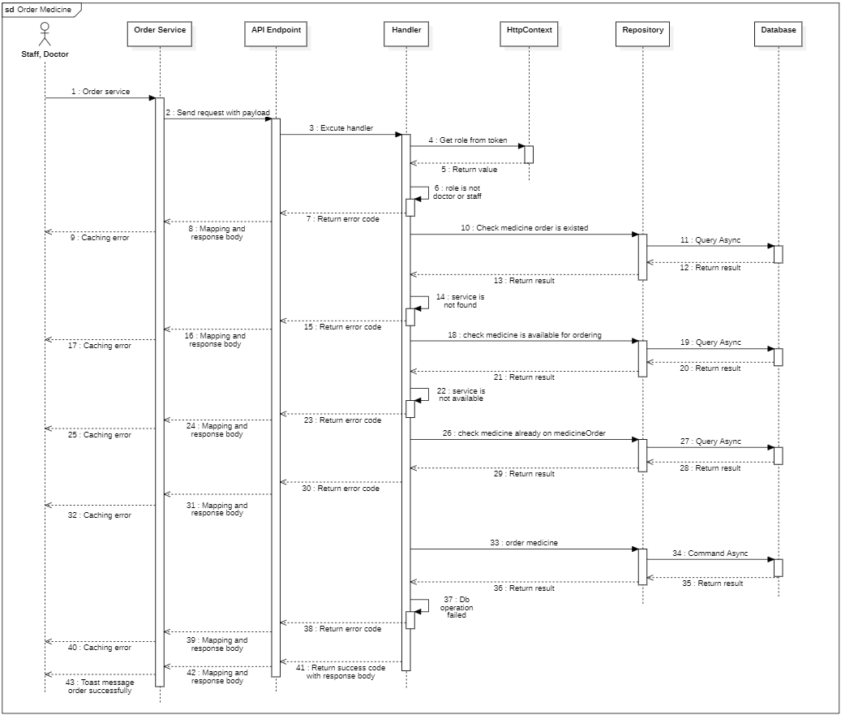

#### d. Database Queries

**public Task<bool> IsMedicineOrderExist**(Guid medicineOrderId, CancellationToken cancellationToken)

{

return _medicineOrders.AnyAsync(entity => entity.Id == medicineOrderId, cancellationToken);

}

**public Task<bool> IsMedicineAvailable**(Guid medicineId, CancellationToken cancellationToken)

{

return _medicines.AnyAsync(entity => entity.Id == medicineId, cancellationToken);

}

**public Task<bool> IsMedicineAlreadyExist**(Guid medicineOrderId, Guid medicineId, CancellationToken cancellationToken)

{

return _medicineOrderItems

.Where(entity => entity.MedicineOrderId == medicineOrderId)

.AnyAsync(entity => entity.MedicineId == medicineId);

}

**public async Task<bool> AddMedicineOrderItemCommandAsync**(Guid medicineOrderId, Guid medicineId, CancellationToken cancellationToken)

{

var medicineOrder = await _medicineOrders

.Include(mo => mo.MedicineOrderItems)

.FirstOrDefaultAsync(mo => mo.Id == medicineOrderId, cancellationToken);

if (medicineOrder == null)

{

return false;

}

var medicine = await _medicines

.FirstOrDefaultAsync(m => m.Id == medicineId, cancellationToken);

if (medicine == null)

{

return false;

}

var newMedicineOrderItem = new MedicineOrderItem

{

MedicineOrderId = medicineOrder.Id,

MedicineId = medicine.Id,

Description = string.Empty,

Quantity = 0

};

_medicineOrderItems.Add(newMedicineOrderItem);

return await _context.SaveChangesAsync(cancellationToken) > 0;

}

## 10. Queue Rooms

### 10.1. Create queue room

#### a. Class diagram

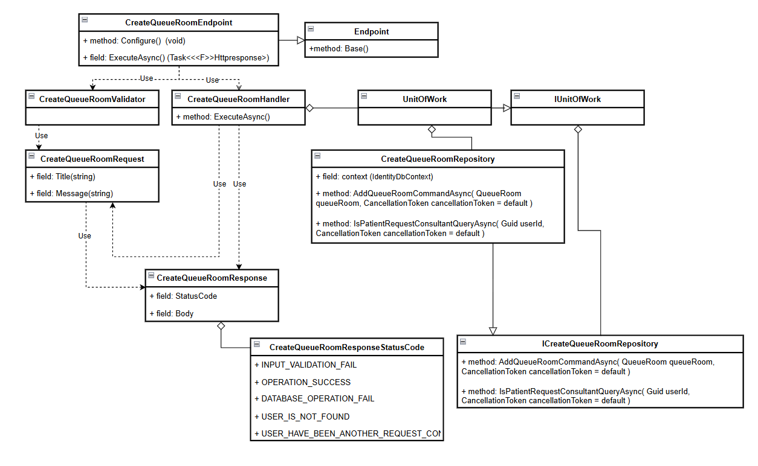

#### b. Class Specifications

#### CreateQueueRoomEndpoint class

* 1. *Same as common given before,* [*review here*](https://docs.google.com/document/d/1tTZUy0kDp6tdHb6MY85cNBVlDSK0k0N9w2NXBLPTu-c/edit?fbclid=IwY2xjawGRuZpleHRuA2FlbQIxMAABHUWj7GBmcsB0TEQOSeFgkcMlTv6kK6aEkUnExmkf0x_20x3n5Tikj9MvPA_aem_7Ik47wBVUygzT8J9mpiG0w#heading=h.m7r87enxie2d)*.*

1. ***Endpoint abstract class***
   1. *Same as common given before,* [*review here*](https://docs.google.com/document/d/1tTZUy0kDp6tdHb6MY85cNBVlDSK0k0N9w2NXBLPTu-c/edit?fbclid=IwY2xjawGRuZpleHRuA2FlbQIxMAABHUWj7GBmcsB0TEQOSeFgkcMlTv6kK6aEkUnExmkf0x_20x3n5Tikj9MvPA_aem_7Ik47wBVUygzT8J9mpiG0w#heading=h.ac857vak9ccs)*.*
2. ***CreateQueueRoomValidator class***
   1. *Same as common given before,* [*review here*](https://docs.google.com/document/d/1tTZUy0kDp6tdHb6MY85cNBVlDSK0k0N9w2NXBLPTu-c/edit?fbclid=IwY2xjawGRuZpleHRuA2FlbQIxMAABHUWj7GBmcsB0TEQOSeFgkcMlTv6kK6aEkUnExmkf0x_20x3n5Tikj9MvPA_aem_7Ik47wBVUygzT8J9mpiG0w#heading=h.mapewhyr52db)*.*
3. ***CreateQueueRoomHandler class***
   1. *Same as common given before,* [*review here*](https://docs.google.com/document/d/1tTZUy0kDp6tdHb6MY85cNBVlDSK0k0N9w2NXBLPTu-c/edit?fbclid=IwY2xjawGRuZpleHRuA2FlbQIxMAABHUWj7GBmcsB0TEQOSeFgkcMlTv6kK6aEkUnExmkf0x_20x3n5Tikj9MvPA_aem_7Ik47wBVUygzT8J9mpiG0w#heading=h.3lfr3mcrnl8j)*.*
4. ***IUnitOfWork interface***
   1. *Same as common given before,* [*review here*](https://docs.google.com/document/d/1tTZUy0kDp6tdHb6MY85cNBVlDSK0k0N9w2NXBLPTu-c/edit?fbclid=IwY2xjawGRuZpleHRuA2FlbQIxMAABHUWj7GBmcsB0TEQOSeFgkcMlTv6kK6aEkUnExmkf0x_20x3n5Tikj9MvPA_aem_7Ik47wBVUygzT8J9mpiG0w#heading=h.plvhy3azezgm)*.*
5. ***UnitOfWork class***
   1. *Same as common given before,* [*review here*](https://docs.google.com/document/d/1tTZUy0kDp6tdHb6MY85cNBVlDSK0k0N9w2NXBLPTu-c/edit?fbclid=IwY2xjawGRuZpleHRuA2FlbQIxMAABHUWj7GBmcsB0TEQOSeFgkcMlTv6kK6aEkUnExmkf0x_20x3n5Tikj9MvPA_aem_7Ik47wBVUygzT8J9mpiG0w#heading=h.75tksa2v2ybj)*.*
6. ***CreateQueueRoomRequest class***

| **No** | **Fields** | **Description** |
| --- | --- | --- |
| *01* | *Title* | *This field contain Title information* |
| *02* | *Message* | *This field contain Message information* |

1. ***CreateQueueRoomResponse class***

| **No** | **Fields** | **Description** |
| --- | --- | --- |
| *01* | *StatusCode* | *This field will return an app code and http code.* |
| *02* | *Body* | *Contain list object information: CreateQueueRoomId* |

1. ***CreateQueueRoomResponseStatusCode Enum class***

This enum class contains some necessary app code like OPERATION_SUCCESS, .... Purpose to handle response with specifically code of errors.

1. ***ICreateQueueRoomRepository interface***

This interface class contains method to interact with database

| **No** | **Method** | **Description** |
| --- | --- | --- |
| *01* | ***AddQueueRoomCommandAsync****( QueueRoom queueRoom, CancellationToken cancellationToken = default )* | *Defines a method to AddQueueRoomCommandAsync* |
| *02* | ***IsPatientRequestConsultantQueryAsync****( Guid userId, CancellationToken cancellationToken = default )* | *Defines a method to IsPatientRequestConsultantQueryAsync* |

1. ***CreateQueueRoomRepository***

This class is an implementation of the *IAssignChatRoomRepository* interface***.***

| **No** | **Fields** | **Description** |
| --- | --- | --- |
| *01* | *_context* | *This field is database context* |
| *02* | *_chatRooms* | *Property to interact with the ChatRoom table in the database* |
| *03* | *_patients* | *Property to interact with the Patient table in the database* |
| *04* | *_queueRooms* | *Property to interact with the QueueRoom table in the database* |

| **No** | **Method** | **Description** |
| --- | --- | --- |
| *01* | ***AddQueueRoomCommandAsync****( QueueRoom queueRoom, CancellationToken cancellationToken = default )* | *Defines a method to AddQueueRoomCommandAsync* |
| *02* | ***IsPatientRequestConsultantQueryAsync****( Guid userId, CancellationToken cancellationToken = default )* | *Defines a method to IsPatientRequestConsultantQueryAsync* |

#### c. Sequence Diagram(s)

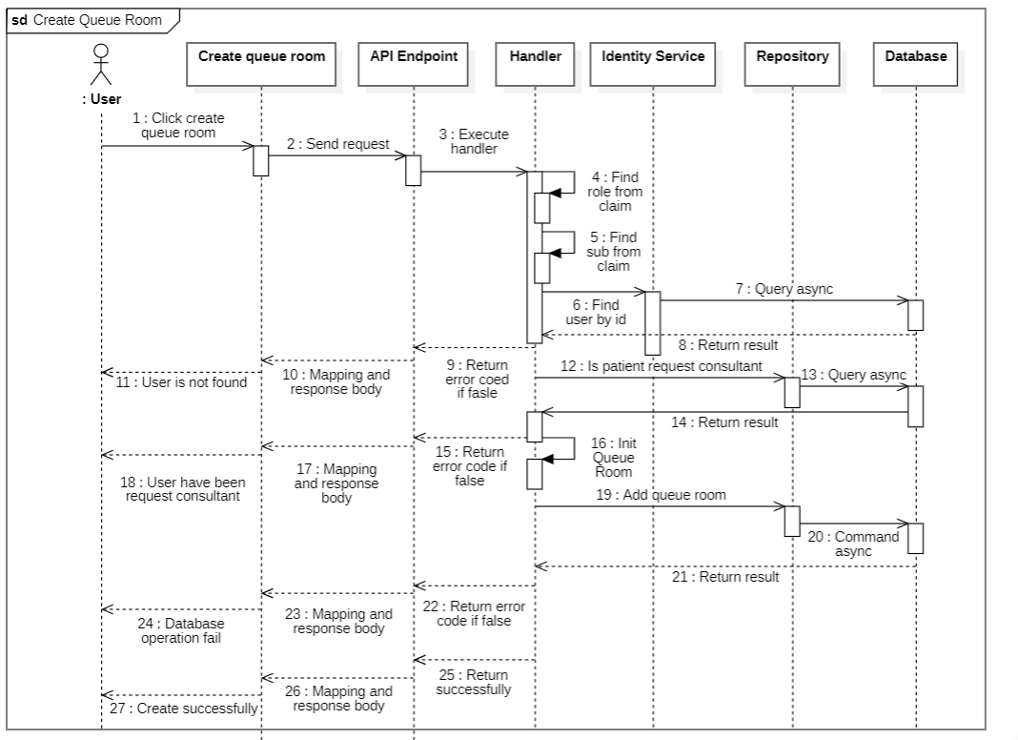

#### d. Database Queries

public async Task<bool> AddQueueRoomCommandAsync(

QueueRoom queueRoom,

CancellationToken cancellationToken = default

)

{

try

{

_queueRooms.Add(queueRoom);

await _context.SaveChangesAsync(cancellationToken: cancellationToken);

return true;

}

catch (Exception ex)

{

return false;

}

}

public Task<bool> IsPatientRequestConsultantQueryAsync(

Guid userId,

CancellationToken cancellationToken = default

)

{

return _queueRooms

.Where(predicate: queueRoom =>

queueRoom.PatientId == userId && queueRoom.IsSuported == false

)

.AnyAsync(cancellationToken: cancellationToken);

}

### 10.2. Get All Queue Room

#### a. Class diagram

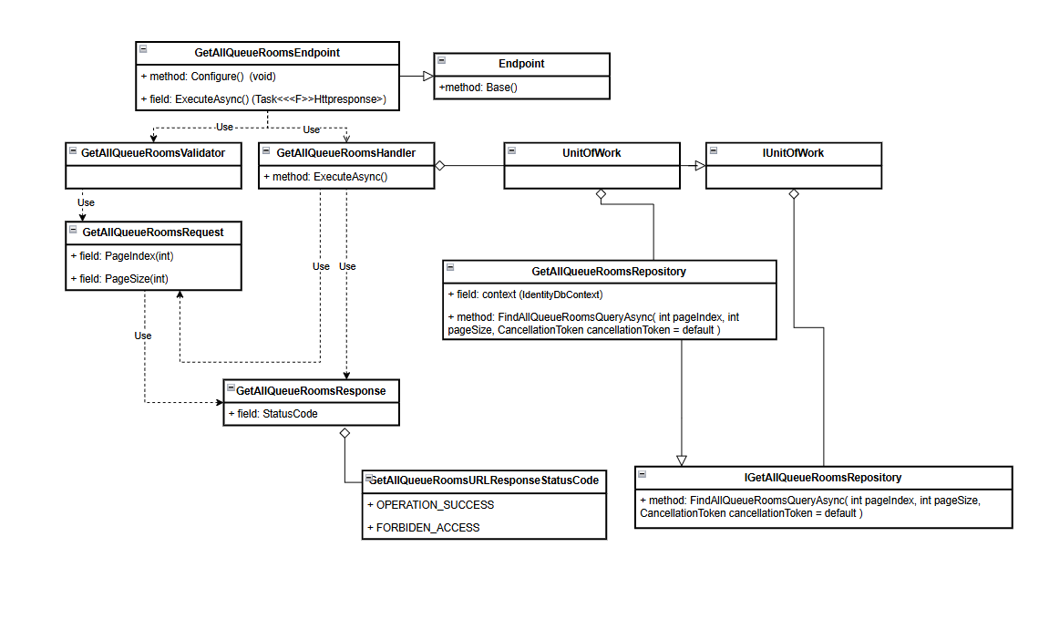

#### b. Class Specifications

#### GetAllQueueRoomEndpoint class

* 1. *Same as common given before,* [*review here*](https://docs.google.com/document/d/1tTZUy0kDp6tdHb6MY85cNBVlDSK0k0N9w2NXBLPTu-c/edit?fbclid=IwY2xjawGRuZpleHRuA2FlbQIxMAABHUWj7GBmcsB0TEQOSeFgkcMlTv6kK6aEkUnExmkf0x_20x3n5Tikj9MvPA_aem_7Ik47wBVUygzT8J9mpiG0w#heading=h.m7r87enxie2d)*.*

1. ***Endpoint abstract class***
   1. *Same as common given before,* [*review here*](https://docs.google.com/document/d/1tTZUy0kDp6tdHb6MY85cNBVlDSK0k0N9w2NXBLPTu-c/edit?fbclid=IwY2xjawGRuZpleHRuA2FlbQIxMAABHUWj7GBmcsB0TEQOSeFgkcMlTv6kK6aEkUnExmkf0x_20x3n5Tikj9MvPA_aem_7Ik47wBVUygzT8J9mpiG0w#heading=h.ac857vak9ccs)*.*
2. ***GetAllQueueRoomValidator class***
   1. *Same as common given before,* [*review here*](https://docs.google.com/document/d/1tTZUy0kDp6tdHb6MY85cNBVlDSK0k0N9w2NXBLPTu-c/edit?fbclid=IwY2xjawGRuZpleHRuA2FlbQIxMAABHUWj7GBmcsB0TEQOSeFgkcMlTv6kK6aEkUnExmkf0x_20x3n5Tikj9MvPA_aem_7Ik47wBVUygzT8J9mpiG0w#heading=h.mapewhyr52db)*.*
3. ***GetAllQueueRoomHandler class***
   1. *Same as common given before,* [*review here*](https://docs.google.com/document/d/1tTZUy0kDp6tdHb6MY85cNBVlDSK0k0N9w2NXBLPTu-c/edit?fbclid=IwY2xjawGRuZpleHRuA2FlbQIxMAABHUWj7GBmcsB0TEQOSeFgkcMlTv6kK6aEkUnExmkf0x_20x3n5Tikj9MvPA_aem_7Ik47wBVUygzT8J9mpiG0w#heading=h.3lfr3mcrnl8j)*.*
4. ***IUnitOfWork interface***
   1. *Same as common given before,* [*review here*](https://docs.google.com/document/d/1tTZUy0kDp6tdHb6MY85cNBVlDSK0k0N9w2NXBLPTu-c/edit?fbclid=IwY2xjawGRuZpleHRuA2FlbQIxMAABHUWj7GBmcsB0TEQOSeFgkcMlTv6kK6aEkUnExmkf0x_20x3n5Tikj9MvPA_aem_7Ik47wBVUygzT8J9mpiG0w#heading=h.plvhy3azezgm)*.*
5. ***UnitOfWork class***
   1. *Same as common given before,* [*review here*](https://docs.google.com/document/d/1tTZUy0kDp6tdHb6MY85cNBVlDSK0k0N9w2NXBLPTu-c/edit?fbclid=IwY2xjawGRuZpleHRuA2FlbQIxMAABHUWj7GBmcsB0TEQOSeFgkcMlTv6kK6aEkUnExmkf0x_20x3n5Tikj9MvPA_aem_7Ik47wBVUygzT8J9mpiG0w#heading=h.75tksa2v2ybj)*.*
6. ***GetAllQueueRoomRequest class***

| **No** | **Fields** | **Description** |
| --- | --- | --- |
| *01* | *PageIndex* | *This field contain page index information* |
| *02* | *PageSize* | *This field contain page size information* |

1. ***CreateQueueRoomResponse class***

| **No** | **Fields** | **Description** |
| --- | --- | --- |
| *01* | *StatusCode* | *This field will return an app code and http code.* |
| *02* | *Body* | *Contain list object information: CreateQueueRoomId* |

1. ***GetAllQueueRoomResponseStatusCode Enum class***

This enum class contains some necessary app code like OPERATION_SUCCESS, .... Purpose to handle response with specifically code of errors.

1. ***IGetAllQueueRoomRepository interface***

This interface class contains method to interact with database

| **No** | **Method** | **Description** |
| --- | --- | --- |
| *01* | ***CountQueueRoomsQueryAsync****(CancellationToken cancellationToken = default)* | *Defines a method to CountQueueRoomsQueryAsync* |
| *02* | ***FindAllQueueRoomsQueryAsync****( int pageIndex, int pageSize, CancellationToken cancellationToken = default )* | *Defines a method to FindAllQueueRoomsQueryAsync* |

1. ***GetAllQueueRoomRepository***

This class is an implementation of the *IGetAllQueueRoomRepository* interface***.***

| **No** | **Fields** | **Description** |
| --- | --- | --- |
| *01* | *_context* | *This field is database context* |
| *04* | *_queueRooms* | *Property to interact with the QueueRoom table in the database* |

| **No** | **Method** | **Description** |
| --- | --- | --- |
| *01* | ***CountQueueRoomsQueryAsync****(CancellationToken cancellationToken = default)* | *Defines a method to CountQueueRoomsQueryAsync* |
| *02* | ***FindAllQueueRoomsQueryAsync****( int pageIndex, int pageSize, CancellationToken cancellationToken = default )* | *Defines a method to FindAllQueueRoomsQueryAsync* |

#### c. Sequence Diagram(s)

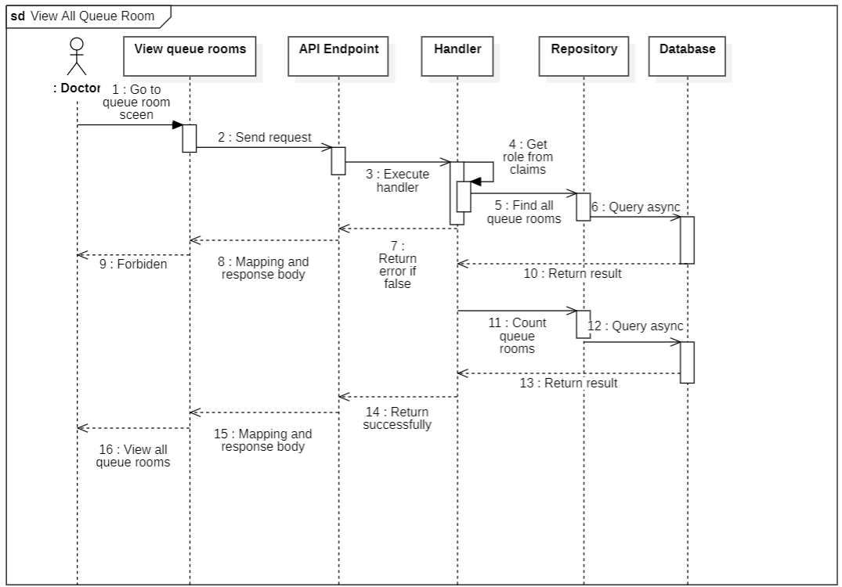

#### d. Database Queries

public Task<int> CountQueueRoomsQueryAsync(CancellationToken cancellationToken = default)

{

return _queueRooms

.Where(predicate: entity => entity.IsSuported)

.CountAsync(cancellationToken: cancellationToken);

}

public async Task<IEnumerable<QueueRoom>> FindAllQueueRoomsQueryAsync(

int pageIndex,

int pageSize,

CancellationToken cancellationToken = default

)

{

return await _queueRooms

.AsNoTracking()

.Where(predicate: entity => entity.IsSuported == false)

.OrderBy(keySelector: entity => entity.CreatedAt)

.Select(selector: entity => new QueueRoom()

{

Id = entity.Id,

Title = entity.Title,

Message = entity.Message,

Patient = new()

{

User = new()

{

Id = entity.Patient.User.Id,

FullName = entity.Patient.User.FullName,

Avatar = entity.Patient.User.Avatar,

}

}

})

.Skip(count: (pageIndex - 1) * pageSize)

.Take(count: pageSize)

.ToListAsync(cancellationToken: cancellationToken);

}

## 11. Chat Rooms

### 11.1. Assign chat room

#### a. Class diagram

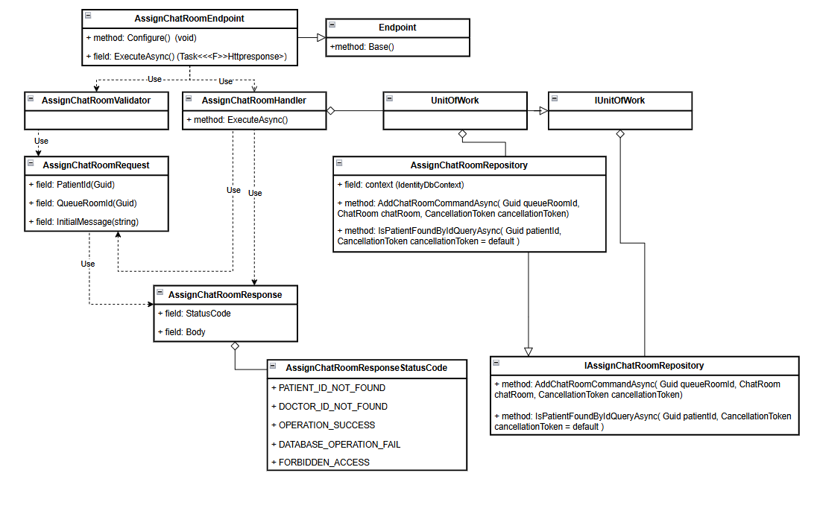

#### b. Class Specifications

#### AssignChatRoomEndpoint class

* 1. *Same as common given before,* [*review here*](https://docs.google.com/document/d/1tTZUy0kDp6tdHb6MY85cNBVlDSK0k0N9w2NXBLPTu-c/edit?fbclid=IwY2xjawGRuZpleHRuA2FlbQIxMAABHUWj7GBmcsB0TEQOSeFgkcMlTv6kK6aEkUnExmkf0x_20x3n5Tikj9MvPA_aem_7Ik47wBVUygzT8J9mpiG0w#heading=h.m7r87enxie2d)*.*

1. ***Endpoint abstract class***
   1. *Same as common given before,* [*review here*](https://docs.google.com/document/d/1tTZUy0kDp6tdHb6MY85cNBVlDSK0k0N9w2NXBLPTu-c/edit?fbclid=IwY2xjawGRuZpleHRuA2FlbQIxMAABHUWj7GBmcsB0TEQOSeFgkcMlTv6kK6aEkUnExmkf0x_20x3n5Tikj9MvPA_aem_7Ik47wBVUygzT8J9mpiG0w#heading=h.ac857vak9ccs)*.*
2. ***AssignChatRoomValidator class***
   1. *Same as common given before,* [*review here*](https://docs.google.com/document/d/1tTZUy0kDp6tdHb6MY85cNBVlDSK0k0N9w2NXBLPTu-c/edit?fbclid=IwY2xjawGRuZpleHRuA2FlbQIxMAABHUWj7GBmcsB0TEQOSeFgkcMlTv6kK6aEkUnExmkf0x_20x3n5Tikj9MvPA_aem_7Ik47wBVUygzT8J9mpiG0w#heading=h.mapewhyr52db)*.*
3. ***AssignChatRoomHandler class***
   1. *Same as common given before,* [*review here*](https://docs.google.com/document/d/1tTZUy0kDp6tdHb6MY85cNBVlDSK0k0N9w2NXBLPTu-c/edit?fbclid=IwY2xjawGRuZpleHRuA2FlbQIxMAABHUWj7GBmcsB0TEQOSeFgkcMlTv6kK6aEkUnExmkf0x_20x3n5Tikj9MvPA_aem_7Ik47wBVUygzT8J9mpiG0w#heading=h.3lfr3mcrnl8j)*.*
4. ***IUnitOfWork interface***
   1. *Same as common given before,* [*review here*](https://docs.google.com/document/d/1tTZUy0kDp6tdHb6MY85cNBVlDSK0k0N9w2NXBLPTu-c/edit?fbclid=IwY2xjawGRuZpleHRuA2FlbQIxMAABHUWj7GBmcsB0TEQOSeFgkcMlTv6kK6aEkUnExmkf0x_20x3n5Tikj9MvPA_aem_7Ik47wBVUygzT8J9mpiG0w#heading=h.plvhy3azezgm)*.*
5. ***UnitOfWork class***
   1. *Same as common given before,* [*review here*](https://docs.google.com/document/d/1tTZUy0kDp6tdHb6MY85cNBVlDSK0k0N9w2NXBLPTu-c/edit?fbclid=IwY2xjawGRuZpleHRuA2FlbQIxMAABHUWj7GBmcsB0TEQOSeFgkcMlTv6kK6aEkUnExmkf0x_20x3n5Tikj9MvPA_aem_7Ik47wBVUygzT8J9mpiG0w#heading=h.75tksa2v2ybj)*.*
6. ***AssignChatRoomRequest class***

| **No** | **Fields** | **Description** |
| --- | --- | --- |
| *01* | *PatientId* | *This field contain PatientId information* |
| *02* | *QueueRoomId* | *This field contain QueueRoomId information* |
|  | *InitialMessage* | *This field contain InitialMessage information* |

1. ***AssignChatRoomResponse class***

| **No** | **Fields** | **Description** |
| --- | --- | --- |
| *01* | *StatusCode* | *This field will return an app code and http code.* |
| *02* | *Body* | *Contain list object information: AssignChatRoomId* |

1. ***AssignChatRoomResponseStatusCode Enum class***

This enum class contains some necessary app code like OPERATION_SUCCESS, .... Purpose to handle response with specifically code of errors.

1. ***AssignChatRoomRepository interface***

This interface class contains method to interact with database

| **No** | **Method** | **Description** |
| --- | --- | --- |
| *01* | ***AddChatRoomCommandAsync****( Guid queueRoomId, ChatRoom chatRoom, CancellationToken cancellationToken = default )* | *Defines a method to AddChatRoomCommandAsync* |
| *02* | ***IsPatientFoundByIdQueryAsync****( Guid patientId, CancellationToken cancellationToken = default )* | *Defines a method to IsPatientFoundByIdQueryAsync* |

1. ***AssignChatRoomRepository***

This class is an implementation of the *IAssignChatRoomRepository* interface***.***

| **No** | **Fields** | **Description** |
| --- | --- | --- |
| *01* | *_context* | *This field is database context* |
| *02* | *_chatRooms* | *Property to interact with the ChatRoom table in the database* |
| *03* | *_patients* | *Property to interact with the Patient table in the database* |
| *04* | *_queueRooms* | *Property to interact with the QueueRoom table in the database* |

| **No** | **Method** | **Description** |
| --- | --- | --- |
| *01* | ***AddChatRoomCommandAsync****( Guid queueRoomId, ChatRoom chatRoom, CancellationToken cancellationToken = default )* | *Defines a method to AddChatRoomCommandAsync* |
| *02* | ***IsPatientFoundByIdQueryAsync****( Guid patientId, CancellationToken cancellationToken = default )* | *Defines a method to IsPatientFoundByIdQueryAsync* |

#### c. Sequence Diagram(s)

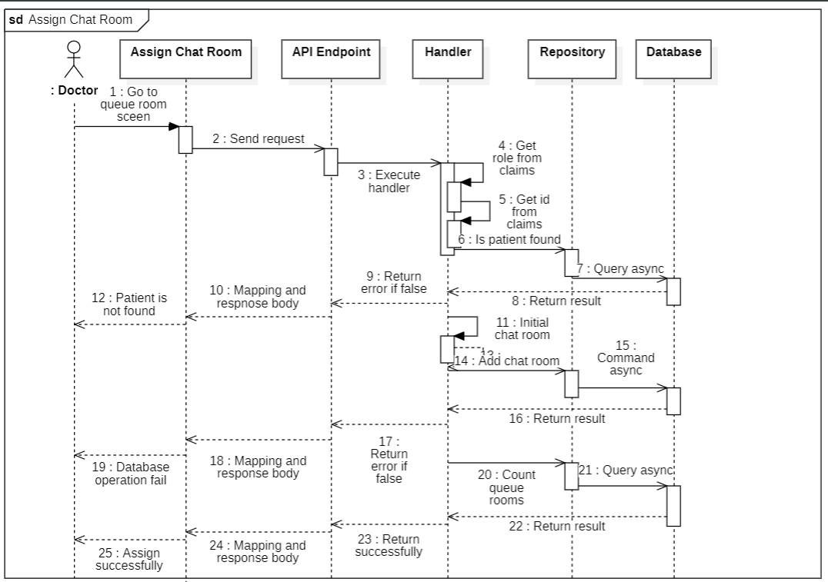

#### d. Database Queries

public async Task<bool> AddChatRoomCommandAsync(

Guid queueRoomId,

ChatRoom chatRoom,

CancellationToken cancellationToken = default

)

{

var dbTransactionResult = false;

await _context

.Database.CreateExecutionStrategy()

.ExecuteAsync(operation: async () =>

{

await using var transaction = await _context.Database.BeginTransactionAsync(

cancellationToken

);

try

{

_chatRooms.Add(entity: chatRoom);

await _queueRooms

.Where(predicate: entity => entity.Id == queueRoomId)

.ExecuteUpdateAsync(setPropertyCalls: entity =>

entity.SetProperty(x => x.IsSuported, true)

);

await _context.SaveChangesAsync(cancellationToken: cancellationToken);

await transaction.CommitAsync(cancellationToken: cancellationToken);

dbTransactionResult = true;

}

catch (Exception ex)

{

await transaction.RollbackAsync(cancellationToken: cancellationToken);

dbTransactionResult = false;

}

});

return dbTransactionResult;

}

public Task<bool> IsPatientFoundByIdQueryAsync(

Guid patientId,

CancellationToken cancellationToken = default

)

{

return _patients.AnyAsync(entity => entity.UserId.Equals(patientId));

}

## 12. Chat Contents

### 12.1. Get Chats By ChatRoomId

#### a. Class diagram

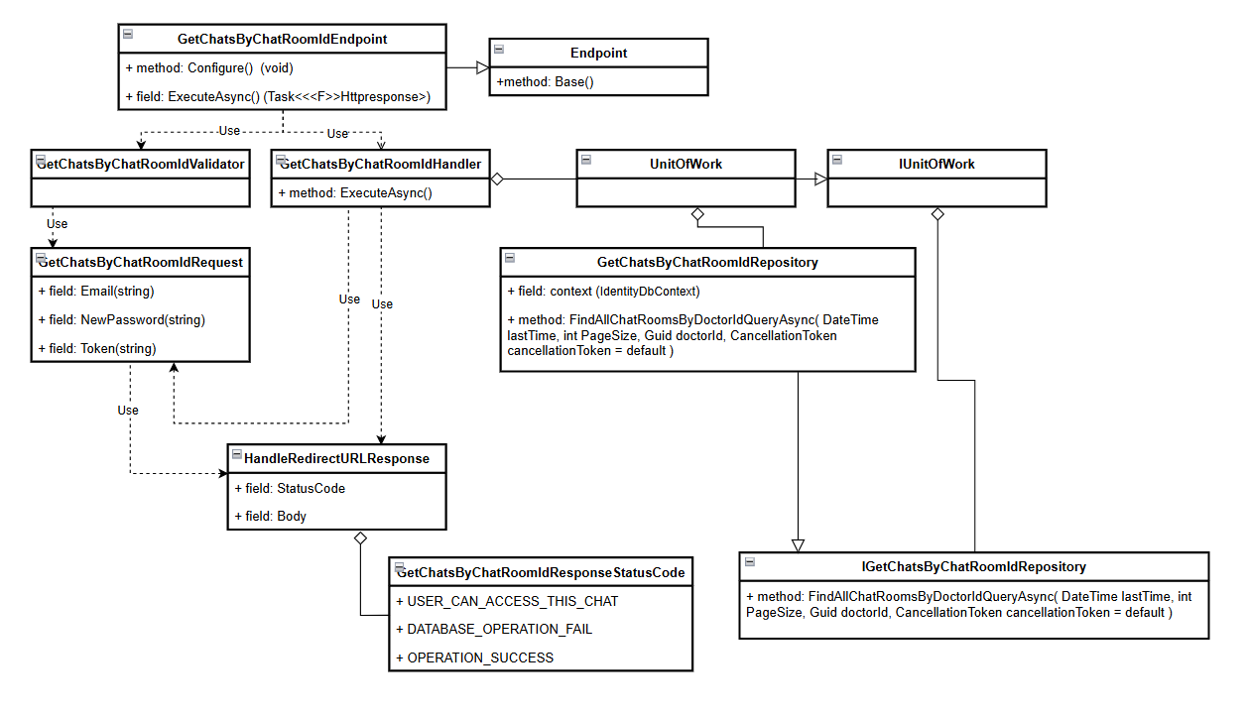

#### b. Class Specifications

#### GetChatsByChatRoomIdEndpoint class

* 1. *Same as common given before,* [*review here*](https://docs.google.com/document/d/1tTZUy0kDp6tdHb6MY85cNBVlDSK0k0N9w2NXBLPTu-c/edit?fbclid=IwY2xjawGRuZpleHRuA2FlbQIxMAABHUWj7GBmcsB0TEQOSeFgkcMlTv6kK6aEkUnExmkf0x_20x3n5Tikj9MvPA_aem_7Ik47wBVUygzT8J9mpiG0w#heading=h.m7r87enxie2d)*.*

1. ***Endpoint abstract class***
   1. *Same as common given before,* [*review here*](https://docs.google.com/document/d/1tTZUy0kDp6tdHb6MY85cNBVlDSK0k0N9w2NXBLPTu-c/edit?fbclid=IwY2xjawGRuZpleHRuA2FlbQIxMAABHUWj7GBmcsB0TEQOSeFgkcMlTv6kK6aEkUnExmkf0x_20x3n5Tikj9MvPA_aem_7Ik47wBVUygzT8J9mpiG0w#heading=h.ac857vak9ccs)*.*
2. ***GetChatsByChatRoomIdValidator class***
   1. *Same as common given before,* [*review here*](https://docs.google.com/document/d/1tTZUy0kDp6tdHb6MY85cNBVlDSK0k0N9w2NXBLPTu-c/edit?fbclid=IwY2xjawGRuZpleHRuA2FlbQIxMAABHUWj7GBmcsB0TEQOSeFgkcMlTv6kK6aEkUnExmkf0x_20x3n5Tikj9MvPA_aem_7Ik47wBVUygzT8J9mpiG0w#heading=h.mapewhyr52db)*.*
3. ***GetChatsByChatRoomIdHandler class***
   1. *Same as common given before,* [*review here*](https://docs.google.com/document/d/1tTZUy0kDp6tdHb6MY85cNBVlDSK0k0N9w2NXBLPTu-c/edit?fbclid=IwY2xjawGRuZpleHRuA2FlbQIxMAABHUWj7GBmcsB0TEQOSeFgkcMlTv6kK6aEkUnExmkf0x_20x3n5Tikj9MvPA_aem_7Ik47wBVUygzT8J9mpiG0w#heading=h.3lfr3mcrnl8j)*.*
4. ***IUnitOfWork interface***
   1. *Same as common given before,* [*review here*](https://docs.google.com/document/d/1tTZUy0kDp6tdHb6MY85cNBVlDSK0k0N9w2NXBLPTu-c/edit?fbclid=IwY2xjawGRuZpleHRuA2FlbQIxMAABHUWj7GBmcsB0TEQOSeFgkcMlTv6kK6aEkUnExmkf0x_20x3n5Tikj9MvPA_aem_7Ik47wBVUygzT8J9mpiG0w#heading=h.plvhy3azezgm)*.*
5. ***UnitOfWork class***
   1. *Same as common given before,* [*review here*](https://docs.google.com/document/d/1tTZUy0kDp6tdHb6MY85cNBVlDSK0k0N9w2NXBLPTu-c/edit?fbclid=IwY2xjawGRuZpleHRuA2FlbQIxMAABHUWj7GBmcsB0TEQOSeFgkcMlTv6kK6aEkUnExmkf0x_20x3n5Tikj9MvPA_aem_7Ik47wBVUygzT8J9mpiG0w#heading=h.75tksa2v2ybj)*.*
6. ***GetChatsByChatRoomIdRequest class***

| **No** | **Fields** | **Description** |
| --- | --- | --- |
| *01* | *LastReportDate* | *This field contain LastReportDate information* |
| *02* | *ChatRoomId* | *This field contain ChatRoomId information* |
|  | *PageSize* | *This field contain PageSize information* |

1. ***GetChatsByChatRoomIdResponse class***

| **No** | **Fields** | **Description** |
| --- | --- | --- |
| *01* | *StatusCode* | *This field will return an app code and http code.* |
| *02* | *Body* | *Contain list object information: ChatContentId, SenderId, Content, Time, IsRemoved, AssetUrl* |

1. ***GetChatsByChatRoomIdResponseStatusCode Enum class***

This enum class contains some necessary app code like OPERATION_SUCCESS, .... Purpose to handle response with specifically code of errors.

1. ***IGetChatsByChatRoomIdRepository interface***

This interface class contains method to interact with database

| **No** | **Method** | **Description** |
| --- | --- | --- |
| *01* | ***FindAllChatRoomsByDoctorIdQueryAsync****( DateTime lastTime, int PageSize, Guid doctorId, CancellationToken cancellationToken = default )* | *Defines a method to FindAllChatRoomsByDoctorIdQueryAsync* |

1. ***GetChatsByChatRoomIdRepository***

This class is an implementation of the *IOrderMedicineRepository* interface***.***

| **No** | **Fields** | **Description** |
| --- | --- | --- |
| *01* | *_context* | *This field is database context* |
| *02* | *_chatRooms* | *Property to interact with the ChatRoom table in the database* |

| **No** | **Method** | **Description** |
| --- | --- | --- |
| *01* | ***FindAllChatRoomsByDoctorIdQueryAsync****( DateTime lastTime, int PageSize, Guid doctorId, CancellationToken cancellationToken = default )* | *Defines a method to FindAllChatRoomsByDoctorIdQueryAsync* |

#### c. Sequence Diagram(s)

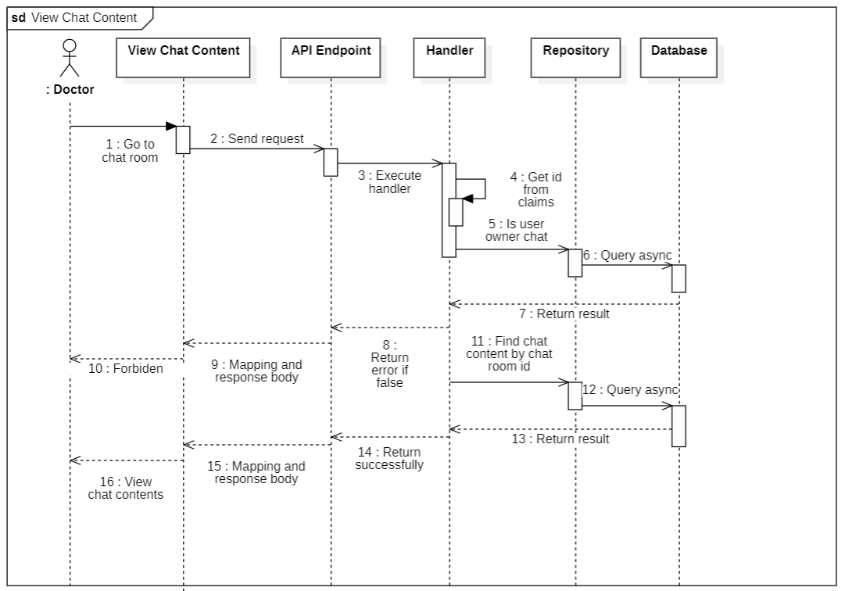

#### d. Database Queries

public async Task<IEnumerable<ChatRoom>> FindAllChatRoomsByDoctorIdQueryAsync(

DateTime lastTime,

int PageSize,

Guid doctorId,

CancellationToken cancellationToken = default

)

{

return await _chatRooms

.AsNoTracking()

.Where(predicate: chatRoom =>

chatRoom.DoctorId == doctorId && chatRoom.LatestTimeMessage < lastTime

)

.OrderByDescending(keySelector: chatRoom => chatRoom.LatestTimeMessage)

.Select(selector: chatRoom => new ChatRoom()

{

Id = chatRoom.Id,

IsEnd = chatRoom.IsEnd,

LastMessage = chatRoom.LastMessage,

ExpiredTime = chatRoom.ExpiredTime,

LatestTimeMessage = chatRoom.LatestTimeMessage,

Patient = new()

{

User = new()

{

Id = chatRoom.Patient.User.Id,

Avatar = chatRoom.Patient.User.Avatar,

FullName = chatRoom.Patient.User.FullName

}

}

})

.Take(count: PageSize)

.ToListAsync(cancellationToken: cancellationToken);

}

### 12.2. Create chat content

#### a. Class diagram

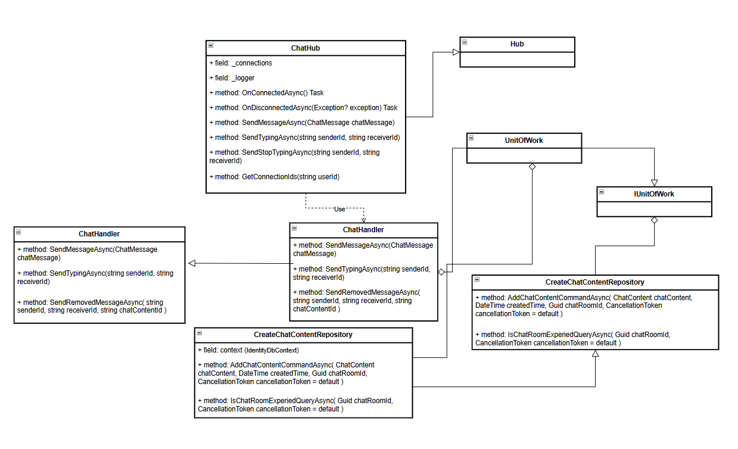

#### b. Class Specifications

1. ***ChatHandler class***

*ChatHandler class implement IChatHandler interface*

| **No** | **Fields** | **Description** |
| --- | --- | --- |
| *01* | *_huBcontext* | *This field contain IHubContext<ChatHub> information* |
| *02* | *_unitOfWork* | *This field contain UnitOfWork information* |

| **No** | **Method** | **Description** |
| --- | --- | --- |
| *01* | ***SendMessageAsync(ChatMessage chatMessage)*** | *Defines a method to SendMessageAsync* |
| *02* | ***SendTypingAsync(string senderId, string receiverId)*** | *Defines a method to SendTypingAsync* |
| *03* | ***SendStopTypingAsync(string senderId, string receiverId)*** | *Defines a method to SendStopTypingAsync* |

1. ***ChatHub class (implement Hub class)***

| **No** | **Fields** | **Description** |
| --- | --- | --- |
| *01* | *_connections* | *Contains connection ids* |
| *02* | *_logger* | *Use to Log information* |

| **No** | **Method** | **Description** |
| --- | --- | --- |
| *01* | ***OnConnectedAsync() Task*** | *Defines a method to on connected* |
| *02* | ***OnDisconnectedAsync****(Exception? exception)* ***Task*** | *Defines a method to on disconnected* |
| *02* | ***SendMessageAsync(ChatMessage chatMessage)*** | *Defines a method to SendMessageAsync* |
| *03* | ***SendTypingAsync(string senderId, string receiverId)*** | *Defines a method to SendTypingAsync* |
| *04* | ***SendStopTypingAsync(string senderId, string receiverId)*** | *Defines a method to SendStopTypingAsync* |
| *05* | ***GetConnectionIds(string userId)*** | *Defines a method to GetConnectionIds* |

1. ***IUnitOfWork interface***
   1. *Same as common given before,* [*review here*](https://docs.google.com/document/d/1tTZUy0kDp6tdHb6MY85cNBVlDSK0k0N9w2NXBLPTu-c/edit?fbclid=IwY2xjawGRuZpleHRuA2FlbQIxMAABHUWj7GBmcsB0TEQOSeFgkcMlTv6kK6aEkUnExmkf0x_20x3n5Tikj9MvPA_aem_7Ik47wBVUygzT8J9mpiG0w#heading=h.plvhy3azezgm)*.*

***4. UnitOfWork class***

* 1. *Same as common given before,* [*review here*](https://docs.google.com/document/d/1tTZUy0kDp6tdHb6MY85cNBVlDSK0k0N9w2NXBLPTu-c/edit?fbclid=IwY2xjawGRuZpleHRuA2FlbQIxMAABHUWj7GBmcsB0TEQOSeFgkcMlTv6kK6aEkUnExmkf0x_20x3n5Tikj9MvPA_aem_7Ik47wBVUygzT8J9mpiG0w#heading=h.75tksa2v2ybj)*.*

***5. ICreateChatContentRepository interface***

This interface class contains method to interact with database

| **No** | **Method** | **Description** |
| --- | --- | --- |
| *01* | ***AddChatContentCommandAsync****( ChatContent chatContent, DateTime createdTime, Guid chatRoomId, CancellationToken cancellationToken = default )* | *Defines a method to AddChatContentCommandAsync* |
| *02* | ***IsChatRoomExperiedQueryAsync****( Guid chatRoomId, CancellationToken cancellationToken = default)* | *Defines a method to IsChatRoomExperiedQueryAsync* |

***6. CreateChatContentRepository***

This class is an implementation of the *I****CreateChatContent****Repository* interface***.***

| **No** | **Fields** | **Description** |
| --- | --- | --- |
| *01* | *_context* | *This field is database context* |
| *02* | *_chatRooms* | *Property to interact with the ChatRoom table in the database* |
| *03* | *_chatContent* | *Property to interact with the ChatConent table in the database* |

| **No** | **Method** | **Description** |
| --- | --- | --- |
| *01* | ***AddChatContentCommandAsync****( ChatContent chatContent, DateTime createdTime, Guid chatRoomId, CancellationToken cancellationToken = default )* | *Defines a method to FindAllChatRoomsByDoctorIdQueryAsync* |
| *02* | ***IsChatRoomExperiedQueryAsync****( Guid chatRoomId, CancellationToken cancellationToken = default)* | *Defines a method to IsChatRoomExperiedQueryAsync* |

#### c. Sequence Diagram(s)

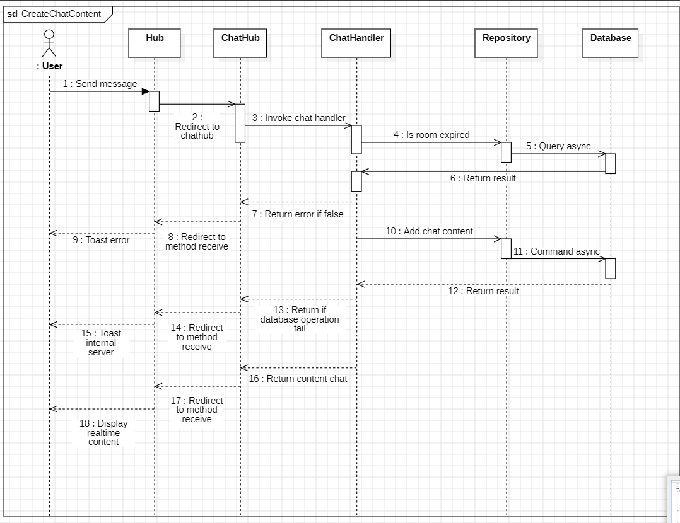

#### d. Database Queries

public async Task<bool> AddChatContentCommandAsync(

ChatContent chatContent,

DateTime createdTime,

Guid chatRoomId,

CancellationToken cancellationToken = default

)

{

var dbResult = false;

await _context

.Database.CreateExecutionStrategy()

.ExecuteAsync(operation: async () =>

{

using var transaction = await _context.Database.BeginTransactionAsync(

cancellationToken: cancellationToken

);

try

{

_chatContents.Add(entity: chatContent);

await _chatRooms

.Where(predicate: chatRoom => chatRoom.Id == chatRoomId)

.ExecuteUpdateAsync(setPropertyCalls: builder =>

builder.SetProperty(chatRoom => chatRoom.LatestTimeMessage, createdTime)

);

await _context.SaveChangesAsync(cancellationToken: cancellationToken);

await transaction.CommitAsync(cancellationToken: cancellationToken);

dbResult = true;

}

catch (Exception e)

{

await transaction.RollbackAsync(cancellationToken: cancellationToken);

dbResult = false;

}

});

return dbResult;

}

public Task<bool> IsChatRoomExperiedQueryAsync(

Guid chatRoomId,

CancellationToken cancellationToken = default

)

{

return _chatRooms

.Where(predicate: chatRoom => chatRoom.Id == chatRoomId && chatRoom.IsEnd)

.AnyAsync(cancellationToken: cancellationToken);

}

## 13. Payment

### 13.1. Handle redirect url Payment

#### a. Class diagram

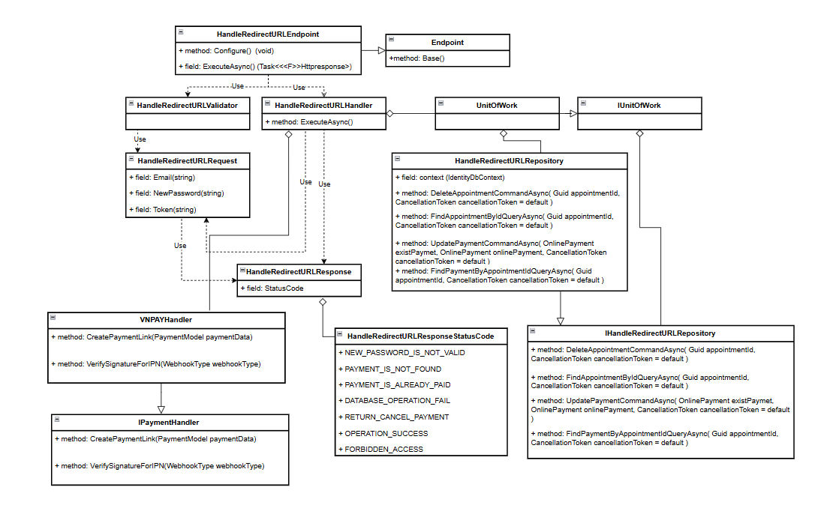

#### b. Class Specifications

#### HandleRedirectURLEndpoint class

* 1. *Same as common given before,* [*review here*](https://docs.google.com/document/d/1tTZUy0kDp6tdHb6MY85cNBVlDSK0k0N9w2NXBLPTu-c/edit?fbclid=IwY2xjawGRuZpleHRuA2FlbQIxMAABHUWj7GBmcsB0TEQOSeFgkcMlTv6kK6aEkUnExmkf0x_20x3n5Tikj9MvPA_aem_7Ik47wBVUygzT8J9mpiG0w#heading=h.m7r87enxie2d)*.*

1. ***Endpoint abstract class***
   1. *Same as common given before,* [*review here*](https://docs.google.com/document/d/1tTZUy0kDp6tdHb6MY85cNBVlDSK0k0N9w2NXBLPTu-c/edit?fbclid=IwY2xjawGRuZpleHRuA2FlbQIxMAABHUWj7GBmcsB0TEQOSeFgkcMlTv6kK6aEkUnExmkf0x_20x3n5Tikj9MvPA_aem_7Ik47wBVUygzT8J9mpiG0w#heading=h.ac857vak9ccs)*.*
2. ***HandleRedirectURLValidator class***
   1. *Same as common given before,* [*review here*](https://docs.google.com/document/d/1tTZUy0kDp6tdHb6MY85cNBVlDSK0k0N9w2NXBLPTu-c/edit?fbclid=IwY2xjawGRuZpleHRuA2FlbQIxMAABHUWj7GBmcsB0TEQOSeFgkcMlTv6kK6aEkUnExmkf0x_20x3n5Tikj9MvPA_aem_7Ik47wBVUygzT8J9mpiG0w#heading=h.mapewhyr52db)*.*
3. ***HandleRedirectURLHandler class***
   1. *Same as common given before,* [*review here*](https://docs.google.com/document/d/1tTZUy0kDp6tdHb6MY85cNBVlDSK0k0N9w2NXBLPTu-c/edit?fbclid=IwY2xjawGRuZpleHRuA2FlbQIxMAABHUWj7GBmcsB0TEQOSeFgkcMlTv6kK6aEkUnExmkf0x_20x3n5Tikj9MvPA_aem_7Ik47wBVUygzT8J9mpiG0w#heading=h.3lfr3mcrnl8j)*.*
4. ***IUnitOfWork interface***
   1. *Same as common given before,* [*review here*](https://docs.google.com/document/d/1tTZUy0kDp6tdHb6MY85cNBVlDSK0k0N9w2NXBLPTu-c/edit?fbclid=IwY2xjawGRuZpleHRuA2FlbQIxMAABHUWj7GBmcsB0TEQOSeFgkcMlTv6kK6aEkUnExmkf0x_20x3n5Tikj9MvPA_aem_7Ik47wBVUygzT8J9mpiG0w#heading=h.plvhy3azezgm)*.*
5. ***UnitOfWork class***
   1. *Same as common given before,* [*review here*](https://docs.google.com/document/d/1tTZUy0kDp6tdHb6MY85cNBVlDSK0k0N9w2NXBLPTu-c/edit?fbclid=IwY2xjawGRuZpleHRuA2FlbQIxMAABHUWj7GBmcsB0TEQOSeFgkcMlTv6kK6aEkUnExmkf0x_20x3n5Tikj9MvPA_aem_7Ik47wBVUygzT8J9mpiG0w#heading=h.75tksa2v2ybj)*.*
6. ***HandleRedirectURLRequest class***

| **No** | **Fields** | **Description** |
| --- | --- | --- |
| *01* | *AppointmentId* | *This field requires the user to enter the AppointmentId .* |
| *02* | *Amount* | *This field requires the user to enter the Amount .* |
| *03* | *BankCode* | *This field requires the user to enter the BankCode .* |
| *04* | *BankTransactionNo* | *This field requires the user to enter the BankTransactionNo .* |
| *05* | *CardType* | *This field requires the user to enter the CardType .* |
| *06* | *OrderInfo* | *This field requires the user to enter the OrderInfo .* |
| *07* | *PayDate* | *This field requires the user to enter the PayDate .* |
| *08* | *ResponseCode* | *This field requires the user to enter the ResponseCode .* |
| *09* | *TerminalCode* | *This field requires the user to enter the TerminalCode .* |
| *10* | *TransactionNo* | *This field requires the user to enter the TransactionNo .* |
| *11* | *TransactionStatus* | *This field requires the user to enter the TransactionStatus .* |
| *12* | *TransactionRef* | *This field requires the user to enter the TransactionRef .* |
| *13* | *SecureHash* | *This field requires the user to enter the SecureHash .* |
| *14* | *HashKey* | *This field requires the user to enter the HashKey .* |

1. ***HandleRedirectURLResponse class***

| **No** | **Fields** | **Description** |
| --- | --- | --- |
| *01* | *StatusCode* | *This field will return an app code and http code.* |
| *02* | *Body* | *This field contain a object: Amount, TransactionId, PaymentDate, AppointmentDate, DoctorName* |

1. ***HandleRedirectURLResponseStatusCode Enum class***

This enum class contains some necessary app code like OPERATION_SUCCESS, DATABASE_OPERATION_FAILED, PAYMENT_IS_NOT_FOUND, .... Purpose to handle response with specifically code of errors and success.

1. ***IHandleRedirectURLRepository interface***

This interface class contains method to interact with database

| **No** | **Method** | **Description** |
| --- | --- | --- |
| *01* | ***DeleteAppointmentCommandAsync****( Guid appointmentId, CancellationToken cancellationToken = default )* | *Defines a method to DeleteAppointmentCommandAsync* |
| *02* | ***FindAppointmentByIdQueryAsync****( Guid appointmentId, CancellationToken cancellationToken = default )* | *Defines a method to FindAppointmentByIdQueryAsync* |
| *03* | ***UpdatePaymentCommandAsync****( OnlinePayment existPaymet, OnlinePayment onlinePayment, CancellationToken cancellationToken = default )* | *Defines a method to UpdatePaymentCommandAsync* |
| *04* | ***FindPaymentByAppointmentIdQueryAsync****( Guid appointmentId, CancellationToken cancellationToken = default )* | *Defines a method to FindPaymentByAppointmentIdQueryAsync* |

1. ***HandleRedirectURLRepository***

This class is an implementation of the *IOrderMedicineRepository* interface***.***

| **No** | **Fields** | **Description** |
| --- | --- | --- |
| *01* | *_context* | *This field is database context* |
| *02* | *_appointment* | *Property to interact with the Appointment table in the database* |
| *03* | *_onlinePayment* | *Property to interact with the OnlinePayment table in the database* |
| *04* | *_doctors* | *Property to interact with the Doctor table in the database* |

| **No** | **Method** | **Description** |
| --- | --- | --- |
| *01* | ***DeleteAppointmentCommandAsync****( Guid appointmentId, CancellationToken cancellationToken = default )* | *Defines a method to DeleteAppointmentCommandAsync* |
| *02* | ***FindAppointmentByIdQueryAsync****( Guid appointmentId, CancellationToken cancellationToken = default )* | *Defines a method to FindAppointmentByIdQueryAsync* |
| *03* | ***UpdatePaymentCommandAsync****( OnlinePayment existPaymet, OnlinePayment onlinePayment, CancellationToken cancellationToken = default )* | *Defines a method to UpdatePaymentCommandAsync* |
| *04* | ***FindPaymentByAppointmentIdQueryAsync****( Guid appointmentId, CancellationToken cancellationToken = default )* | *Defines a method to FindPaymentByAppointmentIdQueryAsync* |

#### c. Sequence Diagram(s)

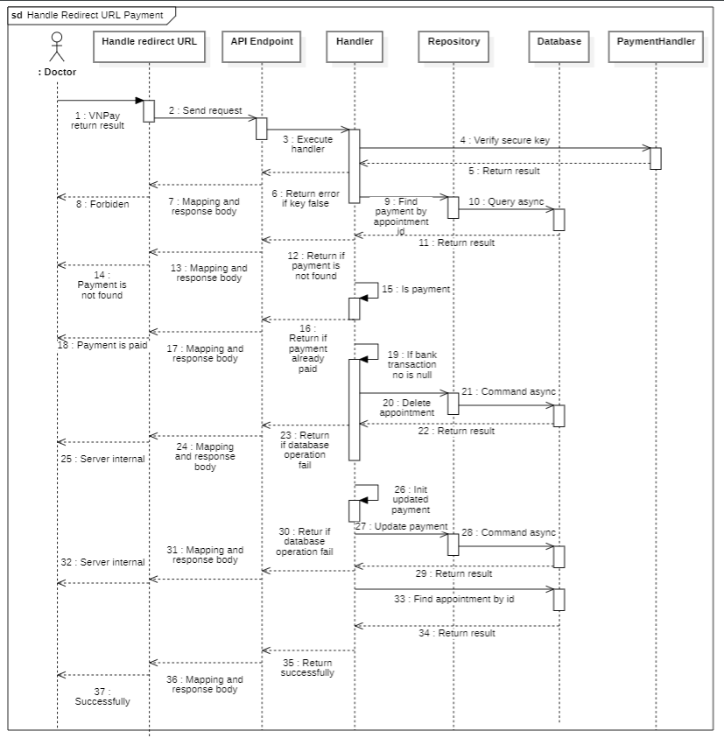

#### d. Database Queries

public async Task<bool> DeleteAppointmentCommandAsync(

Guid appointmentId,

CancellationToken cancellationToken = default

)

{

try

{

var payment = await _onlinePayment

.Where(predicate: entity => entity.AppointmentId == appointmentId)

.FirstOrDefaultAsync(cancellationToken: cancellationToken);

_onlinePayment.Remove(payment);

_appointments.Remove(new Appointment { Id = appointmentId });

await _context.SaveChangesAsync(cancellationToken: cancellationToken);

return true;

}

catch (Exception ex)

{

await Console.Out.WriteLineAsync(ex.Message);

return false;

}

}

public Task<Appointment> FindAppointmentByIdQueryAsync(

Guid appointmentId,

CancellationToken cancellationToken = default

)

{

return _appointments

.Where(predicate: entity => entity.Id == appointmentId)

.Select(selector: entity => new Appointment()

{

Schedule = new()

{

Doctor = new()

{

User = new() { FullName = entity.Schedule.Doctor.User.FullName }

},

StartDate = entity.Schedule.StartDate

},

})

.FirstOrDefaultAsync(cancellationToken: cancellationToken);

}

public Task<OnlinePayment> FindPaymentByAppointmentIdQueryAsync(

Guid appointmentId,

CancellationToken cancellationToken = default

)

{

return _onlinePayment

.Where(predicate: entity => entity.AppointmentId == appointmentId)

.FirstOrDefaultAsync(cancellationToken: cancellationToken);

}

public async Task<bool> UpdatePaymentCommandAsync(

OnlinePayment existPaymet,

OnlinePayment onlinePayment,

CancellationToken cancellationToken = default

)

{

var dbTransactionResult = false;

await _context

.Database.CreateExecutionStrategy()

.ExecuteAsync(operation: async () =>

{

await using var transaction = await _context.Database.BeginTransactionAsync(

cancellationToken: cancellationToken

);

_onlinePayment.Attach(entity: existPaymet).CurrentValues.SetValues(onlinePayment);

try

{

await _appointments

.Where(predicate: entity => entity.Id == existPaymet.AppointmentId)

.ExecuteUpdateAsync(

setPropertyCalls: (

entity => entity.SetProperty(entity => entity.DepositPayment, true)

)

);

dbTransactionResult =

await _context.SaveChangesAsync(cancellationToken: cancellationToken) > 0;

await transaction.CommitAsync(cancellationToken: cancellationToken);

}

catch (Exception e)

{

await Console.Out.WriteLineAsync(e.Message);

await transaction.RollbackAsync(cancellationToken: cancellationToken);

}

});

return dbTransactionResult;

}

## 

## 14. Admin

### 14.1. Doctor

##### 14.1.1. Add doctor

###### a. Class diagram

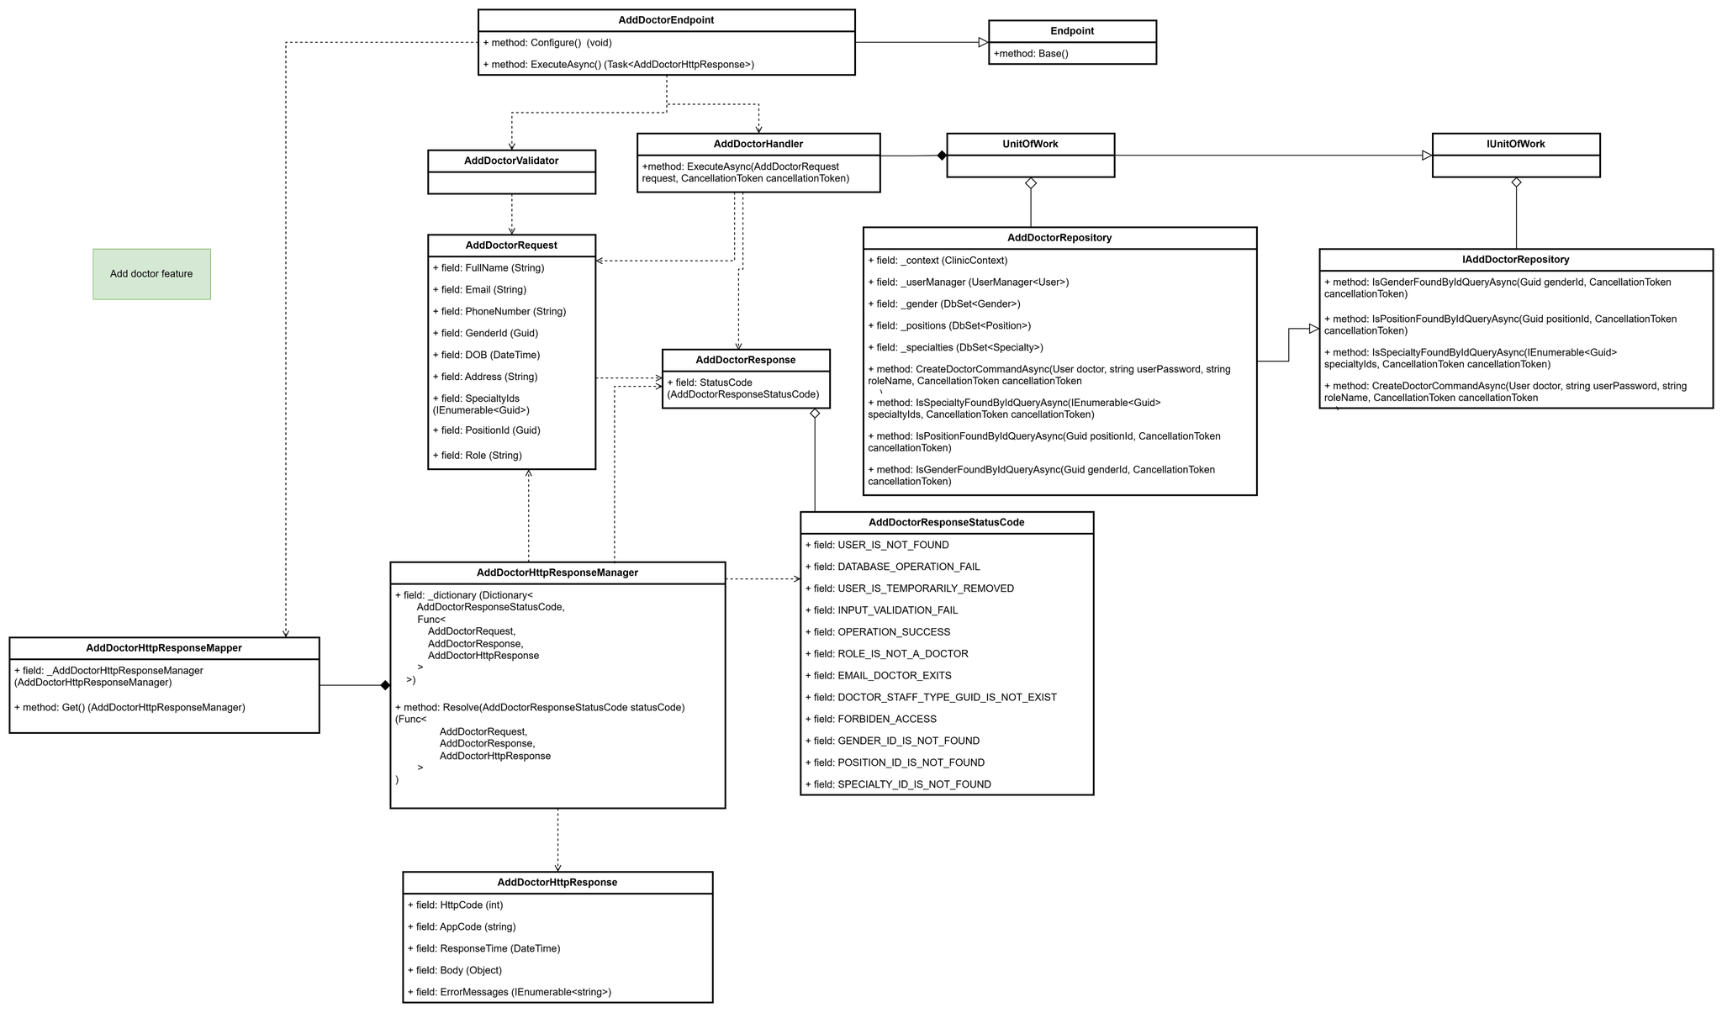

###### b. Class Specifications

1. ***AddDoctorEndpoint class***

*Same as common given before,* *review here**.*

1. ***Endpoint abstract class***

*Same as common given before,* *review here**.*

1. ***AddDoctorValidator class***

*Same as common given before,* *review here**.*

1. ***AddDoctorHandler class***

*Same as common given before,* *review here**.*

1. ***IUnitOfWork interface***

*Same as common given before,* *review here**.*

1. ***UnitOfWork class***

*Same as common given before,* *review here**.*

1. ***AddDoctorRequest class***

*This class is a data transfer object (DTO) that represents the data needed to register a new doctor. It implements the IFeatureRequest interface, which returns an AddDoctorResponse, defining the expected response after the doctor is added.*

| **No** | **Fields** | **Description** |
| --- | --- | --- |
| *01* | *FullName* | *Represents the full name of the doctor. It includes first, middle, and last names as a single string.* |
| *02* | *PhoneNumber* | *Represents the contact phone number of the doctor. This number is used for contacting the doctor if needed.* |
| *03* | *Email* | *Represents the email address of the doctor. This will be used for communication.* |
| *04* | *Password* | *This field requires the user to enter the account password* |
| *05* | *GenderId* | *Represents the unique identifier for the gender of the doctor. It links to a record in the Gender table.* |
| *06* | *DOB* | *Represents the date of birth of the doctor. This is used for age verification and record purposes.* |
| *07* | *Address* | *Represents the residential address of the doctor. This can include street, city, and postal code information.* |
| *08* | *SpecialtyIds* | *Represents a collection of specialty identifiers for the doctor. Each ID corresponds to a medical specialty in the Specialty table.* |
| *09* | *PositionId* | *Represents the unique identifier for the doctor’s position. This ID links to a record in the Position table, defining the doctor’s role within the clinic.* |
| *10* | *Role* | *Represents the role assigned to the doctor within the system, such as "Doctor" or "Staff." This could also be used for authorization and permissions.* |

1. ***AddDoctorResponse class***

| **No** | **Fields** | **Description** |
| --- | --- | --- |
| *01* | *StatusCode* | *This field will return an app code and http code.* |

1. ***AddDoctorResponseStatusCode Enum class***

This enum class contains some necessary app code like USER_IS_NOT_FOUND, DATABASE_OPERATION_FAIL, USER_IS_TEMPORARILY_REMOVED,.... Purpose to handle response with specifically code of errors.

1. ***IAddDoctorRepository interface***

This interface class contains method to interact with database

| **No** | **Method** | **Description** |
| --- | --- | --- |
| *01* | ***IsGenderFoundByIdQueryAsync****(Guid genderId, CancellationToken cancellationToken)* | *Defines a method to check if the gender exists or not.* |
| *02* | ***IsPositionFoundByIdQueryAsync****(Guid positionId, CancellationToken cancellationToken)* | *Defines a method to check if the position exists or not.* |
| *03* | ***IsSpecialtyFoundByIdQueryAsync****(IEnumerable<Guid> specialtyIds, CancellationToken cancellationToken)* | *Defines a method to check if the specialty exists or not.* |
| *04* | ***CreateDoctorCommandAsync****(User doctor, string userPassword, string roleName, CancellationToken cancellationToken)* | *Defines a method to create a doctor.* |

1. ***AddDoctorRepository***

This class is an implementation of the IAddDoctorRepository interface***.***

| **No** | **Fields** | **Description** |
| --- | --- | --- |
| *01* | *_context* | *This field represents the*database context *for the clinic. It serves as the main gateway to interact with the database, allowing CRUD operations for various entities.* |
| *02* | *_userManager* | *This field represents the User Manager for handling user-related operations, such as creating, updating, and managing users. It provides tools to work with identity features like authentication and authorization.* |
| *03* | *_gender* | *This field represents the Gender table in the database. It enables interaction with gender-related records, allowing querying, adding, updating, and deleting gender entries.* |
| *04* | *_positions* | *This field represents the Position table in the database. It allows interaction with position data, supporting operations such as querying and modifying records related to different job positions within the clinic.* |
| *05* | *_specialties* | *This field represents the Specialty table in the database. It provides access to specialty information, enabling operations like querying and managing specialties related to medical fields.* |

| **No** | **Method** | **Description** |
| --- | --- | --- |
| *01* | ***IsGenderFoundByIdQueryAsync****(Guid genderId, CancellationToken cancellationToken)* | *Execute statements that interact with the database and return a gender record or null* |
| *02* | ***IsPositionFoundByIdQueryAsync****(Guid positionId, CancellationToken cancellationToken)* | *Execute statements that interact with the database and return a position record or null* |
| *03* | ***IsSpecialtyFoundByIdQueryAsync****(IEnumerable<Guid> specialtyIds, CancellationToken cancellationToken)* | *Execute statements that interact with the database and return a specialty record or null* |
| *04* | ***CreateDoctorCommandAsync****(User doctor, string userPassword, string roleName, CancellationToken cancellationToken)* | *Execute statements that interact with the database and create a doctor record and return created doctor or return null* |

###### c. Sequence Diagram(s)

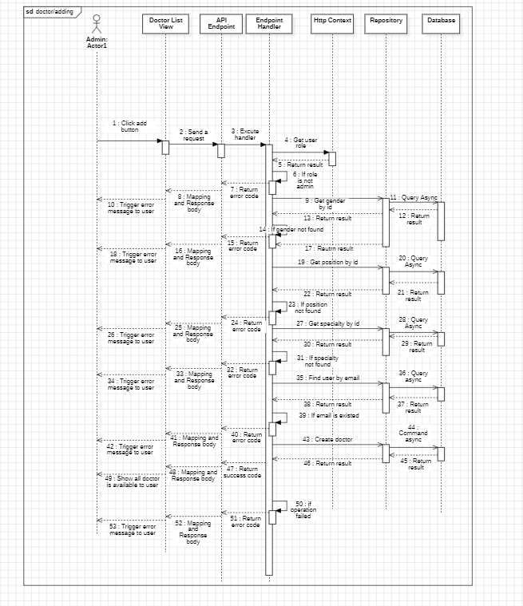

###### d. Database Queries

**public async Task<bool> CreateDoctorCommandAsync(**

User doctor,

string userPassword,

string roleName,

CancellationToken cancellationToken

)

{

var dbTransactionResult = false;

await _context

.Database.CreateExecutionStrategy()

.ExecuteAsync(operation: async () =>

{

using var transaction = await _context.Database.BeginTransactionAsync(

cancellationToken: cancellationToken

);

try

{

var result = await _userManager.CreateAsync(

user: doctor,

password: userPassword

);

if (!result.Succeeded)

{

throw new DbUpdateConcurrencyException();

}

result = await _userManager.AddToRoleAsync(user: doctor, role: roleName);

if (!result.Succeeded)

{

throw new DbUpdateConcurrencyException();

}

var emailConfirmationToken =

await _userManager.GenerateEmailConfirmationTokenAsync(user: doctor);

await _userManager.ConfirmEmailAsync(

user: doctor,

token: emailConfirmationToken

);

await _context.SaveChangesAsync(cancellationToken: cancellationToken);

await transaction.CommitAsync(cancellationToken: cancellationToken);

dbTransactionResult = true;

}

catch (Exception e)

{

Console.Write(e);

await transaction.RollbackAsync(cancellationToken: cancellationToken);

}

});

return dbTransactionResult;

}

**public Task<bool> IsGenderFoundByIdQueryAsync(**

Guid genderId,

CancellationToken cancellationToken

)

{

return _gender.AnyAsync(

predicate: entity => entity.Id == genderId,

cancellationToken: cancellationToken

);

}

**public Task<bool> IsPositionFoundByIdQueryAsync(**

Guid positionId,

CancellationToken cancellationToken

)

{

return _positions.AnyAsync(

predicate: entity => entity.Id == positionId,

cancellationToken: cancellationToken

);

}

**public Task<bool> IsSpecialtyFoundByIdQueryAsync(**

IEnumerable<Guid> specialtyIds,

CancellationToken cancellationToken

)

{

return _specialties.AnyAsync(

predicate: entity => specialtyIds.Contains(entity.Id),

cancellationToken: cancellationToken

);

}

##### 14.1.2. Get all doctor

###### a. Class diagram

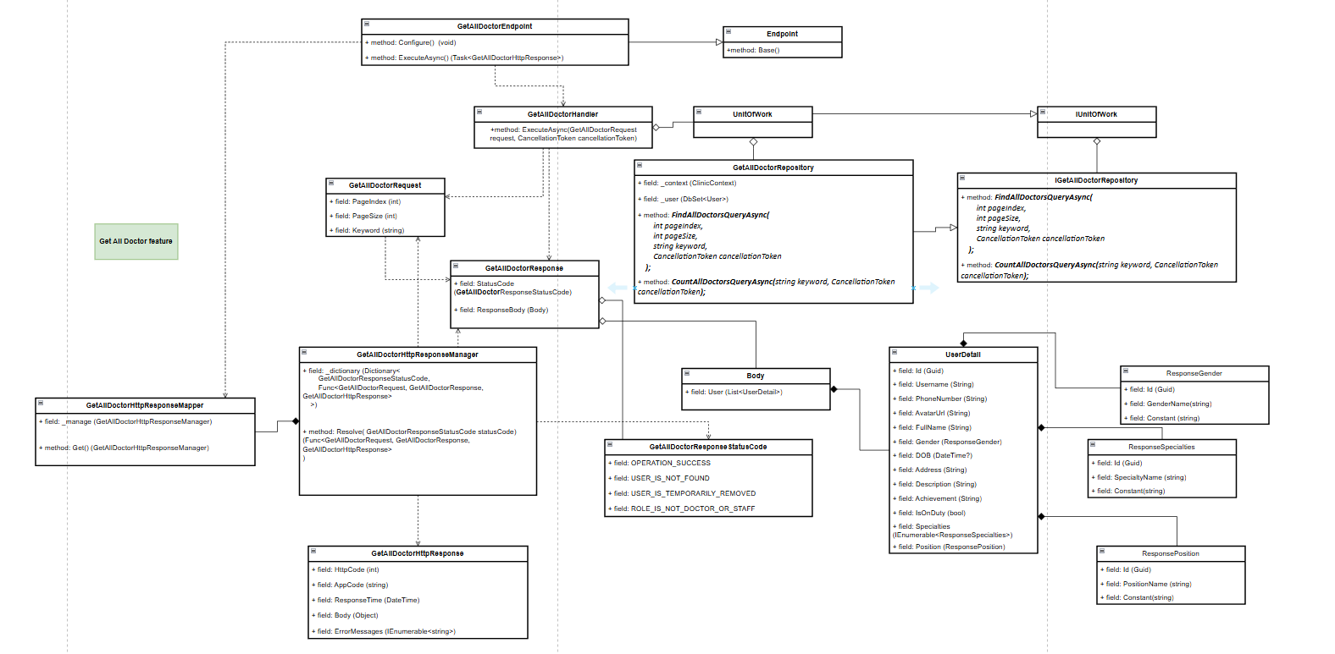

###### b. Class Specifications

1. ***GetAllDoctorEndpoint class***

***a.*** ***Same as common given before,*** [***review here***](https://docs.google.com/document/d/1tTZUy0kDp6tdHb6MY85cNBVlDSK0k0N9w2NXBLPTu-c/edit?fbclid=IwY2xjawGRuZpleHRuA2FlbQIxMAABHUWj7GBmcsB0TEQOSeFgkcMlTv6kK6aEkUnExmkf0x_20x3n5Tikj9MvPA_aem_7Ik47wBVUygzT8J9mpiG0w#heading=h.m7r87enxie2d)***.***

1. ***Endpoint abstract class***

***a.*** ***Same as common given before,*** [***review here***](https://docs.google.com/document/d/1tTZUy0kDp6tdHb6MY85cNBVlDSK0k0N9w2NXBLPTu-c/edit?fbclid=IwY2xjawGRuZpleHRuA2FlbQIxMAABHUWj7GBmcsB0TEQOSeFgkcMlTv6kK6aEkUnExmkf0x_20x3n5Tikj9MvPA_aem_7Ik47wBVUygzT8J9mpiG0w#heading=h.ac857vak9ccs)***.***

1. ***GetAllDoctorValidator class***

***a.*** ***Same as common given before,*** [***review here***](https://docs.google.com/document/d/1tTZUy0kDp6tdHb6MY85cNBVlDSK0k0N9w2NXBLPTu-c/edit?fbclid=IwY2xjawGRuZpleHRuA2FlbQIxMAABHUWj7GBmcsB0TEQOSeFgkcMlTv6kK6aEkUnExmkf0x_20x3n5Tikj9MvPA_aem_7Ik47wBVUygzT8J9mpiG0w#heading=h.mapewhyr52db)***.***

1. ***GetAllDoctorHandler class***

***a.*** ***Same as common given before,*** [***review here***](https://docs.google.com/document/d/1tTZUy0kDp6tdHb6MY85cNBVlDSK0k0N9w2NXBLPTu-c/edit?fbclid=IwY2xjawGRuZpleHRuA2FlbQIxMAABHUWj7GBmcsB0TEQOSeFgkcMlTv6kK6aEkUnExmkf0x_20x3n5Tikj9MvPA_aem_7Ik47wBVUygzT8J9mpiG0w#heading=h.3lfr3mcrnl8j)***.***

1. ***IUnitOfWork interface***

***a.*** ***Same as common given before,*** [***review here***](https://docs.google.com/document/d/1tTZUy0kDp6tdHb6MY85cNBVlDSK0k0N9w2NXBLPTu-c/edit?fbclid=IwY2xjawGRuZpleHRuA2FlbQIxMAABHUWj7GBmcsB0TEQOSeFgkcMlTv6kK6aEkUnExmkf0x_20x3n5Tikj9MvPA_aem_7Ik47wBVUygzT8J9mpiG0w#heading=h.plvhy3azezgm)***.***

1. ***UnitOfWork class***

***a.*** ***Same as common given before,*** [***review here***](https://docs.google.com/document/d/1tTZUy0kDp6tdHb6MY85cNBVlDSK0k0N9w2NXBLPTu-c/edit?fbclid=IwY2xjawGRuZpleHRuA2FlbQIxMAABHUWj7GBmcsB0TEQOSeFgkcMlTv6kK6aEkUnExmkf0x_20x3n5Tikj9MvPA_aem_7Ik47wBVUygzT8J9mpiG0w#heading=h.75tksa2v2ybj)***.***

1. ***GetAllDoctorRequest class***

| ***No*** | ***Fields*** | ***Description*** |
| --- | --- | --- |
| ***01*** | ***PageIndex*** | ***Current index of page for paginating.*** |
| ***02*** | ***PageSize*** | ***Number of elements in 1 page for paginating.*** |
| ***03*** | ***Keyword*** | ***Keyword for filtering data.*** |

***8.*** ***GetAllDoctorResponse class***

| ***No*** | ***Fields*** | ***Description*** |
| --- | --- | --- |
| ***01*** | ***StatusCode*** | ***This field will return an app code and http code.*** |
| ***02*** | ***ResponseBody*** | ***Contains the main data body of the response*** |

***9.*** ***Body class***

| ***No*** | ***Fields*** | ***Description*** |
| --- | --- | --- |
| ***01*** | ***Users*** | ***A paginated list of doctors (represented by User class), containing details such as ID, username, contact info, etc.*** |

***10.*** ***User class***

| ***No*** | ***Fields*** | ***Description*** |
| --- | --- | --- |
| ***01*** | ***Id*** | ***Unique identifier for the doctor.*** |
| ***02*** | ***PhoneNumber*** | ***The contact phone number of the doctor.*** |
| ***03*** | ***DOB*** | ***Date of birth of the patient.*** |
| ***04*** | ***AvatarUrl*** | ***URL or path to the patient’s avatar image.*** |
| ***05*** | ***Address*** | ***Patient's address.*** |
| ***06*** | ***Gender*** | ***Patient’s gender.*** |
| ***07*** | ***PhoneNumber*** | ***Patient's contact phone number*** |
| ***08*** | ***Description*** | ***Short description or bio of the doctor.*** |
| ***09*** | ***Achievement*** | ***Achievements or professional recognitions of the doctor.*** |
| ***10*** | ***IsOnDuty*** | ***Boolean flag indicating if the doctor is currently on duty.*** |
| ***11*** | ***Specialty*** | ***A list of specialties the doctor has, represented by the SpecialtyDTO class.*** |
| ***12*** | ***Position*** | ***The doctor’s position, represented by the PositionDTO class.*** |

***11.*** ***GenderDTO Class***

| ***No*** | ***Fields*** | ***Description*** |
| --- | --- | --- |
| ***01*** | ***Id*** | ***Unique identifier for the gender.*** |
| ***02*** | ***Name*** | ***The name of the gender (e.g., Male, Female).*** |
| ***03*** | ***Constant*** | ***A constant value representing the gender.*** |

***12.*** ***SpecialtyDTO class***

| ***No*** | ***Fields*** | ***Description*** |
| --- | --- | --- |
| ***01*** | ***Id*** | ***Unique identifier for the specialty.*** |
| ***02*** | ***Name*** | ***Name of the specialty (e.g., Cardiology, Dermatology).*** |
| ***03*** | ***Constant*** | ***A constant value representing the specialty.*** |

***13.*** ***PositionDTO class***

| ***No*** | ***Fields*** | ***Description*** |
| --- | --- | --- |
| ***01*** | ***Id*** | ***Unique identifier for the position.*** |
| ***02*** | ***Name*** | ***Name of the position (e.g., Senior Doctor, Junior Doctor).*** |
| ***03*** | ***Constant*** | ***A constant value representing the position.*** |

***14.*** ***GetAllDoctorResponseStatusCode Enum class***

***This enum class contains some necessary app code like OPERATION_SUCCESS, DATABASE_OPERATION_FAIL, ROLE_IS_NOT_ADMIN ,.... Purpose to handle response with specifically code of errors.***

***15.*** ***IGetAllDoctorRepository interface***

***This interface class contains method to interact with database***

| ***No*** | ***Method*** | ***Description*** |
| --- | --- | --- |
| ***01*** | ***public Task<int> CountAllDoctorsQueryAsync(****string keyword, CancellationToken cancellationToken****)*** | ***Defines a method to count the total number of doctors matching the given keyword, considering filters for removed status and doctor association.*** |
| ***02*** | ***public async Task<IEnumerable<User>> FindAllDoctorsQueryAsync(***  *int pageIndex,*  *int pageSize,*  *string keyword,*  *CancellationToken cancellationToken*  ***)*** | ***Defines a method to retrieve a paginated list of doctors, with support for filtering by keyword and applying removal status filters.*** |

***16.*** ***GetAllDoctorRepository***

***This class is an implementation of the ICreateScheduleRepository interface.***

| ***No*** | ***Fields*** | ***Description*** |
| --- | --- | --- |
| ***01*** | ***_context*** | ***This field is database context*** |
| ***02*** | ***_users*** | ***Property to interact with the Users table in the database, which contains doctor and user data.*** |

| ***No*** | ***Method*** | ***Description*** |
| --- | --- | --- |
| ***01*** | ***public Task<int> CountAllDoctorsQueryAsync(****string keyword, CancellationToken cancellationToken****)*** | ***Executes a query to count all doctors in the database whose name matches the given keyword. The query filters for doctors that are not removed.*** |
| ***02*** | ***public async Task<IEnumerable<User>> FindAllDoctorsQueryAsync(***  *int pageIndex,*  *int pageSize,*  *string keyword,*  *CancellationToken cancellationToken*  ***)*** | ***Executes a query to retrieve a paginated list of doctors from the database, based on the provided page index, page size, and keyword. It includes filters for non-removed doctors and includes relevant doctor details such as position, specialties, and status.*** |

###### c. Sequence Diagram(s)

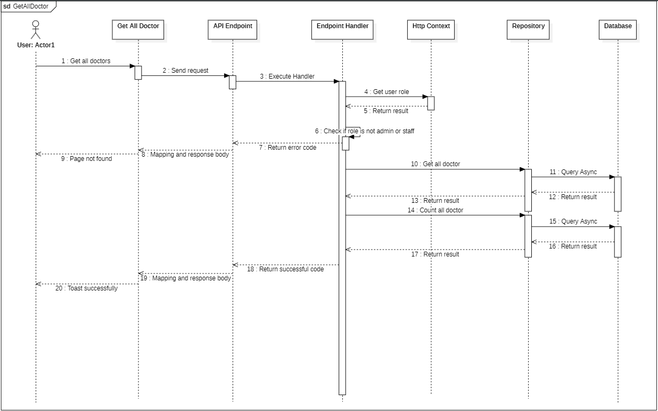

###### d. Database Queries

**public Task<int> CountAllDoctorsQueryAsync(string keyword, CancellationToken cancellationToken)**

{

return _users

.AsNoTracking()

.Where(predicate: user =>

user.Doctor != null

&& user.RemovedAt == Application.Commons.Constance.CommonConstant.MIN_DATE_TIME

&& user.RemovedBy

== Application.Commons.Constance.CommonConstant.DEFAULT_ENTITY_ID_AS_GUID

&& (user.FullName.Contains(keyword))

)

.CountAsync(cancellationToken: cancellationToken);

}

**public async Task<IEnumerable<User>> FindAllDoctorsQueryAsync(**

**int pageIndex,**

**int pageSize,**

**string keyword,**

**CancellationToken cancellationToken**

**)**

{

return await _users

.AsNoTracking()

.Where(predicate: user =>

user.Doctor != null

&& user.RemovedAt == Application.Commons.Constance.CommonConstant.MIN_DATE_TIME

&& user.RemovedBy

== Application.Commons.Constance.CommonConstant.DEFAULT_ENTITY_ID_AS_GUID

&& (user.FullName.Contains(keyword))

)

.Select(selector: user => new User()

{

Id = user.Id,

UserName = user.UserName,

FullName = user.FullName,

PhoneNumber = user.PhoneNumber,

Avatar = user.Avatar,

Gender = new()

{

Id = user.Gender.Id,

Name = user.Gender.Name,

Constant = user.Gender.Constant,

},

Doctor = new()

{

DOB = user.Doctor.DOB,

Description = user.Doctor.Description,

Position = new()

{

Id = user.Doctor.Position.Id,

Name = user.Doctor.Position.Name,

Constant = user.Doctor.Position.Constant,

},

DoctorSpecialties = user

.Doctor.DoctorSpecialties.Select(doctorSpecialty => new DoctorSpecialty()

{

Specialty = new Specialty

{

Id = doctorSpecialty.Specialty.Id,

Name = doctorSpecialty.Specialty.Name,

Constant = doctorSpecialty.Specialty.Constant,

},

})

.ToList(),

Address = user.Doctor.Address,

Achievement = user.Doctor.Achievement,

IsOnDuty = user.Doctor.IsOnDuty,

},

})

.Skip((pageIndex - 1) * pageSize)

.Take(pageSize)

.ToListAsync(cancellationToken: cancellationToken);

}

### 14.2. Create a medicine

#### a. Class diagram

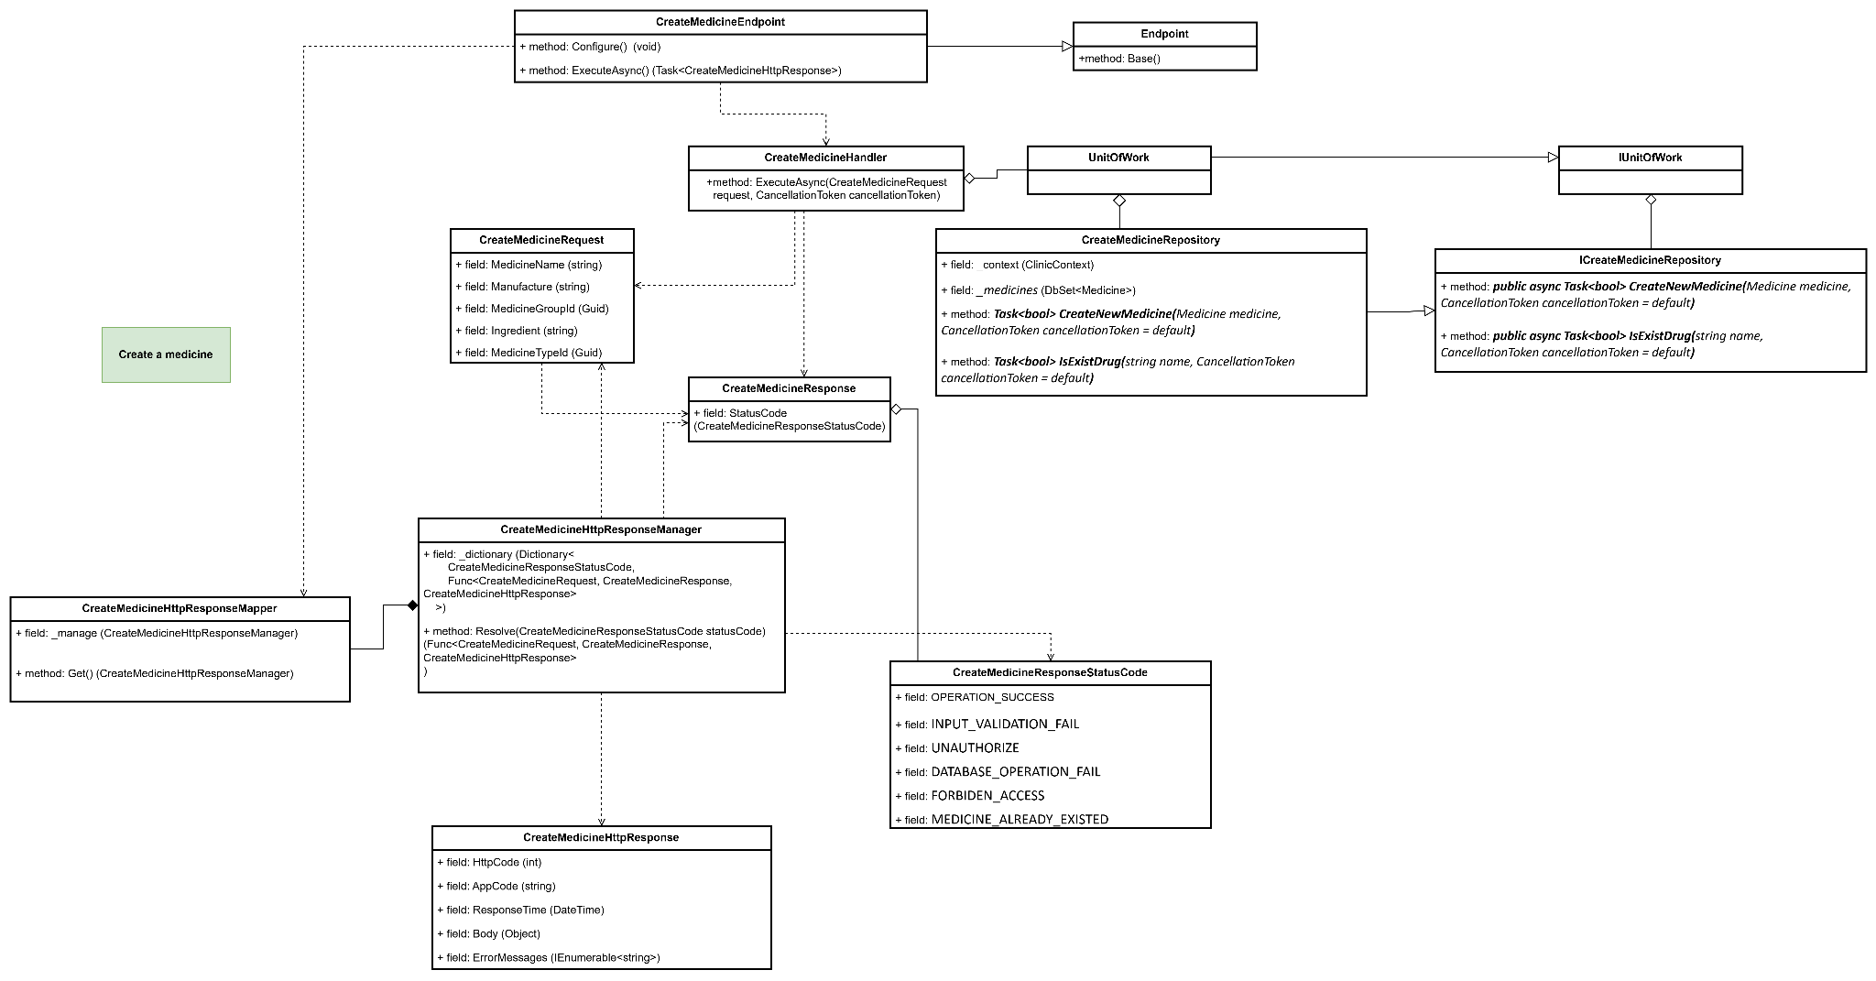

#### b. Class Specifications

#### CreateMedicineEndpoint class

*Same as common given before,* [*review here*](https://docs.google.com/document/d/1tTZUy0kDp6tdHb6MY85cNBVlDSK0k0N9w2NXBLPTu-c/edit?fbclid=IwY2xjawGRuZpleHRuA2FlbQIxMAABHUWj7GBmcsB0TEQOSeFgkcMlTv6kK6aEkUnExmkf0x_20x3n5Tikj9MvPA_aem_7Ik47wBVUygzT8J9mpiG0w#heading=h.m7r87enxie2d)*.*

1. ***Endpoint abstract class***

*Same as common given before,* [*review here*](https://docs.google.com/document/d/1tTZUy0kDp6tdHb6MY85cNBVlDSK0k0N9w2NXBLPTu-c/edit?fbclid=IwY2xjawGRuZpleHRuA2FlbQIxMAABHUWj7GBmcsB0TEQOSeFgkcMlTv6kK6aEkUnExmkf0x_20x3n5Tikj9MvPA_aem_7Ik47wBVUygzT8J9mpiG0w#heading=h.ac857vak9ccs)*.*

1. ***CreateMedicineValidator class***

*Same as common given before,* [*review here*](https://docs.google.com/document/d/1tTZUy0kDp6tdHb6MY85cNBVlDSK0k0N9w2NXBLPTu-c/edit?fbclid=IwY2xjawGRuZpleHRuA2FlbQIxMAABHUWj7GBmcsB0TEQOSeFgkcMlTv6kK6aEkUnExmkf0x_20x3n5Tikj9MvPA_aem_7Ik47wBVUygzT8J9mpiG0w#heading=h.mapewhyr52db)*.*

1. ***CreateMedicineHandler class***

*Same as common given before,* [*review here*](https://docs.google.com/document/d/1tTZUy0kDp6tdHb6MY85cNBVlDSK0k0N9w2NXBLPTu-c/edit?fbclid=IwY2xjawGRuZpleHRuA2FlbQIxMAABHUWj7GBmcsB0TEQOSeFgkcMlTv6kK6aEkUnExmkf0x_20x3n5Tikj9MvPA_aem_7Ik47wBVUygzT8J9mpiG0w#heading=h.3lfr3mcrnl8j)*.*

1. ***IUnitOfWork interface***

*Same as common given before,* [*review here*](https://docs.google.com/document/d/1tTZUy0kDp6tdHb6MY85cNBVlDSK0k0N9w2NXBLPTu-c/edit?fbclid=IwY2xjawGRuZpleHRuA2FlbQIxMAABHUWj7GBmcsB0TEQOSeFgkcMlTv6kK6aEkUnExmkf0x_20x3n5Tikj9MvPA_aem_7Ik47wBVUygzT8J9mpiG0w#heading=h.plvhy3azezgm)*.*

1. ***UnitOfWork class***

*Same as common given before,* [*review here*](https://docs.google.com/document/d/1tTZUy0kDp6tdHb6MY85cNBVlDSK0k0N9w2NXBLPTu-c/edit?fbclid=IwY2xjawGRuZpleHRuA2FlbQIxMAABHUWj7GBmcsB0TEQOSeFgkcMlTv6kK6aEkUnExmkf0x_20x3n5Tikj9MvPA_aem_7Ik47wBVUygzT8J9mpiG0w#heading=h.75tksa2v2ybj)*.*

1. ***CreateMedicineRequest class***

| **No** | **Fields** | **Description** |
| --- | --- | --- |
| *01* | *MedicineName* | *This property stores the name of the medicine being created. It is marked with init, allowing it to be set during object initialization but making it immutable afterward.* |
| *02* | *Manufacture* | *This property specifies the manufacturer of the medicine. Like MedicineName, it is initialized at the time of object creation and remains unchanged afterward.* |
| *03* | *MedicineGroupId* | *This property represents the unique identifier for the group to which the medicine belongs. It is essential for categorizing the medicine appropriately within the system.* |
| *04* | *Ingredient* | *This property contains the list of ingredients or active components in the medicine, providing critical information about its composition.* |
| *05* | *MedicineTypeId* | *This property indicates the unique identifier for the type of medicine (e.g., tablet, syrup, etc.), helping to classify the medicine within the system's taxonomy.* |

1. ***CreateMedicineResponse class***

| **No** | **Fields** | **Description** |
| --- | --- | --- |
| *01* | *StatusCode* | *This field will return an app code and http code.* |

1. ***CreateMedicineResponseStatusCode Enum class***

This enum class defines essential application codes that facilitate the management of response statuses within the application. It includes codes such as INPUT_VALIDATION_FAIL, which indicates that input data validation has failed; OPERATION_SUCCESS, signifying a successful operation; and UNAUTHORIZE, which denotes that the user lacks the necessary authorization for a specific action. Additionally, it features DATABASE_OPERATION_FAIL, indicating an error during a database operation, and FORBIDEN_ACCESS, which reflects that access to a particular resource is not permitted. Lastly, MEDICINE_ALREADY_EXISTED specifies that the indicated medicine already exists in the system. Collectively, these codes are designed to effectively handle various outcomes, allowing for streamlined management of success and error statuses throughout the application.

1. ***CreateMedicineRepository interface***

This interface class contains method to interact with database

| **No** | **Method** | **Description** |
| --- | --- | --- |
| *01* | ***public async Task<bool> CreateNewMedicine(****Medicine medicine, CancellationToken cancellationToken = default****)*** | *Define a method to add a new medicine to the context and save it. It handles exceptions by logging the error and returning a boolean indicating success or failure.* |
| *02* | ***public async Task<bool> IsExistDrug(****string name, CancellationToken cancellationToken = default****)*** | *Define a method to check for the existence of a medicine by name, returning a boolean indicating whether a match was found.* |

1. ***CreateMedicineRepository class***

This class is an implementation of the *IGetUserProfileRepository* interface***.***

| **No** | **Fields** | **Description** |
| --- | --- | --- |
| *01* | *_context* | *This field is database context* |
| *02* | *_medicines* | *Property to interact with the Medicines table in the database* |

| **No** | **Method** | **Description** |
| --- | --- | --- |
| *01* | ***public async Task<bool> CreateNewMedicine(****Medicine medicine, CancellationToken cancellationToken = default****)*** | *Execute statements that interact with the database and return the desired value* |
| *02* | ***public async Task<bool> IsExistDrug(****string name, CancellationToken cancellationToken = default****)*** | *Execute statements that interact with the database and return the desired value* |

#### c. Sequence Diagram(s)

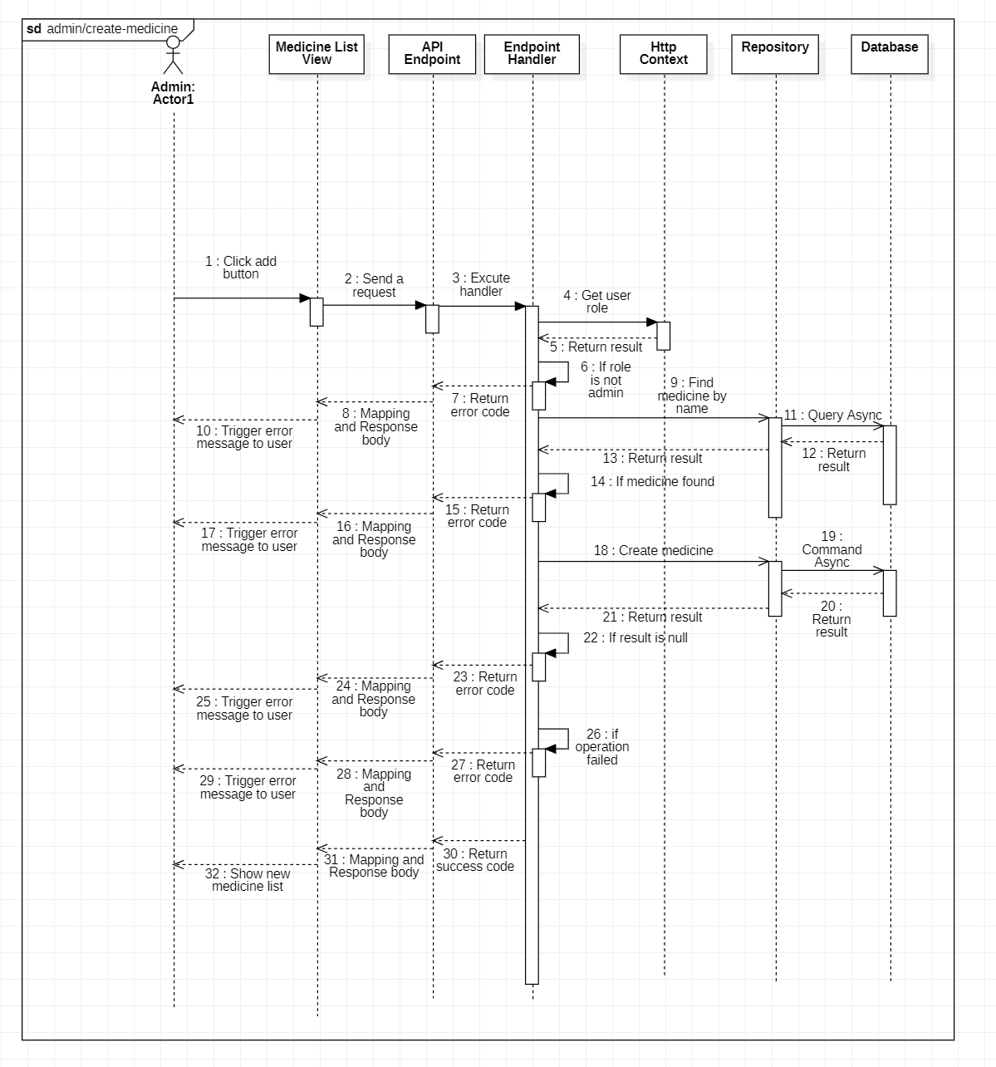

#### d. Database Queries

**public async Task<bool> CreateNewMedicine(Medicine medicine, CancellationToken cancellationToken = default)**

{

try

{

_medicines.Add(medicine);

await _context.SaveChangesAsync(cancellationToken: cancellationToken);

}

catch (Exception ex)

{

await Console.Out.WriteLineAsync(ex.ToString());

return false;

}

return true;

}

**public async Task<bool> IsExistDrug(string name, CancellationToken cancellationToken = default)**

{

return await _medicines

.AnyAsync(medicine => medicine.Name == name, cancellationToken);

}

### 14.3. Create a service

#### a. Class diagram

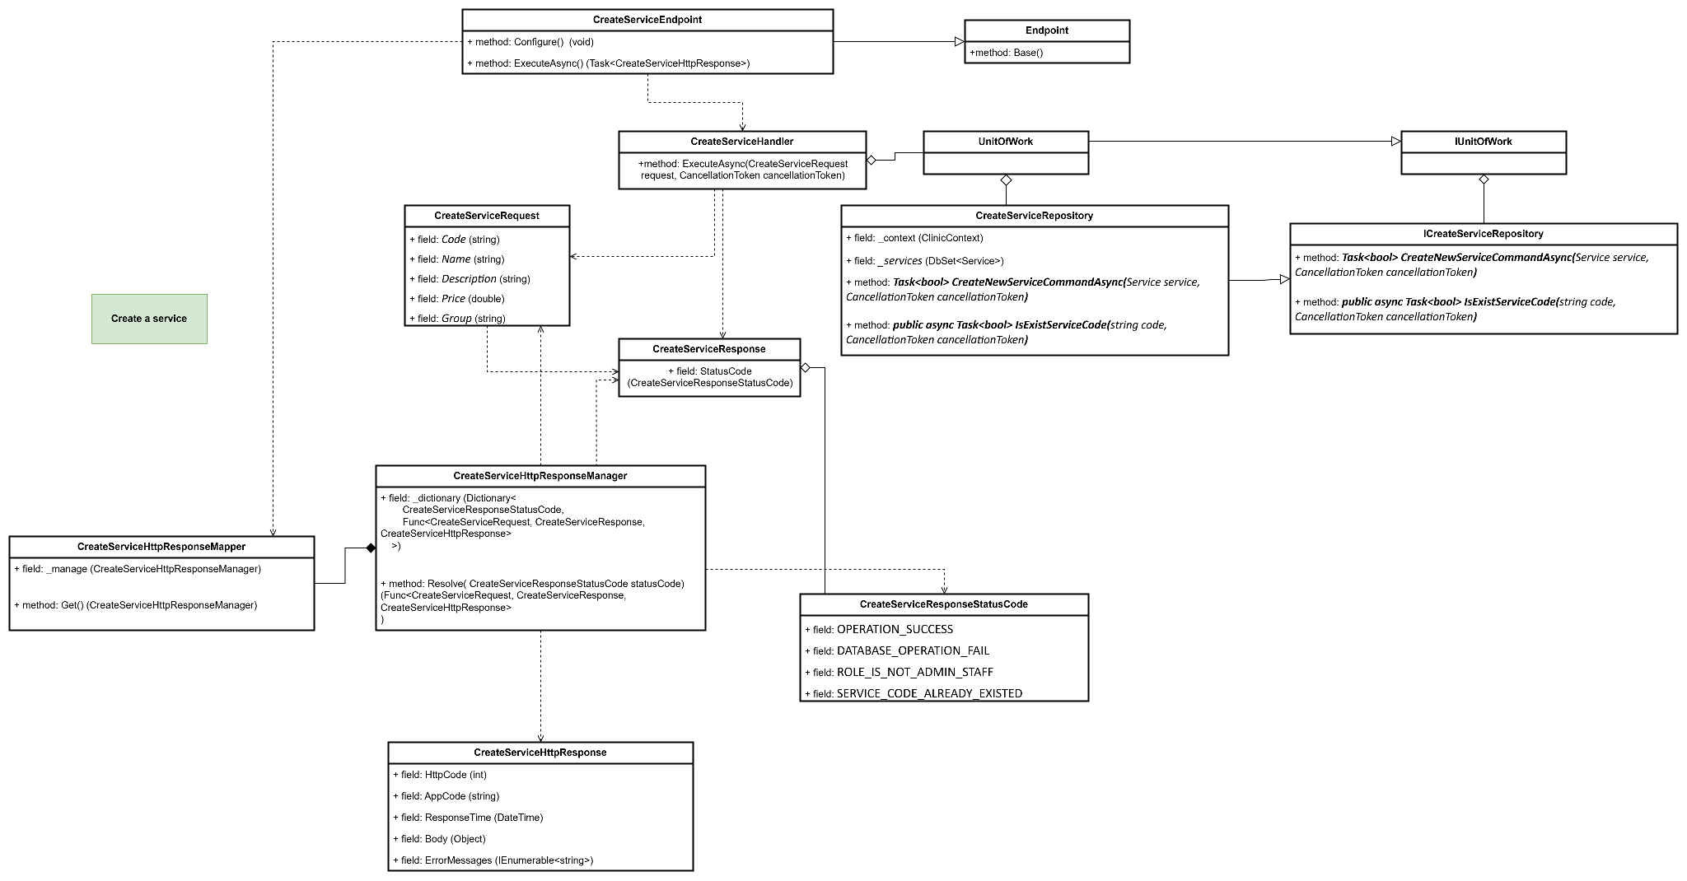

#### b. Class Specifications

#### CreateServiceEndpoint class

*Same as common given before,* [*review here*](https://docs.google.com/document/d/1tTZUy0kDp6tdHb6MY85cNBVlDSK0k0N9w2NXBLPTu-c/edit?fbclid=IwY2xjawGRuZpleHRuA2FlbQIxMAABHUWj7GBmcsB0TEQOSeFgkcMlTv6kK6aEkUnExmkf0x_20x3n5Tikj9MvPA_aem_7Ik47wBVUygzT8J9mpiG0w#heading=h.m7r87enxie2d)*.*

1. ***Endpoint abstract class***

*Same as common given before,* [*review here*](https://docs.google.com/document/d/1tTZUy0kDp6tdHb6MY85cNBVlDSK0k0N9w2NXBLPTu-c/edit?fbclid=IwY2xjawGRuZpleHRuA2FlbQIxMAABHUWj7GBmcsB0TEQOSeFgkcMlTv6kK6aEkUnExmkf0x_20x3n5Tikj9MvPA_aem_7Ik47wBVUygzT8J9mpiG0w#heading=h.ac857vak9ccs)*.*

1. ***CreateServiceValidator class***

*Same as common given before,* [*review here*](https://docs.google.com/document/d/1tTZUy0kDp6tdHb6MY85cNBVlDSK0k0N9w2NXBLPTu-c/edit?fbclid=IwY2xjawGRuZpleHRuA2FlbQIxMAABHUWj7GBmcsB0TEQOSeFgkcMlTv6kK6aEkUnExmkf0x_20x3n5Tikj9MvPA_aem_7Ik47wBVUygzT8J9mpiG0w#heading=h.mapewhyr52db)*.*

1. ***CreateServiceHandler class***

*Same as common given before,* [*review here*](https://docs.google.com/document/d/1tTZUy0kDp6tdHb6MY85cNBVlDSK0k0N9w2NXBLPTu-c/edit?fbclid=IwY2xjawGRuZpleHRuA2FlbQIxMAABHUWj7GBmcsB0TEQOSeFgkcMlTv6kK6aEkUnExmkf0x_20x3n5Tikj9MvPA_aem_7Ik47wBVUygzT8J9mpiG0w#heading=h.3lfr3mcrnl8j)*.*

1. ***IUnitOfWork interface***

*Same as common given before,* [*review here*](https://docs.google.com/document/d/1tTZUy0kDp6tdHb6MY85cNBVlDSK0k0N9w2NXBLPTu-c/edit?fbclid=IwY2xjawGRuZpleHRuA2FlbQIxMAABHUWj7GBmcsB0TEQOSeFgkcMlTv6kK6aEkUnExmkf0x_20x3n5Tikj9MvPA_aem_7Ik47wBVUygzT8J9mpiG0w#heading=h.plvhy3azezgm)*.*

1. ***UnitOfWork class***

*Same as common given before,* [*review here*](https://docs.google.com/document/d/1tTZUy0kDp6tdHb6MY85cNBVlDSK0k0N9w2NXBLPTu-c/edit?fbclid=IwY2xjawGRuZpleHRuA2FlbQIxMAABHUWj7GBmcsB0TEQOSeFgkcMlTv6kK6aEkUnExmkf0x_20x3n5Tikj9MvPA_aem_7Ik47wBVUygzT8J9mpiG0w#heading=h.75tksa2v2ybj)*.*

1. ***CreateServiceRequest class***

| **No** | **Fields** | **Description** |
| --- | --- | --- |
| *01* | *Code* | *A unique identifier or code for the item or service.* |
| *02* | *Name* | *The name of the item or service.* |
| *03* | *Description* | *A detailed description of the item or service.* |
| *04* | *Price* | *The cost of the item or service, represented as an integer.* |
| *05* | *Group* | *Indicates the category or group to which the item or service belongs.* |

1. ***CreateServiceResponse class***

| **No** | **Fields** | **Description** |
| --- | --- | --- |
| *01* | *StatusCode* | *This field will return an app code and http code.* |

1. ***CreateServiceResponseStatusCode Enum class***

This enum class contains important app codes such as OPERATION_SUCCESS, DATABASE_OPERATION_FAIL, ROLE_IS_NOT_ADMIN_STAFF, and SERVICE_CODE_ALREADY_EXISTED. These codes are specifically designed to handle responses related to success and error statuses within the application, facilitating the management of various outcomes, such as indicating successful operations, identifying database errors, ensuring proper role authorization, and enforcing the uniqueness of service codes.

1. ***CreateServiceRepository interface***

This interface class contains method to interact with database

| **No** | **Method** | **Description** |
| --- | --- | --- |
| *01* | ***public async Task<bool> CreateNewServiceCommandAsync(****Service service, CancellationToken cancellationToken****)*** | *Defines a method to add a new service to the database and returns whether the operation was successful.* |
| *02* | ***public async Task<bool> IsExistServiceCode(****string code, CancellationToken cancellationToken****)*** | *Defines a method to check if a service code exists in the database and returns a boolean indicating its existence.* |

1. ***CreateServiceRepository class***

This class is an implementation of the *IGetUserProfileRepository* interface***.***

| **No** | **Fields** | **Description** |
| --- | --- | --- |
| *01* | *_context* | *This field is database context* |
| *02* | *_services* | *Property to interact with the Services table in the database* |

| **No** | **Method** | **Description** |
| --- | --- | --- |
| *01* | ***public async Task<bool> CreateNewServiceCommandAsync(****Service service, CancellationToken cancellationToken****)*** | *Execute statements that interact with the database and return the desired value* |
| *02* | ***public async Task<bool> IsExistServiceCode(****string code, CancellationToken cancellationToken****)*** | *Execute statements that interact with the database and return the desired value* |

#### c. Sequence Diagram(s)

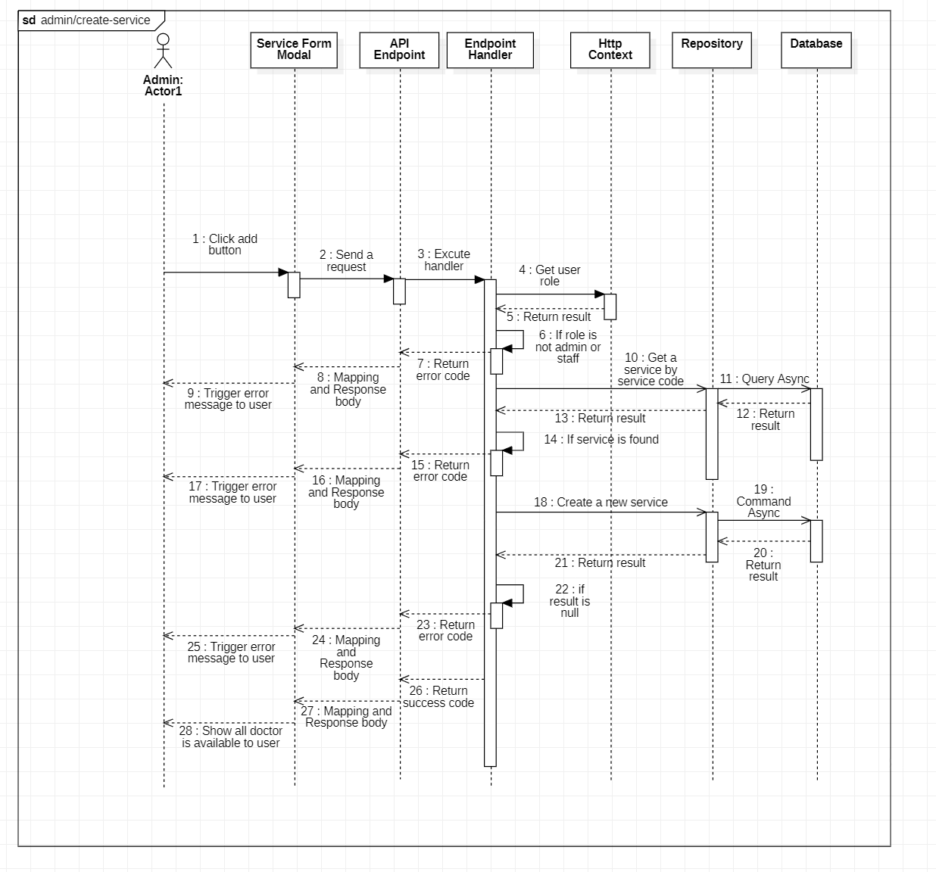

#### d. Database Queries

**public async Task<bool> CreateNewServiceCommandAsync(Service service, CancellationToken cancellationToken)**

{

try

{

_services.Add(service);

await _context.SaveChangesAsync(cancellationToken: cancellationToken);

}

catch (Exception ex)

{

await Console.Out.WriteLineAsync(ex.ToString());

return false;

}

return true;

}

**public async Task<bool> IsExistServiceCode(string code, CancellationToken cancellationToken)**

{

return await _services.AnyAsync(entity => entity.Code.Equals(code), cancellationToken);

}